­­

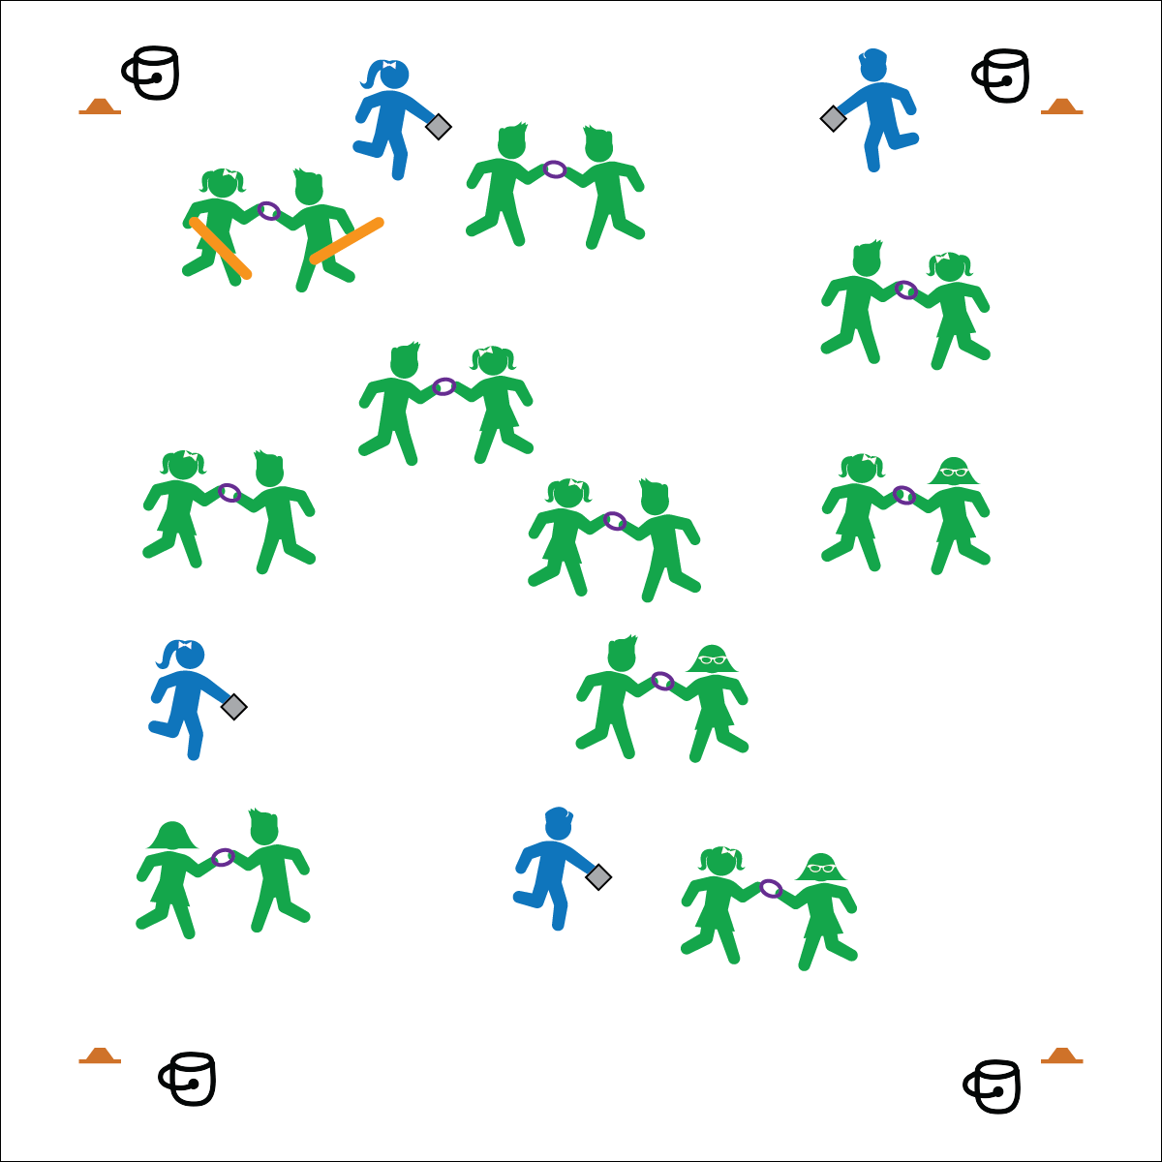

**Activity Procedures:**

1. Let’s play Olympic Ring Fun Fact Tag! The purpose of the activity is for the “Olympic Rings” (pairs holding rings) to avoid being tagged, and to learn fun facts about the Olympics.
2. When I say, “GO!” Olympic Rings and taggers should begin skipping around the activity area. Olympic Rings can either tag themselves (see below) or be tagged by a player carrying a noodle. Olympians are the only players allowed to run and cannot be tagged.
3. Olympic Rings, you tag yourself if you fall down, bump into others, let go of the deck ring, or step out of bounds. You must then put the ring on the ground and do 5 jumping jacks before returning to the game.
4. If you are tagged by a player carrying a noodle, squat down and call for help. The Olympians’ job is to help Olympic Rings who have been tagged to return to the game. They will read you their Olympic Fun Fact Question Card. The Olympic Ring player who answers correctly will switch places with the Olympian, exchanging the Fun Fact Card for another before rejoining the game. If both students answer the question correctly, they play Rock, Paper, Scissors to determine who becomes the new Olympian.

**Grade Level Progression:**

**3rd:** Allow Olympic Rings to move alone rather than in pairs. Everyone carries Olympic Fun Fact Question Cards, and anyone can help anyone else return to the game.

**4th:** Play the activity as described above.

**5th:** Introduce alternative locomotor movements in addition to skipping.

**Equipment:**

* Cones to create boundaries
* 1 deck ring per 2 students
* 2, 2-foot foam noodles
* Olympic Fun Fact Question Cards
* 4 buckets, discs, or boxes to hold extra Olympic Fun Fact Question Cards.

**Set-Up:**

1. Use cones to create a large activity area.
2. Designate 4–5 students as “Olympians,” each with an Olympic Fun Fact Question Card.
3. Distribute the remaining cards evenly in the buckets/discs/boxes and place 1 in each corner of the activity area.
4. Pair the remaining students, each pair with a deck ring.
5. Designate 1 pair as taggers, both students with a noodle (in addition to their deck ring).

* **Skill:** I will perform different locomotor movements.
* **Cognitive:** I will learn and remember fun facts about the Olympic Games.
* **Fitness:** I will actively participate in this cardiovascular activity.
* **Personal & Social Responsibility:** I will work with others by cooperating and being a good teammate.
* Move As A Team
* Safe Tagging

**OLYMPIC RING FUN FACT TAG**

**OLYMPIC RING FUN FACT TAG**



Control, Cooperation, Fact, Locomotor, Run, Skip, Teamwork



* **Standard 1 [E1.4-5b]** Uses various locomotor skills in a variety of small-sided practice tasks (4); Demonstrates mature patterns of locomotor skills in dynamic small-sided practice tasks (5a); Combines locomotor and manipulative skills in a variety of small-sided practice tasks/games environments (5b).
* **Standard** **3 [E3.3-5]** Engages in the activities of physical education class without teacher prompting (3); Actively engages in the activities of physical education class, both teacher-directed and independent (4); Actively engages in all the activities of physical education (5).



* **DOK** **1:** What is 1 Olympic Fun Fact you learned today?
* **DOK 2:** How would you compare and contrast the Winter Olympics with the Summer Olympics?
* **DOK 3:** What else would you include on a list of facts about the Olympics?



**Preview new content:** Many students may have limited knowledge about the Olympics. If you find that this is the case, have the students read and share an Olympic Fun Fact Question Card with one another before you begin the activity. Discuss the answers with the class and provide some context. That way, as you complete the activity, students will have access to prior knowledge.



* **Adaptation:** Everyone jogs or runs instead of skipping.
* **Extension:** Keep score. Everyone starts with 10 points. Lose 1 point every time you answer a question incorrectly and gain 1 point by answering correctly.