­­

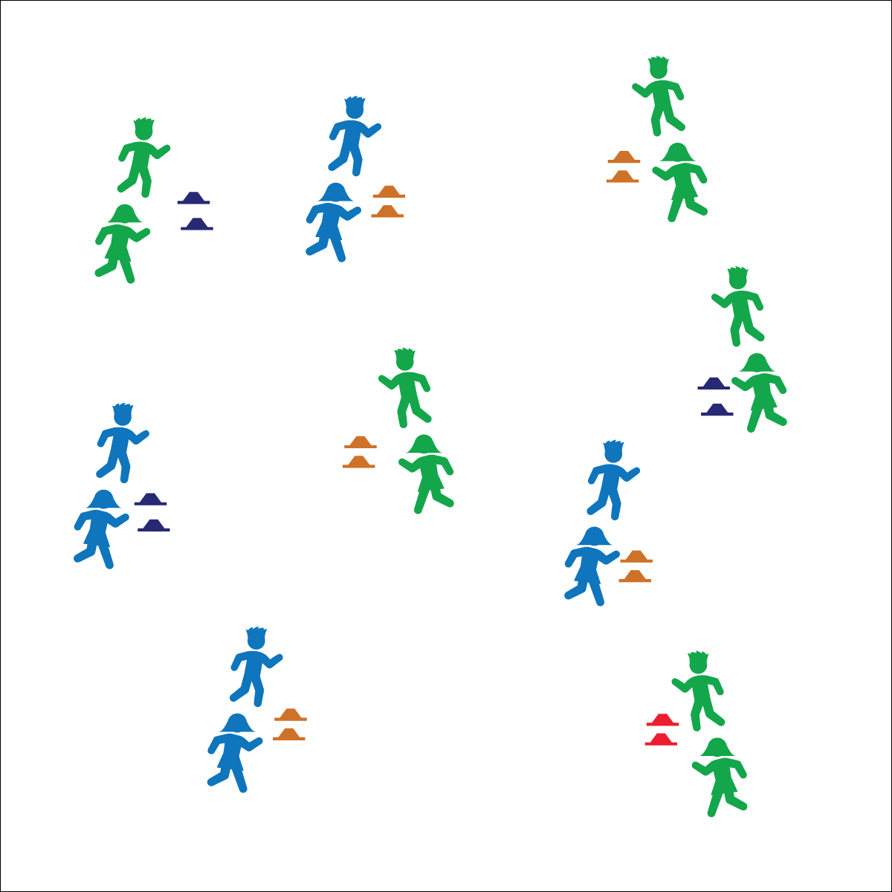

**Activity Procedures:**

1. Today’s activity is called Olympic Ski Jumping Combine. The object of the activity is to complete a variety of jumps for distance while having fun with our classmates.
2. When I say, “GO!” 1 person from your group will stand at the 1st cone and try to jump as far as possible. The other person will measure the jumper’s distance by placing the 2nd cone at the spot where they landed. Then switch roles and continue taking turns to perform horizontal jumps for distance, trying to be the Olympic champion!
3. Teachers, have students perform a variety of jumps during this activity. They can start with a standing horizontal jump, then progress to a running horizontal jump. Next, jump horizontally and backward for distance, and then finish with freestyle ski jumping—students must complete tricks in the air before landing.

**Grade Level Progression:**

**3rd:** Play the activity as described above.

**4th:** Have students develop and implement a simple scoring system.

**5th:** Add both judging and scoring to the activity. The judge will monitor takeoff and landing very closely. Students measure each distance correctly with a ruler and record the data.

* **Skill:** I will take off and land with 2 feet safely.
* **Cognitive:** I will explain the critical elements to jumping both horizontally and vertically.
* **Fitness:** I will apply aerobic fitness and muscular strength to ski jumping.
* **Personal & Social Responsibility:** I will work cooperatively with my classmates to succeed.
* Marshmallow Feet on Landing
* Take Off Like Superman
* Be Cooperative

**Equipment:**

* 2 cones per group of 2–3 students
* Optional: 1 ruler, pencil and paper per group of 2–3 students

**Set-Up:**

1. Scatter the pairs of cones throughout the activity area.
2. Students in groups of 2–3, each group at a set of cones.
3. Be sure all groups have enough space around their cones to perform a variety of jumps safely.

**OLYMPIC SKI JUMPING COMBINE**

**OLYMPIC SKI JUMPING COMBINE**



Backward, Cooperation, Forward, Jump, Land, Power, Sprint, Takeoff



* **Standard** **1 [E3.3-5]** Jumps and lands in the horizontal and vertical planes using a mature pattern (3); Uses spring-and-step takeoffs and landings specific to gymnastics (4); Combines jumping and landing patterns with locomotors and manipulative skills in dance, gymnastics, and small-sided practice tasks/games environments (5).
* **Standard 2 [E3.3-5]** Combines movement concepts (direction, levels, force, time) with skills as directed by the teacher (3); Applies the movement concepts of speed, endurance, and pacing for running (4a); Analyzes movement situations and applies movement concepts (e.g., force, direction, speed, pathways, extensions) in small-sided practice task/game environments, dance, and gymnastics (5c).



* **DOK** **1:** What is power?
* **DOK 2:** How can power affect our performance when jumping for distance?
* **DOK 3:** What would happen if you decreased the amount of power you applied during takeoff?

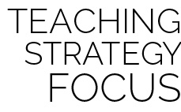

**Help students practice skills.** Ski Jumping Combine adds variety to horizontal and vertical jumping while providing ample opportunity for students to practice basic fundamental skills. This unique, game-based practice environment provides challenge and interest while helping students development skill competency and confidence.



* **Adaptation:** Students complete the challenges while traveling with short jump ropes for distance, performing a jogging step or forward-jumping motion.
* **Extension:** Students develop a scoring system for freestyle jumping that rewards the difficulty and personal style of the jumps.