­­

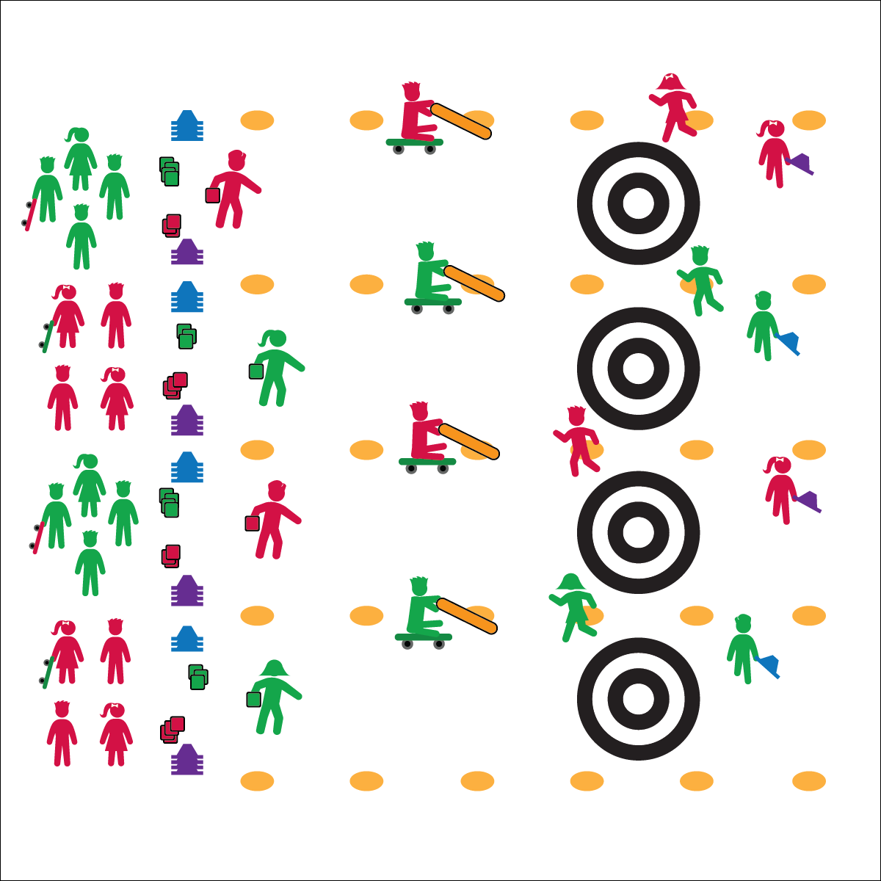

* **Skill:** I will demonstrate proper underhand throwing with a focus on accuracy.
* **Cognitive:** I will follow rules and strategy for scoring.
* **Fitness:** I will apply fitness concepts during my participation.
* **Personal & Social Responsibility:** I will work   
  cooperatively with my team and praise the efforts  
  of my teammates.
* Respect the Olympic Spirit
* Safety First
* Work Cooperatively

**Equipment:**

* 1 scooter per group of 4 students
* 1 4-foot noodle per group of 4 students
* 16 low-profile cones per rink
* 16 bean bags per rink
* Poly spots and/or floor tape

**Set-Up:**

1. Using poly spots, divide the playing area into rinks (alleys). Make 1 rink for every 8 students.
2. Using floor tape, make a classic target at 1 end of each rink.
3. Place 16 bean bags, 16 cones (both in 2 piles of 8) and 2 scooters at the other end of each rink.
4. Students in groups of 4; 2 groups at each rink.

**Activity Procedures:**

1. Today’s activity is called Olympic Curling. The object of the activity is to score points by getting the rocks (bean bags) closest to the button (center of the target). Teams consist of 4 players, and each player has a role (Lead, Second, Third, and Skip). There will be 4 ends (rounds) so everyone can fill each role.
2. **Lead:** Throws (delivers) the rock (bean bag) underhand toward the house (target). **Second:** Marks the placement of the rock once it has stopped moving by replacing it with a cone. **Third:** Acts as the sweep, using the noodle and scooter to help guide the rock into the house (target). **Skip:** The captain of the team; helps the Third with strategy while skipping along the edge of the rink. The Skip can communicate with the third but not touch the rock.
3. To start, the Skip begins to skip the length of the rink and will continue until the rock is placed.
4. The first team’s Lead throws a rock (bean bag) toward the house, aiming at the button. The Third is on a scooter in the rink and gets 1 more push to redirect the rock. Noodles can’t be used to stop a rock.
5. Once the rock comes to a stop, the Second replaces it with a cone as a marker. If the rock collides with a cone already in place, that cone is removed and a new cone is placed where the rock stops.
6. Teams alternate turns for throwing rocks. Players rotate positions and play until all players get a chance to throw. Note: unlike in regulation curling, each player will only send 1 rock down the rink.
7. Scoring: Only 1 team can score in an end. A team scores 1 point for every rock that is closer to the button than the other team’s best rock. The students switch positions and play another end. Curling is traditionally played for 8 ends; modify the number of ends based on your class’ time.

**Grade Level Progression:**

**3rd:** Play the activity without a sweep.

**4–5th:** Play the activity as described.

**OLYMPIC CURLING**

**OLYMPIC CURLING**



Button, Delivery, Eight-Ender, End, Hammer, House, Lead, Rink, Rock, Second, Skip, Sweep, Third



* **Standard** **2 [E3.3-5]** Combines movement concepts (direction, levels, force, time) with skills as directed by the teacher (3); Applies the movement concepts of speed, endurance, and pacing for running (4a); Applies movement concepts to strategy in game situations (5a); Analyzes movement situations and applies movement concepts (e.g., force, direction, speed, pathways, extensions) in small-sided practice task/game environments, dance, and gymnastics (5c).
* **Standard 3 [E2.3-5]** Engages in the activities of physical education class without teacher prompting (3); Actively engages in the activities of physical education class, both teacher-directed and independent (4); Actively engages in all the activities of physical education (5).
* **Standard 4 [E4.3-5]** Works cooperatively with others (3a); Praises others for their success in movement performance (3b); Praises the movement performance of others both more and less-skilled (4a); Accepts “players” of all skill levels into the physical activity (4b); Accepts, recognizes, and actively involves others with both higher and lower skill abilities into physical activities and group projects (5).



* **DOK** **1:** How do you keep score during 1 end of curling?
* **DOK 2:** What were some strategies your team used to score points?
* **DOK 3:** Describe some defensive strategies you can use in curling to prevent your opponents from scoring.

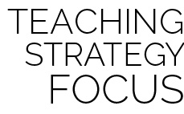

**Preview new content:** Students may have watched curling on TV, but many will minimize the importance of targeting and overemphasize the importance of scoring points. By previewing past Olympic performances with a focus on targeting, students can develop connections to authentic skill application.



* **Adaptation:** Play the activity with alternative equipment (e.g., Voit foam balls, fitness balls, or soft flying discs).
* **Extension:** Have the Lead throw blindfolded. The Skip can direct the Lead on direction and where to throw the rock (bean bag).