­­



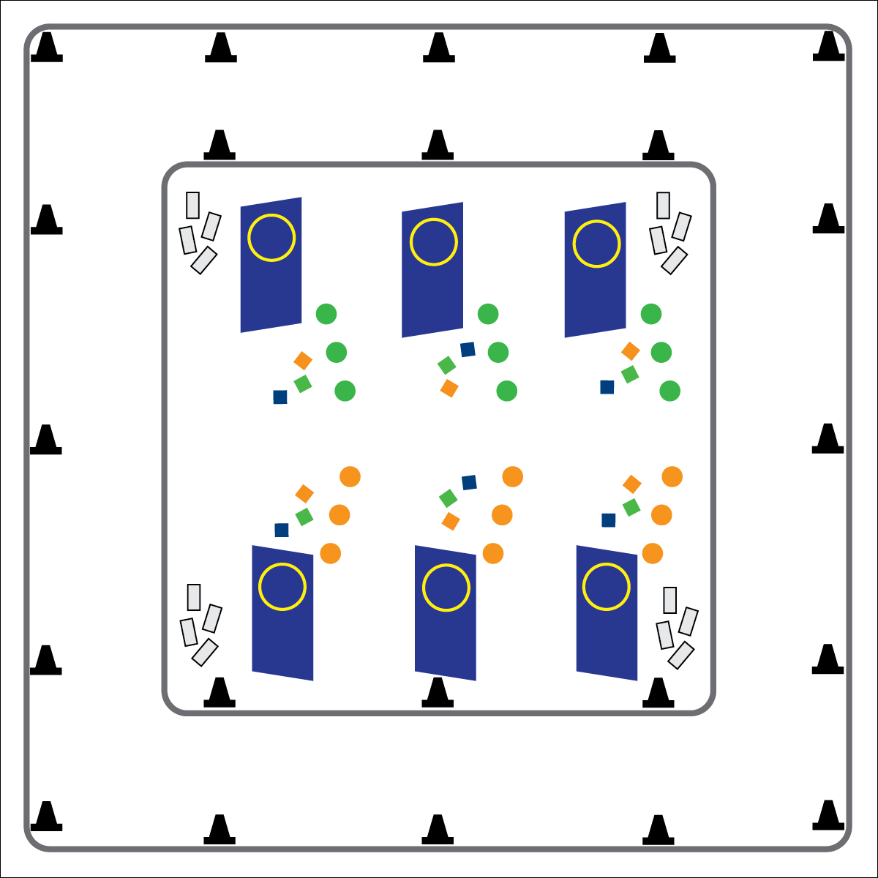

* **Skill:** I will perform proper overhand throws at a stationary target.
* **Cognitive:** I will understand how different forms of movement affect my heart and body in different ways.
* **Fitness:** I will participate in activities designed to improve cardiorespiratory endurance.
* **Personal and Social Responsibility:** I will participate safely and independently during physical education class.
* Eyes on Targets
* Move Safely in Space
* Throw with Accuracy

**Equipment:**

* 28 cones
* 6 tumbling mats
* 6 hula hoops
* 18 spot markers
* 18 bean bags or yarn balls
* Locomotor Movement Cards

**Set-Up:**

1. Use cones to outline a running track around the perimeter of the activity area. Place Locomotor Movements Cards in a pile nearby.
2. Spaced evenly throughout the inside of the track, stand up the tumbling mats and tape a hula hoop to each one to form a vertical target. Place 3 poly spots in front of each target at varying distances, and place 3 bean bags nearby.
3. Send half of the class to the track. The other half spread evenly across the targets.

**Activity Procedures:**

1. It’s time for the Locomotor Biathlon, a long-endurance fitness event that combines elements of traveling long distances and target practice. We’ll use locomotor skills combined with overhand throws.
2. If you are beginning on the track, when I say, “GO!” choose a Locomotor Movement Card. Hold onto it as you follow its instructions (movement type and number of laps). When you’re done, return your card and move to the end of the line at one of the targets for target practice.
3. If you start with target practice, line up so 1 person practices at a time. You have 3 bean bag throws to earn points. Hit the target (inside of hoop) from the closest spot to earn 1 point, from the middle spot to earn 2 points, and from the farthest spot to earn 3 points. After throwing all 3, pick your bean bags up, give them to the next person, and go choose a Locomotor Movement Card to move around the track.
4. Continue rotating between the track and target practice until you hear the stop signal.
5. Add your points together and keep track of them during your Biathlon event so you know if you make the medal podium at the end!
6. Bronze Medal = __ to __ points; Silver Medal = __ to __ points; Gold Medal = __ to __ points

**Grade Level Progression:**

**3rd:** Play the activity as described above.

**4th:** Play the activity with scarfs as skis.

**5th:** Play the activity with scooters.

**LOCOMOTOR BIATHLON**

**LOCOMOTOR BIATHLON**



General Space, Locomotor, Overhand, Physical Activity, Run, Skip, Target, Throw, Underhand, Walk



* **Standard 1 [E14.3,4a,5b]** Throws overarm, demonstrating three of the five critical elements of a mature pattern, in non-dynamic environments, for distance and/or force (3); Throws overarm using a mature pattern in non-dynamic environments (4a); Throws (both underhand and overarm) to a large target with accuracy (5b).
* **Standard 3 [E3.3-5]** Describes the concept of fitness and provides examples of physical activity to enhance fitness (3); Identifies the components of health-related fitness (4); Differentiates between skill-related and health-related fitness (5).



* **DOK 1:** What are the locomotor movements?
* **DOK 2:** What locomotor movements move you around the track quickly? Slowly?
* **DOK 3:** Can you think of any ways we could practice getting better at throwing at the target?

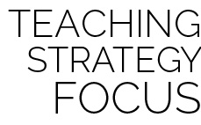

**Help students engage in cognitively complex tasks.** Execution of locomotor and manipulative skill combinations within a dynamic activity environment is both physically and cognitively complex for intermediate school students. Biathlon challenges the students to throw at a target after performing a locomotor movement, increasing the heart rate. The students will have to learn how to perform in a challenging aerobic environment.



* **Adaptation:** Allow students to choose locomotor movements that fit their skillset. Allow students to continue throwing the bean bags until they earn at least 1 point.
* **Extension:** Remove the poly spots that are closest to the target. Introduce a “throw until you miss” policy, with students taking 1 step backward after every successful throw.