­­

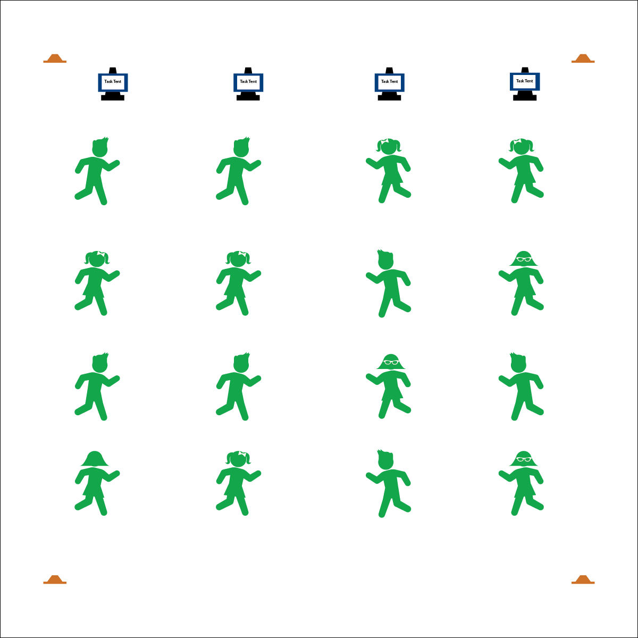

* **Skill:** I will participate in this activity with proper form and attention to safety.
* **Cognitive:** I will explain how to demonstrate safe participation.
* **Fitness:** I will pace myself so that I increase my heart rate and warm up my muscles.
* **Personal & Social Responsibility:** I will work independently.

**TRAIN LIKE AN OLYMPIAN**

* Follow Exercise Cues
* Listen for Start/Stop Signals
* Pace Your Activity to Warm Up Your Muscles

**Equipment:**

* Train Like an Olympic Athlete Routine Cards
* Tabata audio cues (Tabata timer app)
* Task tents
* 4 low-profile cones

**Set-Up:**

1. Use cones to create a large activity area.
2. Place Routine Cards in task tents or display them using a projector.
3. Scatter students in view of the routine cards and with enough personal space for safe movement.

**Activity Procedures:**

1. Today we are going to warm up our bodies by training like Olympic athletes!
2. Tabata-style training was created by a Japanese scientist named Dr. Izumi Tabata. We may adjust our timing and intensity, but true Tabata workouts combine 20 seconds of vigorous activity with 10 seconds of rest in between each set.
3. When I say, “GO!” begin following the routine card displayed on the task tents. When I say, “FREEZE,” we’ll take 10 seconds of rest and prepare for the next exercise on the routine card. Our warm-up will take 4 minutes total.

**Grade Level Progression:**

**3rd:** Perform the warm-up as described above. Assign students to each routine card.

**4th:** Students choose the Olympic sport they’d like to train for and perform the corresponding Tabata exercises.

**5th:** During the module, allow students to research Olympic sports and develop their own warm-ups.

**TRAIN LIKE AN OLYMPIAN**



* **DOK 1:** How can you recognize appropriate and safe fitness participation?
* **DOK 2:** How do exercise/activity cues affect safe participation?
* **DOK 3:** How is appropriate behavior related to independent participation?



* **Standard** **3 [E2.3-5]** Engages in the activities of physical education class without teacher prompting (3); Actively engages in the activities of physical education class, both teacher-directed and independent (4); Actively engages in all the activities of physical education (5).
* **Standard 3 [E4.3,5]** Recognizes the importance of warm-up and cool-down relative to vigorous physical activity (3); Identifies the need for warm-up and cool-down relative to various physical activities (5).
* **Standard 4 [E1.3-5]** Exhibits personal responsibility in teacher-directed activities (3); Exhibits responsible behavior in independent group situations (4); Engages in physical activity with responsible interpersonal behavior (e.g., peer to peer, student to teacher, student to referee) (5).



* **Adaptation:** Pair students to provide a guide for those who require assistance.
* **Extension:** Provide fitness activities at various levels of intensity and difficulty. Allow students to choose their level of participation.



Appropriate, Equipment, Guidance, Identify, Independent, Safe, Safety Concerns, Set, Specific, Tabata Interval Training, Vigorous, Warm-up

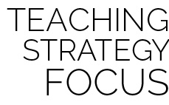

**Identify critical content.** Safe and appropriate participation is absolutely essential for the success of fitness instruction. By starting the Olympic Module with a focus on safe participation, students will understand baseline expectations for their behavior and performance.

**COOPERATIVE BOBSLED**

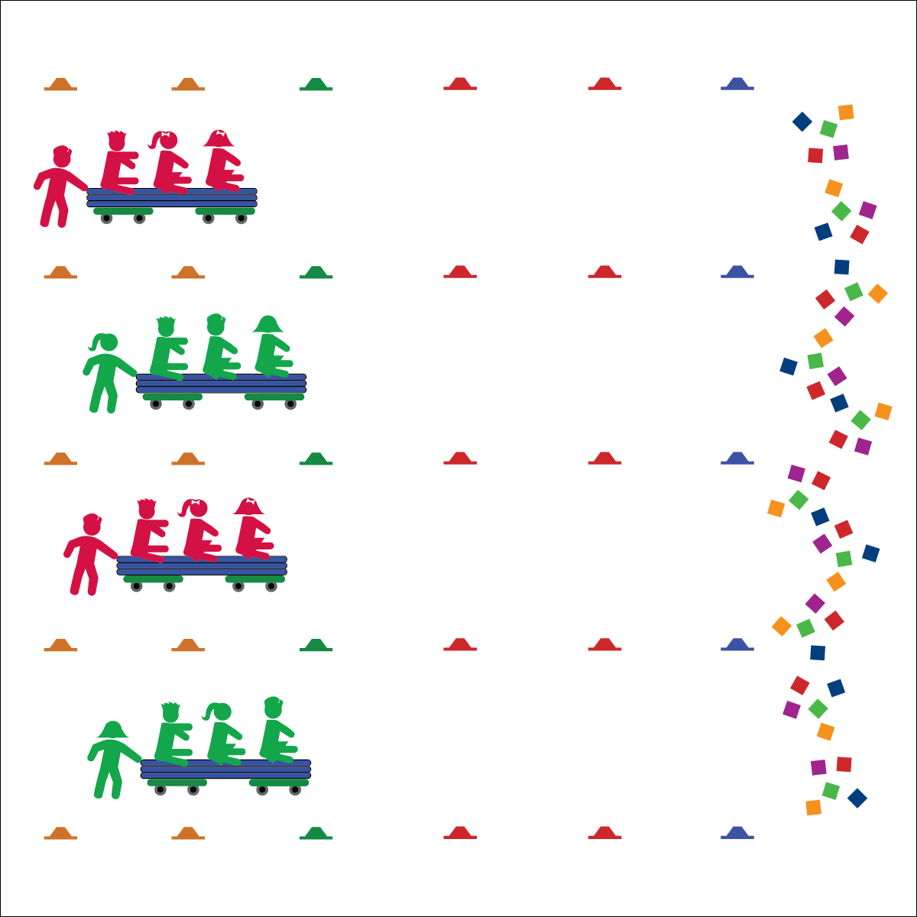

* Communicate Cooperatively with Friends
* Move Safely with Equipment
* Show Teamwork

**Activity Procedures:**

1. Today’s activity is called Cooperative Bobsled Driving. The object of the activity is to work together to move the bobsled safely throughout the activity area and collect gold medals (beanbags).
2. You and the 3 other students at your bobsled are a team. The team member standing up is the pusher. The person sitting in the back will be driver, the person in the middle will balance the sled’s weight, and the person in front is the team’s brake person.
3. When I say, “GO!” your team’s pusher will start moving the group around the cones. The driver will communicate with the pusher in order to help them move safely through the gym. If the sled is going too fast, the brake person will put their feet down to brake.
4. Teachers, give teams a few minutes to discuss strategies for success.
5. Teams will drive from one side of the gym to the other in straight pathways or through cone courses designed by the teacher. When they reach the other side, they collect 1 gold medal and then return to the start line. Rotate roles before starting again.

**Grade Level Progression:**

**3rd:** Play the activity as described above.

**4th:** Add different pathways through teacher-designed bobsled courses.

**5th:** Have students design courses for other groups, then take turns driving all the different pathways.

**Equipment:**

* 2 scooters per group of 4 students
* 1 gymnastics mat per group of 4 students
* 12–48 cones
* 24–48 beanbags

**Set-Up:**

1. Use low-profile cones to create a large activity area with start/stop lines and, if desired, course pathways.
2. Place beanbags at the far side of the gym, near the stop line.
3. Place scooter boards under a gymnastics mat to create “bobsleds.”
4. Place students into groups of 4, each group at a bobsled. 3 students from each group sit on their bobsled.

* **Skill:** I will be mindful of others while moving in open space.
* **Cognitive:** I will explain proper technique for pushing and controlling the bobsled safely in open space.
* **Fitness:** I will apply muscular strength and endurance to this activity.
* **Personal & Social Responsibility:** I will work cooperatively with others by taking turns pushing the bobsled.

**COOPERATIVE BOBSLED**



**Organize students to interact with content.** Group dynamics play a key role in the success of each team. Even though students are required to discuss ideas as a team prior to starting the activity, many students tend to set out on their own—sometimes with limited success—before realizing that they will not be successful until all group members become involved. Move from group to group, offering guidance while also allowing each group to discover their own process to complete the challenge. Monitor student behavior throughout the activity with a careful watch for the unsafe use of equipment and disrespectful language.



* **DOK** **1:** What is cooperation?
* **DOK 2:** How can group cooperation affect the performance of the sled?
* **DOK 3:** How can negative interactions with others affect the sled’s performance and the performance of athletes at the Olympics?



* **Standard** **2 [E1.3-5]** Recognizes the concept of open spaces in a movement context (3); Applies the concept of open spaces to combination skills involving traveling (e.g., dribbling and traveling) (4a); Applies the concept of closing spaces in small-sided practice tasks (4b); Dribbles in general space with changes in direction and speed (4c); Combines spatial concepts with locomotor and non-locomotor movements for small groups in gymnastics, dance, and games environments (5).
* **Standard 4 [E4.3-5]** Works cooperatively with others (3a); Praises others for their success in movement performance (3b); Praises the movement performance of others both more and less-skilled (4a); Accepts “players” of all skill levels into the physical activity (4b); Accepts, recognizes, and actively involves others with both higher and lower skill abilities into physical activities and group projects (5).
* **Standard 5 [E4.3-5]** Describes the positive social interactions that come when engaged with others in physical activity (3); Describes/compares the positive social interactions when engaged in partner, small-group, and large-group physical activities (4); Describes the social benefits gained from participating in physical activity (e.g., recess, youth sport) (5).



Backward, Communication, Cooperation, Curved, Force, Guide, Left, Pathway, Push, Right, Straight, Teamwork



* **Adaptation:** Students go 1 at a time through the bobsled course while partners perform fitness activities. Play the activity with locomotor movements instead of scooters.
* **Extension:** Students design courses for homework and use protractors to design different driving angles for the course. Then use painters’ tape to mark the angles on the ground. The other groups drive the courses for points.

**OLYMPIC VILLAGE CLEAN-UP**

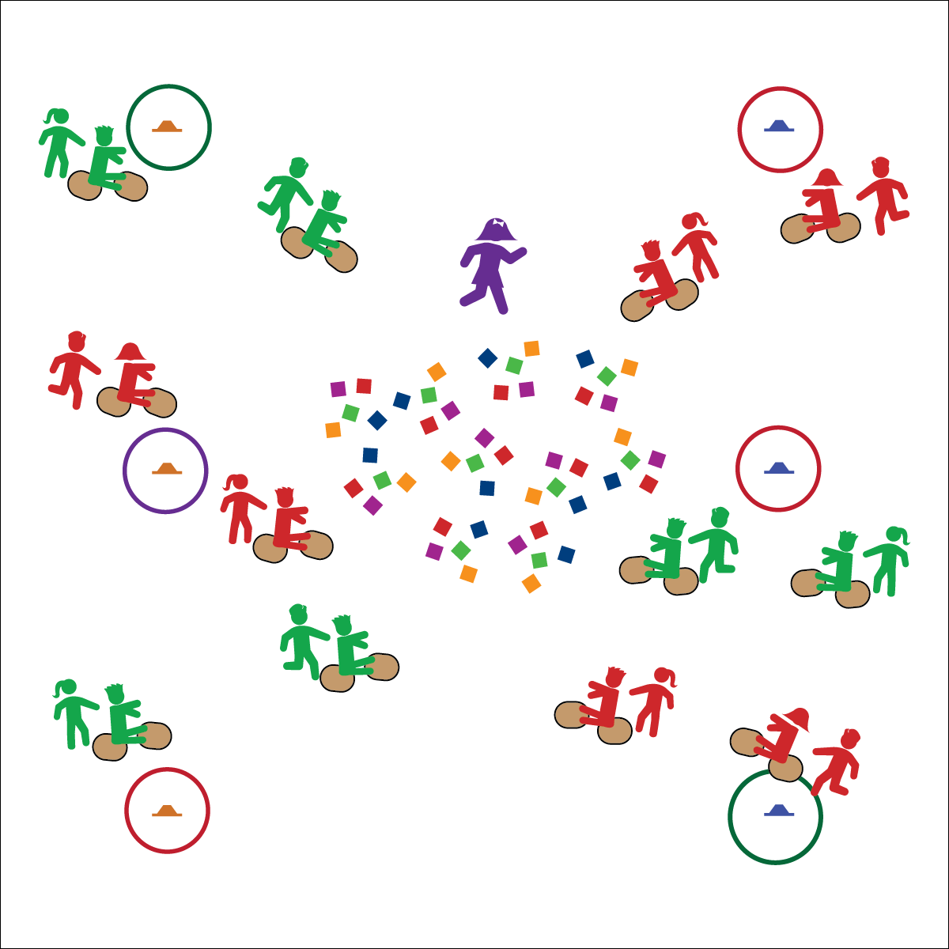

**Equipment:**

* 1 carpet square per student
* 6 cones
* 6 hoops
* 24–64 beanbags or yarn balls
* 1 pinnie

**Set-Up:**

1. Place cones around the perimeter of the activity area with a hoop around each one.
2. Place the beanbags in the center of the area.
3. Using a pinnie, designate 1 students as an “Olympic athlete.”
4. Students in pairs, each pair with 2 carpet squares. Have an equal number of pairs line up behind each cone. This can be played locomotor movements, rather than with carpet squares

**Activity Procedures:**

1. Today’s activity is called Olympic Village Clean-up. The object of the activity is to help clean up the Olympic Village of all the trash (beanbags) left over from the athletes’ daily meals and place them in your waste management center (cone and hoop).
2. 1 person from each pair will be the driver of your clean-up machine. S/he will sit on 1 carpet square with her/his feet on the other (both carpet squares should be face-down). The other person is the “engine,” and s/he will push the driver by the shoulders.
3. When I say, “GO!” the 1st team from each line will attempt to drive to the Olympic Village, pick up 1 piece of trash, and return to their waste management center without being tagged by an athlete.
4. If you are successful, place the trash in the waste management center, high-five the next team in line (who will then attempt to retrieve a piece of trash), and then go to the end of the line. If you are tagged, return the trash to the Olympic Village and go to the end of the line.

**Grade Level Progression:**

**3rd:** Play the activity as described above.

**4th:** Use different colors of beanbags to represent different types of waste. For example, blue=trash, red=recycle, green=compost. Have students sort the trash into the correct piles at the end of the activity.

**5th:** Assign “jobs” to all the groups in the class. Each group will focus on picking up only their type (color) of trash. The class must work together to clean up the Olympic Village.

* **Skill:** I will be mindful of others while moving in open space.
* **Cognitive:** I will explain proper technique for pushing and controlling the clean-up machine safely.
* **Fitness:** I will apply muscular strength and endurance to this activity.
* **Personal & Social Responsibility:** I will work cooperatively with others by taking turns pushing the clean-up machine.
* Communicate Cooperatively with Friends
* Move Safety with Equipment
* Show Teamwork

**OLYMPIC VILLAGE CLEAN-UP**



* **Standard 2 [E5.3-5]** Applies simple strategies/tactics in chasing activities (3a); Applies simple strategies in fleeing activities (3b); Applies simple offensive strategies/tactics in chasing and fleeing activities (4a); Applies simple defensive strategies/tactics in chasing and fleeing activities (4b); Recognizes the type of kicks needed for different games/sports situations (4c); Applies basic offensive and defensive strategies/tactics in invasion small-sided practice tasks (5a); Applies basic offensive and defensive strategies/tactics in net/wall small-sided practice tasks (5b); Recognizes the type of throw, volley, or striking action needed for different games/sports situations (5c).
* **Standard 3 [E2.3-5]** Engages in the activities of physical education class without teacher prompting (3); Actively engages in the activities of physical education class, both teacher-directed and independent (4); Actively engages in all the activities of physical education (5).
* **Standard 4 [E1.3-5]** Exhibits personal responsibility in teacher-directed activities (3); Exhibits responsible behavior in independent group situations (4); Engages in physical activity with responsible interpersonal behavior (e.g., peer to peer, student to teacher, student to referee) (5).



* **DOK 1:** How can you recognize safe behavior during Olympic Village Clean-up?
* **DOK 2:** What did you notice about our game and safety? Can you give examples of safe behaviors and unsafe behaviors?
* **DOK 3:** How is safety related to learning in physical education class?



Compost, Cooperation, Locomotor, Muscular Endurance, Muscular Strength, Recycle, Teamwork, Waste



* **Adaptation:** Use locomotor movements instead of carpet squares.
* **Extension:** Brainstorm ways to implement recycling plans in the cafeteria to reduce school waste and/or start a composting area at school.



**Help students process content.** Olympic Village is an engaging and vigorous physical activity that students enjoy. Allow students to talk freely about the Olympic experience, transfer their thinking from past physically active events, and process the connection between participation in the Olympic Module and good mental and emotional health.

**OLYMPIC RING FUN FACT TAG**

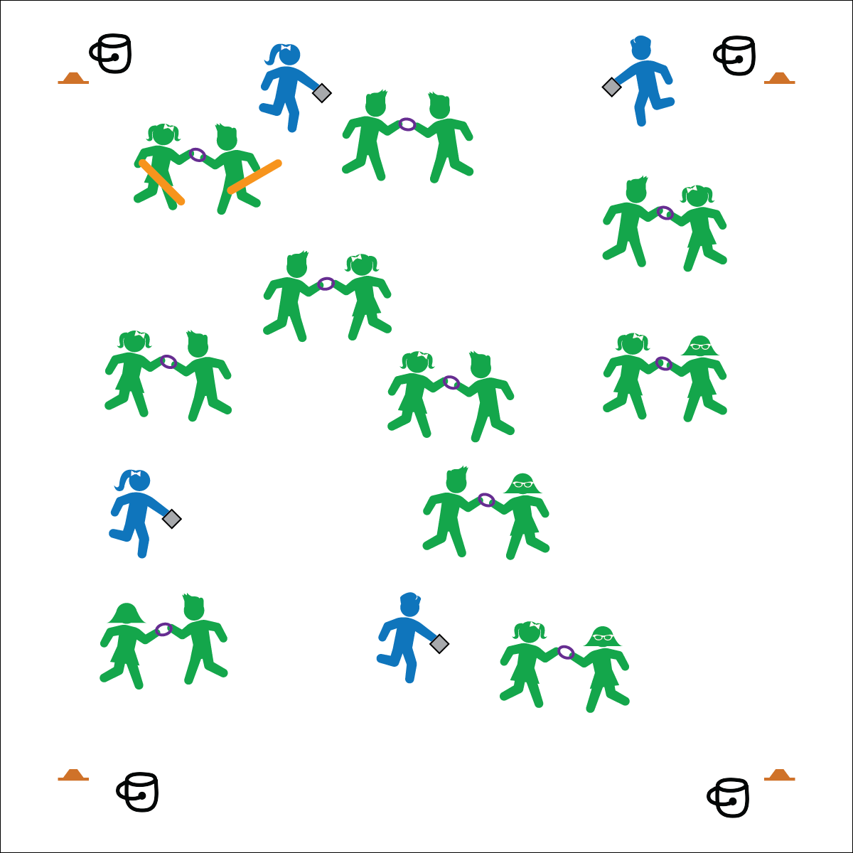

**Equipment:**

* Cones to create boundaries
* 1 deck ring per 2 students
* 2, 2-foot foam noodles
* Olympic Fun Fact Question Cards
* 4 buckets, discs, or boxes to hold extra Olympic Fun Fact Question Cards.

**Set-Up:**

1. Use cones to create a large activity area.
2. Designate 4–5 students as “Olympians,” each with an Olympic Fun Fact Question Card.
3. Distribute the remaining cards evenly in the buckets/discs/boxes and place 1 in each corner of the activity area.
4. Pair the remaining students, each pair with a deck ring.
5. Designate 1 pair as taggers, both students with a noodle (in addition to their deck ring).

* **Skill:** I will perform different locomotor movements.
* **Cognitive:** I will learn and remember fun facts about the Olympic Games.
* **Fitness:** I will actively participate in this cardiovascular activity.
* **Personal & Social Responsibility:** I will work with others by cooperating and being a good teammate.

**Activity Procedures:**

1. Let’s play Olympic Ring Fun Fact Tag! The purpose of the activity is for the “Olympic Rings” (pairs holding rings) to avoid being tagged, and to learn fun facts about the Olympics.
2. When I say, “GO!” Olympic Rings and taggers should begin skipping around the activity area. Olympic Rings can either tag themselves (see below) or be tagged by a player carrying a noodle. Olympians are the only players allowed to run and cannot be tagged.
3. Olympic Rings, you tag yourself if you fall down, bump into others, let go of the deck ring, or step out of bounds. You must then put the ring on the ground and do 5 jumping jacks before returning to the game.
4. If you are tagged by a player carrying a noodle, squat down and call for help. The Olympians’ job is to help Olympic Rings who have been tagged to return to the game. They will read you their Olympic Fun Fact Question Card. The Olympic Ring player who answers correctly will switch places with the Olympian, exchanging the Fun Fact Card for another before rejoining the game. If both students answer the question correctly, they play Rock, Paper, Scissors to determine who becomes the new Olympian.

**Grade Level Progression:**

**3rd:** Allow Olympic Rings to move alone rather than in pairs. Everyone carries Olympic Fun Fact Question Cards, and anyone can help anyone else return to the game.

**4th:** Play the activity as described above.

**5th:** Introduce alternative locomotor movements in addition to skipping.

* Move As A Team
* Safe Tagging

**OLYMPIC RING FUN FACT TAG**



* **Standard 1 [E1.4-5b]** Uses various locomotor skills in a variety of small-sided practice tasks (4); Demonstrates mature patterns of locomotor skills in dynamic small-sided practice tasks (5a); Combines locomotor and manipulative skills in a variety of small-sided practice tasks/games environments (5b).
* **Standard** **3 [E3.3-5]** Engages in the activities of physical education class without teacher prompting (3); Actively engages in the activities of physical education class, both teacher-directed and independent (4); Actively engages in all the activities of physical education (5).



* **DOK** **1:** What is 1 Olympic Fun Fact you learned today?
* **DOK 2:** How would you compare and contrast the Winter Olympics with the Summer Olympics?
* **DOK 3:** What else would you include on a list of facts about the Olympics?



Control, Cooperation, Fact, Locomotor, Run, Skip, Teamwork



* **Adaptation:** Everyone jogs or runs instead of skipping.
* **Extension:** Keep score. Everyone starts with 10 points. Lose 1 point every time you answer a question incorrectly and gain 1 point by answering correctly.



**Preview new content:** Many students may have limited knowledge about the Olympics. If you find that this is the case, have the students read and share an Olympic Fun Fact Question Card with one another before you begin the activity. Discuss the answers with the class and provide some context. That way, as you complete the activity, students will have access to prior knowledge.

**OLYMPIC SKI JUMPING COMBINE**

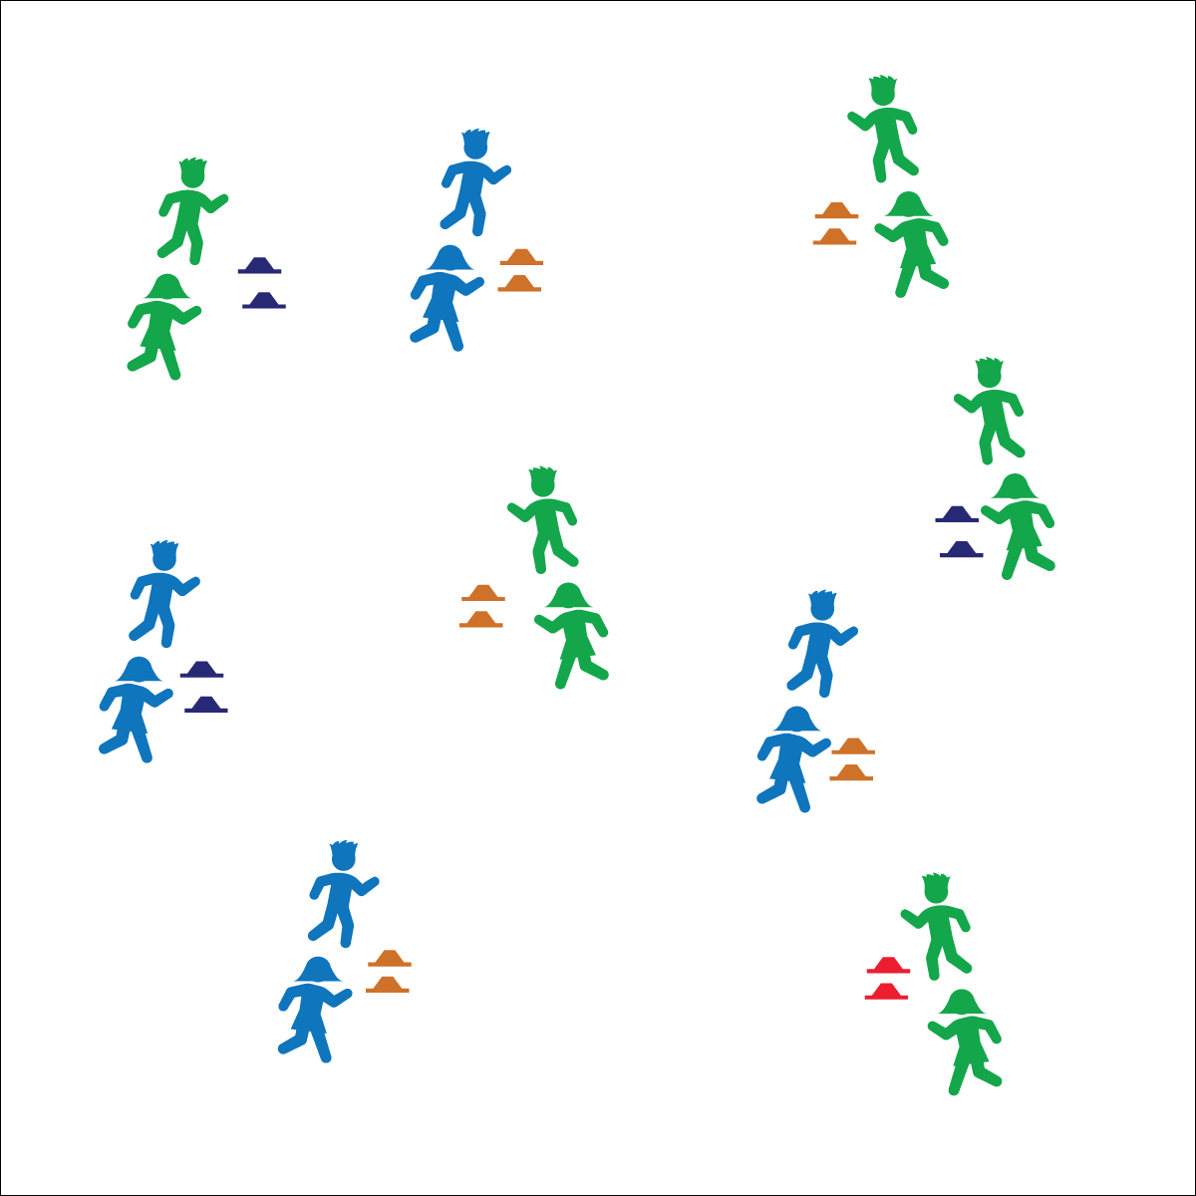

**Activity Procedures:**

1. Today’s activity is called Olympic Ski Jumping Combine. The object of the activity is to complete a variety of jumps for distance while having fun with our classmates.
2. When I say, “GO!” 1 person from your group will stand at the 1st cone and try to jump as far as possible. The other person will measure the jumper’s distance by placing the 2nd cone at the spot where they landed. Then switch roles and continue taking turns to perform horizontal jumps for distance, trying to be the Olympic champion!
3. Teachers, have students perform a variety of jumps during this activity. They can start with a standing horizontal jump, then progress to a running horizontal jump. Next, jump horizontally and backward for distance, and then finish with freestyle ski jumping—students must complete tricks in the air before landing.

**Grade Level Progression:**

**3rd:** Play the activity as described above.

**4th:** Have students develop and implement a simple scoring system.

**5th:** Add both judging and scoring to the activity. The judge will monitor takeoff and landing very closely. Students measure each distance correctly with a ruler and record the data.

**Equipment:**

* 2 cones per group of 2–3 students
* Optional: 1 ruler, pencil and paper per group of 2–3 students

**Set-Up:**

1. Scatter the pairs of cones throughout the activity area.
2. Students in groups of 2–3, each group at a set of cones.
3. Be sure all groups have enough space around their cones to perform a variety of jumps safely.

* **Skill:** I will take off and land with 2 feet safely.
* **Cognitive:** I will explain the critical elements to jumping both horizontally and vertically.
* **Fitness:** I will apply aerobic fitness and muscular strength to ski jumping.
* **Personal & Social Responsibility:** I will work cooperatively with my classmates to succeed.
* Marshmallow Feet on Landing
* Take Off Like Superman
* Be Cooperative

**OLYMPIC SKI JUMPING COMBINE**



**Help students practice skills.** Ski Jumping Combine adds variety to horizontal and vertical jumping while providing ample opportunity for students to practice basic fundamental skills. This unique, game-based practice environment provides challenge and interest while helping students development skill competency and confidence.



* **DOK** **1:** What is power?
* **DOK 2:** How can power affect our performance when jumping for distance?
* **DOK 3:** What would happen if you decreased the amount of power you applied during takeoff?



* **Standard** **1 [E3.3-5]** Jumps and lands in the horizontal and vertical planes using a mature pattern (3); Uses spring-and-step takeoffs and landings specific to gymnastics (4); Combines jumping and landing patterns with locomotors and manipulative skills in dance, gymnastics, and small-sided practice tasks/games environments (5).
* **Standard 2 [E3.3-5]** Combines movement concepts (direction, levels, force, time) with skills as directed by the teacher (3); Applies the movement concepts of speed, endurance, and pacing for running (4a); Analyzes movement situations and applies movement concepts (e.g., force, direction, speed, pathways, extensions) in small-sided practice task/game environments, dance, and gymnastics (5c).



Backward, Cooperation, Forward, Jump, Land, Power, Sprint, Takeoff



* **Adaptation:** Students complete the challenges while traveling with short jump ropes for distance, performing a jogging step or forward-jumping motion.
* **Extension:** Students develop a scoring system for freestyle jumping that rewards the difficulty and personal style of the jumps.

**OLYMPIC CURLING**

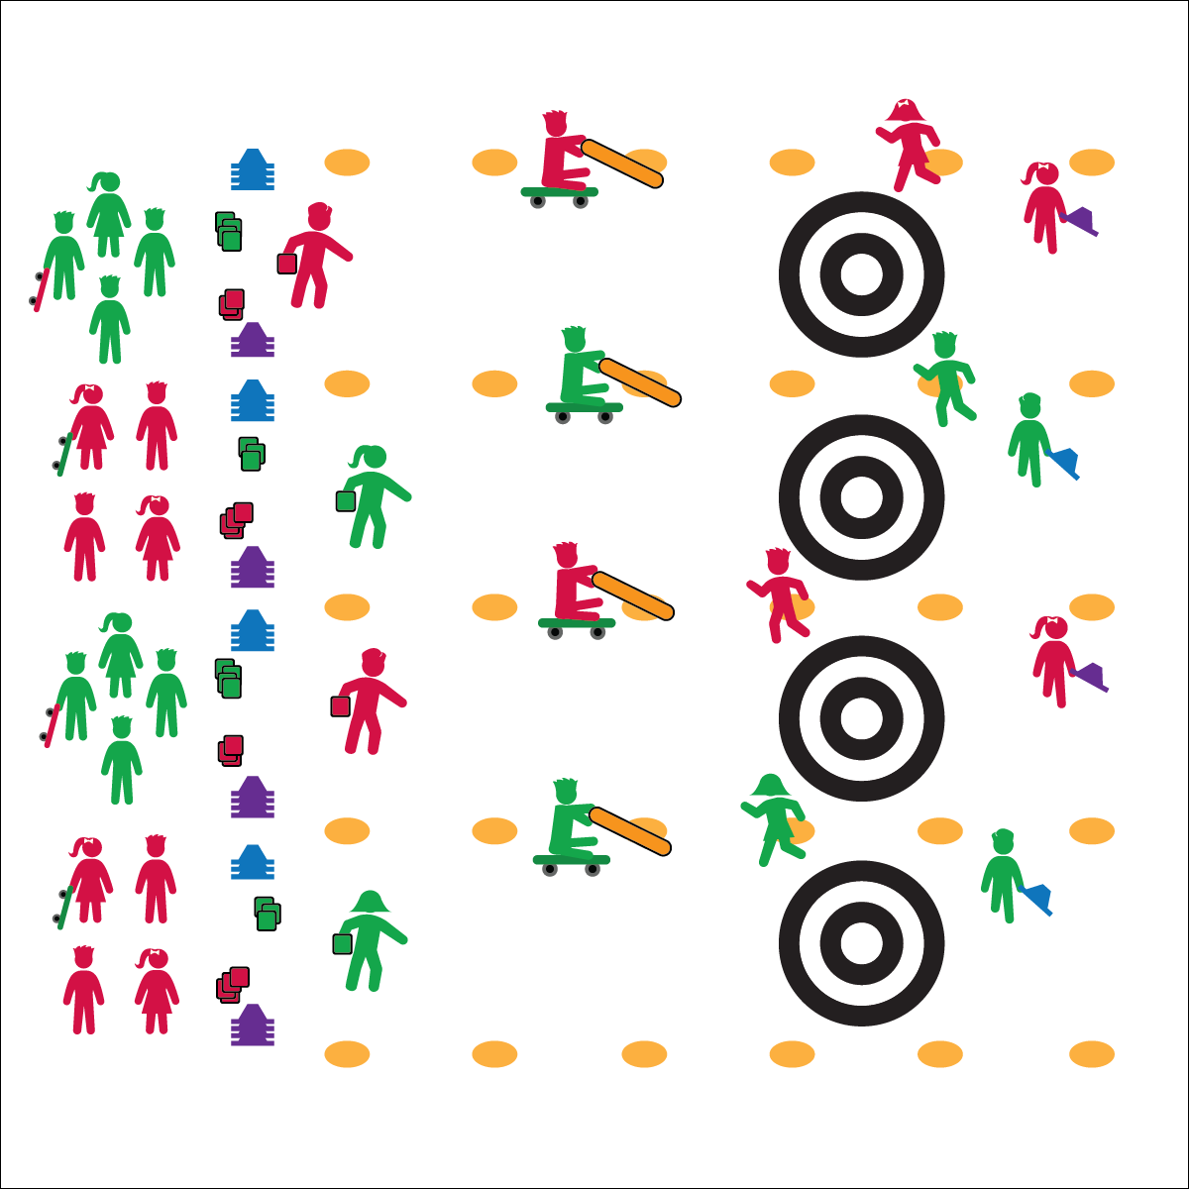

* **Skill:** I will demonstrate proper underhand throwing with a focus on accuracy.
* **Cognitive:** I will follow rules and strategy for scoring.
* **Fitness:** I will apply fitness concepts during my participation.
* **Personal & Social Responsibility:** I will work   
  cooperatively with my team and praise the efforts  
  of my teammates.

**Activity Procedures:**

1. Today’s activity is called Olympic Curling. The object of the activity is to score points by getting the rocks (bean bags) closest to the button (center of the target). Teams consist of 4 players, and each player has a role (Lead, Second, Third, and Skip). There will be 4 ends (rounds) so everyone can fill each role.
2. **Lead:** Throws (delivers) the rock (bean bag) underhand toward the house (target). **Second:** Marks the placement of the rock once it has stopped moving by replacing it with a cone. **Third:** Acts as the sweep, using the noodle and scooter to help guide the rock into the house (target). **Skip:** The captain of the team; helps the Third with strategy while skipping along the edge of the rink. The Skip can communicate with the third but not touch the rock.
3. To start, the Skip begins to skip the length of the rink and will continue until the rock is placed.
4. The first team’s Lead throws a rock (bean bag) toward the house, aiming at the button. The Third is on a scooter in the rink and gets 1 more push to redirect the rock. Noodles can’t be used to stop a rock.
5. Once the rock comes to a stop, the Second replaces it with a cone as a marker. If the rock collides with a cone already in place, that cone is removed and a new cone is placed where the rock stops.
6. Teams alternate turns for throwing rocks. Players rotate positions and play until all players get a chance to throw. Note: unlike in regulation curling, each player will only send 1 rock down the rink.
7. Scoring: Only 1 team can score in an end. A team scores 1 point for every rock that is closer to the button than the other team’s best rock. The students switch positions and play another end. Curling is traditionally played for 8 ends; modify the number of ends based on your class’ time.

**Grade Level Progression:**

**3rd:** Play the activity without a sweep.

**4–5th:** Play the activity as described.

**Equipment:**

* 1 scooter per group of 4 students
* 1 4-foot noodle per group of 4 students
* 16 low-profile cones per rink
* 16 bean bags per rink
* Poly spots and/or floor tape

**Set-Up:**

1. Using poly spots, divide the playing area into rinks (alleys). Make 1 rink for every 8 students.
2. Using floor tape, make a classic target at 1 end of each rink.
3. Place 16 bean bags, 16 cones (both in 2 piles of 8) and 2 scooters at the other end of each rink.
4. Students in groups of 4; 2 groups at each rink.

* Respect the Olympic Spirit
* Safety First
* Work Cooperatively

**OLYMPIC CURLING**



* **Adaptation:** Play the activity with alternative equipment (e.g., Voit foam balls, fitness balls, or soft flying discs).
* **Extension:** Have the Lead throw blindfolded. The Skip can direct the Lead on direction and where to throw the rock (bean bag).



* **Standard** **2 [E3.3-5]** Combines movement concepts (direction, levels, force, time) with skills as directed by the teacher (3); Applies the movement concepts of speed, endurance, and pacing for running (4a); Applies movement concepts to strategy in game situations (5a); Analyzes movement situations and applies movement concepts (e.g., force, direction, speed, pathways, extensions) in small-sided practice task/game environments, dance, and gymnastics (5c).
* **Standard 3 [E2.3-5]** Engages in the activities of physical education class without teacher prompting (3); Actively engages in the activities of physical education class, both teacher-directed and independent (4); Actively engages in all the activities of physical education (5).
* **Standard 4 [E4.3-5]** Works cooperatively with others (3a); Praises others for their success in movement performance (3b); Praises the movement performance of others both more and less-skilled (4a); Accepts “players” of all skill levels into the physical activity (4b); Accepts, recognizes, and actively involves others with both higher and lower skill abilities into physical activities and group projects (5).



Button, Delivery, Eight-Ender, End, Hammer, House, Lead, Rink, Rock, Second, Skip, Sweep, Third



* **DOK** **1:** How do you keep score during 1 end of curling?
* **DOK 2:** What were some strategies your team used to score points?
* **DOK 3:** Describe some defensive strategies you can use in curling to prevent your opponents from scoring.



**Preview new content:** Students may have watched curling on TV, but many will minimize the importance of targeting and overemphasize the importance of scoring points. By previewing past Olympic performances with a focus on targeting, students can develop connections to authentic skill application.

**LOCOMOTOR BIATHLON**

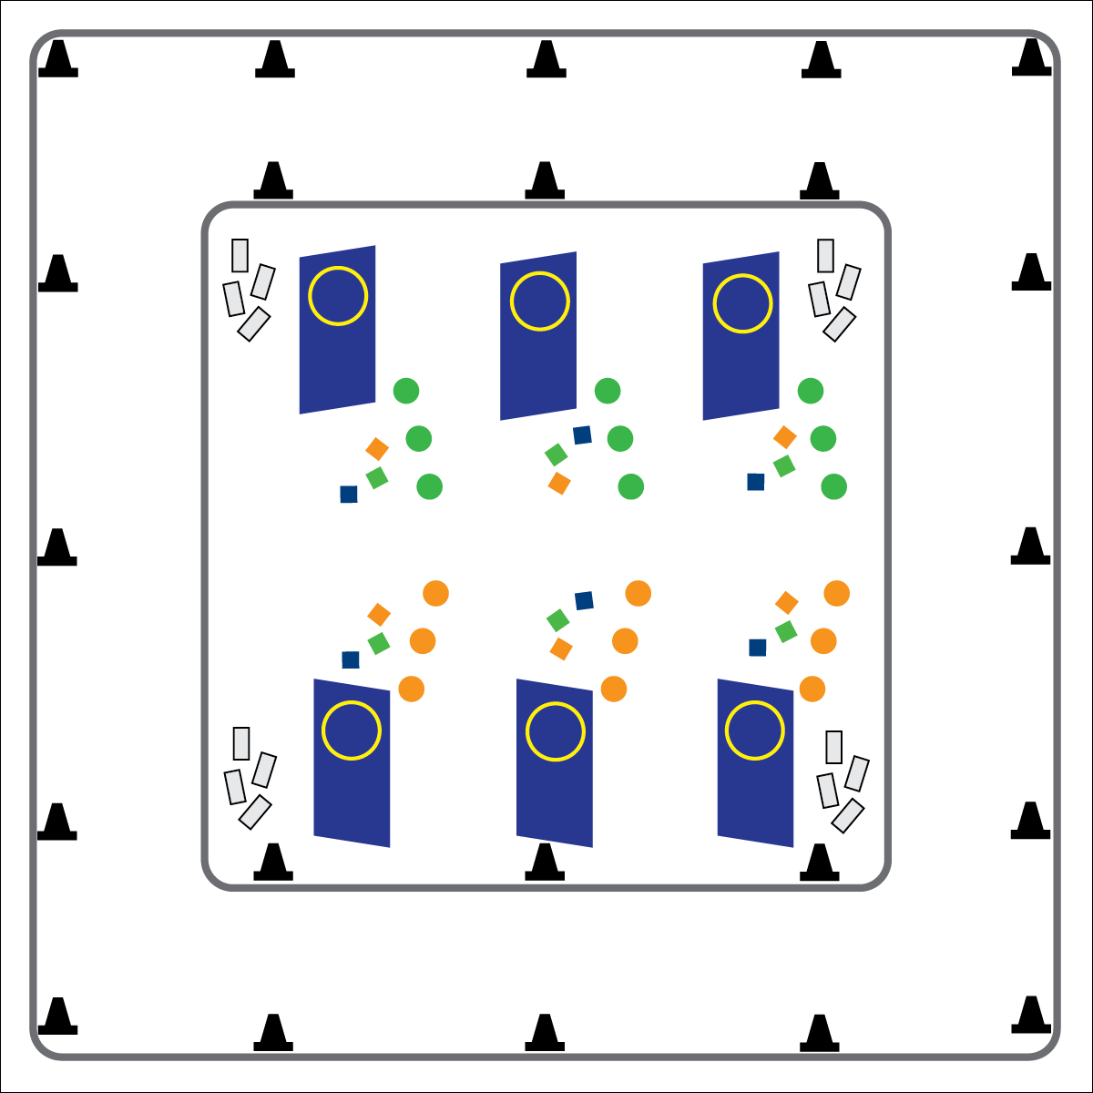

**Activity Procedures:**

1. It’s time for the Locomotor Biathlon, a long-endurance fitness event that combines elements of traveling long distances and target practice. We’ll use locomotor skills combined with overhand throws.
2. If you are beginning on the track, when I say, “GO!” choose a Locomotor Movement Card. Hold onto it as you follow its instructions (movement type and number of laps). When you’re done, return your card and move to the end of the line at one of the targets for target practice.
3. If you start with target practice, line up so 1 person practices at a time. You have 3 bean bag throws to earn points. Hit the target (inside of hoop) from the closest spot to earn 1 point, from the middle spot to earn 2 points, and from the farthest spot to earn 3 points. After throwing all 3, pick your bean bags up, give them to the next person, and go choose a Locomotor Movement Card to move around the track.
4. Continue rotating between the track and target practice until you hear the stop signal.
5. Add your points together and keep track of them during your Biathlon event so you know if you make the medal podium at the end!
6. Bronze Medal = __ to __ points; Silver Medal = __ to __ points; Gold Medal = __ to __ points

**Grade Level Progression:**

**3rd:** Play the activity as described above.

**4th:** Play the activity with scarfs as skis.

**5th:** Play the activity with scooters.

* Eyes on Targets
* Move Safely in Space
* Throw with Accuracy

**Equipment:**

* 28 cones
* 6 tumbling mats
* 6 hula hoops
* 18 spot markers
* 18 bean bags or yarn balls
* Locomotor Movement Cards

**Set-Up:**

1. Use cones to outline a running track around the perimeter of the activity area. Place Locomotor Movements Cards in a pile nearby.
2. Spaced evenly throughout the inside of the track, stand up the tumbling mats and tape a hula hoop to each one to form a vertical target. Place 3 poly spots in front of each target at varying distances, and place 3 bean bags nearby.
3. Send half of the class to the track. The other half spread evenly across the targets.

* **Skill:** I will perform proper overhand throws at a stationary target.
* **Cognitive:** I will understand how different forms of movement affect my heart and body in different ways.
* **Fitness:** I will participate in activities designed to improve cardiorespiratory endurance.
* **Personal and Social Responsibility:** I will participate safely and independently during physical education class.

**LOCOMOTOR BIATHLON**



* **Standard 1 [E14.3,4a,5b]** Throws overarm, demonstrating three of the five critical elements of a mature pattern, in non-dynamic environments, for distance and/or force (3); Throws overarm using a mature pattern in non-dynamic environments (4a); Throws (both underhand and overarm) to a large target with accuracy (5b).
* **Standard 3 [E3.3-5]** Describes the concept of fitness and provides examples of physical activity to enhance fitness (3); Identifies the components of health-related fitness (4); Differentiates between skill-related and health-related fitness (5).



General Space, Locomotor, Overhand, Physical Activity, Run, Skip, Target, Throw, Underhand, Walk



* **Adaptation:** Allow students to choose locomotor movements that fit their skillset. Allow students to continue throwing the bean bags until they earn at least 1 point.
* **Extension:** Remove the poly spots that are closest to the target. Introduce a “throw until you miss” policy, with students taking 1 step backward after every successful throw.



* **DOK 1:** What are the locomotor movements?
* **DOK 2:** What locomotor movements move you around the track quickly? Slowly?
* **DOK 3:** Can you think of any ways we could practice getting better at throwing at the target?



**Help students engage in cognitively complex tasks.** Execution of locomotor and manipulative skill combinations within a dynamic activity environment is both physically and cognitively complex for intermediate school students. Biathlon challenges the students to throw at a target after performing a locomotor movement, increasing the heart rate. The students will have to learn how to perform in a challenging aerobic environment.