­­­

­

* Word
* Word
* Word
* **Skill:** I will …
* **Cognitive:** I will …
* **Fitness:** I will …
* **Personal & Social Responsibility:** I will …
* **Standard # [CODE HERE]** Outcomes text here.
* **Standard # [CODE HERE]** Outcomes text here.
* **Standard # [CODE HERE]** Outcomes text here.
* Assessment Description

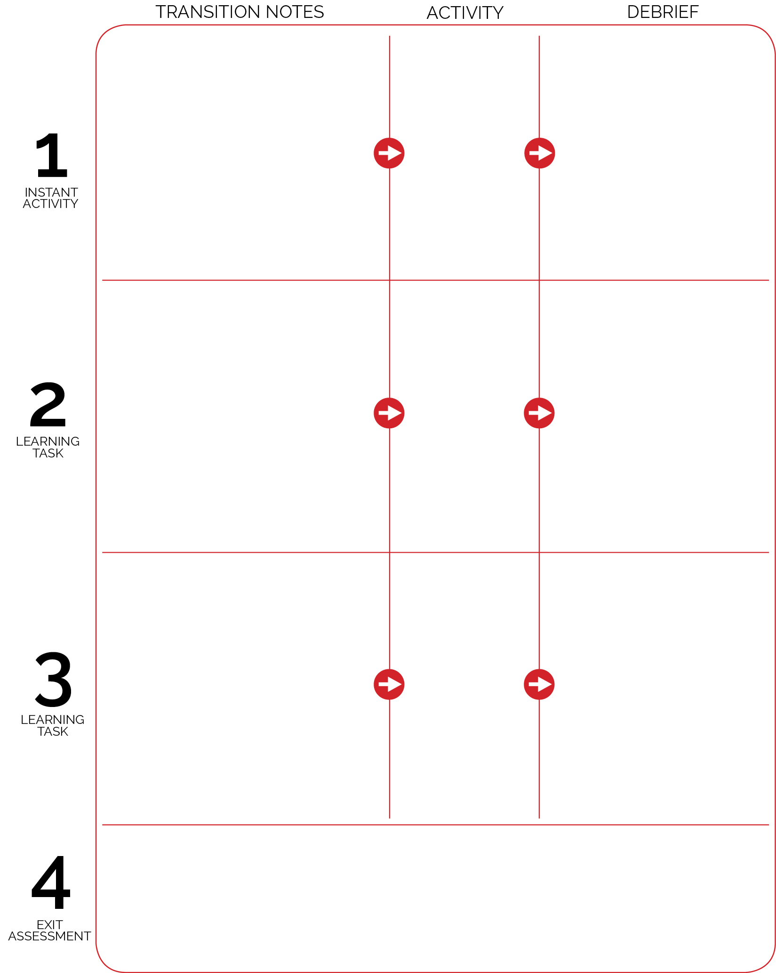

Activity Name

Activity Name

Activity Name

* Question 1
* Question 2
* Question 3

Assessment logistics…

* Question 1
* Question 2
* Question 3
* Question 1
* Question 2
* Question 3

Notes go here…

Notes go here…

Notes go here…