­­­

­

* Tabata Interval Training
* Warm-up
* Communication
* Force
* Guide
* Pathway
* Teamwork
* **Skill:** I will be mindful of others while moving in open space.
* **Cognitive:** I will explain proper technique for pushing and controlling the bobsled safely in open space.
* **Fitness:** I will apply muscular strength and endurance to this activity.
* **Personal & Social Responsibility:** I will work cooperatively with others by taking turns pushing the bobsled.
* **Standard3 [E4.3,5]** Recognizes the importance of warm-up and cool-down relative to vigorous physical activity (3); Identifies the need for warm-up and cool-down relative to various physical activities (5).
* **Standard 4 [E1.3-5]** Exhibits personal responsibility in teacher-directed activities (3); Exhibits responsible behavior in independent group situations (4); Engages in physical activity with responsible interpersonal behavior (e.g., peer to peer, student to teacher, student to referee) (5).
* **Standard 4 [E4.3-5]** Works cooperatively with others (3a); Praises others for their success in movement performance (3b); Praises the movement performance of others both more and less-skilled (4a); Accepts “players” of all skill levels into the physical activity (4b); Accepts, recognizes, and actively involves others with both higher and lower skill abilities into physical activities and group projects (5).
* Self-Assessment (Pre-Assessment)

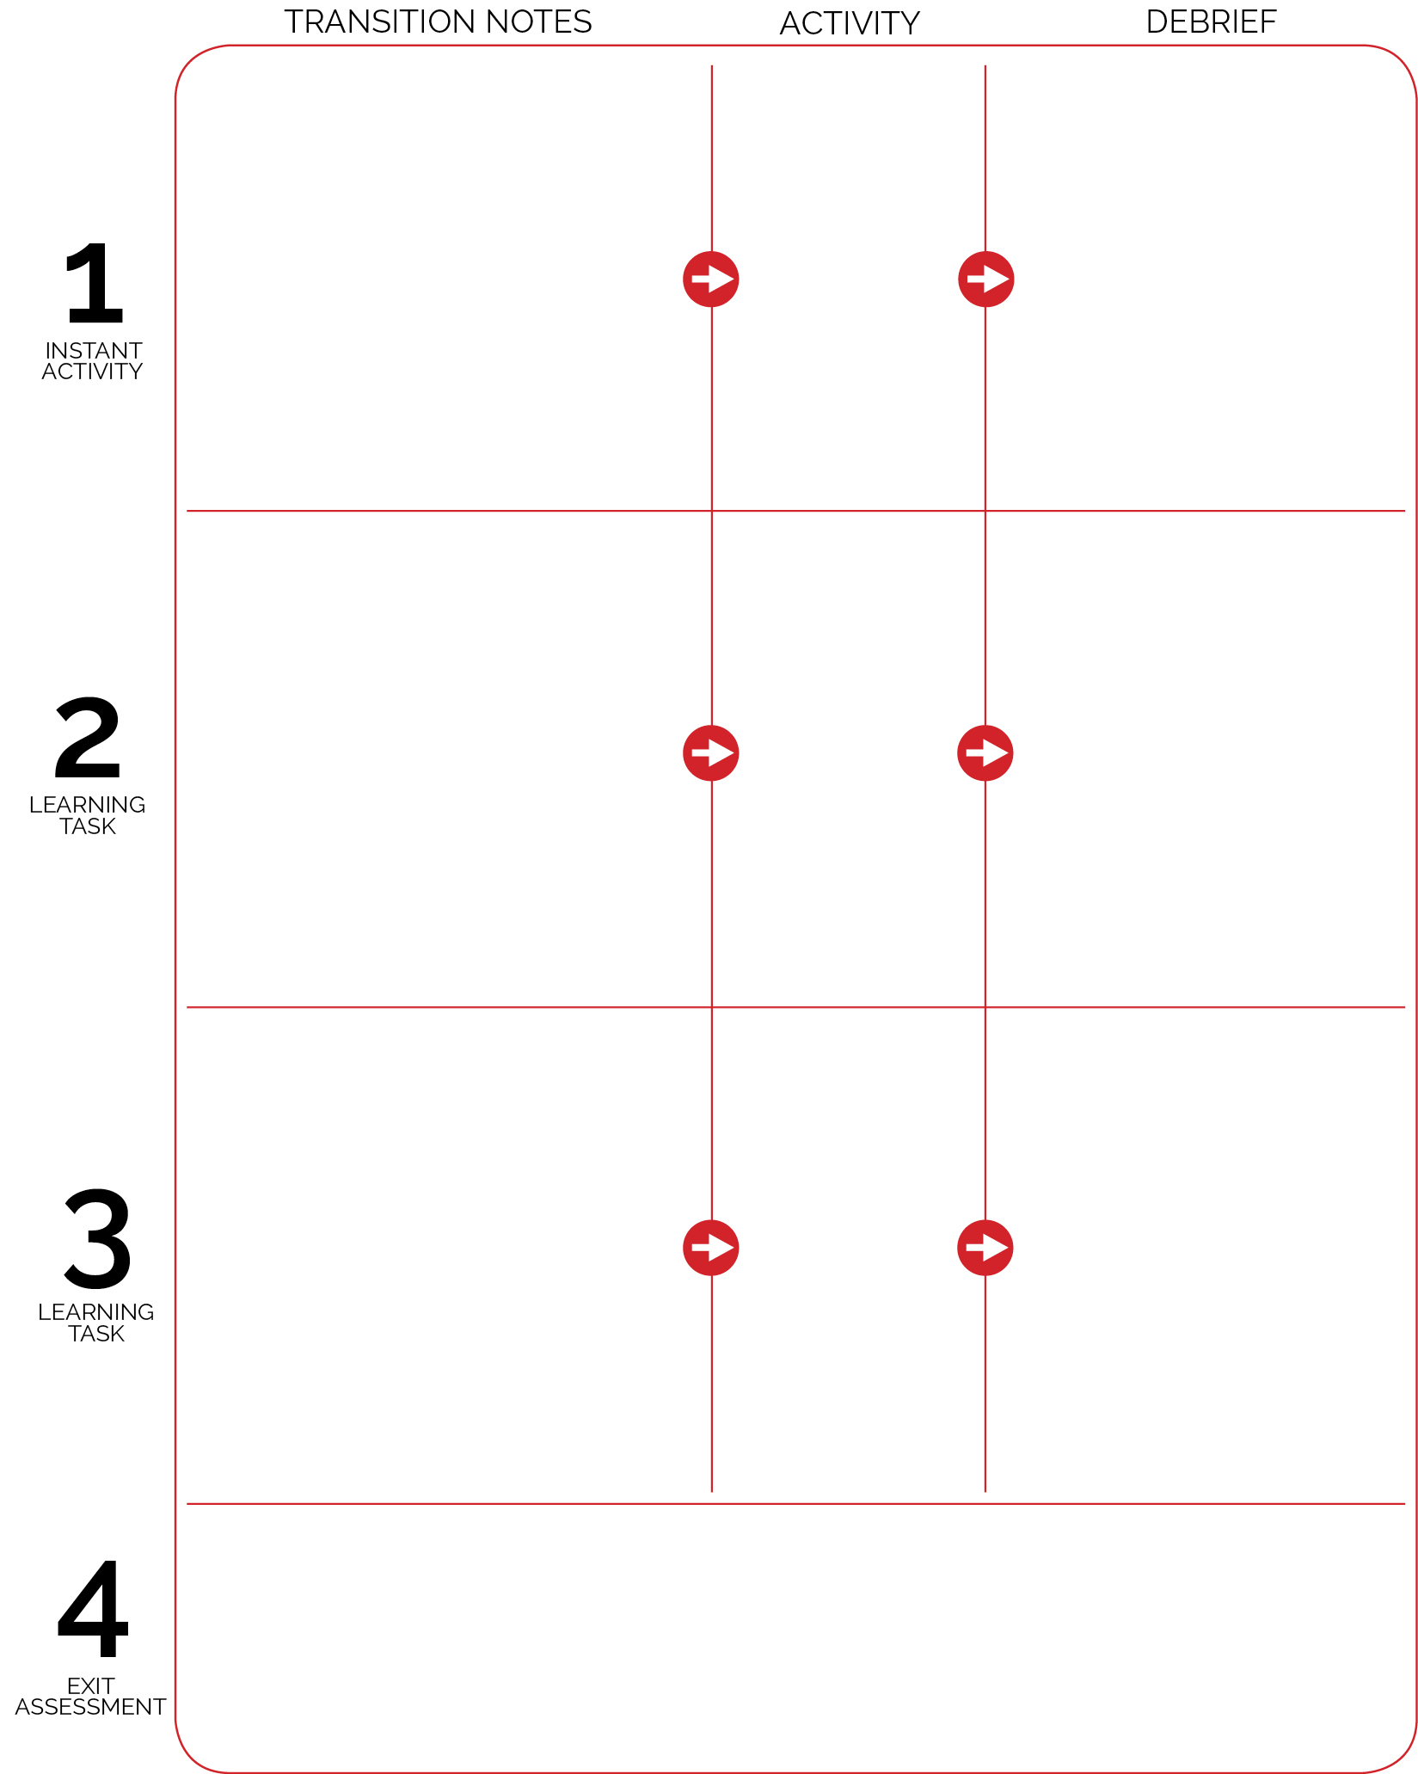

Cooperative Bobsled

Train Like an Olympian

Around the World RPS

* What is cooperation?
* How can group cooperation affect the performance of the sled?
* How can negative interactions with others affect the sled’s performance and the performance of athletes at the Olympics?

Students collect self-assessment and pencil from 4 piles of worksheets (1 in each corner). Complete the Pre-assessments for *following directions* and *working safely*.

* How can you recognize appropriate and safe fitness participation?
* How do exercise/activity cues affect safe participation?
* How is appropriate behavior related to independent participation?

The Olympics are about to begin!

* What is the Olympic Spirit?
* How can we display the Olympic Spirit in physical education class?

As students enter the activity area they can begin to play Around the World RPS. If they are waiting for a player to arrive at a World Zone Card, they can complete an aerobic exercise like a jumping jack, or burpee.

Use Around the World RPS as a way to introduce the international spirit of the Olympics.

Students transition to spaced floor spots for Tabata Training. Routine card is displayed using computer projector.

When the Tabata interval music starts, students follow the routine card.

Create groups of 4. Designate 2 equipment captains for each group. The equipment captains build the bobsled. The rest of the students are the course crew. They set up the bobsled course.

Teams meet at their starting lines and get 2 practice rounds.