­­­

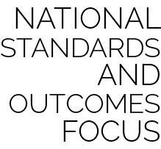

* **Standard 4 [E2.3-5]:** Works independently for extended periods of time (3); Reflects on personal social behavior in physical activity (4); Participates with responsible personal behavior in a variety of physical activity contexts, environments, and facilities (5a); Exhibits respect for self with appropriate behavior while engaging in physical activity (5b).
* **Standard 5 [E1.3-5]:** Discusses the relationship between physical activity and good health (3); Examines the health benefits of participating in physical activity (4); Compares the health benefits of participating in selected physical activities (5).
* **Standard 5 [E4.3-5]:** Describes the positive social interactions that come when engaged with others in physical activity (3); Describes/compares the positive social interactions when engaged in partner, small-group, and large-group physical activities (4); Describes the social benefits gained from participating in physical activity (e.g., recess, youth sport) (5).

|  |  |  |
| --- | --- | --- |
| **RESOURCES** | **FOCUS OUTCOMES & STANDARDS** | **PAGE** |
| Module Overview |  | **1** |
| Required Materials List |  | **5** |
| **Activity Plans** |  |  |
| Wheelchair Curling | Standard 2 | **7** |
| Para Biathlon | Standard 1 & 5 | **9** |
| Sled Hockey Dribble & Pass | Standard 1, 2, & 4 | **11** |
| Zone Sled Hockey | Standard 1, 2, & 4 | **13** |
| Para Alpine Skiing | Standard 2, 4, & 5 | **15** |
| Para Cross-Country Skiing | Standard 3, 4, & 5 | **17** |
| Paralympic Village Clean-Up | Standard 4 & 5 | **19** |
| Sample First Lesson Plan |  | **21** |
| Academic Language Posters |  | **52 Pages** |
| Para Alpine Skiing Event Cards |  | **4 Pages** |
| Paralympic Sport Descriptions |  | **2 pages** |
| Paralympian Bios |  | **2 pages** |
| **Student Assessment Tools** |  |  |
| Self-Assessment Worksheet |  |  |
| Holistic Performance Rubric |  |  |
| Academic Language Quiz |  |  |
| Teacher Self-Evaluation & Reflection |  |  |

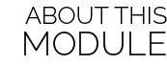

The Paralympic Games were designed to emphasize the participants’ athletic achievements and not their disabilities. The Paralympic movement began with a small gathering of British World War II veterans in 1948. Today, the Paralympics host thousands of competitors from over 100 countries and is one of the largest international sporting events in the world. This module was designed to introduce all students to the Paralympic spirit.

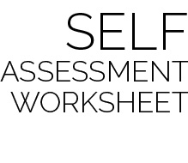

This simple self-assessment provides each student with a structure for reflecting on current skill level, setting a goal for growth and development, and then reassessing progress toward that goal.

The authors recommend that students complete this form as a pre-assessment on the day that skills are first introduced. For example, during the module’s first lesson, students participate in the activity Wheelchair Curling. At the end of this activity, students would complete the Pre and Goal columns for Communication (and possibly Working Safely). Hockey Pass, Hockey Shot, and Working Cooperatively would not be completed until a future lesson introduces those skills. A post-assessment for all skills would then be completed during the final lesson of the module.



Two types of assessment are provided as a part of this module. However, there are many different ways for teachers and students to assess and evaluate student learning and skill development.

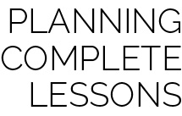

Each Paralympic activity in this module is meant to be one part of a complete lesson. The authors recommend the following formula for creating a 30- to 45-minute lesson:

Instant Activity (not on block plan) *5–10 minutes*

+ Skill Activity with Debrief *10–15 minutes*

+ Event Activity with Debrief *10–15 minutes*

+ Check for Understanding *5 minutes*

**Important:** Suggestions are what they say they are – *suggestions*. All OPEN materials are offered in MS Word format so that you can easily modify our suggestions to meet the needs of your students.

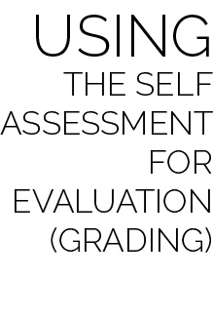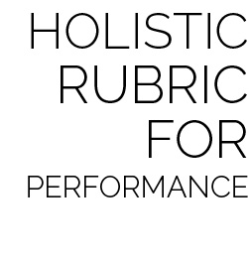

The holistic rubric can be used as both a formative and summative assessment within the module. Providing students with the rubric’s criteria early in the module will allow for discussion and formative evaluation throughout activities and lessons.

Two rubrics are given for teachers to choose from based completely on preference. The Single Holistic Rubric provides one set of criteria, including both skill and personal and social responsibility (PSR) characteristics. The Dual Holistic Rubric separates skill and PSR characteristics, providing two sets of criteria to be evaluated separately. Either rubric can be completed in full on the Module’s station day, providing a final holistic evaluation of each student’s performance.

When evaluating a student’s performance in using the Self-Assessment Worksheet, the student’s score should be based on the process and quality of self-reflection, not the student’s ability to score a full column of stars. Here is a sample rating scale for self-assessment evaluation:

* Well Below Competence (1): Was present, but refused to complete Self-Assessment.
* Lacks Competence (2): Completed each assessment with little effort. Student pre- and post-assessments do not match teacher-observed skill performance.
* Competent (3): Most skill assessments match the student’s skill level with a goal for improvement and an accurate post-assessment. Evidence of reflection is present.
* Proficient (4): All skill assessments match the student’s skill level with a goal for improvement and an accurate post-assessment. Evidence of reflection and a regard for quality of work is present.

*NOTE: The evaluation scale suggested for the self-assessment is consistent with the scale used for the holistic rubrics discussed below. This consistency allows teachers to average several scores for the sake of a final evaluation or grade.*



|  |  |  |
| --- | --- | --- |
| **Lesson** | **Skill Activity** | **Suggested Academic Language** |
| 1 | Wheelchair Curling | Athlete with a Disability, Button, Delivery, Delivery Stick, End, Hammer, House, Lead, Para Sport, Paralympics, Rink, Rock, Second, Skip, Third |
| 2 | Para Biathlon | Biathlon, Cardiorespiratory Endurance, Classification, Eligible Impairment, Health-Related Fitness, Muscular Endurance, Overhand, Throw, Underhand |
| 3 | Sled Hockey Dribble & Pass | Communication, Cooperation, Dribble, Pass, Physical Activity, Power, Safety Concerns |
| 4 | Zone Sled Hockey | Able-bodied Athlete, Control, Etiquette, Force, Muscular Strength, Para Athlete, Paralympian, Safe, Teamwork, Vigorous |
| 5 | Paralympic Village Clean-up & Para Alpine Skiing | Able-Bodied Athlete, Communication, Cooperation, Guide, Paralympian, Paralympics, Safe, Teamwork, Cardiorespiratory Endurance, Downhill, Flat, Giant Slalom, Integrity, Outrigger Ski, Sit-Ski, Slalom |
| 6 | Paralympic Village Clean-up & Para Cross-Country Skiing | Communication, Guidance, Guide, Outrigger Ski, Safe, Sit-Ski |
| 7 | Paralympic Village Clean-up & Student Event Choice | Academic Language Review |