DOWNHILL
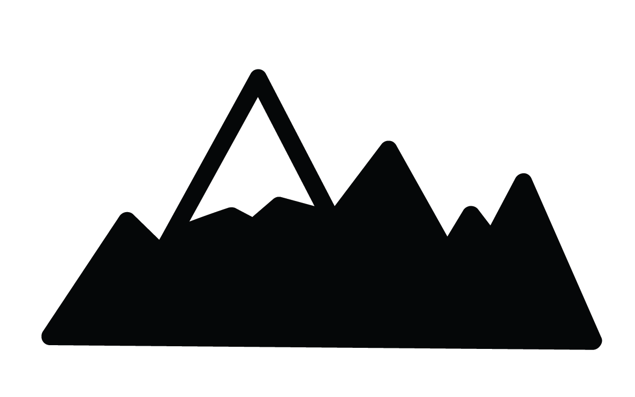

SLALOM

GIANT SLALOM

PARA SNOWBOARD

