­­

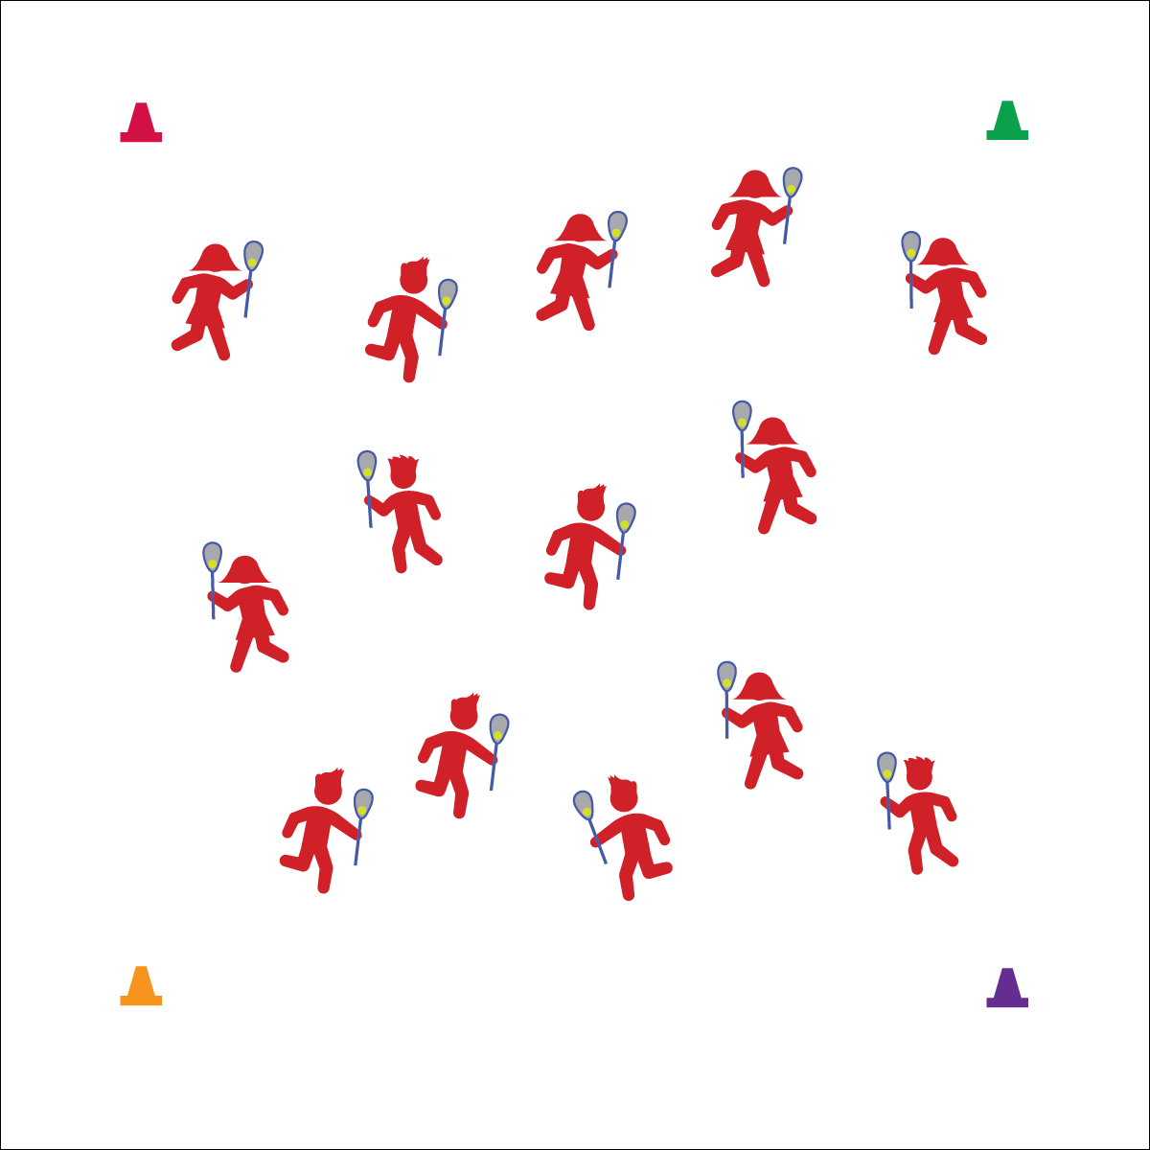

**Cradle**

* Top Grip with Fingers
* Bottom Hand Guides
* Roll Fingers, Wrist, and Elbow

**Activity Procedures:**

1. Today’s activity is called Yum Yum Yum. We’re going to practice our lacrosse cradling skills while we identify healthy foods.
2. The object of the activity is to jog in open space while cradling your lacrosse ball in order to keep the ball and your stick under control.
3. I’m going to call out different foods. When you hear a healthy (green light) food, holler, “Yum, Yum, Yum!” and jog around the activity area while cradling your ball. When you hear an unhealthy (red light) food, carefully set your stick and ball on the ground, get into plank position and holler, “Whoa, time to slow down!” Hold plank position until you hear a healthy food, and then get back up, jog, and cradle.
4. If your ball drops out of your stick, quickly pick it back up and continue jogging.

**Grade Level Progression:**

**3rd:** Start at a walking pace.

**4th:** Progress to a jog.

**5th:** Add changes in speed and direction on the teacher’s signal.

**Equipment:**

* 1 lacrosse stick per student
* 1 ball per student
* 4 cones
* Hand Placement Chart
* Lax Skill Cue Chart

**Set-Up:**

1. Create a large activity area using cones.
2. Students scattered in the activity area, each with a lacrosse stick and a ball.

**YUM YUM YUM**

* **Skill:** I will demonstrate the cues for cradling a lacrosse ball.
* **Cognitive:** I will discuss healthy foods that provide fuel for physical activity.
* **Fitness:** I will stay actively engaged in all activities.
* **Personal & Social Responsibility:** I will demonstrate safe activity behaviors.

**YUM YUM YUM**



* Use a variety of different lacrosse sticks to allow students to experience success and practice basic movements.
* Use visual posters or models of healthy foods.

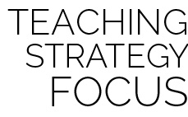

**Identify critical content.** This basic activity provides an opportunity for teachers to introduce the parts of a lacrosse stick and the fundamentals for cradling. Take a few minutes throughout the activity to quiz students on terminology and cues.



* **Standard 1 [E6.3-4]** Performs a sequence of locomotor skills, transitioning from one skill to another smoothly/without hesitation (3); Combines traveling with manipulative skills of dribbling, throwing, catching, and striking in teacher- and/or student-designed small-sided practice tasks (4).
* **Standard 2 [E2.3-5]** Recognizes locomotor skills specific to a wide variety of physical activities (3); Combines movement concepts with skills in small-sided practice tasks, gymnastics, and dance environments (4); Combines movement concepts with skills in small-sided practice tasks/games environments, gymnastics, and dance with self-direction (5).
* **Standard 3 [E6.3-5]** Identifies foods that are beneficial for pre- and post-physical activity (3); Discusses the importance of hydration and hydration choices relative to physical activities (4); Analyzes the impact of food choices relative to physical activity, youth sports & personal health (5).



Cradle, Jog, Lacrosse, Lacrosse Stick, Stick Head, Stick Shaft



* **DOK 1:** What would you include on a list of healthy foods?
* **DOK 2:** What do you know about how healthy foods fuel our bodies?
* **DOK 3:** What would happen to your body and performance if you ate foods filled with processed sugar right before playing a game of lacrosse?
* **DOK 3:** What would happen to your body and performance if you ate foods filled with fat right before playing a game of lacrosse?
* **DOK 3:** What would happen if you ate fresh fruit right before playing a game of lacrosse?