­­



**CLEAN YOUR YARD**

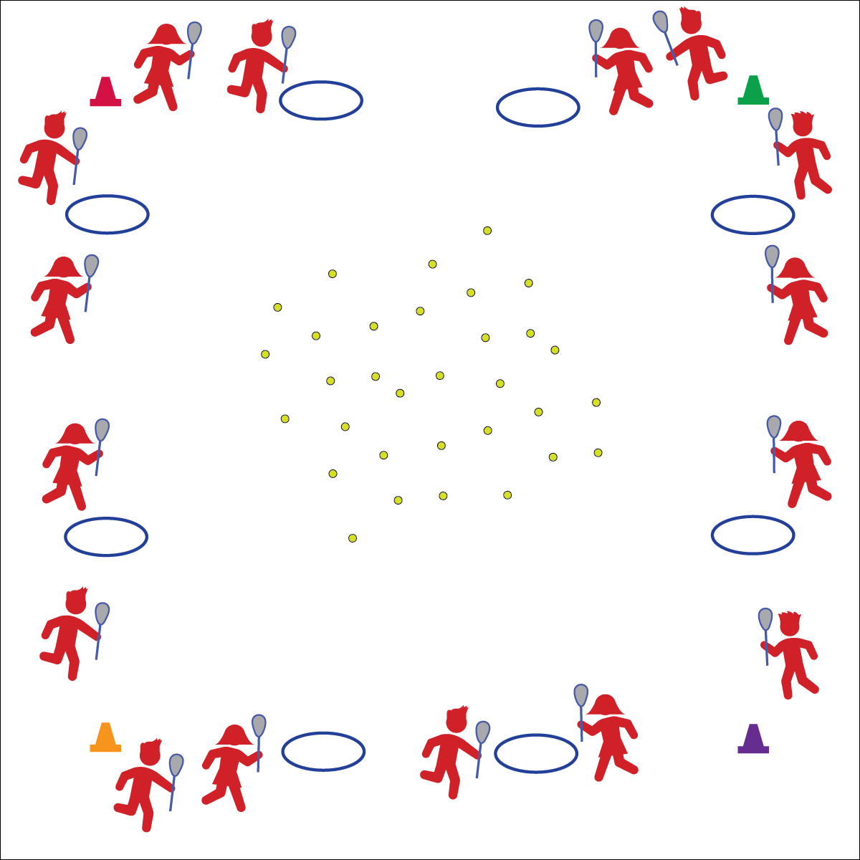

* **Skill:** I will demonstrate the cues for scooping ground balls.
* **Cognitive:** I will discuss the importance of working independently and safely with lacrosse equipment.
* **Fitness:** I will stay actively engaged in all activities.
* **Personal & Social Responsibility:** I will work safely with my peers and equipment.

**Scoop Ground Balls**

* Top Hand Below Head
* Stick Low, Parallel to Ground
* Bend and Knees, Hips Low
* Scoop Low, Quick, and Through
* Bring Up to Cradle

**Equipment:**

* 1 lacrosse stick per student
* 2–4 balls per student (or bean bags)
* 1 hula hoop per 2 students
* 4 cones
* Lax Skill Cue Chart

**Set-Up:**

1. Create a large activity area using cones to represent the boundaries of the “yard.”
2. Scatter balls and bean bags around the yard.
3. Space hula hoops around the perimeter of the yard.
4. Pair students, each student with a lacrosse stick.
5. Assign each pair to a hoop.

**Activity Procedures:**

1. Today’s activity is called Clean Up Your Yard.
2. The objective of this activity is to work with your partner to collect the most balls or bean bags.
3. On the start signal, the first person from each team will jog into the yard and use the lacrosse stick to scoop up one ball/bean bag and return it to their hoop using cradling skills.
4. Once the ball is inside the hoop, her/his partner will jog to scoop up another ball and return it to the hoop.
5. This will continue until the all of the balls have been collected and the yard is clean.

**Grade Level Progression:**

**3rd–4th:** Play the activity as described above.

**5th:** Add a throw and catch from a cleaning partner to a hoop partner as students return with lacrosse balls.

**CLEAN YOUR YARD**



Actively Engage, Control, Cradle, Cues, Ground Ball, Safety, Scoop



* **Standard 1 [E26.4-5]** Combines traveling with the manipulative skills of dribbling, throwing, catching, and striking in teacher- and/or student-designed small-sided practice task environments (4); Combines manipulative skills and traveling for execution to a target (e.g., scoring in soccer, hockey, and basketball) (5).
* **Standard 2 [E2.3-5]** Recognizes locomotor skills specific to a wide variety of physical activities (3); Combines movement concepts with skills in small-sided practice tasks, gymnastics, and dance environments (4); Combines movement concepts with skills in small-sided practice tasks/games environments, gymnastics, and dance with self-direction (5).
* **Standard 4 [E6.3-5]** Works independently and safely in physical activity settings (3); Works safely with peers and equipment in physical activity settings (4); Applies safety principles with age-appropriate physical activities (5).



* **DOK 1:** What would you include on a list about lacrosse safety?
* **DOK 2:** How can we apply what we know about safety to our lacrosse games and activities in physical education?
* **DOK 3:** How is safety related to learning?
* **DOK 4:** Let’s develop a class action plan for keeping everyone safe during lacrosse activities.



**Help students practice skills.** This activity is designed to introduce ground balls in combination with cradling. These skills will be completely new for most students and will likely be very challenging. Stop the activity often to demonstrate good form, highlight student performances, and then restart to allow students to revise their practice with purpose.



* Expand or reduce boundaries based on the needs of your students.
* Use brightly colored equipment and boundary markers.