­­



**TARGET PRACTICE**

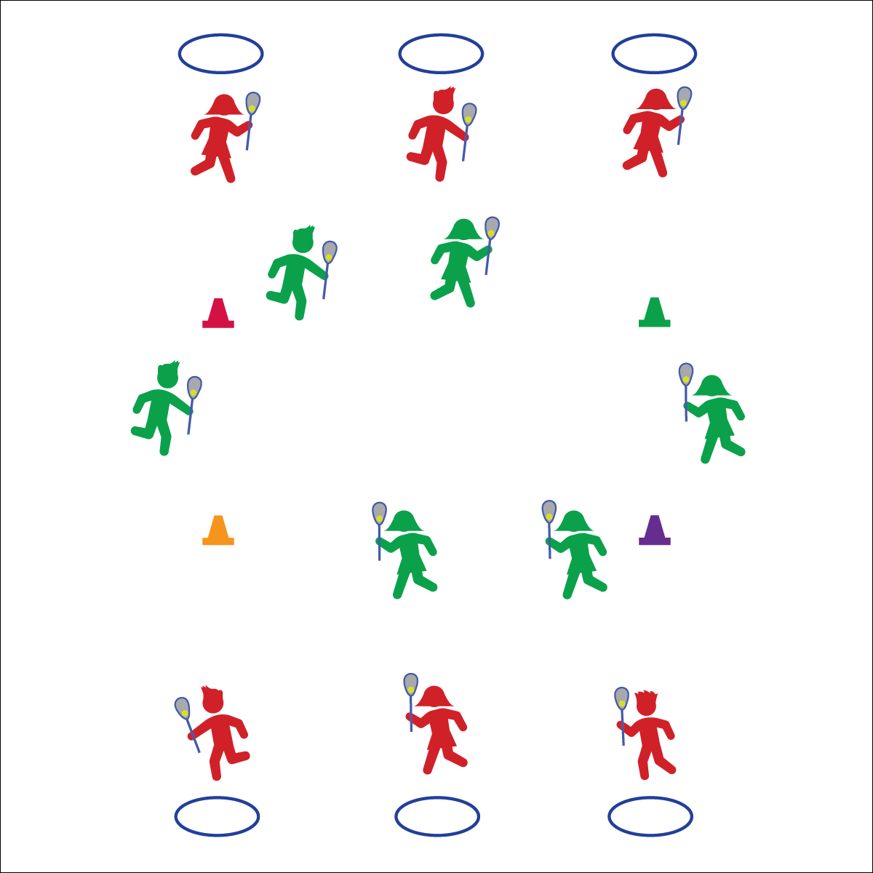

* **Skill:** I will demonstrate the cues for throwing a lacrosse ball to a target.
* **Cognitive:** I will discuss the importance of safety and control during target practice.
* **Fitness:** I will stay actively engaged in all activities.
* **Personal & Social Responsibility:** I will demonstrate safe behaviors during all activities.

**Throw/Pass/Shoot**

* Top Hand Slides Down ½ Way
* Stick Head to Your Ear
* Opposite Foot to Target
* Bottom Hand Points to Target
* Rotate and Snap Top to Target

**Equipment:**

* 1 lacrosse stick per student
* 1 ball per student
* 1 hoop per student
* Duct tape
* 4 cones
* Lax Skill Cue Chart

**Set-Up:**

1. Tape hoops to the wall as targets. Arrange hoops with enough space in between them to create safe areas for throwing and catching off of the wall.
2. Pair students, each student with a stick and ball.
3. Assign each pair to a hoop.
4. Create a large jogging loop using the cones. Place it far enough away from the wall targets so that rebounding balls will not hit or be stepped on by joggers.

**Activity Procedures:**

1. Today’s activity is called Target Practice.
2. The objective of today’s activity is to score points for you and your partner by throwing lacrosse balls into the hoop target. Each time you throw a ball into the hoop you will get a point.
3. When you hear the start signal, the first person from each group will begin throwing the ball to the target. Score and count 1 point each time the ball hits inside the hoop. Your partner will jog the loop while cradling a ball.
4. As soon as the jogging partner returns to the hoop, switch roles so that 1 partner is throwing and the other is jogging.

**Grade Level Progression:**

**3rd:** Begin this activity without students jogging an inside loop to ensure safety.

**4th–5th:** Add the jogging loop.

**TARGET PRACTICE**



Accuracy, Control, Cues, Safety, Stick Head, Stick Shaft, Target



* **Standard 1 [E26.4-5]** Combines traveling with the manipulative skills of dribbling, throwing, catching, and striking in teacher- and/or student-designed small-sided practice task environments (4); Combines manipulative skills and traveling for execution to a target (e.g., scoring in soccer, hockey, and basketball) (5).
* **Standard 4 [E6.3-5]** Works independently and safely in physical activity settings (3); Works safely with peers and equipment in physical activity settings (4); Applies safety principles with age-appropriate physical activities (5).
* **Standard 5 [E2.3-5]** Discusses the challenge that comes from learning a new physical activity (3); Rates the enjoyment of participating in challenging and mastered physical activities (4); Expresses (via written essay, visual art, creative dance) the enjoyment and/or challenge of participating in a favorite physical activity. (5).



* **DOK 1:** How would you describe safe lacrosse target practice?
* **DOK 2:** How does accuracy affect safety?
* **DOK 3:** What facts would you select to support the importance of safety during target practice? Why did you chose those facts?



**Review content.** Before, during, and after this activity, it will be important to review the safety expectations you have for your students. Take time to discuss the importance of safety and help students understand the big picture with respect to safe behaviors and positive participation.



* Increase the size of the targets.
* Use targets with bright colors and/or auditory signals.
* Provide videos and or graphical demonstrations visible from each target.