­­



**LAX TAG**

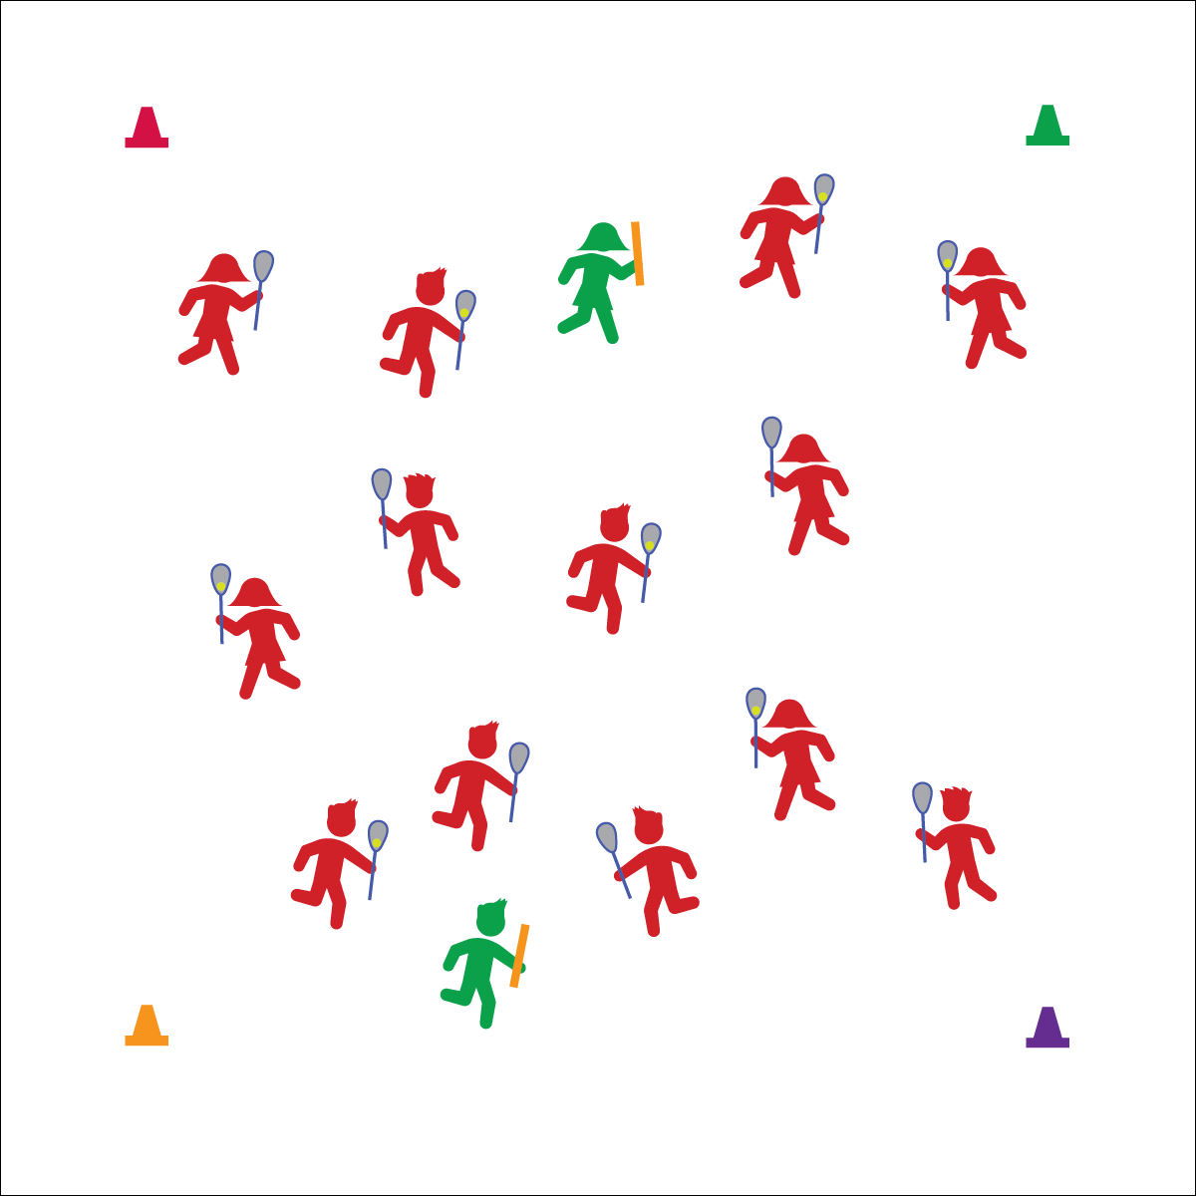

* **Skill:** I will look for and move into open space while fleeing taggers.
* **Cognitive:** I will discuss strategies and tactics for fleeing.
* **Fitness:** I will stay actively engaged in all activities.
* **Personal & Social Responsibility:** I will work independently and safely with 0 safety reminders from the teacher.

**Cradle**

* Top Hand Below Head
* Grip with Fingers
* Bottom Hand Guides
* Roll Fingers, Wrist, and Elbow
* Body Protects the Ball

**Equipment:**

* 1 lacrosse stick per student
* Noodles to identify taggers
* 1 ball per 2 students
* 4 cones

**Set-Up:**

1. Create a large activity area using cones as a boundary.
2. Designate 1–3 students to be taggers, each with a noodle.
3. Scatter students, each with a lacrosse stick (except taggers).
4. Give ½ of the students a ball.

**Activity Procedures:**

1. Today’s activity is called Lacrosse Tag.
2. The objective of this activity is to avoid taggers while cradling a lacrosse ball.
3. Your ball is your safety source. As long as you have a ball, you cannot be tagged. If you drop your ball, you cannot pick it back up. However, anyone without a ball can try to scoop it up for themselves.
4. When you hear the start signal, everyone will start jogging around the activity area. Those who have a ball will begin cradling it as they move. Taggers have noodles and will try to tag players without a ball. Be gentle and only tag the back and shoulders.
5. If you are tagged, move to the perimeter, set your lacrosse stick on the ground, and ski jump over it (side to side) 10 times before rejoining the game.

**Grade Level Progression:**

**3rd:** Play at a speed-walking pace.

**4th–5th:** Play the activity as described above.

**LAX TAG**



Chase, Dodge, Flee, Independent, Safety, Strategy, Tactic



* **Standard 2 [E1.3,4a,5]** Recognizes the concept of open spaces in a movement context (3); Applies the concept of open spaces to combination skills involving traveling (e.g., dribbling and traveling) (4a); Combines spatial concepts with locomotor and non-locomotor movements for small groups in game environments (5).
* **Standard 2 [E5.3-5]** Applies simple strategies/tactics in chasing activities (3a); Applies simple strategies in fleeing activities (3b); Applies simple offensive strategies/tactics in chasing and fleeing activities (4a); Applies simple defensive strategies/tactics in chasing and fleeing activities (4b); Recognizes the type of kicks needed for different games/sports situations (4c); Applies basic offensive and defensive strategies/tactics in invasion small-sided practice tasks (5a); Applies basic offensive and defensive strategies/tactics in net/wall small-sided practice tasks (5b).
* **Standard 4 [E6.3-5]** Works independently and safely in physical activity settings (3); Works safely with peers and equipment in physical activity settings (4); Applies safety principles with age-appropriate physical activities (5).



* **DOK 1:** What is a strategy?
* **DOK 1:** What is a tactic?
* **DOK 2:** Give an example of an offensive strategy or tactic used in Lax Tag.
* **DOK 3:** How is the use of that strategy or tactic related to success on offense?



**Help students process content.** Understanding strategies and tactics is essential for successful participation in actual lacrosse gameplay. Tag can be a familiar setting for students to begin to understand some of the basic strategies and tactics of invasion sports. However, understanding can only come if students are given the opportunity to think critically about their experiences using the academic language of lacrosse with the expectation that they will summarize and elaborate on their performance.



* Increase or decrease the number of taggers.
* Modify the reentry task to match the needs and abilities of the students.
* Change the locomotor requirements based on the needs and abilities of the students.