­­



**SHARKS IN THE SEA**

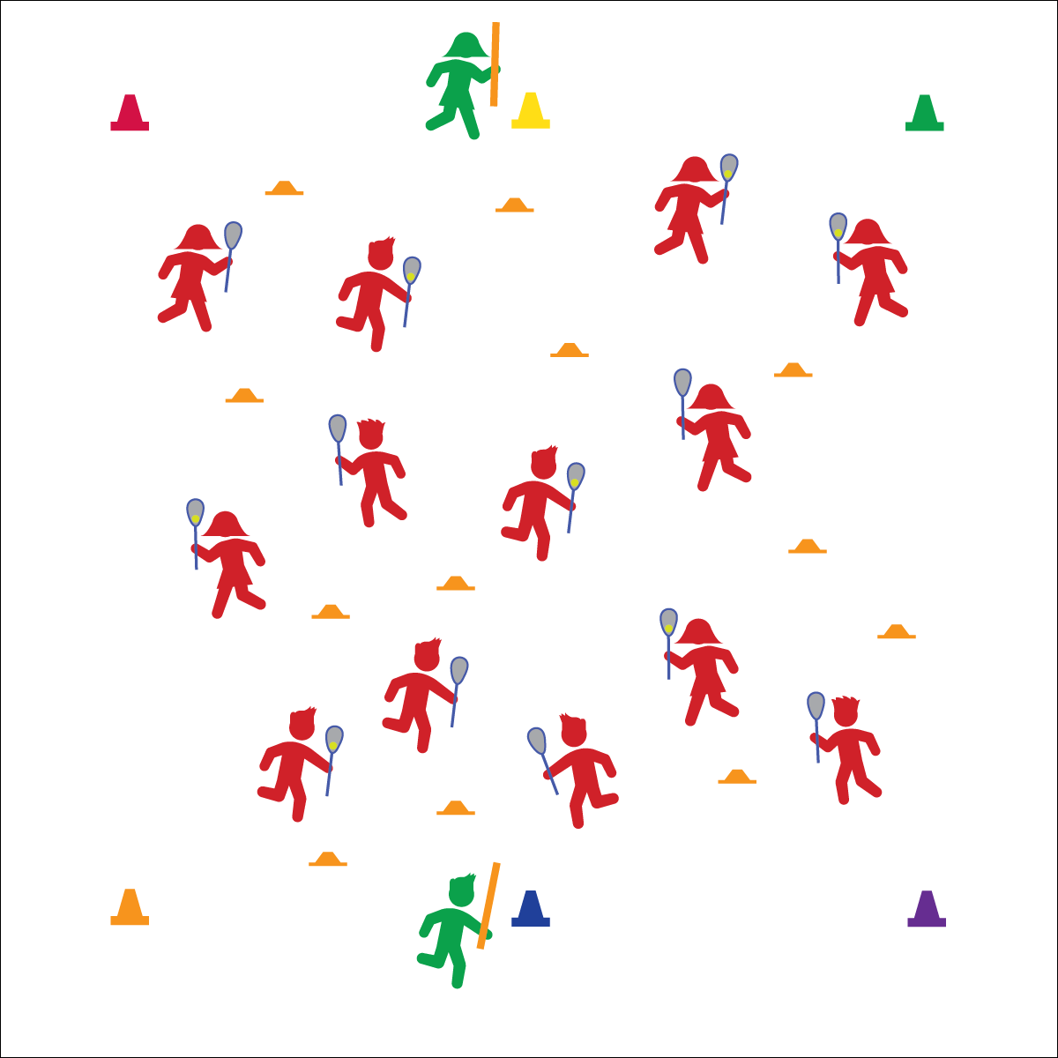

* **Skill:** I will apply the concepts of opening and closing space.
* **Cognitive:** I will discuss the concepts of open and closed space as it relates to lacrosse.
* **Fitness:** I will stay actively engaged in all activities.
* **Personal & Social Responsibility:** I will maintain control of my body movements and behaviors to promote safety.

**Split Dodge**

* Cross the Body
* Hands Swap
* Protect the Stick

**Face Dodge**

* Hands Stay
* Stick Straight Up
* Cross the Body
* Shoulder Protects the Stick

**Equipment:**

* 1 lacrosse stick and ball per student
* 2 noodles to designate taggers
* 6 cones
* 12 low-profiles cones
* Lax Skill Cue Chart

**Set-Up:**

1. Create a large activity area using 6 cones; 4 cones in the corners and 2 cones to mark a centerline diving the area in half.
2. Scatter low-profile cones throughout the activity area.
3. Scatter students throughout the activity area, each with a lacrosse stick and ball.
4. Designate 2 students as sharks. They hold foam noodles rather than lacrosse sticks.
5. Sharks begin standing next to centerline cones.

**Activity Procedures:**

1. Today’s game is called Sharks in the Sea, and we’ll be working on protecting the ball from defenders using face dodges and split dodges.
2. The object for the offense (students with sticks) is to continue moving in the activity area without dropping their lacrosse balls. The object for the sharks is to make the offense drop their lacrosse balls by applying defensive pressure and trying to safely tag them. If tagged (or ball is dropped), offense must jog around 1 cone, and then return to the game.
3. On the start signal, all offensive students will begin moving. Sharks will stay at the cones. Offense, practice a split dodge each time you move to a low-profile cone, and use face dodges when pressured by a shark. (Teachers, demonstrate each dodge.)
4. When I yell, “SHARKS IN THE SEA!” the sharks will move into the activity area and begin to apply defensive pressure by closing space and tagging. (Teachers, demonstrate safe lift checks.)
5. On the freeze signal, stop, look, and listen.

**Grade Level Progression:**

**3rd:** Play the activity with the teacher acting as sharks.

**4th:** Play the activity with sharks anchored to a low-profile cone. They may pivot but not leave the cone.

**5th:** Play the activity as described above.

**SHARKS IN THE SEA**



Close Space, Face Dodge, Split Dodge



* **Standard 1 [E26.4]** Combines traveling with the manipulative skills of dribbling, throwing, catching, and striking in teacher- and/or student-designed small-sided practice task environments (4).
* **Standard 2 [E1.3-5]** Recognizes the concept of open spaces in a movement context (3); Applies the concept of open spaces to combination skills involving traveling (e.g., dribbling and traveling) (4a); Applies the concept of closing spaces in small-sided practice tasks (4b); Dribbles in general space with changes in direction and speed (4c); Combines spatial concepts with locomotor and non-locomotor movements for small groups in gymnastics, dance, and games environments (5).
* **Standard 3 [E2.3-5]** Engages in the activities of physical education class without teacher prompting (3); Actively engages in the activities of physical education class, both teacher-directed and independent (4); Actively engages in all the activities of physical education (5).
* **Standard 4 [E6.3-5]** Works independently and safely in physical activity settings (3); Works safely with peers and equipment in physical activity settings (4); Applies safety principles with age-appropriate physical activities (5).



* **DOK 1:** How would you describe open space? Closed space?
* **DOK 2:** What do you know about open space and offensive movement?
* **DOK 2:** What do you know about closing space and defensive movement?
* **DOK 3:** How can you change your position or movement during game play in order to create open space?
* **DOK 3:** How can you change your position or movement during game play in order to close space?



**Examine similarities and differences.** Opening and closing space in all invasion sports are interrelated concepts that can be difficult for young players to both understand and then execute. By drawing out similarities and differences between these two concepts during discussion, you’re allowing students to analyze what they’ve experienced beyond the performance cues they’ve heard while play is happening.



* Increase or decrease the number of sharks.
* Use brightly colored boundary makers.
* Use different types of balls to decrease or increase the difficulty level.
* Do not allow lift checking.