­­



**LACROSSE BASKETBALL**

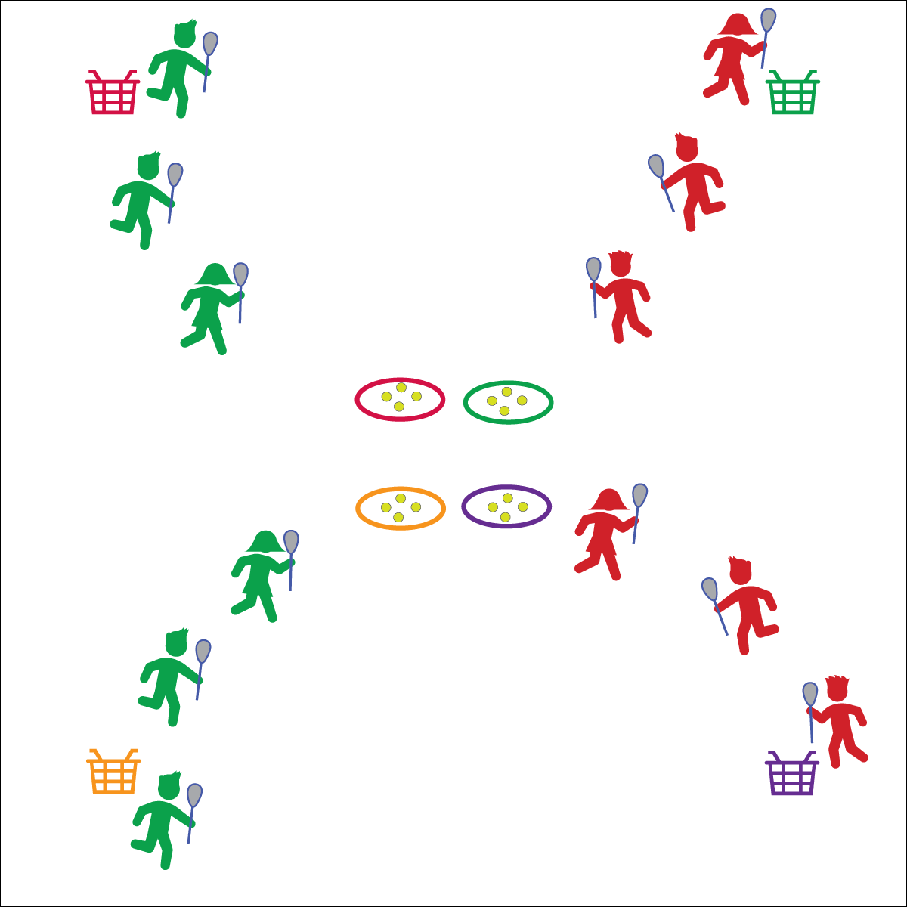

* **Skill:** I will combine lacrosse skills in order to help my team score goals in the basket.
* **Cognitive:** I will discuss the importance of changing speed and direction in game situations.
* **Fitness:** I will stay actively engaged in all activities.
* **Personal & Social Responsibility:** I will use positive language while communicating with my teammates.

**Pass & Receive**

* Show a Stick Target to Receive
* Look for Stick Target Before Passing
* Maintain Control
* Positive Communication

**Equipment:**

* 1 lacrosse stick and ball per student
* 4 baskets or buckets
* 4 hoops

**Set-Up:**

1. Create a large activity area with 1 basket or bucket in each corner.
2. Place 4 hoops in the center of the activity area with 4 balls in each hoop.
3. Create 4 equal teams. Assign each team a hoop and a basket.
4. Designate 1 player as the goal player. They stand next to the team’s basket.

**Activity Procedures:**

1. Today we’re going to play a game of Lacrosse Basketball. The object of the game is to score by passing the ball to your “goal player” in the corner of the activity area who will dunk it in the basket.
2. You’ll do that by taking a ball from your hoop and passing it from teammate to teammate until the final pass goes to the goal player.
3. Students in possession of a ball may NOT move with it. Multiple balls can be in play at a time in order to keep all students active.
4. Goal players must catch the ball in the air in order to drop it in the basket for a point. A ball not caught by the goal player can be rolled back out into play.

**Grade Level Progression:**

**3rd–4th:** Designate 1 player from each team to play defense. She/he may intercept passes from other teams and then cradle the ball back to the hoops.

**5th:** Remove goal players and replace baskets/buckets with a pop-up goal in each corner.

**LACROSSE BASKETBALL**



Combine, Cradle, Close Space, Direction, Goal, Open Space, Pass, Skill, Speed



* **Standard 1 [E6.3-4]** Performs a sequence of locomotor skills, transitioning from one skill to another smoothly/without hesitation (3); Combines traveling with manipulative skills of dribbling, throwing, catching, and striking in teacher- and/or student-designed small-sided practice tasks (4).
* **Standard 1 [E16.3-5]** Catches a gently tossed hand-sized ball from a partner, demonstrating four of the five critical elements of a mature pattern (3); Catches a thrown ball above the head, at chest/waist level, and below the waist using a mature pattern in a non-dynamic environment. (4); Catches with accuracy, both partners moving (5b); Catches with reasonable accuracy in dynamic, small-sided practice tasks (5c).
* **Standard 1 [E26.4-5]** Combines traveling with the manipulative skills of dribbling, throwing, catching, and striking in teacher- and/or student-designed small-sided practice task environments (4); Combines manipulative skills and traveling for execution to a target (e.g., scoring in soccer, hockey, and basketball) (5).
* **Standard 2 [E1.3-5]** Recognizes the concept of open spaces in a movement context (3); Applies the concept of open spaces to combination skills involving traveling (e.g., dribbling and traveling) (4a); Applies the concept of closing spaces in small-sided practice tasks (4b); Dribbles in general space with changes in direction and speed (4c); Combines spatial concepts with locomotor and non-locomotor movements for small groups in gymnastics, dance, and games environments (5).
* **Standard 2 [E2.3-5]** Recognizes locomotor skills specific to a wide variety of physical activities (3); Combines movement concepts with skills in small-sided practice tasks (4); Combines movement concepts with skills in small-sided practice tasks/games environments with self-direction (5).



* **DOK 1:** When would you need to change speed or direction in Lacrosse Basketball?
* **DOK 2:** How might your change in speed or direction affect a defensive player?
* **DOK 3:** How would you adapt the game of Lacrosse Basketball in order to require more changes in speed and/or direction?



**Organize students to interact with content.** Lacrosse is a dynamic team sport in which students combine their abilities and effort with their teammates to execute a game plan. Small-sided games like lacrosse basketball provide a developmentally appropriate environment for students to experiment and interact with skill theme and movement concepts while cooperating with teammates.



* Provide auditory signals on goals.
* Use a variety of safe passable objects, allowing students to pass the ball with feet or along the ground.