­­

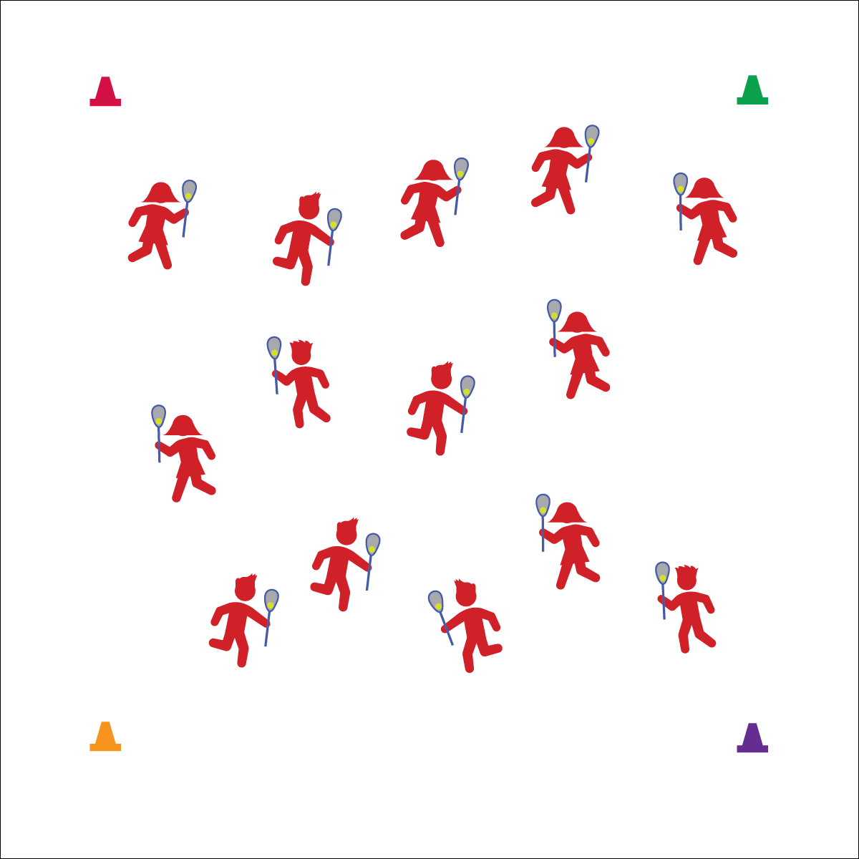

**Cradle**

* Top Grip with Fingers
* Bottom Hand Guides
* Roll Fingers, Wrist, and Elbow

**Activity Procedures:**

1. Today’s activity is called Yum Yum Yum. We’re going to practice our lacrosse cradling skills while we identify healthy foods.
2. The object of the activity is to jog in open space while cradling your lacrosse ball in order to keep the ball and your stick under control.
3. I’m going to call out different foods. When you hear a healthy (green light) food, holler, “Yum, Yum, Yum!” and jog around the activity area while cradling your ball. When you hear an unhealthy (red light) food, carefully set your stick and ball on the ground, get into plank position and holler, “Whoa, time to slow down!” Hold plank position until you hear a healthy food, and then get back up, jog, and cradle.
4. If your ball drops out of your stick, quickly pick it back up and continue jogging.

**Grade Level Progression:**

**3rd:** Start at a walking pace.

**4th:** Progress to a jog.

**5th:** Add changes in speed and direction on the teacher’s signal.

**Equipment:**

* 1 lacrosse stick per student
* 1 ball per student
* 4 cones
* Hand Placement Chart
* Lax Skill Cue Chart

**Set-Up:**

1. Create a large activity area using cones.
2. Students scattered in the activity area, each with a lacrosse stick and a ball.

**YUM YUM YUM**

* **Skill:** I will demonstrate the cues for cradling a lacrosse ball.
* **Cognitive:** I will discuss healthy foods that provide fuel for physical activity.
* **Fitness:** I will stay actively engaged in all activities.
* **Personal & Social Responsibility:** I will demonstrate safe activity behaviors.

**YUM YUM YUM**



* Use a variety of different lacrosse sticks to allow students to experience success and practice basic movements.
* Use visual posters or models of healthy foods.



**Identify critical content.** This basic activity provides an opportunity for teachers to introduce the parts of a lacrosse stick and the fundamentals for cradling. Take a few minutes throughout the activity to quiz students on terminology and cues.



* **Standard 1 [E6.3-4]** Performs a sequence of locomotor skills, transitioning from one skill to another smoothly/without hesitation (3); Combines traveling with manipulative skills of dribbling, throwing, catching, and striking in teacher- and/or student-designed small-sided practice tasks (4).
* **Standard 2 [E2.3-5]** Recognizes locomotor skills specific to a wide variety of physical activities (3); Combines movement concepts with skills in small-sided practice tasks, gymnastics, and dance environments (4); Combines movement concepts with skills in small-sided practice tasks/games environments, gymnastics, and dance with self-direction (5).
* **Standard 3 [E6.3-5]** Identifies foods that are beneficial for pre- and post-physical activity (3); Discusses the importance of hydration and hydration choices relative to physical activities (4); Analyzes the impact of food choices relative to physical activity, youth sports & personal health (5).



Cradle, Jog, Lacrosse, Lacrosse Stick, Stick Head, Stick Shaft



* **DOK 1:** What would you include on a list of healthy foods?
* **DOK 2:** What do you know about how healthy foods fuel our bodies?
* **DOK 3:** What would happen to your body and performance if you ate foods filled with processed sugar right before playing a game of lacrosse?
* **DOK 3:** What would happen to your body and performance if you ate foods filled with fat right before playing a game of lacrosse?
* **DOK 3:** What would happen if you ate fresh fruit right before playing a game of lacrosse?

**CLEAN YOUR YARD**

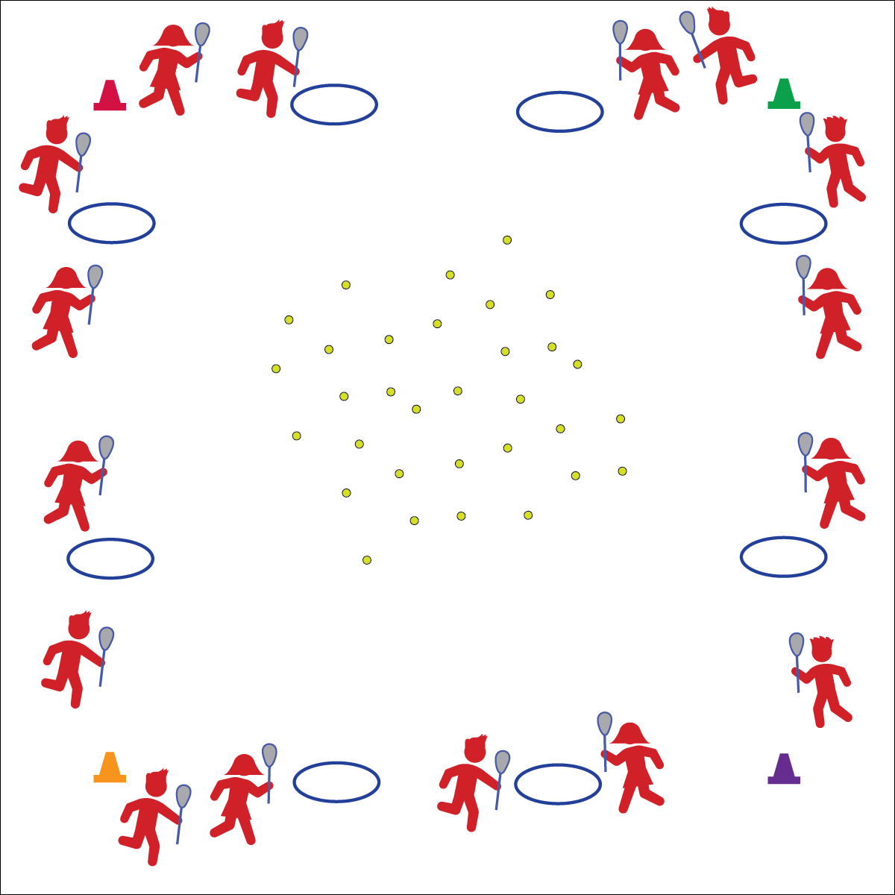

**Equipment:**

* 1 lacrosse stick per student
* 2–4 balls per student (or bean bags)
* 1 hula hoop per 2 students
* 4 cones
* Lax Skill Cue Chart

**Set-Up:**

1. Create a large activity area using cones to represent the boundaries of the “yard.”
2. Scatter balls and bean bags around the yard.
3. Space hula hoops around the perimeter of the yard.
4. Pair students, each student with a lacrosse stick.
5. Assign each pair to a hoop.

**Scoop Ground Balls**

* Top Hand Below Head
* Stick Low, Parallel to Ground
* Bend and Knees, Hips Low
* Scoop Low, Quick, and Through
* Bring Up to Cradle
* **Skill:** I will demonstrate the cues for scooping ground balls.
* **Cognitive:** I will discuss the importance of working independently and safely with lacrosse equipment.
* **Fitness:** I will stay actively engaged in all activities.
* **Personal & Social Responsibility:** I will work safely with my peers and equipment.

**Activity Procedures:**

1. Today’s activity is called Clean Up Your Yard.
2. The objective of this activity is to work with your partner to collect the most balls or bean bags.
3. On the start signal, the first person from each team will jog into the yard and use the lacrosse stick to scoop up one ball/bean bag and return it to their hoop using cradling skills.
4. Once the ball is inside the hoop, her/his partner will jog to scoop up another ball and return it to the hoop.
5. This will continue until the all of the balls have been collected and the yard is clean.

**Grade Level Progression:**

**3rd–4th:** Play the activity as described above.

**5th:** Add a throw and catch from a cleaning partner to a hoop partner as students return with lacrosse balls.

**CLEAN YOUR YARD**



* **DOK 1:** What would you include on a list about lacrosse safety?
* **DOK 2:** How can we apply what we know about safety to our lacrosse games and activities in physical education?
* **DOK 3:** How is safety related to learning?
* **DOK 4:** Let’s develop a class action plan for keeping everyone safe during lacrosse activities.



* **Standard 1 [E26.4-5]** Combines traveling with the manipulative skills of dribbling, throwing, catching, and striking in teacher- and/or student-designed small-sided practice task environments (4); Combines manipulative skills and traveling for execution to a target (e.g., scoring in soccer, hockey, and basketball) (5).
* **Standard 2 [E2.3-5]** Recognizes locomotor skills specific to a wide variety of physical activities (3); Combines movement concepts with skills in small-sided practice tasks, gymnastics, and dance environments (4); Combines movement concepts with skills in small-sided practice tasks/games environments, gymnastics, and dance with self-direction (5).
* **Standard 4 [E6.3-5]** Works independently and safely in physical activity settings (3); Works safely with peers and equipment in physical activity settings (4); Applies safety principles with age-appropriate physical activities (5).



* Expand or reduce boundaries based on the needs of your students.
* Use brightly colored equipment and boundary markers.



Actively Engage, Control, Cradle, Cues, Ground Ball, Safety, Scoop



**Help students practice skills.** This activity is designed to introduce ground balls in combination with cradling. These skills will be completely new for most students and will likely be very challenging. Stop the activity often to demonstrate good form, highlight student performances, and then restart to allow students to revise their practice with purpose.

**MUSICAL LAX**



**Scoop Ground Balls**

* Top Hand Below Head
* Stick Low, Parallel to Ground
* Bend and Knees, Hips Low
* Scoop Low, Quick, and Through
* Bring Up to Cradle
* **Skill:** I will combine the skills of fielding ground balls and cradling with moving in open space.
* **Cognitive:** I will discuss the enjoyment and importance of participating in challenging activities.
* **Fitness:** I will stay actively engaged in all activities.
* **Personal & Social Responsibility:** I will use positive self-talk while learning lacrosse skills.

**Equipment:**

* 1 lacrosse stick per student
* 1 ball per student
* 4 large cones
* Music player and music
* Lax Skill Cue Chart

**Set-Up:**

1. Use cones to create a large activity area.
2. Scatter students throughout the space, each with a lacrosse stick and ball.

**Activity Procedures:**

1. Today’s activity is called Musical Lacrosse.
2. This fun activity will help us practice scooping up ground balls and cradling.
3. When the music starts, begin cradling the ball and moving around the activity area. When you hear the music stop playing, stop moving, and drop your ball, and then quickly find another one and scoop it up.
4. When the music starts again, begin cradling the ball and moving around the activity area again.

**Grade Level Progression:**

**3rd:** Play the activity as described above.

**4th–5th:** Add cones throughout the activity area. When students approach a cone, they practice dodges.

**MUSICAL LAX**



* Use visual start and stop signals.
* Use different types and sizes of balls to make scooping ground balls less or more challenging.



Control, Cradle, Ground Ball, Open Space, Scoop



* **Standard 1 [E26.4-5]** Combines traveling with the manipulative skills of dribbling, throwing, catching, and striking in teacher- and/or student-designed small-sided practice task environments (4); Combines manipulative skills and traveling for execution to a target (e.g., scoring in soccer, hockey, and basketball) (5).
* **Standard 2 [E2.3-5]** Recognizes locomotor skills specific to a wide variety of physical activities (3); Combines movement concepts with skills in small-sided practice tasks, gymnastics, and dance environments (4); Combines movement concepts with skills in small-sided practice tasks/games environments, gymnastics, and dance with self-direction (5).
* **Standard 4 [E6.3-5]** Works independently and safely in physical activity settings (3); Works safely with peers and equipment in physical activity settings (4); Applies safety principles with age-appropriate physical activities (5).
* **Standard 5 [E2.3-5]** Discusses the challenge that comes from learning a new physical activity (3); Rates the enjoyment of participating in challenging and mastered physical activities (4); Expresses (via written essay, visual art, creative dance) the enjoyment and/or challenge of participating in a favorite physical activity. (5).



* **DOK 1:** How can you recognize a challenging activity?
* **DOK 2:** What are the similarities and differences between challenging activities and easy activities?
* **DOK 3:** What is one example from your own life that you can share that demonstrates the importance of trying and sticking with a challenge? Can you provide details on why you chose this example?



**Help students engage in cognitively complex tasks.** 3rd through 5th grade students learning lacrosse will most likely find themselves in the cognitive stage of motor learning. They are working to understand the mechanics of the skill while trying to coordinate their movements to make it happen. Positive self-talk and consistent encouragement will be just as important as corrective feedback.

**TARGET PRACTICE**

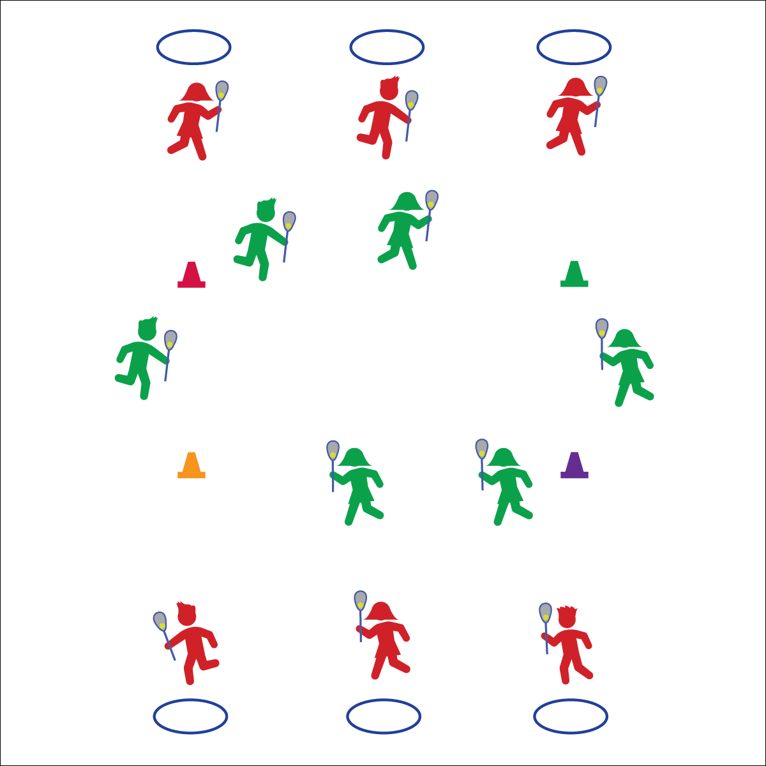

**Equipment:**

* 1 lacrosse stick per student
* 1 ball per student
* 1 hoop per student
* Duct tape
* 4 cones
* Lax Skill Cue Chart

**Set-Up:**

1. Tape hoops to the wall as targets. Arrange hoops with enough space in between them to create safe areas for throwing and catching off of the wall.
2. Pair students, each student with a stick and ball.
3. Assign each pair to a hoop.
4. Create a large jogging loop using the cones. Place it far enough away from the wall targets so that rebounding balls will not hit or be stepped on by joggers.

**Throw/Pass/Shoot**

* Top Hand Slides Down ½ Way
* Stick Head to Your Ear
* Opposite Foot to Target
* Bottom Hand Points to Target
* Rotate and Snap Top to Target
* **Skill:** I will demonstrate the cues for throwing a lacrosse ball to a target.
* **Cognitive:** I will discuss the importance of safety and control during target practice.
* **Fitness:** I will stay actively engaged in all activities.
* **Personal & Social Responsibility:** I will demonstrate safe behaviors during all activities.

**Activity Procedures:**

1. Today’s activity is called Target Practice.
2. The objective of today’s activity is to score points for you and your partner by throwing lacrosse balls into the hoop target. Each time you throw a ball into the hoop you will get a point.
3. When you hear the start signal, the first person from each group will begin throwing the ball to the target. Score and count 1 point each time the ball hits inside the hoop. Your partner will jog the loop while cradling a ball.
4. As soon as the jogging partner returns to the hoop, switch roles so that 1 partner is throwing and the other is jogging.

**Grade Level Progression:**

**3rd:** Begin this activity without students jogging an inside loop to ensure safety.

**4th–5th:** Add the jogging loop.

**TARGET PRACTICE**



* Increase the size of the targets.
* Use targets with bright colors and/or auditory signals.
* Provide videos and or graphical demonstrations visible from each target.



* **Standard 1 [E26.4-5]** Combines traveling with the manipulative skills of dribbling, throwing, catching, and striking in teacher- and/or student-designed small-sided practice task environments (4); Combines manipulative skills and traveling for execution to a target (e.g., scoring in soccer, hockey, and basketball) (5).
* **Standard 4 [E6.3-5]** Works independently and safely in physical activity settings (3); Works safely with peers and equipment in physical activity settings (4); Applies safety principles with age-appropriate physical activities (5).
* **Standard 5 [E2.3-5]** Discusses the challenge that comes from learning a new physical activity (3); Rates the enjoyment of participating in challenging and mastered physical activities (4); Expresses (via written essay, visual art, creative dance) the enjoyment and/or challenge of participating in a favorite physical activity. (5).



Accuracy, Control, Cues, Safety, Stick Head, Stick Shaft, Target



* **DOK 1:** How would you describe safe lacrosse target practice?
* **DOK 2:** How does accuracy affect safety?
* **DOK 3:** What facts would you select to support the importance of safety during target practice? Why did you chose those facts?



**Review content.** Before, during, and after this activity, it will be important to review the safety expectations you have for your students. Take time to discuss the importance of safety and help students understand the big picture with respect to safe behaviors and positive participation.

**LAX TAG**

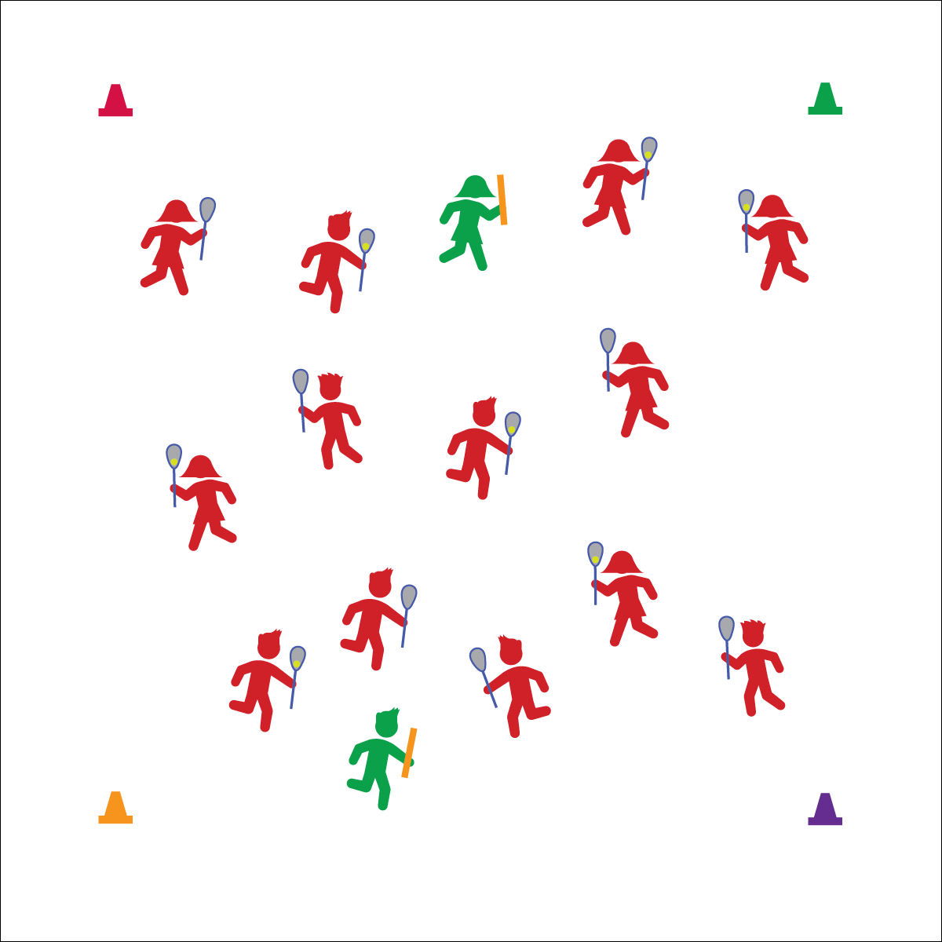

**Cradle**

* Top Hand Below Head
* Grip with Fingers
* Bottom Hand Guides
* Roll Fingers, Wrist, and Elbow
* Body Protects the Ball

**Equipment:**

* 1 lacrosse stick per student
* Noodles to identify taggers
* 1 ball per 2 students
* 4 cones

**Set-Up:**

1. Create a large activity area using cones as a boundary.
2. Designate 1–3 students to be taggers, each with a noodle.
3. Scatter students, each with a lacrosse stick (except taggers).
4. Give ½ of the students a ball.

* **Skill:** I will look for and move into open space while fleeing taggers.
* **Cognitive:** I will discuss strategies and tactics for fleeing.
* **Fitness:** I will stay actively engaged in all activities.
* **Personal & Social Responsibility:** I will work independently and safely with 0 safety reminders from the teacher.

**Activity Procedures:**

1. Today’s activity is called Lacrosse Tag.
2. The objective of this activity is to avoid taggers while cradling a lacrosse ball.
3. Your ball is your safety source. As long as you have a ball, you cannot be tagged. If you drop your ball, you cannot pick it back up. However, anyone without a ball can try to scoop it up for themselves.
4. When you hear the start signal, everyone will start jogging around the activity area. Those who have a ball will begin cradling it as they move. Taggers have noodles and will try to tag players without a ball. Be gentle and only tag the back and shoulders.
5. If you are tagged, move to the perimeter, set your lacrosse stick on the ground, and ski jump over it (side to side) 10 times before rejoining the game.

**Grade Level Progression:**

**3rd:** Play at a speed-walking pace.

**4th–5th:** Play the activity as described above.

**LAX TAG**





* **DOK 1:** What is a strategy?
* **DOK 1:** What is a tactic?
* **DOK 2:** Give an example of an offensive strategy or tactic used in Lax Tag.
* **DOK 3:** How is the use of that strategy or tactic related to success on offense?
* Increase or decrease the number of taggers.
* Modify the reentry task to match the needs and abilities of the students.
* Change the locomotor requirements based on the needs and abilities of the students.



* **Standard 2 [E1.3,4a,5]** Recognizes the concept of open spaces in a movement context (3); Applies the concept of open spaces to combination skills involving traveling (e.g., dribbling and traveling) (4a); Combines spatial concepts with locomotor and non-locomotor movements for small groups in game environments (5).
* **Standard 2 [E5.3-5]** Applies simple strategies/tactics in chasing activities (3a); Applies simple strategies in fleeing activities (3b); Applies simple offensive strategies/tactics in chasing and fleeing activities (4a); Applies simple defensive strategies/tactics in chasing and fleeing activities (4b); Recognizes the type of kicks needed for different games/sports situations (4c); Applies basic offensive and defensive strategies/tactics in invasion small-sided practice tasks (5a); Applies basic offensive and defensive strategies/tactics in net/wall small-sided practice tasks (5b).
* **Standard 4 [E6.3-5]** Works independently and safely in physical activity settings (3); Works safely with peers and equipment in physical activity settings (4); Applies safety principles with age-appropriate physical activities (5).



Chase, Dodge, Flee, Independent, Safety, Strategy, Tactic



**Help students process content.** Understanding strategies and tactics is essential for successful participation in actual lacrosse gameplay. Tag can be a familiar setting for students to begin to understand some of the basic strategies and tactics of invasion sports. However, understanding can only come if students are given the opportunity to think critically about their experiences using the academic language of lacrosse with the expectation that they will summarize and elaborate on their performance.

**SHARKS IN THE SEA**

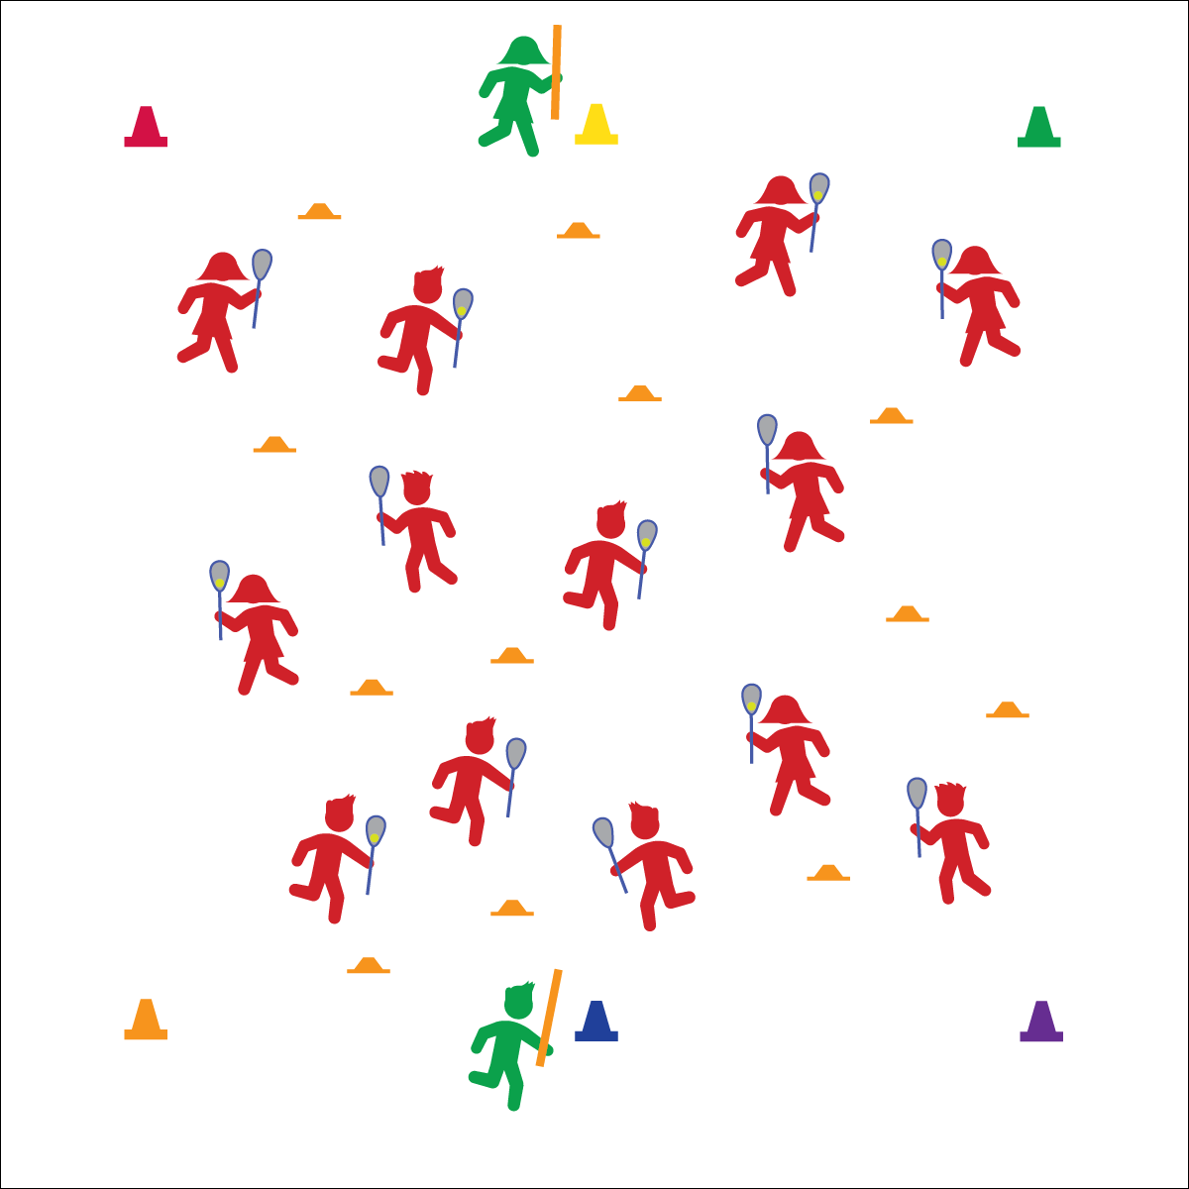

**Split Dodge**

* Cross the Body
* Hands Swap
* Protect the Stick

**Face Dodge**

* Hands Stay
* Stick Straight Up
* Cross the Body
* Shoulder Protects the Stick
* **Skill:** I will apply the concepts of opening and closing space.
* **Cognitive:** I will discuss the concepts of open and closed space as it relates to lacrosse.
* **Fitness:** I will stay actively engaged in all activities.
* **Personal & Social Responsibility:** I will maintain control of my body movements and behaviors to promote safety.

**Activity Procedures:**

1. Today’s game is called Sharks in the Sea, and we’ll be working on protecting the ball from defenders using face dodges and split dodges.
2. The object for the offense (students with sticks) is to continue moving in the activity area without dropping their lacrosse balls. The object for the sharks is to make the offense drop their lacrosse balls by applying defensive pressure and trying to safely tag them. If tagged (or ball is dropped), offense must jog around 1 cone, and then return to the game.
3. On the start signal, all offensive students will begin moving. Sharks will stay at the cones. Offense, practice a split dodge each time you move to a low-profile cone, and use face dodges when pressured by a shark. (Teachers, demonstrate each dodge.)
4. When I yell, “SHARKS IN THE SEA!” the sharks will move into the activity area and begin to apply defensive pressure by closing space and tagging. (Teachers, demonstrate safe lift checks.)
5. On the freeze signal, stop, look, and listen.

**Grade Level Progression:**

**3rd:** Play the activity with the teacher acting as sharks.

**4th:** Play the activity with sharks anchored to a low-profile cone. They may pivot but not leave the cone.

**5th:** Play the activity as described above.

**Equipment:**

* 1 lacrosse stick and ball per student
* 2 noodles to designate taggers
* 6 cones
* 12 low-profiles cones
* Lax Skill Cue Chart

**Set-Up:**

1. Create a large activity area using 6 cones; 4 cones in the corners and 2 cones to mark a centerline diving the area in half.
2. Scatter low-profile cones throughout the activity area.
3. Scatter students throughout the activity area, each with a lacrosse stick and ball.
4. Designate 2 students as sharks. They hold foam noodles rather than lacrosse sticks.
5. Sharks begin standing next to centerline cones.

**SHARKS IN THE SEA**



* Increase or decrease the number of sharks.
* Use brightly colored boundary makers.
* Use different types of balls to decrease or increase the difficulty level.
* Do not allow lift checking.



Close Space, Face Dodge, Split Dodge



* **Standard 1 [E26.4]** Combines traveling with the manipulative skills of dribbling, throwing, catching, and striking in teacher- and/or student-designed small-sided practice task environments (4).
* **Standard 2 [E1.3-5]** Recognizes the concept of open spaces in a movement context (3); Applies the concept of open spaces to combination skills involving traveling (e.g., dribbling and traveling) (4a); Applies the concept of closing spaces in small-sided practice tasks (4b); Dribbles in general space with changes in direction and speed (4c); Combines spatial concepts with locomotor and non-locomotor movements for small groups in gymnastics, dance, and games environments (5).
* **Standard 3 [E2.3-5]** Engages in the activities of physical education class without teacher prompting (3); Actively engages in the activities of physical education class, both teacher-directed and independent (4); Actively engages in all the activities of physical education (5).
* **Standard 4 [E6.3-5]** Works independently and safely in physical activity settings (3); Works safely with peers and equipment in physical activity settings (4); Applies safety principles with age-appropriate physical activities (5).



* **DOK 1:** How would you describe open space? Closed space?
* **DOK 2:** What do you know about open space and offensive movement?
* **DOK 2:** What do you know about closing space and defensive movement?
* **DOK 3:** How can you change your position or movement during game play in order to create open space?
* **DOK 3:** How can you change your position or movement during game play in order to close space?



**Examine similarities and differences.** Opening and closing space in all invasion sports are interrelated concepts that can be difficult for young players to both understand and then execute. By drawing out similarities and differences between these two concepts during discussion, you’re allowing students to analyze what they’ve experienced beyond the performance cues they’ve heard while play is happening.

**PARTNER TOSS & CATCH**

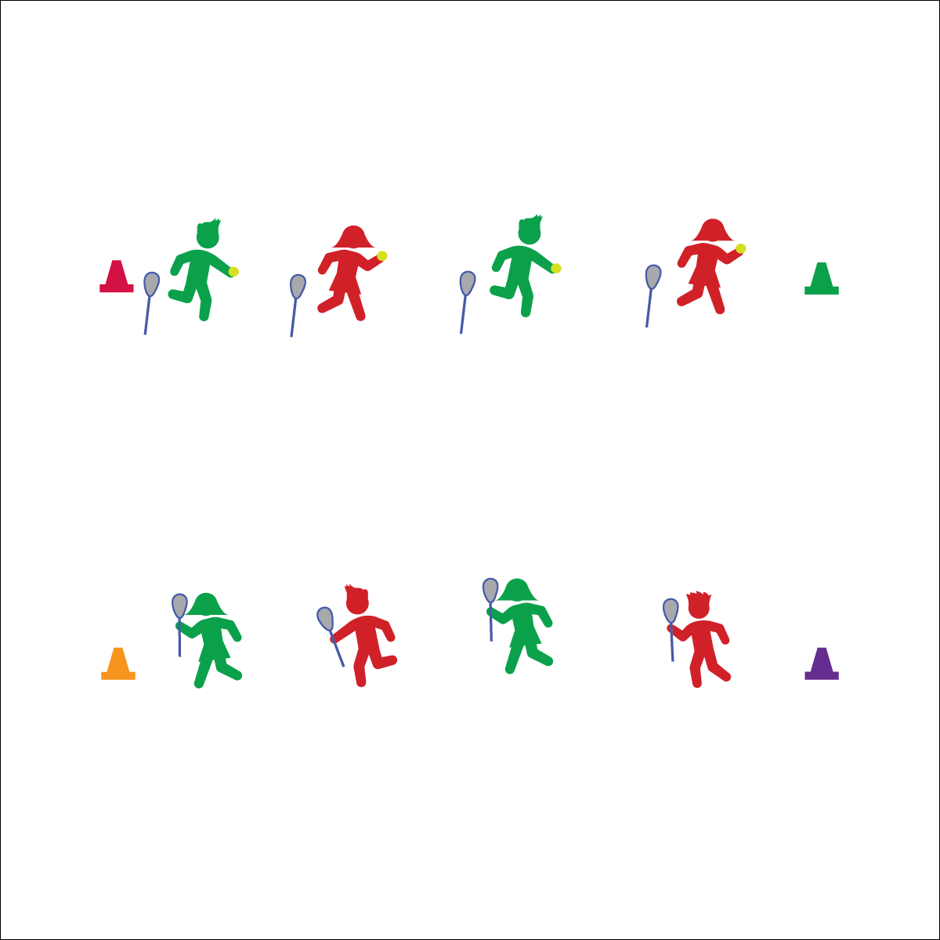

**Catch**

* Top Hand Just Below Head
* Bottom Hand in the Center
* Stick to the Ball
* Cushion and Cradle the Catch

**Activity Procedures:**

1. Today we’re going to work on 3 levels of tossing and catching.
2. Level 1: The partner with the ball will put her/his stick on the ground and hold the ball in hand. We’ll start with 1-handed catches. The catcher will hold the stick with 1 hand right next to the head of the stick. Tosser will toss the ball just above the catcher’s shoulder; 5 tosses right, then 5 left, then switch roles.
3. Level 2: Students use a 2-handed catch and cradle. Continue with a tosser and catcher. Now, the catcher will hold the stick with 2 hands (1 at the head, and 1 in the middle of the stick’s shaft). After each catch, cradle the ball for 5 seconds, then roll the ball back to the tosser (5 left, 5 right, switch roles).
4. Level 3: Students will pass using their sticks. This level is for advanced players. Stay at levels 1 and 2 until students are ready to move on.

**Grade Level Progression:**

**3rd:** Focus practice on Levels 1 and 2.

**4th:** Review at Level 1, but focus practice at Level 2. Some students may be ready for Level 3.

**5th:** Focus practice at Level 3.

**Equipment:**

* 1 lacrosse stick per student
* 1 soft lacrosse or tennis ball per 2 students
* 4 cones
* Lax Skill Cue Chart

**Set-Up:**

1. Create 2 parallel lines with cones at each end.
2. Pair students, each student with a stick and each pair with a ball.
3. Partners standing across from each other, 1 on each line facing their partners.
4. Begin with all lacrosse balls in the same line.

* **Skill:** I will demonstrate the cues for catching a lacrosse ball.
* **Cognitive:** I will discuss the challenges of catching with a lacrosse stick.
* **Fitness:** I will stay actively engaged in all activities.
* **Personal & Social Responsibility:** I will use positive self-talk while learning lacrosse skills.

**PARTNER TOSS & CATCH**



* Use balls of various sizes, shapes, colors, and textures.
* Use balls that provide auditory signals.
* Allow students to roll the ball back and forth, working with lacrosse sticks.



* **Standard 1 [E16.3-4]** Catches a gently tossed hand-sized ball from a partner, demonstrating four of the five critical elements of a mature pattern (3); Catches a thrown ball above the head, at chest/waist level, and below the waist using a mature pattern in a non-dynamic environment (4).
* **Standard 4 [E6.3-5]** Works independently and safely in physical activity settings (3); Works safely with peers and equipment in physical activity settings (4); Applies safety principles with age-appropriate physical activities (5).
* **Standard 5 [E2.3-5]** Discusses the challenge that comes from learning a new physical activity (3); Rates the enjoyment of participating in challenging and mastered physical activities (4); Expresses (via written essay, visual art, creative dance) the enjoyment and/or challenge of participating in a favorite physical activity. (5).



Accurate, Dominant, Grit, Hand, Stick Head, Stick Shaft



* **DOK 1:** What are the cues for catching with a lacrosse stick?
* **DOK 2:** How is catching with a lacrosse stick the same as catching with your hands? How is it different?
* **DOK 3:** What facts would you select to prove that you’ve demonstrated grit during Partner Toss & Catch? Why did you choose those facts?



**Help students practice skills and processes.** Catching in lacrosse can be a challenging barrier to continued participation and success. This activity is placed in the middle of this module purposefully. The authors wanted students to feel enjoyment and success within their lacrosse experience, leading up to the challenging task of catching a ball. However, once catching is introduced, be sure to allow students to develop slowly and purposefully at a pace appropriate to their skill and developmental level. Moving too quickly into dynamic throw-and-catch gameplay may turn students off to the sport.

**LACROSSE BASKETBALL**

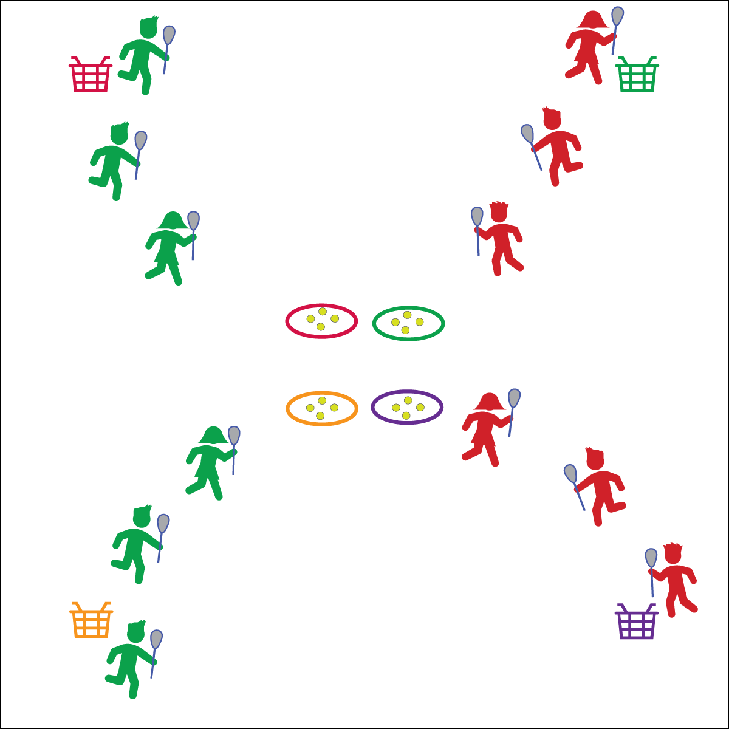

**Pass & Receive**

* Show a Stick Target to Receive
* Look for Stick Target Before Passing
* Maintain Control
* Positive Communication

**Equipment:**

* 1 lacrosse stick and ball per student
* 4 baskets or buckets
* 4 hoops

**Set-Up:**

1. Create a large activity area with 1 basket or bucket in each corner.
2. Place 4 hoops in the center of the activity area with 4 balls in each hoop.
3. Create 4 equal teams. Assign each team a hoop and a basket.
4. Designate 1 player as the goal player. They stand next to the team’s basket.

* **Skill:** I will combine lacrosse skills in order to help my team score goals in the basket.
* **Cognitive:** I will discuss the importance of changing speed and direction in game situations.
* **Fitness:** I will stay actively engaged in all activities.
* **Personal & Social Responsibility:** I will use positive language while communicating with my teammates.

**Activity Procedures:**

1. Today we’re going to play a game of Lacrosse Basketball. The object of the game is to score by passing the ball to your “goal player” in the corner of the activity area who will dunk it in the basket.
2. You’ll do that by taking a ball from your hoop and passing it from teammate to teammate until the final pass goes to the goal player.
3. Students in possession of a ball may NOT move with it. Multiple balls can be in play at a time in order to keep all students active.
4. Goal players must catch the ball in the air in order to drop it in the basket for a point. A ball not caught by the goal player can be rolled back out into play.

**Grade Level Progression:**

**3rd–4th:** Designate 1 player from each team to play defense. She/he may intercept passes from other teams and then cradle the ball back to the hoops.

**5th:** Remove goal players and replace baskets/buckets with a pop-up goal in each corner.

**LACROSSE BASKETBALL**



* Provide auditory signals on goals.
* Use a variety of safe passable objects, allowing students to pass the ball with feet or along the ground.



* **Standard 1 [E6.3-4]** Performs a sequence of locomotor skills, transitioning from one skill to another smoothly/without hesitation (3); Combines traveling with manipulative skills of dribbling, throwing, catching, and striking in teacher- and/or student-designed small-sided practice tasks (4).
* **Standard 1 [E16.3-5]** Catches a gently tossed hand-sized ball from a partner, demonstrating four of the five critical elements of a mature pattern (3); Catches a thrown ball above the head, at chest/waist level, and below the waist using a mature pattern in a non-dynamic environment. (4); Catches with accuracy, both partners moving (5b); Catches with reasonable accuracy in dynamic, small-sided practice tasks (5c).
* **Standard 1 [E26.4-5]** Combines traveling with the manipulative skills of dribbling, throwing, catching, and striking in teacher- and/or student-designed small-sided practice task environments (4); Combines manipulative skills and traveling for execution to a target (e.g., scoring in soccer, hockey, and basketball) (5).
* **Standard 2 [E1.3-5]** Recognizes the concept of open spaces in a movement context (3); Applies the concept of open spaces to combination skills involving traveling (e.g., dribbling and traveling) (4a); Applies the concept of closing spaces in small-sided practice tasks (4b); Dribbles in general space with changes in direction and speed (4c); Combines spatial concepts with locomotor and non-locomotor movements for small groups in gymnastics, dance, and games environments (5).
* **Standard 2 [E2.3-5]** Recognizes locomotor skills specific to a wide variety of physical activities (3); Combines movement concepts with skills in small-sided practice tasks (4); Combines movement concepts with skills in small-sided practice tasks/games environments with self-direction (5).



* **DOK 1:** When would you need to change speed or direction in Lacrosse Basketball?
* **DOK 2:** How might your change in speed or direction affect a defensive player?
* **DOK 3:** How would you adapt the game of Lacrosse Basketball in order to require more changes in speed and/or direction?



**Organize students to interact with content.** Lacrosse is a dynamic team sport in which students combine their abilities and effort with their teammates to execute a game plan. Small-sided games like lacrosse basketball provide a developmentally appropriate environment for students to experiment and interact with skill theme and movement concepts while cooperating with teammates.



Combine, Cradle, Close Space, Direction, Goal, Open Space, Pass, Skill, Speed

**LACROSSE STATIONS**

## 

* **Skill:** I will perform skill assessments to the best of my ability, following as many skills cues as I can.
* **Cognitive:** I will follow the instructions on each station card in order to stay actively engaged with my team.
* **Fitness:** I will find my heart rate after each station in order to see if it is beating faster than when I’m sitting or resting.
* **Personal & Social Responsibility:** I will follow the rules of the Station Day learning environment.
* Start Activity with Music
* When Music Stops: Clean the Area and Rotate

**Equipment:**

* 24 low-profile cones
* Station music and music player
* See station cards for equipment needs

**Set-Up:**

1. Using low-profile cones, create 6–10 grids (depending on size of class and activity area).
2. Set station cards up on tall cones in each grid.
3. Set up each station according to its station card.
4. Designate 1 station as an assessment station.
5. Create groups of 2–4 students, with each group at a different station.

**Activity Procedures:**

1. Today is a Station Day. We’ll complete each station for 2 (or 3) minutes. One station is an assessment station where you’ll be given feedback based on your skill performance.
2. *Teacher: Talk through and/or demonstrate each station. Emphasize expectations at the assessment station.*
3. When the music starts, begin working at your station. When it stops, you’ll have 1 minute to clean up the station equipment and rotate to the next station. Wait until the music begins again before you start the activity at the new station.
4. While we’re learning this station format, I’ll pause the music for a longer period of time so that every team is able to clean up their area and rotate.

**Grade Level Progression:**

**3rd–5th:** Play the activity as described.



* Some students may need step-by-step assistance during clean-up and rotation. Pause the music and don’t restart until every group has safely transitioned.

**LACROSSE STATIONS**



*Select words from previous activities.*



* **Standard 1, 2, 3, 5** [*Select outcomes from previous lessons taught earlier in this module.*]
* **Standard 4 [E2.3-5**] Works independently for extended periods of time (3); Reflects on personal social behavior in physical activity (4); Participates with responsible personal behavior in a variety of physical activity contexts, environments and facilities (5a); Exhibits respect for self with appropriate behavior while engaging in physical activity (5b).



*Select questions to review from the module that you’re teaching or the assessment that you’re using.*



**Organize students to interact with content:** The use of grids to organize students into learning stations is an effective way to manage activity, assessment, and cooperative learning opportunities. Practice using this format several times, especially with young children, before attempting to facilitate an assessment experience. Students need time to master the management aspects of station work. However, once this routine is learned, it often becomes an essential management tool in physical education.