* Square from Head to Shoulders.
* Most of the time the stick head and ball should stay in this box.

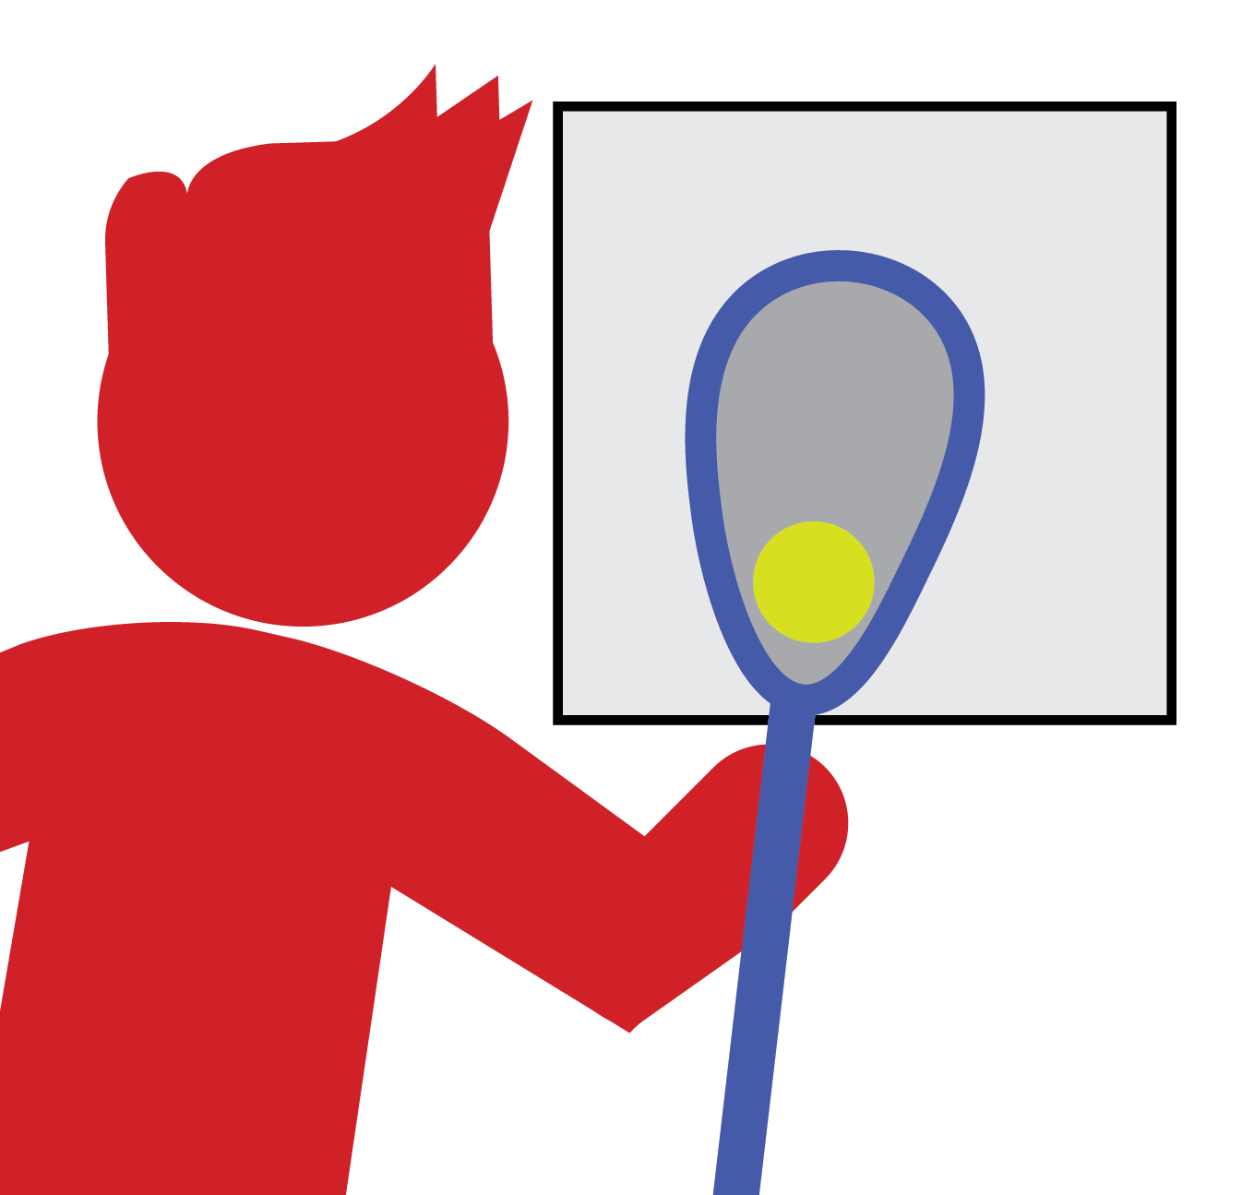

LAX BOX

**The Lax Box**

* Top Dominant Hand Just Below Head  
  (Touching Plastic)
* Head and Ball in the Box
* Grip with Fingers
* Bottom Hand Guides on Lower Part of Stick
* Roll Fingers, Wrist, and Elbow  
  (in Sync with Running Motion)
* Body Protects the Ball

**Cradle Cues**

* Top Hand Just Below Head (Touching Plastic)
* Bottom Hand in the Center of Stick Shaft
* Stick Low, Parallel to Ground
* Bend at Knees, Hips Get Low
* Scoop Low, Quick, and Through to Ear
* Bring Up to Cradle in the Box

***PROGRESSION:*** *Work to separate hands until the dominant hand is at the top and the non-dominant hand is at the bottom of the shaft.*

**Ground Ball Cues**

* Top Hand Slides Down (Middle of the Shaft)
* Bottom Hand is on the Bottom of the Stick
* Stick Head to Your Ear (Back through the Box)
* Bottom Hand Points to Target
* Rotate and Snap Top to Target

**Shooting/Passing Cues**

**Catching Cues**

* Top Hand Just Below Head (Touching Plastic)
* Stick Head in the Box
* Bottom Hand in the Center of the Stick
* Move Stick Head to the Ball
* Move Your Feet to Position Stick Head
* Cushion and Cradle the Catch

***PROGRESSION****: Work to separate hands until the dominant hand is at the top and the non-dominant hand is at the bottom of the shaft.*

* Bottom Hand Release
* Cross the Body
* Hands Swap
* Protect the Stick

**Split Dodge Cues**

* Hands Stay on Stick
* Stick Straight Up
* Cross the Body
* Shoulder Protects the Stick

**Face Dodge Cues**