**CLEAN YOUR YARD**

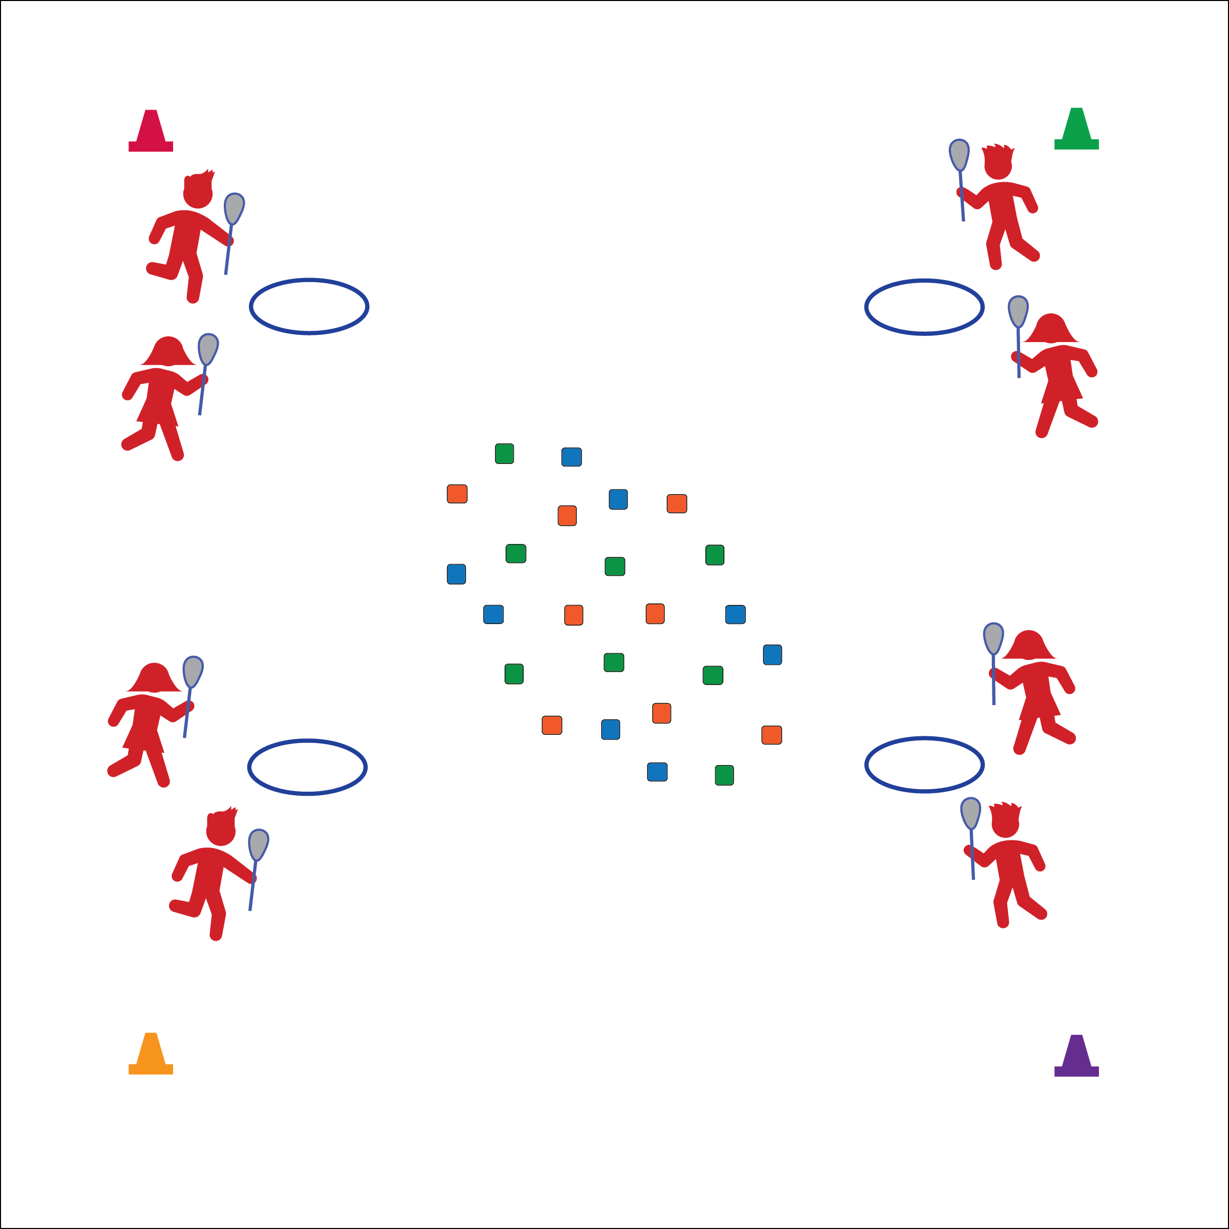

**Equipment**

* A box of bean bags
* 1 lacrosse stick per player
* 1 hoop per pair of players

**Set-Up**

* Scatter bean bags in area.
* Everyone with a lacrosse stick.
* 2 players per team, 1 team   
  per hoop.

**How to play**

1. The object of the game is for you and your partner to collect the most bean bags in your hoop.
2. Do that by moving in the activity area, scooping a bean bag with your stick, and then returning it to your hoop.
3. As soon as you drop the bean bag in your hoop, your partner can start.

**TARGET PRACTICE ON GOAL**

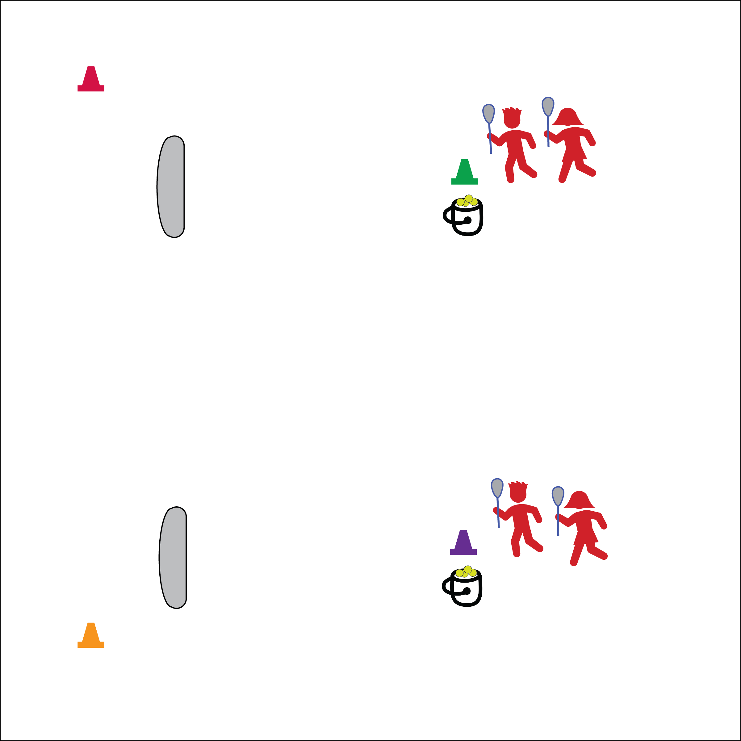

**Equipment**

* 2 buckets of foam balls
* 1 lacrosse stick per player
* 2 pop-up goals
* 2 cones

**How to play**

1. Take turns shooting on goal.
2. Leave shots in goal after your turn and return to the opposite line (change lines after each shot).
3. When 1 bucket is empty, both lines will stop, retrieve all balls from the goal, and then start again.

**Set-Up**

* Create 2 lines, 1 behind each cone facing the goal.

**LAX TAG**

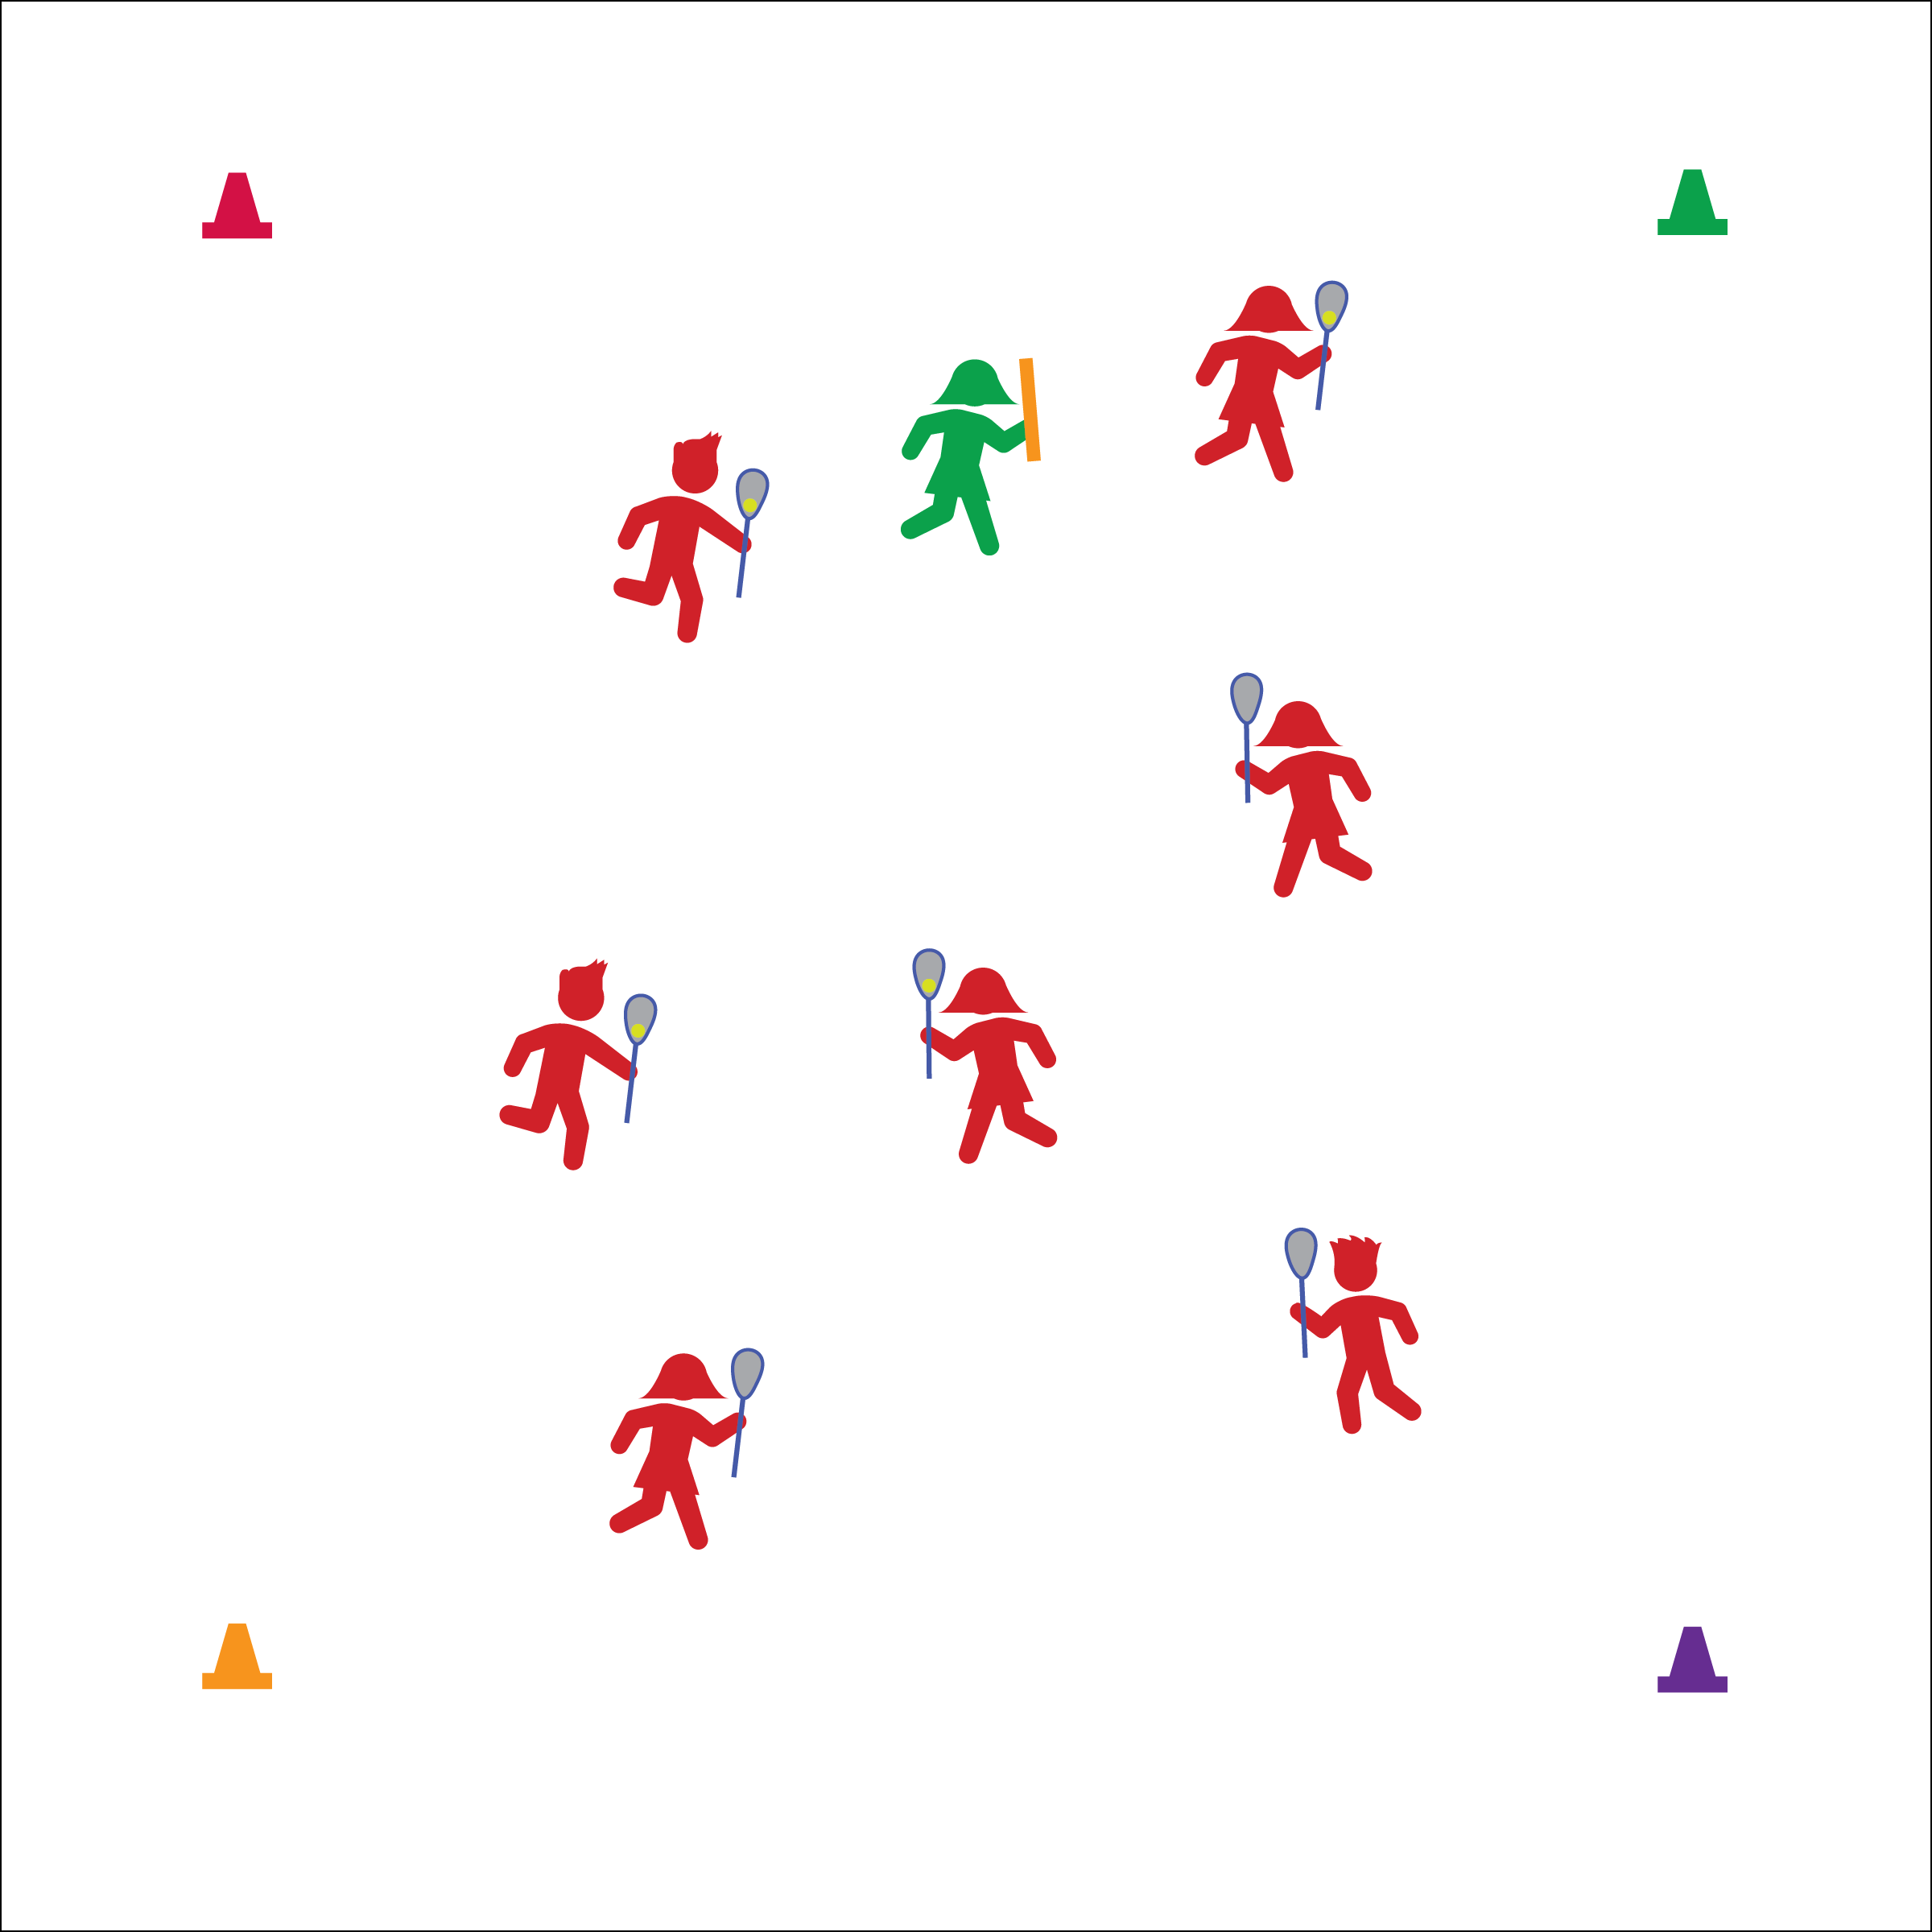

**Set-Up**

* All players with a stick and ball except for 1 player.
* 1 player with a noodle.
* Players scattered in activity area.

**How to play**

1. When the station music starts, begin at a speed-walking pace.
2. Players cradle in the activity area while avoiding the tagger.
3. If tagged, self-toss the ball 3 times and then return to the game.
4. Tagger, count 30-Mississippi and then yell, “new tagger!” The game stops until a new tagger volunteers.

**Equipment**

* 1 stick and ball per player
* 1 foam noodle

**PARTNER TOSS & CATCH**

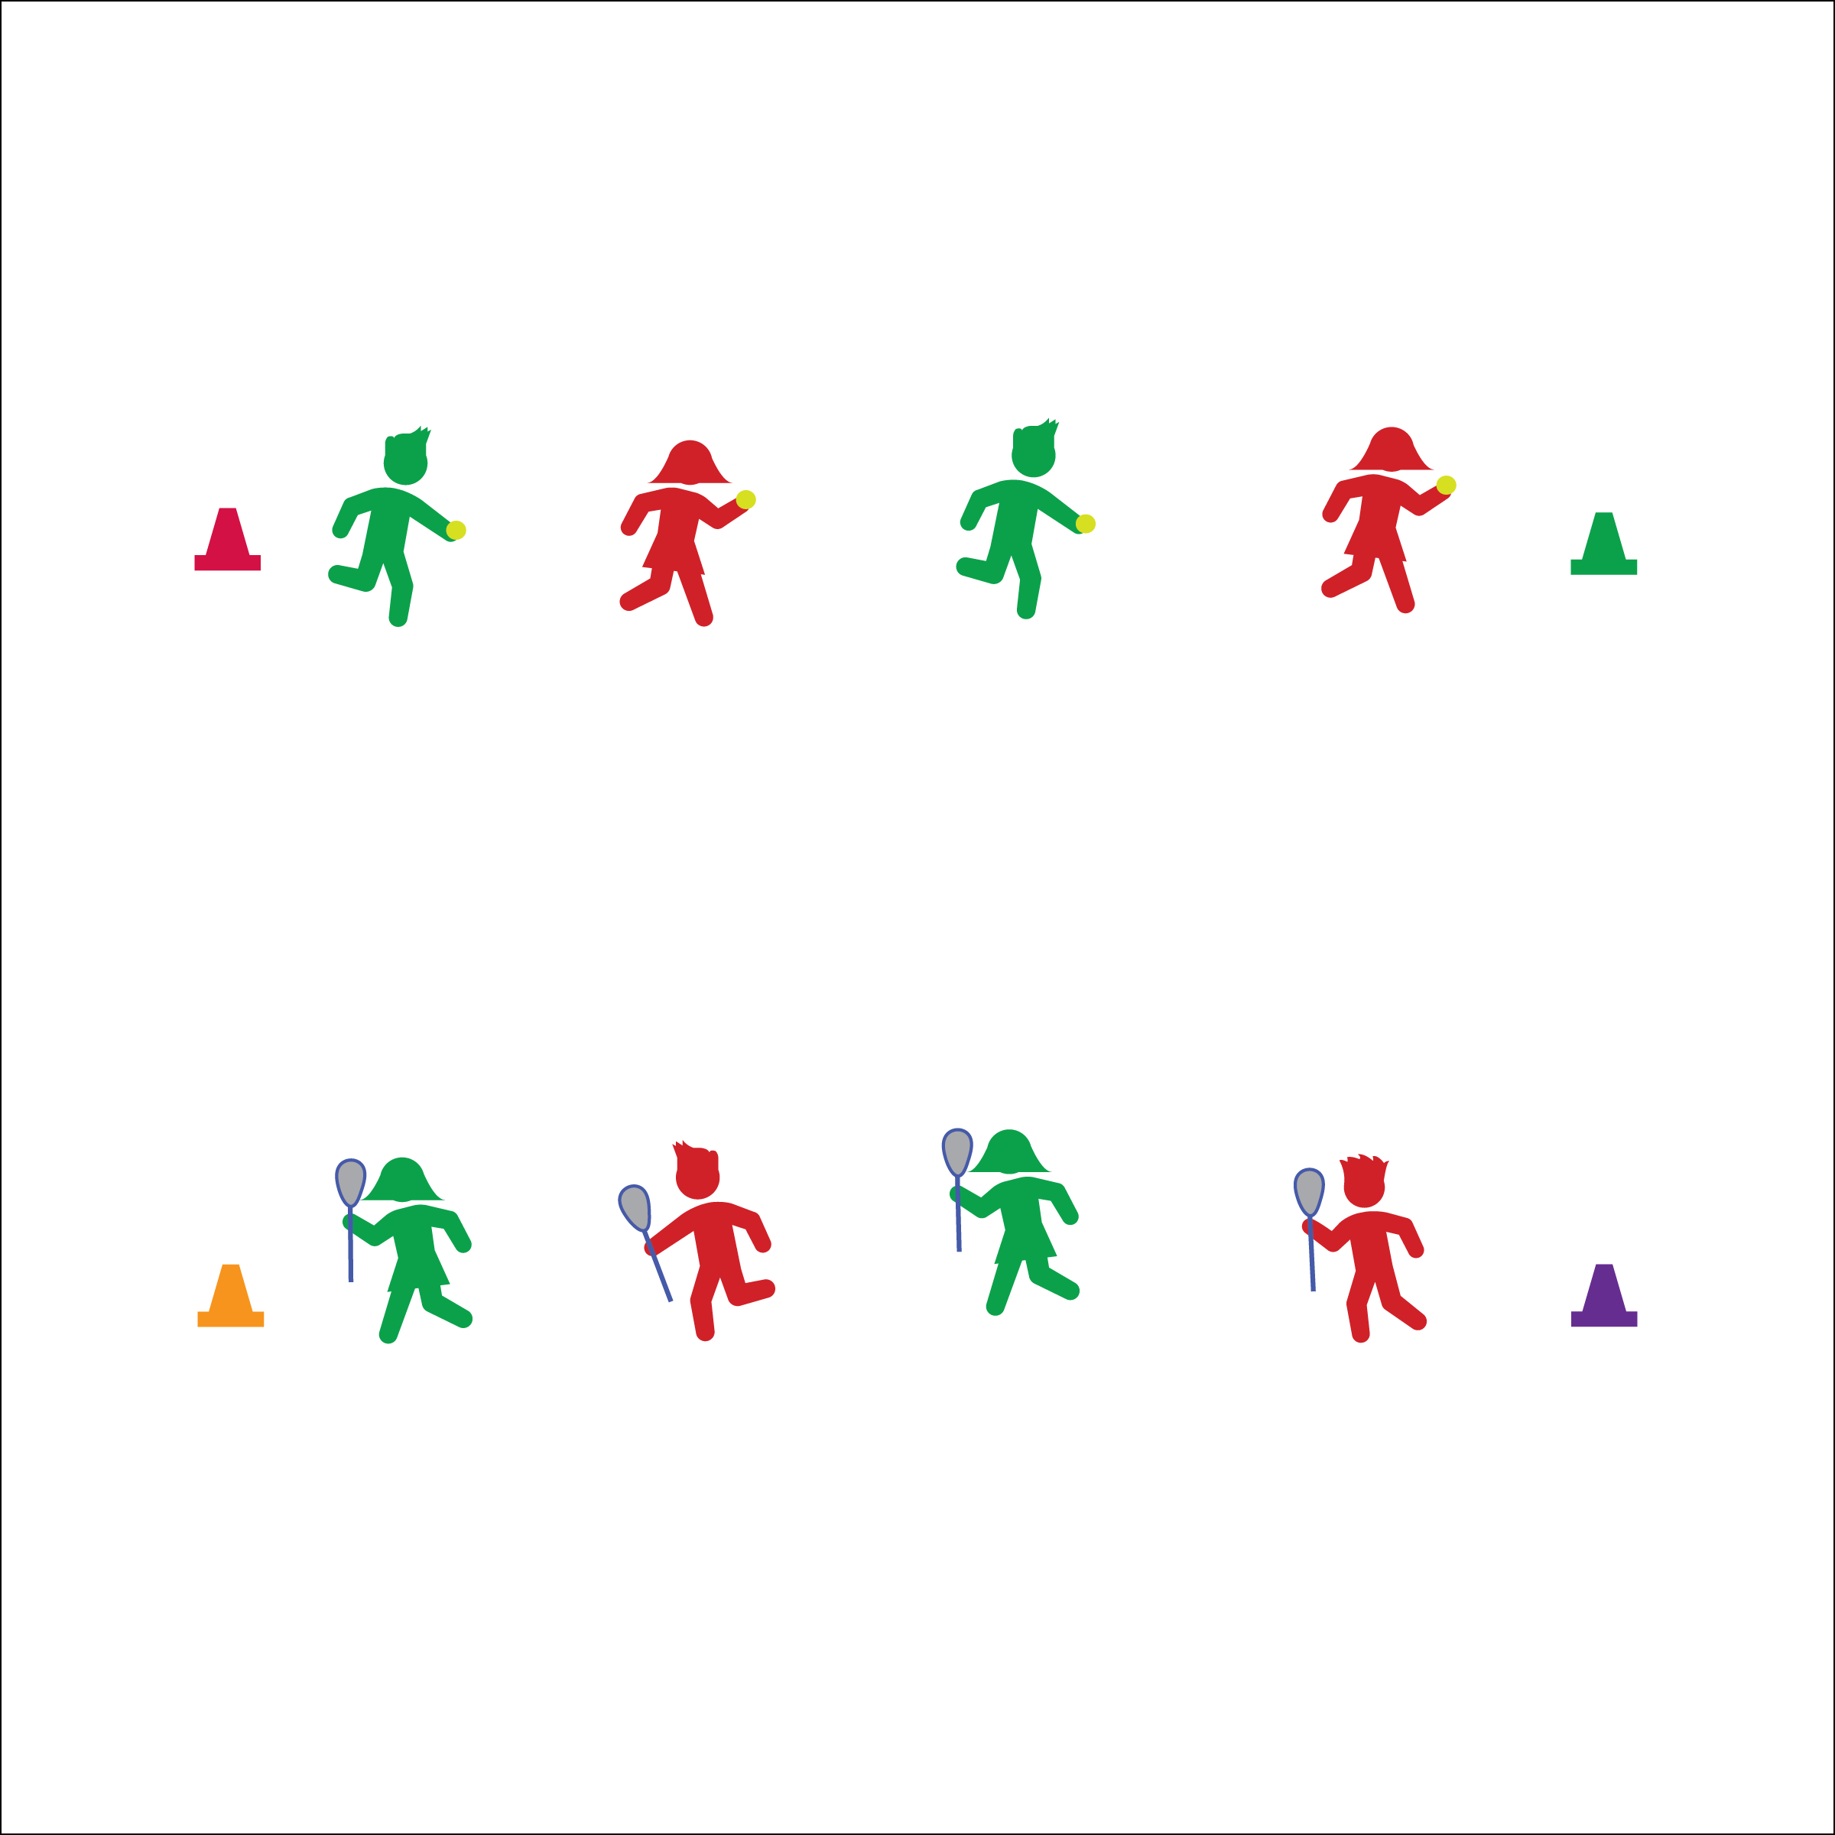

**Set-Up**

* Stand across from your partner, forming 2 parallel lines of players tossing and catching.
* 1 player has a stick, the other has a ball.

**How to play**

1. The player with the ball will toss it into the catcher’s Lax Box.
2. The catcher will cushion and cradle the catch and then roll it back to the tosser.
3. Complete 5 tosses and then switch roles. The tosser becomes the catcher, and the catcher becomes the tosser.

**Equipment**

* 1 stick and ball per pair of players

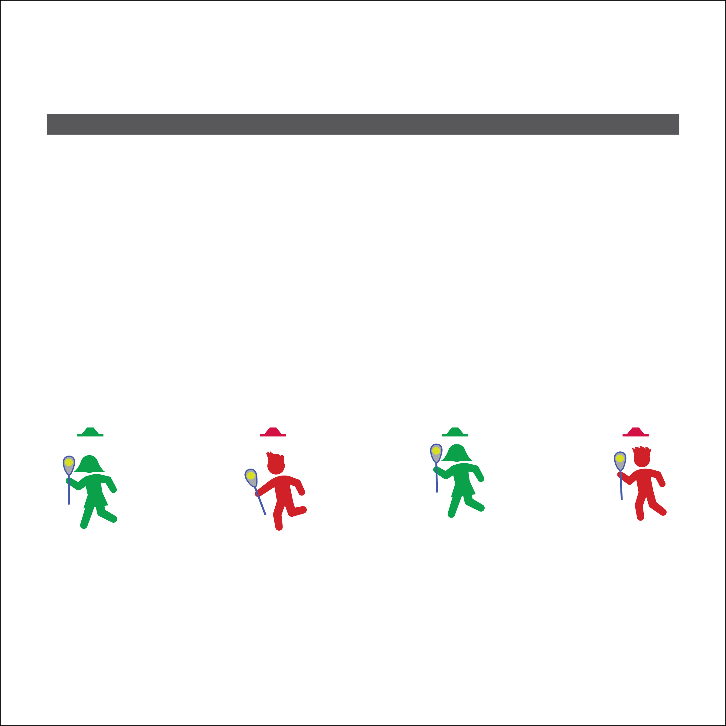

**Set-Up**

* Stand behind your low-profile cone with your lacrosse stick and ball.
* Face the wall.

**How to play**

1. When the music starts, begin throwing your ball against the wall so that it bounces straight back to you.
2. Scoop it up or catch it and then throw again.
3. If a ball rolls or bounces into another player’s space or in front of cones, yell, “BALL!” and wait for other players to stop throwing.
4. Retrieve you ball, return to your cone, and then start again.

**Equipment**

* 1 stick and ball per player
* 1 low-profile cone per player

**WALL BALL**

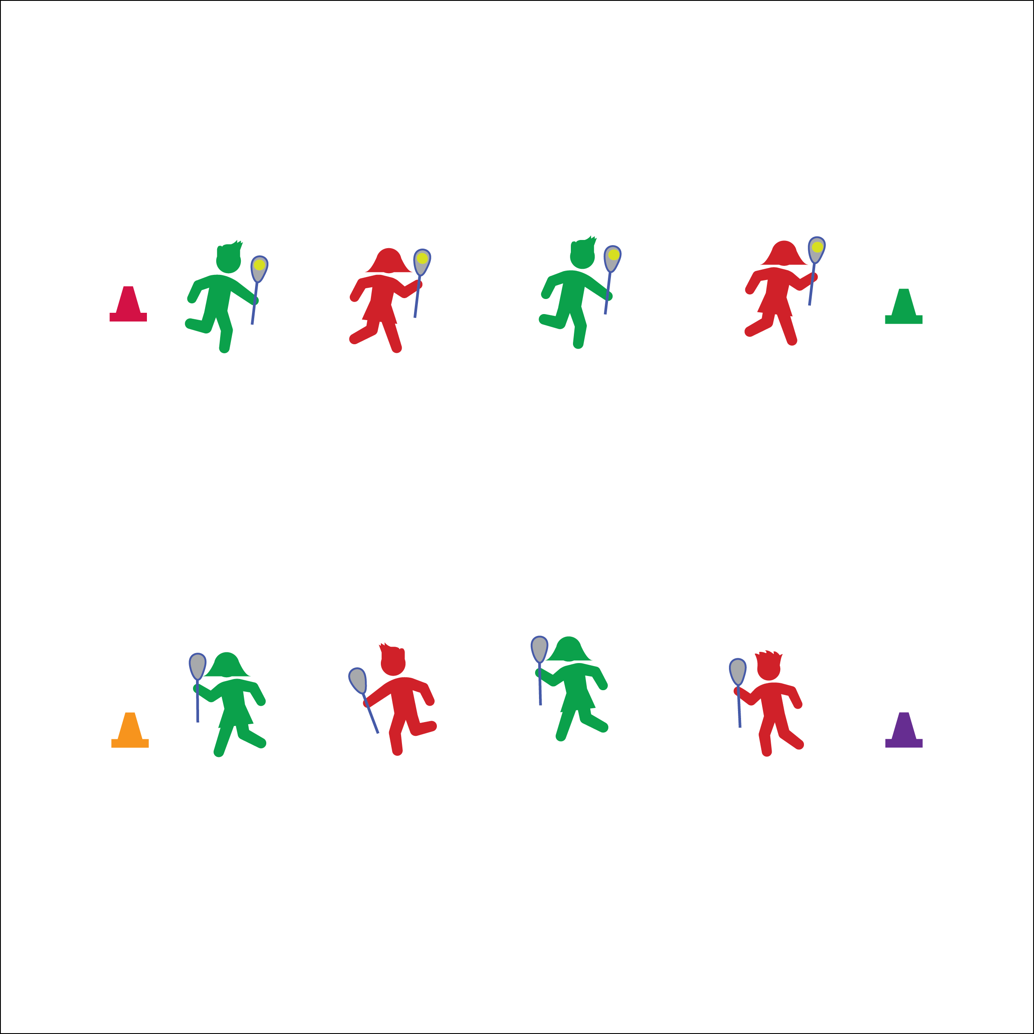

**Equipment**

* 1 lacrosse stick per player
* 1 ball per pair of players

**Set-Up**

* Stand across from your partner, forming 2 parallel lines of players rolling and scooping.
* Both players have a stick, 1 player   
  has a ball.

**How to play**

1. When the station music starts, the player with the ball will use the stick to roll the ball to her/his partner.
2. The partner will scoop it, bring it up into the Lax Box for 3 cradles, and then roll it back to her/his partner.
3. Keep rolling and scooping until the station music stops.

**PARTNER ROLL AND SCOOP**

**SELF TOSS & CATCH**

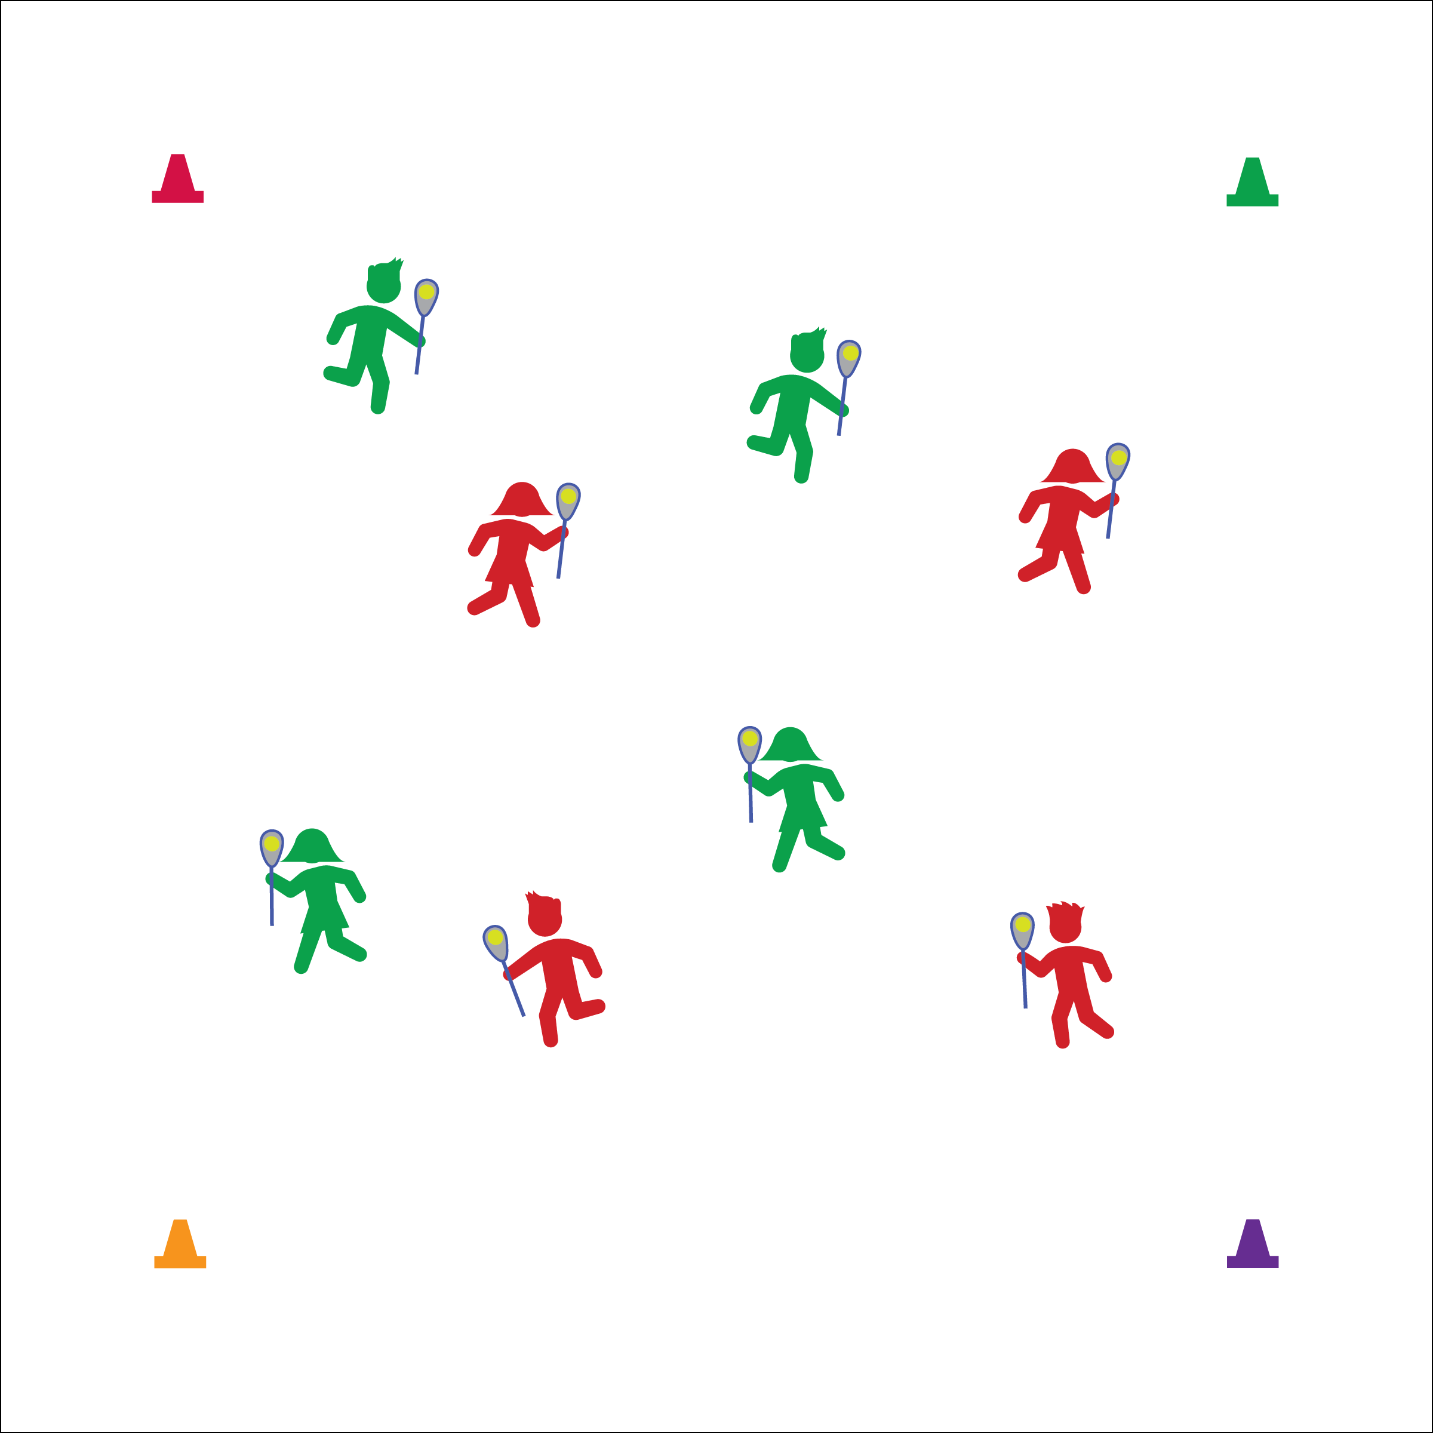

**Set-Up**

* Stand in the activity area with your lacrosse stick and ball.

**Equipment**

* 1 stick and ball per player

**How to play**

1. When the station music starts, toss the ball straight up (just a few inches) and then catch it in your stick.
2. If you make 10 catches in a row, toss the ball just a little higher.
3. Repeat until the ball can be tossed just above your head.
4. If there’s still time left, try to toss it up, let it bounce 1 time, and then catch it after the bounce.



**SELF-ASSESSMENT**

1. Complete the self-assessment for lacrosse.
2. When finished, perform the following exercise sequence until it’s time to rotate to the next station:
   1. 3 push-ups
   2. 11 squats
   3. 33 jumping jacks