­­­­­

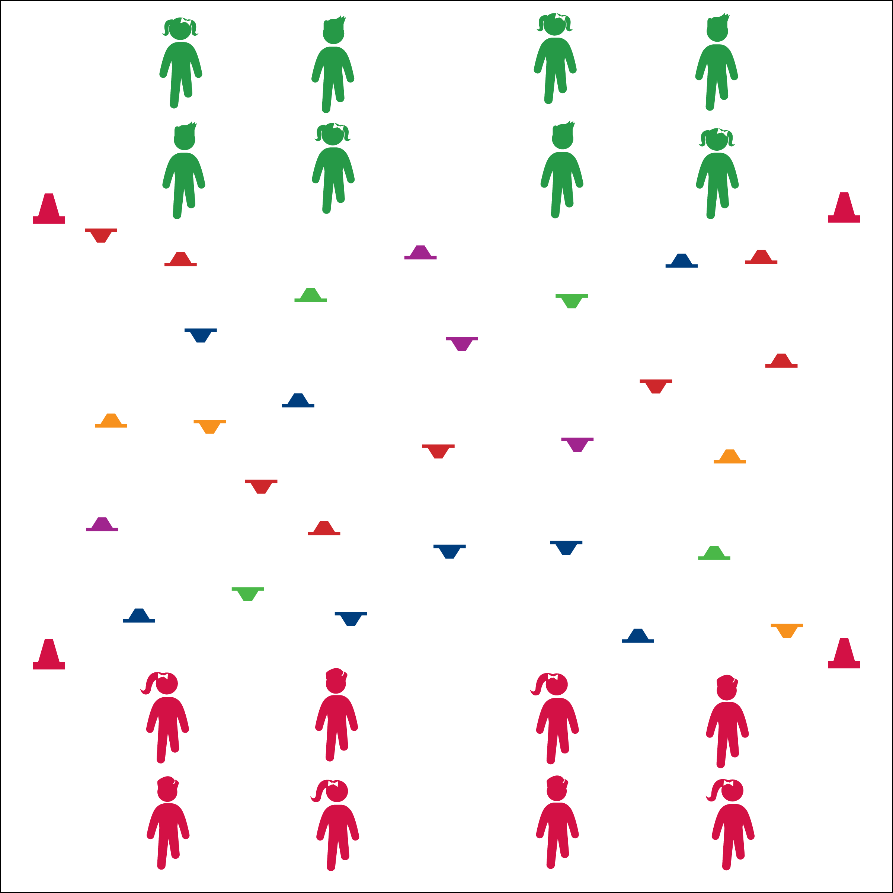

**Activity Procedures:**

1. Today’s Plug & Play Fitness activity is a classic game of Build & Break designed to help us build aerobic capacity. The object of the activity is for the Builders to set all cones right-side-up and for the Bulldozers to flip all cones upside-down.
2. On the “GO!” signal, partner A will quickly move to a cone and flip it in the direction that helps her/his team. Partner B will do jumping jacks (or other aerobic activity). As soon as Partner A is done, she/he will move quickly to give Partner B a high-5 and roles will switch.
3. Continue until you hear the stop signal.

**Grade Level Progression:**

**3rd:** Play the activity as described.

**4th:** Students waiting for partners perform more vigorous activities (e.g., burpees).

**5th:** Decrease the size of the activity area and require students to bear walk to the cones.

**Equipment:**

* 24–48 low-profile cones
* 4 large cones to create boundaries

**Set-Up:**

* Create a large activity area using 4 cones.
* Scatter low profile cones with ½ right-side-up and ½ upside-down.
* Create 2 equal teams, Builders vs Bulldozers. Each team on an end line facing the other. Within each team, pair students and designate partner A and partner B.
* Keep Your Body Moving
* Be Safe and Be Quick
* Watch Out for Other Players
* **Skill:** I will move safely within the activity area by maintaining balance at a safe speed.
* **Cognitive:** I will discuss the importance of aerobic capacity.
* **Fitness:** I will pace my activity so that I work within my target heart rate zone.
* **Personal & Social Responsibility:** I will demonstrate teamwork by taking turns with my partner.

**AEROBIC BUILD & BREAK**



Aerobic Capacity, Intensity, Pace



* **Standard** **3 [E2.3-5]** Engages in the activities of physical education class without teacher prompting (3); Actively engages in the activities of physical education class, both teacher-directed and independent (4); Actively engages in all the activities of physical education (5).
* **Standard 3 [E5.3]** Demonstrates, with teacher direction, the health-related fitness components (3).



* **DOK 1:** What would you include on a list about aerobic capacity?
* **DOK 2:** How would you summarize the importance of aerobic capacity in playing your favorite sport or active game?
* **DOK 3:** How would you change something that you do every day (a daily habit) to create an opportunity to maintain or enhance your aerobic capacity?



**Help students process content.** Guided discussion is essential for the processing and anchoring of essential knowledge. Just as students benefit from the physical activity they receive in physical education classes, they also benefit from time taken to examine skill and fitness concepts that will be essential to developing and maintaining a healthy and active lifestyle. The debrief questions provided within Plug & Play Fitness activities will help facilitate these essential discussions.



* Use large cones that are easy to tip over.
* Allow students to use scooters or other ways of moving within the activity area.
* Focus modes of movement on student needs and abilities. Bear or crab walking can help students build or maintain upper-body strength and endurance.

**AEROBIC BUILD & BREAK**