­­­­­

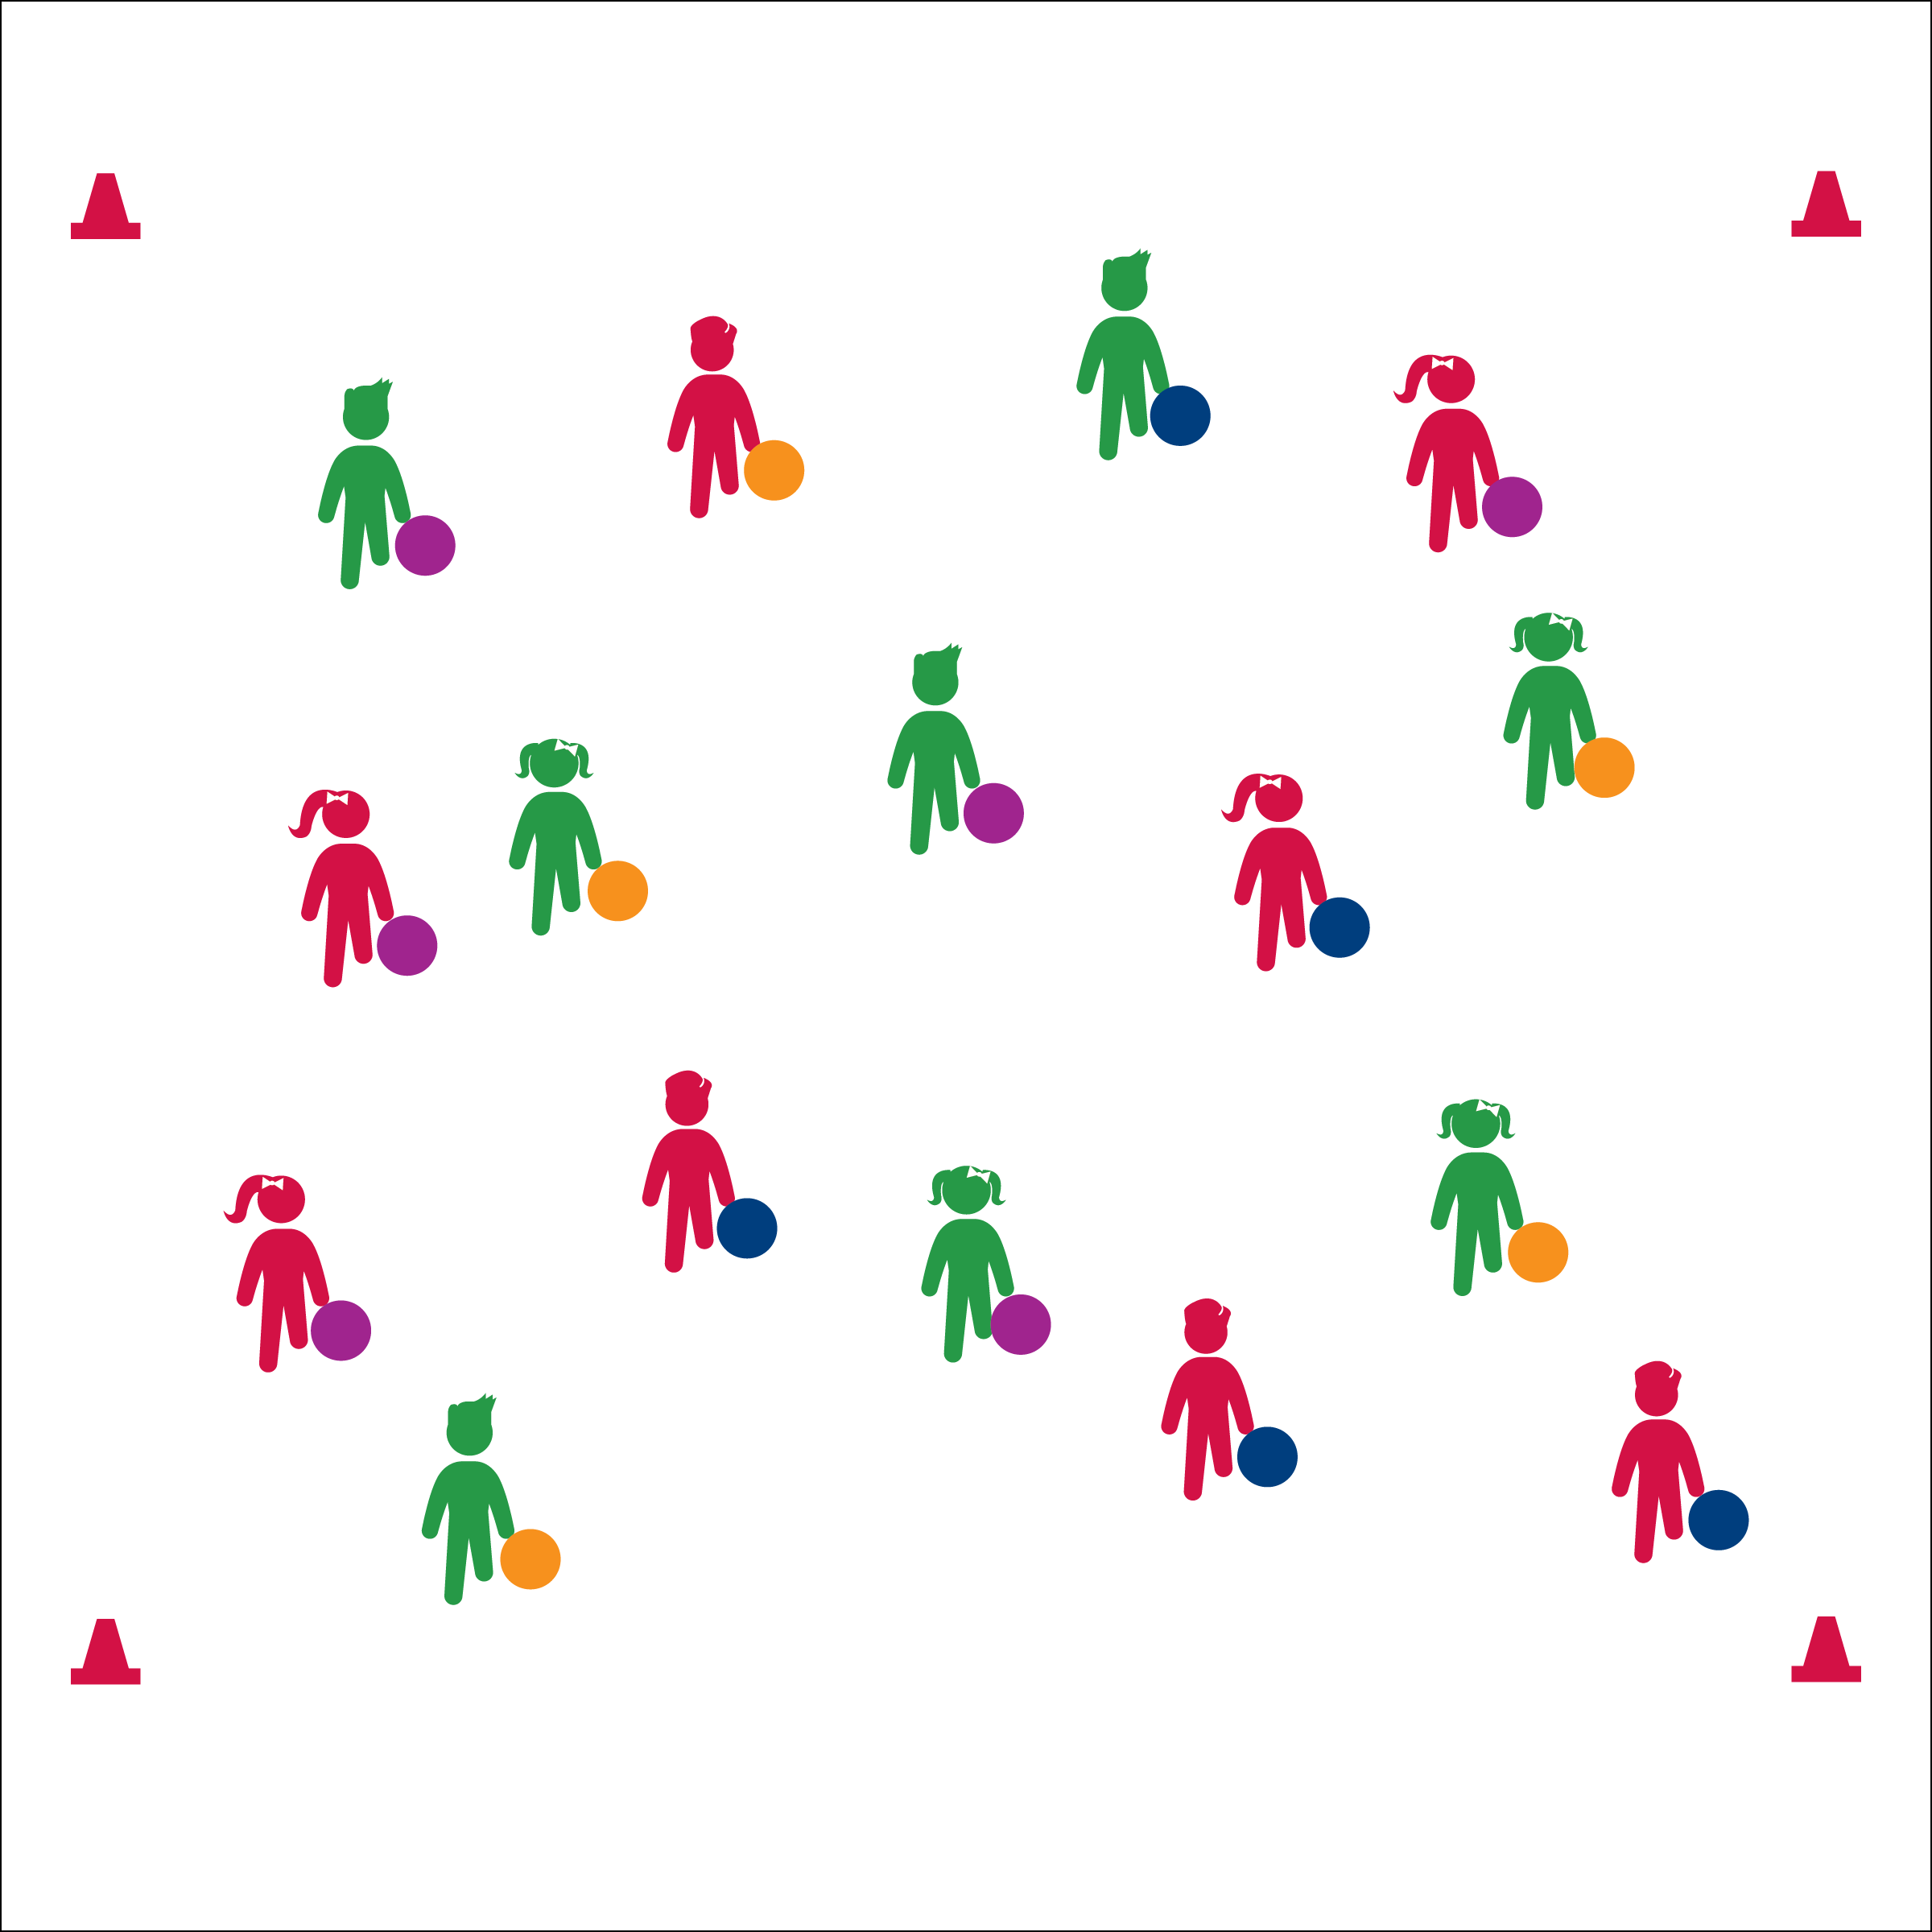

* **Skill:** I will use helpful touches in order to keep foam balls rolling.
* **Cognitive:** I will discuss the importance of aerobic capacity.
* **Fitness:** I will pace my activity so that I work within my target heart rate zone.
* **Personal & Social Responsibility:** I will show respect for my classmates by demonstrating helpful touches.
* Roll, Move, Roll, Repeat
* Helpful Touches
* Need Help? Yes, Please.
* Thanks! No Problem.

**Equipment:**

* 1 ball per student
* 4 large cones to create boundaries

**Set-Up:**

* Create a large activity area using 4 cones.
* Students scattered in the activity area, each with a foam ball.

**FREE FOAM BALL FITNESS**

**Activity Procedures:**

1. Today’s Plug & Play Fitness activity is called Free Foam Ball Fitness. The object of the game is to keep your foam ball moving around the activity area. You’ll also help your classmates keep theirs moving with helpful touches.
2. On the “GO!” signal, roll your ball on the floor. Continue to follow it in order to keep it moving.
3. If you move by another foam ball that needs help, you can roll it for your classmate. Use cooperative language like, “need a little help?” and, “Thanks for the help!”
4. Continue until you hear the stop signal.

**Grade Level Progression:**

**3rd:** Play the game as described.

**4th & 5th:** All students hold plank position. Students push foam balls from player to player in order to keep them moving. If a ball moves into empty space, students must bear walk to retrieve and start the ball again.

**FREE FOAM BALL FITNESS**



Aerobic Capacity, Muscular Endurance, Muscular Strength, Vigorous



* **Standard** **3 [E2.3-5]** Engages in the activities of physical education class without teacher prompting (3); Actively engages in the activities of physical education class, both teacher-directed and independent (4); Actively engages in all the activities of physical education (5).
* **Standard 3 [E5.3]** Demonstrates, with teacher direction, the health-related fitness components (3).



* **DOK 1:** How can you recognize a game, sport, or activity that helps build or maintain aerobic capacity?
* **DOK 2:** How did your health-related fitness affect your ability to play Free Foam Ball Fitness?
* **DOK 3:** How would you change this game to make it more or less vigorous?



**Helps students elaborate on content.** Allowing students to modify activities to make them more or less vigorous allows them to think critically about what they experienced in physical education class and elaborate on learned information in a context they are familiar with. If time allows, let students try their modifications and then discuss the results.



* Students use noodles or floor hockey sticks to reach and move foam balls.
* Decrease the number of foam balls. Students work cooperatively.