­­­­­

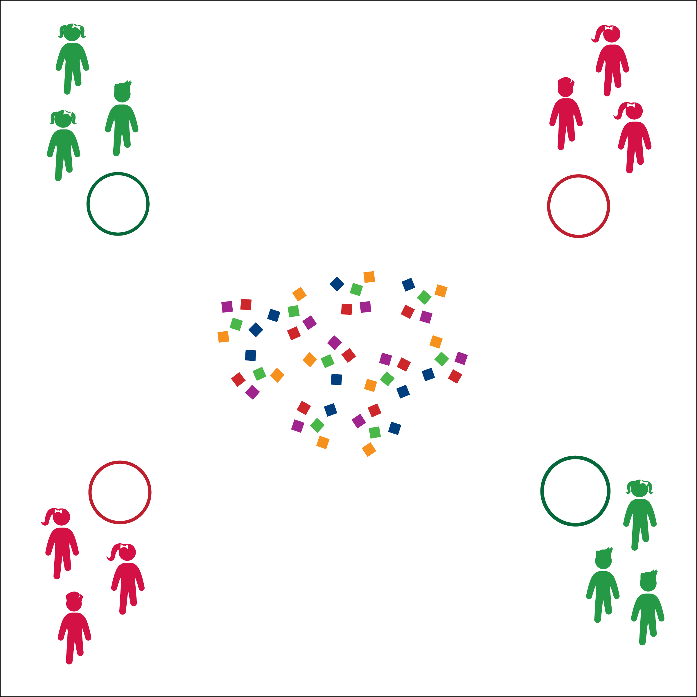

* Move Safely
* 1 Bean Bag at a Time
* Place Bean Bags (Don’t Toss)
* **Skill:** I will move safely within the activity area by maintaining balance at a safe speed.
* **Cognitive:** I will discuss the importance of regular physical activity.
* **Fitness:** I will pace my activity so that I work within my target heart rate zone.
* **Personal & Social Responsibility:** I will follow the rules for Aerobic Treasure Grab without the need for teacher reminders.

**Equipment:**

* 24–48 bean bags
* 1 hoop per group of 2–4 students

**Set-Up:**

1. Use hoops to create activity boundaries and home-base areas for each team.
2. Scatter bean bags in the center of the activity area.
3. Create even teams of no more than 4 players per team, each team behind each hoop.

**Activity Procedures:**

1. Today’s Plug & Play Fitness activity is called Aerobic Treasure Grab.
2. The object of the activity is to collect as many bean bag treasures in your hoop as you can.
3. You’ll do that in a relay-race format with 1 teammate collecting 1 bean bag at a time from the activity area. As soon as each player returns, the next player moves to collect the next bean bag. Students waiting for a turn will perform an aerobic exercise.
4. Once all beanbags have been collected from the center of the activity area, teams can move to other teams’ hoops to “steal” their treasures. You cannot guard your hoop.
5. Freeze when you hear the stop signal.

**Grade Level Progression:**

**3rd:** Begin at a skipping or galloping pace.

**4th & 5th:** Allow students to move at a more vigorous pace.

**AEROBIC TREASURE GRAB**

**AEROBIC TREASURE GRAB**



Aerobic Capacity, Actively Engage, Active Lifestyle, Sedentary Lifestyle, Vigorous



* **Standard 3 [E2.3-5]** Engages in the activities of physical education class without teacher prompting (3); Actively engages in the activities of physical education class, both teacher-directed and independent (4); Actively engages in all the activities of physical education (5).
* **Standard 3 [E5.3]** Demonstrates, with teacher direction, the health-related fitness components (3).



* **DOK 1:** Can you remember the reasons why it’s important to be physically active every day?
* **DOK 2:** How would you compare and/or contract an active lifestyle with a sedentary lifestyle?
* **DOK 3:** Would you consider your lifestyle active or sedentary? Can you support your choice with specific examples?

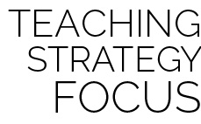

**Help students examine similarities and differences.** Guide students through the process of classifying and comparing sedentary routine activities and active habits. This strategy can help students think deeply about their own lifestyle habits and choices and draw conclusions about how they can improve their daily and weekly routines.



* Students travel in pairs, working cooperatively to grab bean bags.
* Use a variety of objects as treasures, allowing for student preference, skill, and ability.