­­­­­

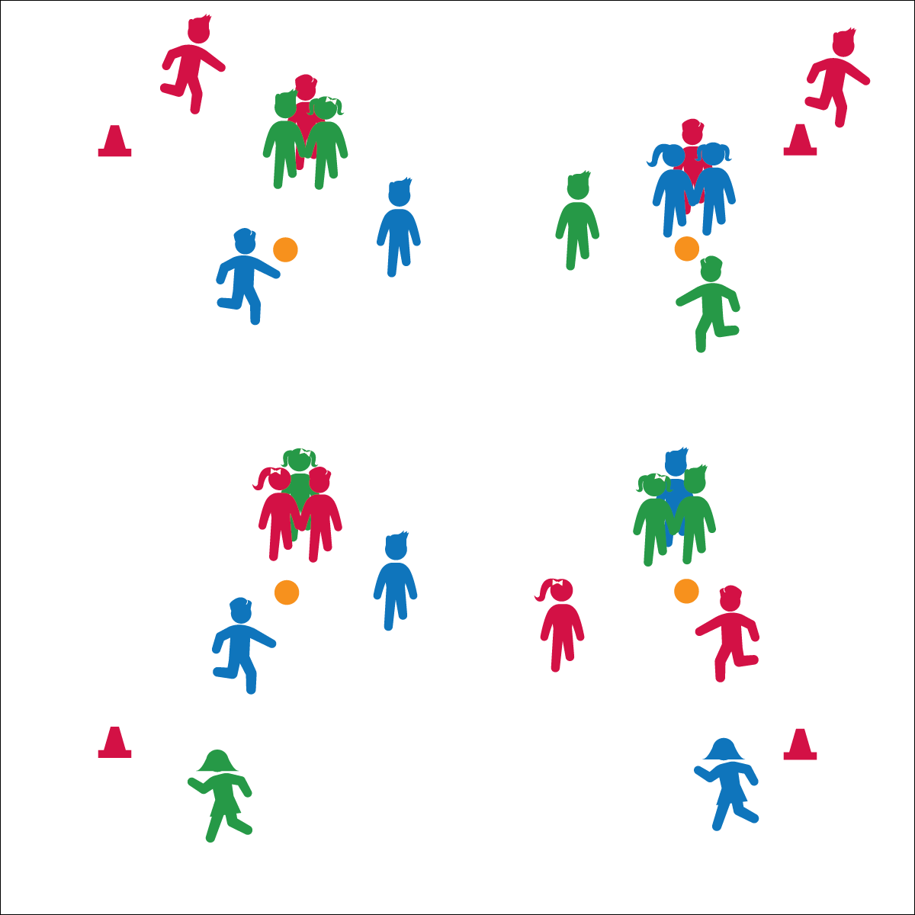

* **Skill:** I will move safely within the activity area by maintaining balance at a safe speed.
* **Cognitive:** I will discuss the benefits of regular physical activity.
* **Fitness:** I will pace my activity so that I work within my target heart rate zone.
* **Personal & Social Responsibility:** I will follow the rules for Team Triangle Tag without the need for teacher reminders.

**TEAM TRIANGLE TAG**

* Safe Tagging Form
* Stay Close to Home Base
* Side-Slide in Athletic Stance

**Equipment:**

* 1 spot marker per 6 students
* 4 large cones

**Set-Up:**

1. Create a large jogging loop using 4 cones.
2. Pairs students into teams of 2. 6 teams will play in each game.
3. Scatter spots inside the jogging loop. These will serve as home bases for the shielding teams and target players.

**Activity Procedures:**

1. Today’s Plug & Play Fitness activity is called Team Triangle Tag.
2. The object of the activity is for each scoring team to tag the target player as many times as possible before the loop runner has completed 1 jogging loop.
3. Each game has 3 teams playing against each other. Team 1 is the scoring team; player A is the tagger and player B is the scorekeeper. Team 2 is the fleeing team; player C is the target player and player D is the loop runner. Team 3 is the shielding team; both players are trying to keep the scoring team from tagging the target player. They will hold hands with the target player to form a triangle, and they will rotate to shield her/him from the tagger.
4. On the start signal, the loop runner begins running, and the tagger starts to chase the target player. When the Loop runner returns, rotate team and player roles.

**Grade Level Progression:**

**3rd:** Begin by teaching Triangle Tag without the loop runner. Introduce loops after students have mastered Triangle Tag.

**4th & 5th:** Play the activity as described above.

**TEAM TRIANGLE TAG**



Aerobic Capacity, Jog, Pace



* **Standard 3 [E2.3-5]** Engages in the activities of physical education class without teacher prompting (3); Actively engages in the activities of physical education class, both teacher-directed and independent (4); Actively engages in all the activities of physical education (5).
* **Standard 3 [E5.3]** Demonstrates, with teacher direction, the health-related fitness components (3).



* **DOK 1:** What would you include on a list about active lifestyles?
* **DOK 2:** How can you apply what you’ve learned in physical education to develop or maintain an active lifestyle?
* **DOK 3:** How is an active lifestyle related to having fun with your friends and family?



**Help students examine their reasoning.** The debrief questions provided above guide students through the process of examining their own routine reasoning related to activity choices and healthful living. Framed in a context of fun and social benefits, students must produce and defend their own statements related to how and why they maintain an active lifestyle.



* Students hold a scarf or deck ring to connect the triangle rather than holding hands.
* Students jump rope or complete another aerobic exercise for a set amount of time rather than running a loop.