­­­­­

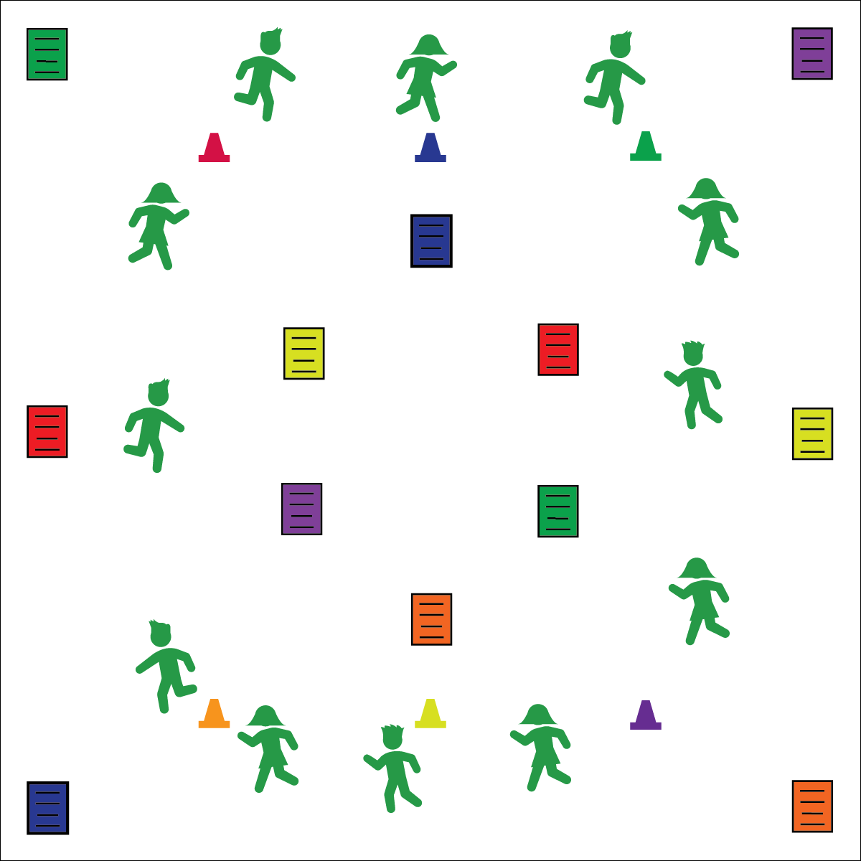

**COLOR CRUSHERS**

* **Skill:** I will demonstrate perfect exercise form.
* **Cognitive:** I will discuss the importance of perfect exercise form.
* **Fitness:** I will pace my activity so that I work within my target heart rate zone.
* **Personal & Social Responsibility:** I will work independently with a focus on improving my fitness.
* Focus on Form
* Pace Your Jog
* Crush the Exercise

**Equipment:**

* 1 set of 6-color cones
* 4 sets of Color Crusher exercise posters

**Set-Up:**

1. Create a large jogging loop using 6-color cones.
2. Post 6-color exercise posters in visible areas throughout the activity area and on the walls.
3. Students scattered around the jogging loop.

**Activity Procedures:**

1. Today’s Plug & Play Fitness activity is called Color Crushers.
2. The object of the activity is for you to crush (i.e., complete) the exercise listed on the exercise posters.
3. When the music starts, everyone will begin jogging around the loop.
4. When the music stops and you hear a color signal (e.g., “BLUE!”), move quickly to a poster and perform the exercise listed.
5. When the music restarts, begin jogging around the loop.

**Grade Level Progression:**

**3rd & 4th:** Play the activity as described above.

**5th:** Provide students with blank exercise posters. Prompt them to create new posters with a focus on all health-related components of fitness.

**COLOR CRUSHERS**



Aerobic Capacity, Flexibility, Exercise Form, Dynamic Stretching, Muscular Fitness



* **Standard** **3 [E2.3-5]** Engages in the activities of physical education class without teacher prompting (3); Actively engages in the activities of physical education class, both teacher-directed and independent (4); Actively engages in all the activities of physical education (5).
* **Standard 3 [E5.3]** Demonstrates, with teacher direction, the health-related fitness components (3).



* **DOK 1:** What is exercise form?
* **DOK 1:** How can you recognize perfect exercise form?
* **DOK 2:** How does exercise form affect how you benefit from the exercises you perform?
* **DOK 3:** What might happen if a person performed an exercise with poor exercise form?
* **DOK 4:** What would we include on a practice plan designed to help us improve our exercise form?



**Identify critical content.** Exercise form is critical to both safety and effectiveness of all fitness exercises. This activity provides an important opportunity to identify and focus on exercise form. Describe, demonstrate, and discuss critical cues for each exercise performed, and then debrief based on student experience and understanding.



* Create custom exercise posters that meet the needs of all of your students.
* Provide a variety of demonstrations and cues to help students experience perfect exercise form.
* Allow students to move around the jogging loop using different locomotor activities, scooters, or wheelchairs.