­­­­­

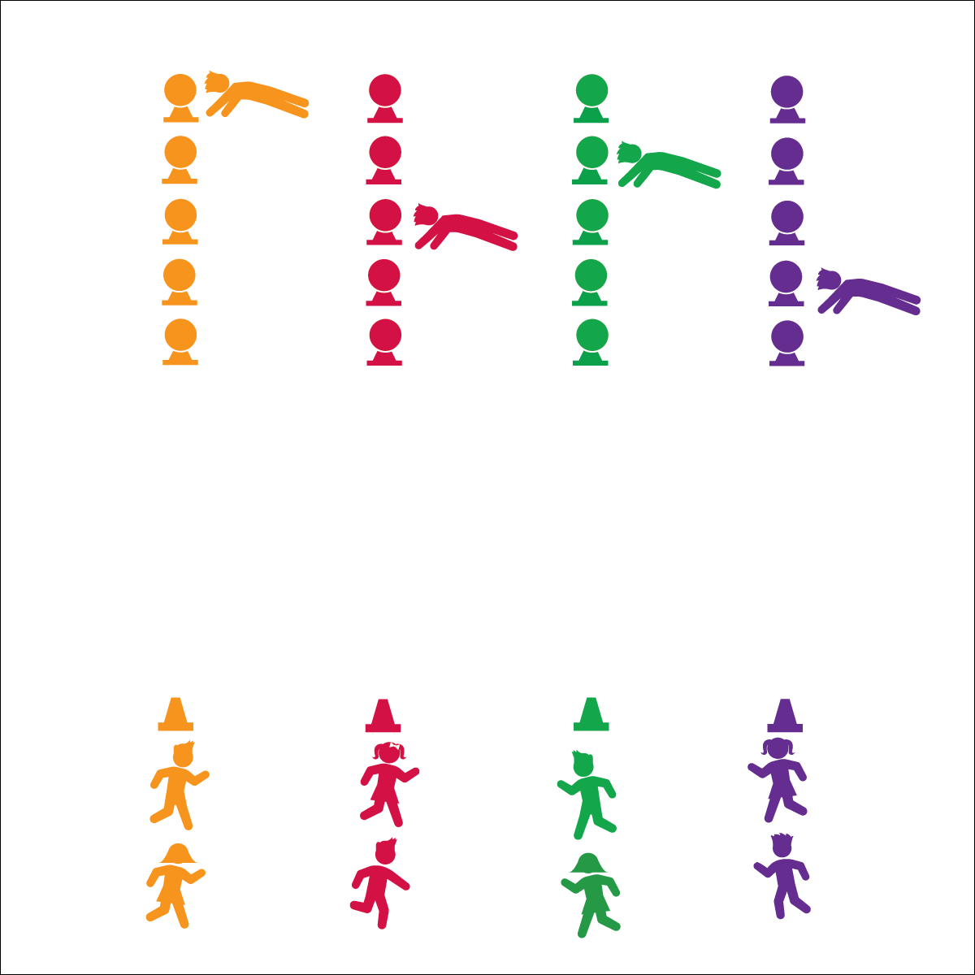

**PLANK-TAP RELAY**

* **Skill:** I will demonstrate perfect exercise form.
* **Cognitive:** I will discuss the benefits of planks.
* **Fitness:** I will pace my activity so that I work within my target heart rate zone.
* **Personal & Social Responsibility:** I will demonstrate teamwork by completing plank-taps quickly and with perfect form.
* Proper Planks
* Control Your Taps

**Equipment:**

* 1 large cone per group of 2–3 students
* 5 low-profile cones per group of 2–3 students
* 5 foam balls (or bean bags) per group of 2–3 students

**Set-Up:**

1. Create 1 relay race line per group using the large cone as the group’s home base.
2. 20 meters from home base, place 5 low-profile cones 1 meter apart with a foam ball balanced on top of each cone.
3. Create teams of no more than 3 students per relay line. Each team at a home base.

**Activity Procedures:**

1. Today’s activity is called Plank-Tap Relay. The object is for our class to collect as many plank-taps as we can. This activity is done in a relay-race format.
2. On the start signal, the first person in each line will run to the end of the row of foam balls, get into plank position, and tap the top of each foam ball with both hands (first left, then right). They will advance through all 5 foam balls before running back and giving a high-5 to the next person in line.
3. Begin on the start signal. Continue through your line until you hear the stop signal, repeating as many times as you can.

**Grade Level Progression:**

**3rd & 4th:** Introduce the activity such that students move to the foam balls, perform squats and tap each ball per squat, and then return to their line. When students have mastered this format, introduce plank-taps.

**5th:** Prompt students to create their own fitness relays.

**PLANK-TAP RELAY**



Core, Exercise Form, Muscular Fitness, Muscle Tone, Plank



* **Standard 3 [E2.3-5]** Engages in the activities of physical education class without teacher prompting (3); Actively engages in the activities of physical education class, both teacher-directed and independent (4); Actively engages in all the activities of physical education (5).
* **Standard 3 [E5.3]** Demonstrates, with teacher direction, the health-related fitness components (3).



* **DOK 1:** How can you recognize good plank position?
* **DOK 2:** What do you notice about your muscles when you hold plank position?
* **DOK 3:** Can you describe what happens to different muscles in your body when you hold plank position? Use specific examples. (E.g., What happens to your arms? Your core?)

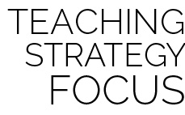

**Organize students to interact with content.** Plug & Play Fitness activities are designed to be done on a regular basis throughout the school year. For example, you could begin one lesson per week with a Plug & Play activity. This ensures that fitness will remain a focus for both you and your students. Be creative and modify the activities to include elements of whatever unit or topic you’re currently teaching. For example, if you are in a floor hockey unit, students can stick-dribble a ball or puck down to the foam balls, perform plank taps, and then stick-dribble back to their teams. Be creative and have fun while you keep the focus on fitness concepts.



* Substitute planks with exercises that meet the needs and abilities of your students.
* Change locomotor movements to meet the skills and abilities of your students.
* Substitute foam balls with larger or smaller objects.