­­­­­

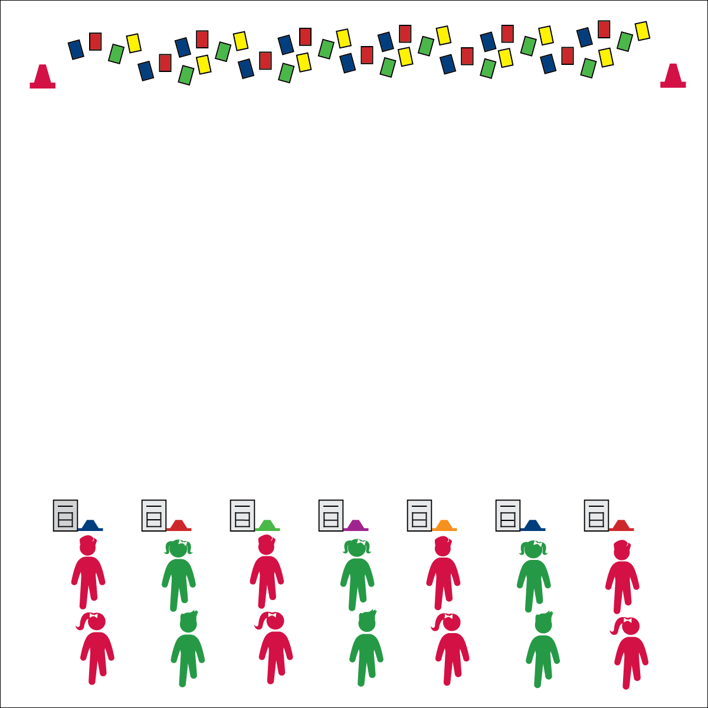

**Equipment:**

* 1 low-profile cone per group of 2–4 students
* 1 deck of Uno cards (or regular playing cards)
* 2 large cones
* 1 Fitness UNO chart per group of 2–4 students

**Set-Up:**

1. Create 2 parallel lines 20 meters apart. Along 1 line, place 2 large cones on each end with cards scattered between the cones. Along the other line, spread low-profile cones evenly as a home base for each team.
2. Create teams of 2–4 students, each team at a home base.

* **Skill:** I will demonstrate perfect exercise form.
* **Cognitive:** I will discuss the importance of aerobic capacity.
* **Fitness:** I will pace my activity so that I work within my target heart rate zone.
* **Personal & Social Responsibility:** I will cooperate with my teammates by following Fitness Uno rules.

**Activity Procedures:**

1. Today’s activity is called Fitness Uno. We’ll be focusing today’s game on aerobic capacity. (Muscular fitness and flexibility UNO charts are also available.)
2. The game is played in 2 phases. During phase 1, teams will collect 7 cards per team in a relay race format. Each player will run to pick up 1 card, return it to home base, and then high-5 the next player so that s/he can collect the next card.
3. In phase 2, teams will work to get rid of all of their collected cards 1 at a time. Use the Fitness UNO chart to identify exercises that correspond to the card color, and then complete the number of repetitions displayed on the card. For example, to discard a “Blue 9,” the entire team must complete 9 repetitions of the exercise that corresponds to the blue cards. As soon as the exercise is complete, a player from your team will run the and put the card back in the card pile at the other end of the activity area.
4. When your team has 1 card left, yell out, “UNO!” before completing the final exercise.

**Grade Level Progression:**

**3rd:** Complete the activity as described above.

**4th:** Introduce Muscular Fitness and Dynamic Stretching UNO charts.

**5th:** Allow students to create their own UNO charts.

* Focus on Exercise Form
* Keep the Pace to Pump Up Your Heart Rate

**FITNESS UNO**

**FITNESS UNO**



Actively Engage, Aerobic Capacity, Exercise Form, Health-Related Fitness, Muscular Fitness, Dynamic Stretching



* **Standard** **3 [E2.3-5]** Engages in the activities of physical education class without teacher prompting (3); Actively engages in the activities of physical education class, both teacher-directed and independent (4); Actively engages in all the activities of physical education (5).
* **Standard 3 [E5.3]** Demonstrates, with teacher direction, the health-related fitness components (3).



* **DOK 1:** What is aerobic capacity? What is Muscular Fitness? What is Flexibility?
* **DOK 2:** What do you know about aerobic capacity? Muscular Fitness? Flexibility?
* **DOK 3:** How is aerobic capacity related to your ability to do the things that you like to do? Muscular Fitness? Flexibility?
* **DOK 4:** Let’s analyze the positive and negative consequences of different lifestyle choices and habits. For example, what are the positive/negative consequences of being physically active every day? What are the positive/negative consequences of playing a lot of video games?



**Identify critical content.** The five components of health-related fitness are among the most critical of content that we can teach intermediate students. Staying active to improve aerobic capacity, muscular fitness, and flexibility are not enough. Students must learn, process, and discuss how fitness components impact their lives both now and in the future. Plug and Play Fitness Activities are designed to allow you to consistently revisit this critical content with fun activities and engaging debrief sessions.



* Create custom Fitness Uno charts that meet the needs of all of your students.
* Deal cards at the start of the activity rather than having students collect them. Then focus student effort and abilities on performing the exercises listed on the Fitness Uno chart.
* Provide a variety of demonstrations and cues to help students experience perfect exercise form.

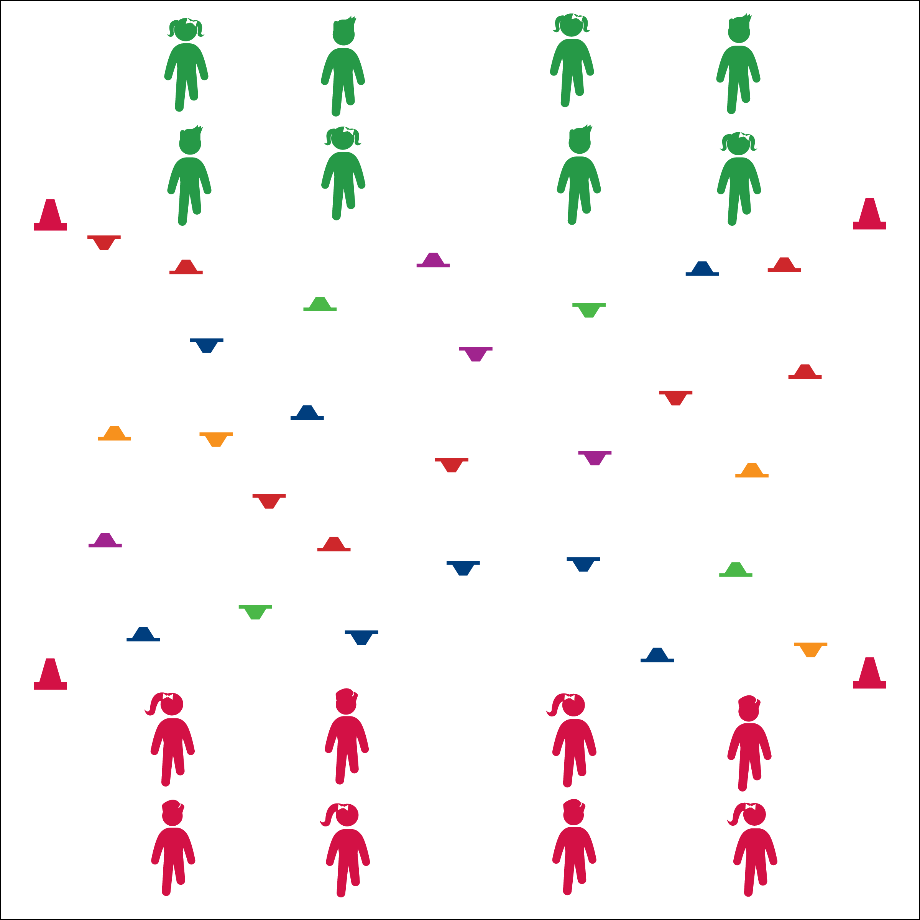

* **Skill:** I will move safely within the activity area by maintaining balance at a safe speed.
* **Cognitive:** I will discuss the importance of aerobic capacity.
* **Fitness:** I will pace my activity so that I work within my target heart rate zone.
* **Personal & Social Responsibility:** I will demonstrate teamwork by taking turns with my partner.

**Equipment:**

* 24–48 low-profile cones
* 4 large cones to create boundaries

**Set-Up:**

1. Create a large activity area using 4 cones.
2. Scatter low profile cones with ½ right-side-up and ½ upside-down.
3. Create 2 equal teams, Builders vs Bulldozers. Each team on an end line facing the other. Within each team, pair students and designate partner A and partner B.

* Keep Your Body Moving
* Be Safe and Be Quick
* Watch Out for Other Players

**Activity Procedures:**

1. Today’s Plug & Play Fitness activity is a classic game of Build & Break designed to help us build aerobic capacity. The object of the activity is for the Builders to set all cones right-side-up and for the Bulldozers to flip all cones upside-down.
2. On the “GO!” signal, partner A will quickly move to a cone and flip it in the direction that helps her/his team. Partner B will do jumping jacks (or other aerobic activity). As soon as Partner A is done, she/he will move quickly to give Partner B a high-5 and roles will switch.
3. Continue until you hear the stop signal.

**Grade Level Progression:**

**3rd:** Play the activity as described.

**4th:** Students waiting for partners perform more vigorous activities (e.g., burpees).

**5th:** Decrease the size of the activity area and require students to bear walk to the cones.

**AEROBIC BUILD & BREAK**

**AEROBIC BUILD & BREAK**



* **DOK 1:** What would you include on a list about aerobic capacity?
* **DOK 2:** How would you summarize the importance of aerobic capacity in playing your favorite sport or active game?
* **DOK 3:** How would you change something that you do every day (a daily habit) to create an opportunity to maintain or enhance your aerobic capacity?



Aerobic Capacity, Intensity, Pace



* **Standard** **3 [E2.3-5]** Engages in the activities of physical education class without teacher prompting (3); Actively engages in the activities of physical education class, both teacher-directed and independent (4); Actively engages in all the activities of physical education (5).
* **Standard 3 [E5.3]** Demonstrates, with teacher direction, the health-related fitness components (3).



* Use large cones that are easy to tip over.
* Allow students to use scooters or other ways of moving within the activity area.
* Focus modes of movement on student needs and abilities. Bear or crab walking can help students build or maintain upper-body strength and endurance.



**Help students process content.** Guided discussion is essential for the processing and anchoring of essential knowledge. Just as students benefit from the physical activity they receive in physical education classes, they also benefit from time taken to examine skill and fitness concepts that will be essential to developing and maintaining a healthy and active lifestyle. The debrief questions provided within Plug & Play Fitness activities will help facilitate these essential discussions.

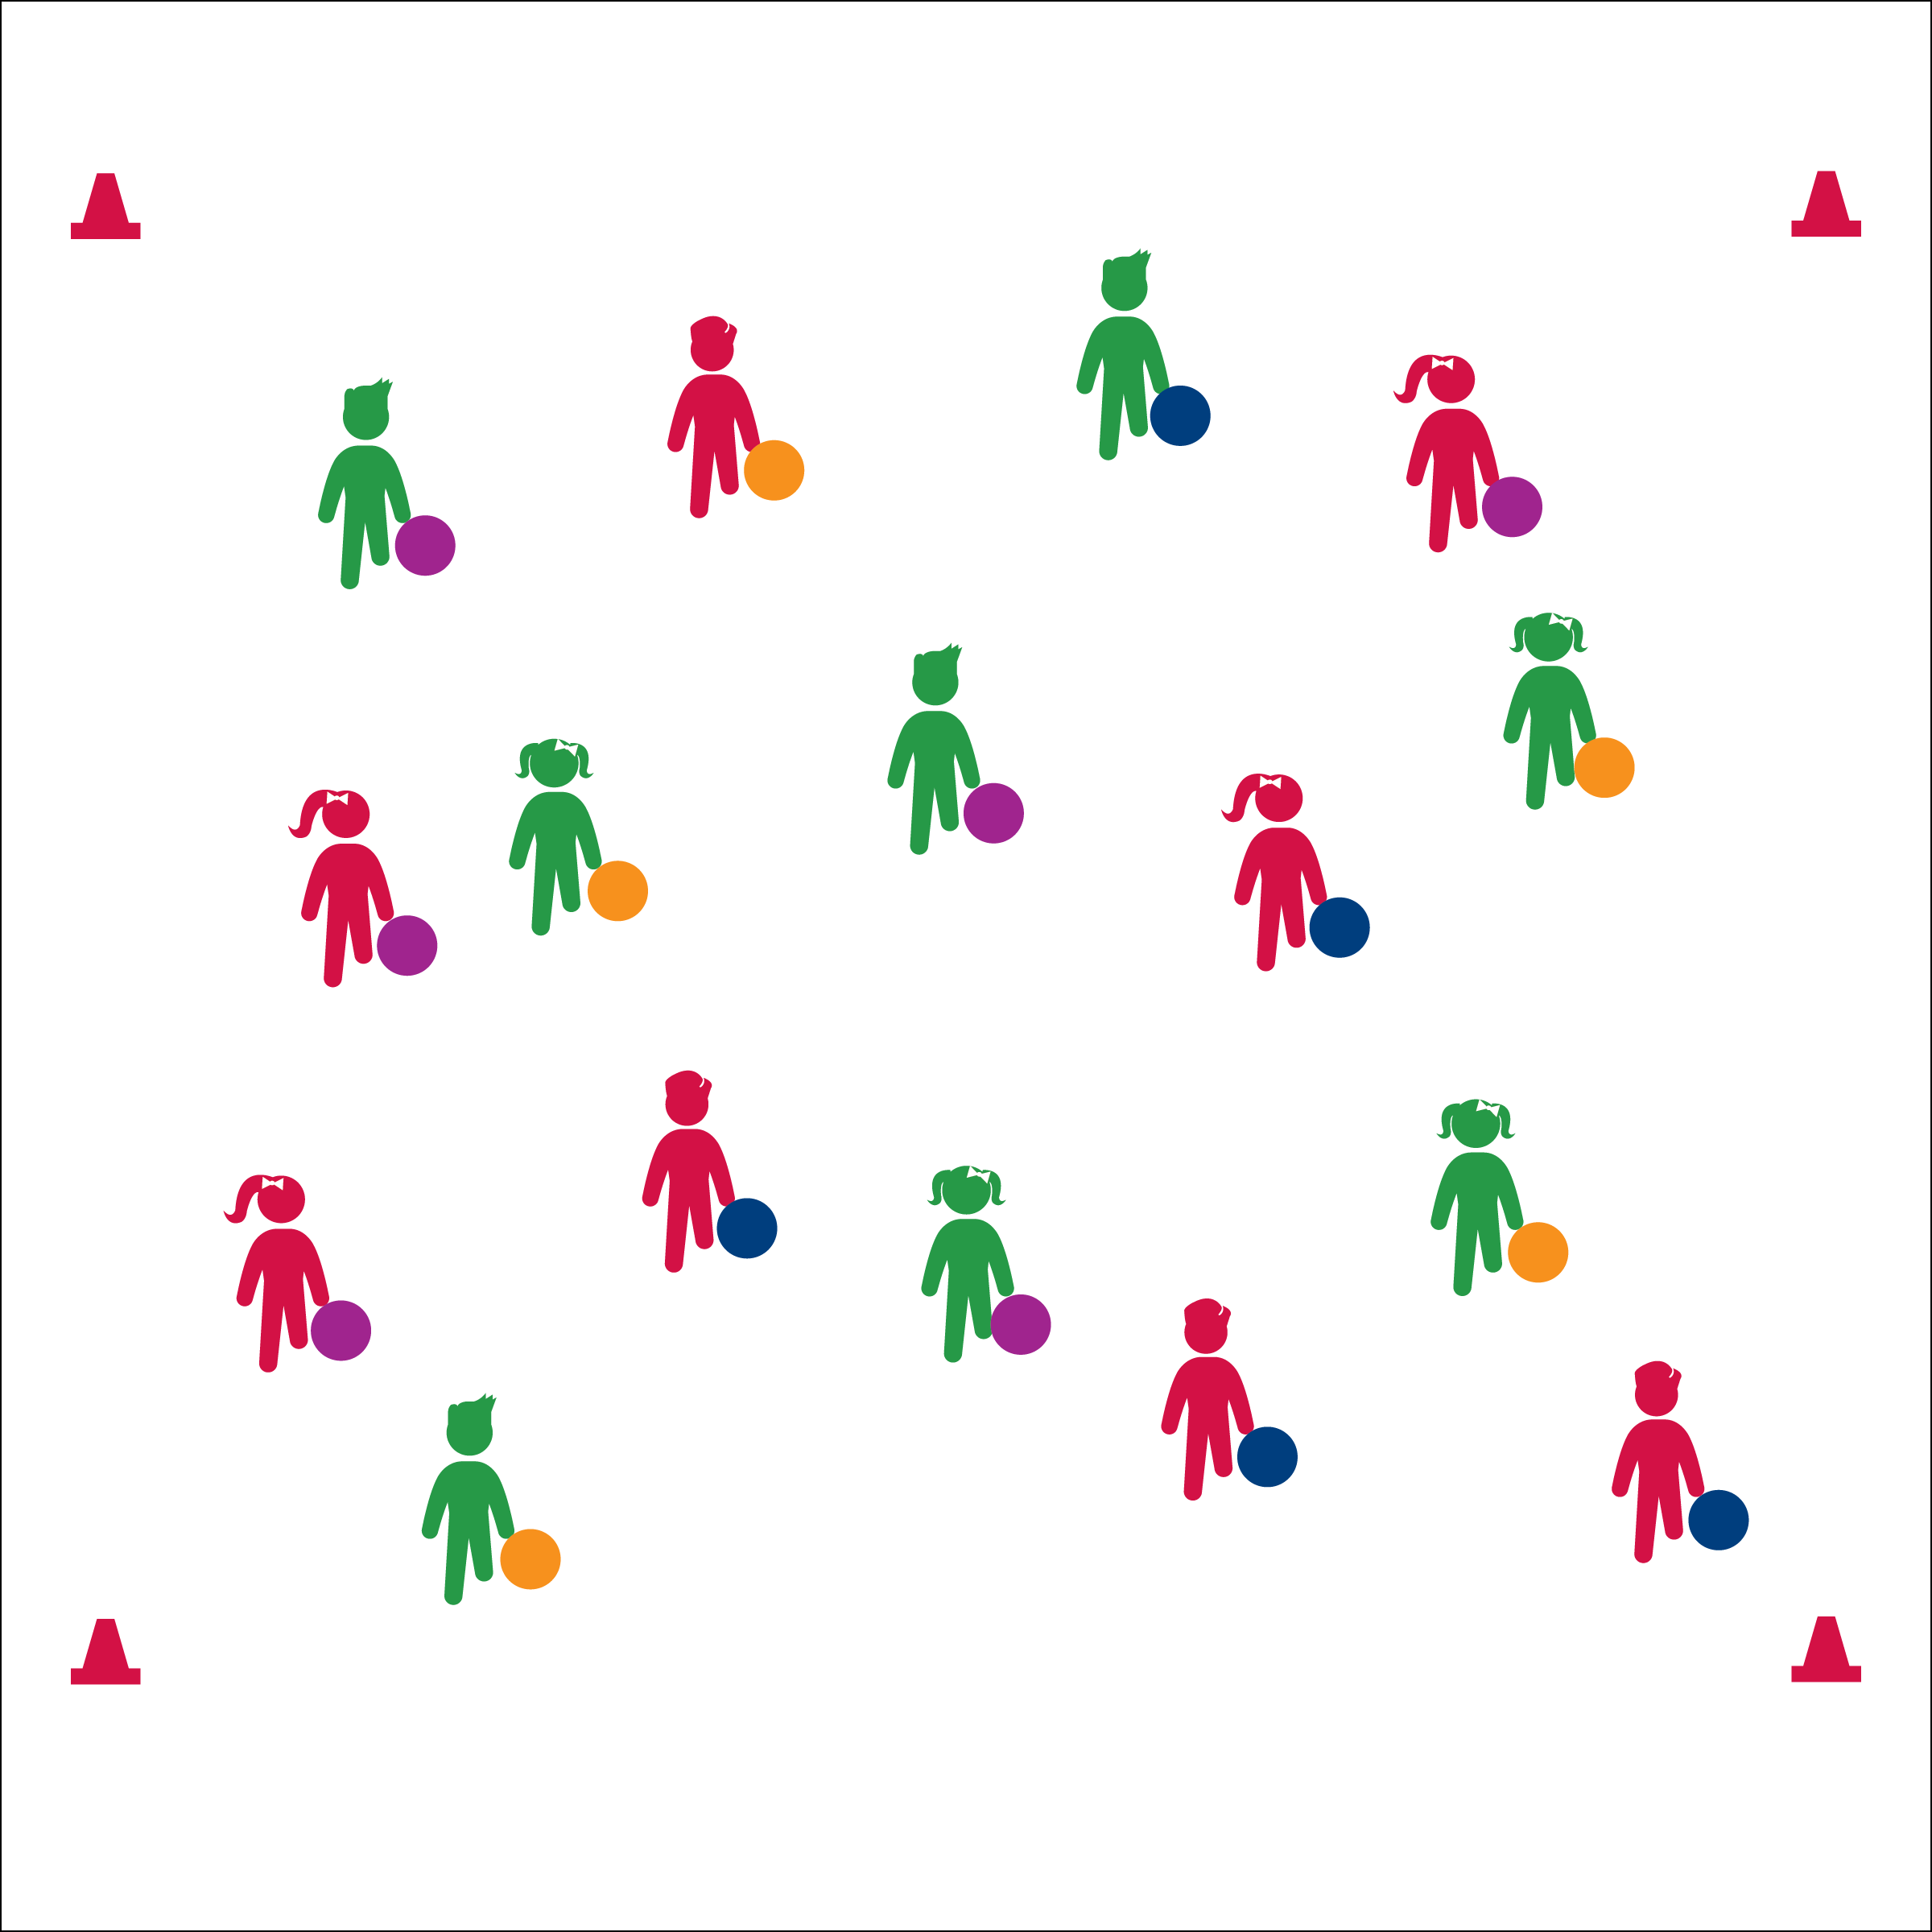

* **Skill:** I will use helpful touches in order to keep foam balls rolling.
* **Cognitive:** I will discuss the importance of aerobic capacity.
* **Fitness:** I will pace my activity so that I work within my target heart rate zone.
* **Personal & Social Responsibility:** I will show respect for my classmates by demonstrating helpful touches.
* Roll, Move, Roll, Repeat
* Helpful Touches
* Need Help? Yes, Please.
* Thanks! No Problem.

**FREE FOAM BALL FITNESS**

**Equipment:**

* 1 ball per student
* 4 large cones to create boundaries

**Set-Up:**

1. Create a large activity area using 4 cones.
2. Students scattered in the activity area, each with a foam ball.

**Activity Procedures:**

1. Today’s Plug & Play Fitness activity is called Free Foam Ball Fitness. The object of the game is to keep your foam ball moving around the activity area. You’ll also help your classmates keep theirs moving with helpful touches.
2. On the “GO!” signal, roll your ball on the floor. Continue to follow it in order to keep it moving.
3. If you move by another foam ball that needs help, you can roll it for your classmate. Use cooperative language like, “need a little help?” and, “Thanks for the help!”
4. Continue until you hear the stop signal.

**Grade Level Progression:**

**3rd:** Play the game as described.

**4th & 5th:** All students hold plank position. Students push foam balls from player to player in order to keep them moving. If a ball moves into empty space, students must bear walk to retrieve and start the ball again.

**FREE FOAM BALL FITNESS**



* Students use noodles or floor hockey sticks to reach and move foam balls.
* Decrease the number of foam balls. Students work cooperatively.



Aerobic Capacity, Muscular Endurance, Muscular Strength, Vigorous



* **Standard** **3 [E2.3-5]** Engages in the activities of physical education class without teacher prompting (3); Actively engages in the activities of physical education class, both teacher-directed and independent (4); Actively engages in all the activities of physical education (5).
* **Standard 3 [E5.3]** Demonstrates, with teacher direction, the health-related fitness components (3).



* **DOK 1:** How can you recognize a game, sport, or activity that helps build or maintain aerobic capacity?
* **DOK 2:** How did your health-related fitness affect your ability to play Free Foam Ball Fitness?
* **DOK 3:** How would you change this game to make it more or less vigorous?



**Helps students elaborate on content.** Allowing students to modify activities to make them more or less vigorous allows them to think critically about what they experienced in physical education class and elaborate on learned information in a context they are familiar with. If time allows, let students try their modifications and then discuss the results.

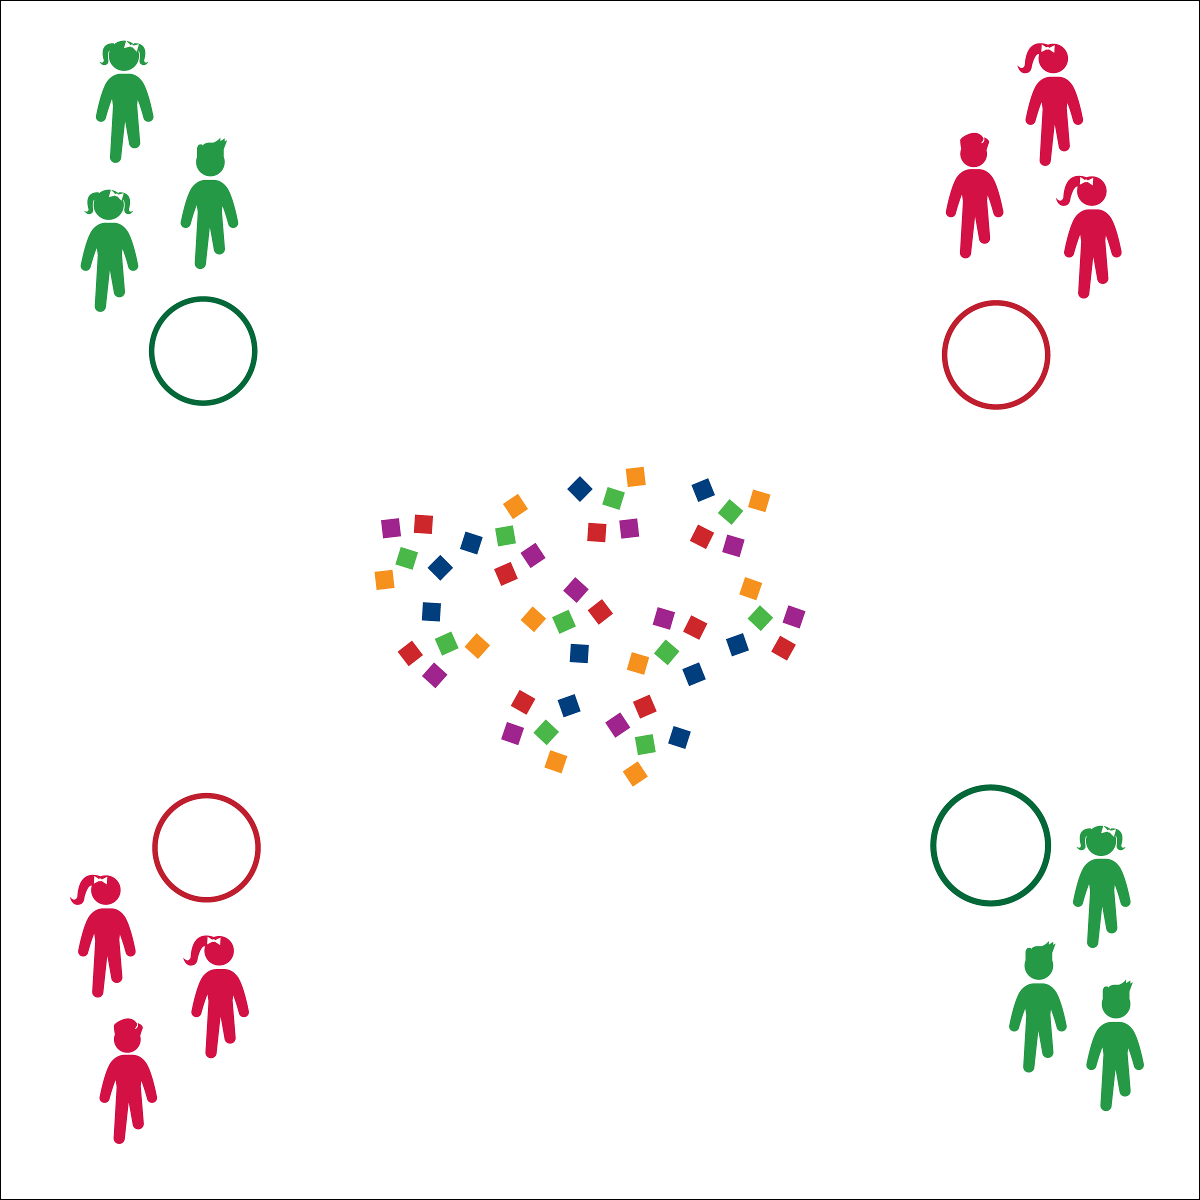

* **Skill:** I will move safely within the activity area by maintaining balance at a safe speed.
* **Cognitive:** I will discuss the importance of regular physical activity.
* **Fitness:** I will pace my activity so that I work within my target heart rate zone.
* **Personal & Social Responsibility:** I will follow the rules for Aerobic Treasure Grab without the need for teacher reminders.

**AEROBIC TREASURE GRAB**

* Move Safely
* 1 Bean Bag at a Time
* Place Bean Bags (Don’t Toss)

**Equipment:**

* 24–48 bean bags
* 1 hoop per group of 2–4 students

**Set-Up:**

1. Use hoops to create activity boundaries and home-base areas for each team.
2. Scatter bean bags in the center of the activity area.
3. Create even teams of no more than 4 players per team, each team behind each hoop.

**Activity Procedures:**

1. Today’s Plug & Play Fitness activity is called Aerobic Treasure Grab.
2. The object of the activity is to collect as many bean bag treasures in your hoop as you can.
3. You’ll do that in a relay-race format with 1 teammate collecting 1 bean bag at a time from the activity area. As soon as each player returns, the next player moves to collect the next bean bag. Students waiting for a turn will perform an aerobic exercise.
4. Once all beanbags have been collected from the center of the activity area, teams can move to other teams’ hoops to “steal” their treasures. You cannot guard your hoop.
5. Freeze when you hear the stop signal.

**Grade Level Progression:**

**3rd:** Begin at a skipping or galloping pace.

**4th & 5th:** Allow students to move at a more vigorous pace.

**AEROBIC TREASURE GRAB**



* Students travel in pairs, working cooperatively to grab bean bags.
* Use a variety of objects as treasures, allowing for student preference, skill, and ability.



Aerobic Capacity, Actively Engage, Active Lifestyle, Sedentary Lifestyle, Vigorous



* **Standard 3 [E2.3-5]** Engages in the activities of physical education class without teacher prompting (3); Actively engages in the activities of physical education class, both teacher-directed and independent (4); Actively engages in all the activities of physical education (5).
* **Standard 3 [E5.3]** Demonstrates, with teacher direction, the health-related fitness components (3).



* **DOK 1:** Can you remember the reasons why it’s important to be physically active every day?
* **DOK 2:** How would you compare and/or contract an active lifestyle with a sedentary lifestyle?
* **DOK 3:** Would you consider your lifestyle active or sedentary? Can you support your choice with specific examples?



**Help students examine similarities and differences.** Guide students through the process of classifying and comparing sedentary routine activities and active habits. This strategy can help students think deeply about their own lifestyle habits and choices and draw conclusions about how they can improve their daily and weekly routines.

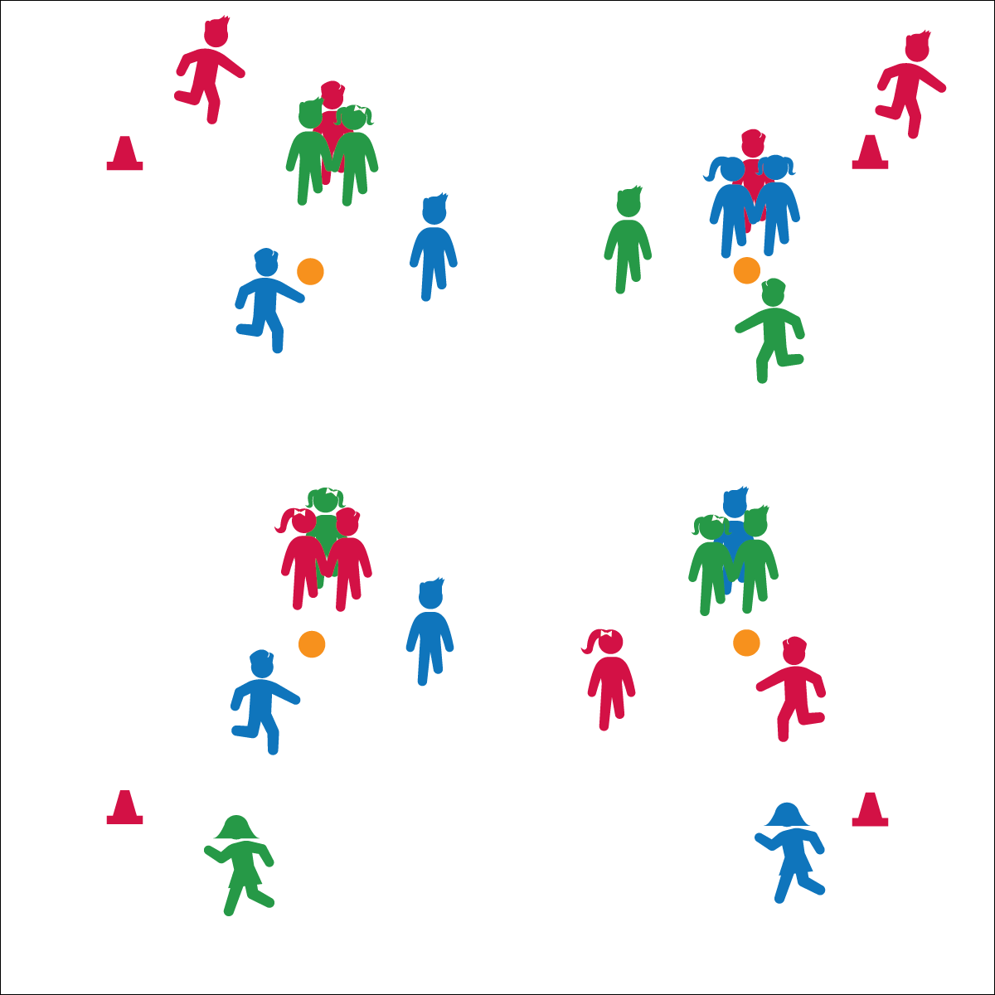

**Activity Procedures:**

1. Today’s Plug & Play Fitness activity is called Team Triangle Tag.
2. The object of the activity is for each scoring team to tag the target player as many times as possible before the loop runner has completed 1 jogging loop.
3. Each game has 3 teams playing against each other. Team 1 is the scoring team; player A is the tagger and player B is the scorekeeper. Team 2 is the fleeing team; player C is the target player and player D is the loop runner. Team 3 is the shielding team; both players are trying to keep the scoring team from tagging the target player. They will hold hands with the target player to form a triangle, and they will rotate to shield her/him from the tagger.
4. On the start signal, the loop runner begins running, and the tagger starts to chase the target player. When the Loop runner returns, rotate team and player roles.

**Grade Level Progression:**

**3rd:** Begin by teaching Triangle Tag without the loop runner. Introduce loops after students have mastered Triangle Tag.

**4th & 5th:** Play the activity as described above.

* **Skill:** I will move safely within the activity area by maintaining balance at a safe speed.
* **Cognitive:** I will discuss the benefits of regular physical activity.
* **Fitness:** I will pace my activity so that I work within my target heart rate zone.
* **Personal & Social Responsibility:** I will follow the rules for Team Triangle Tag without the need for teacher reminders.

**TEAM TRIANGLE TAG**

* Safe Tagging Form
* Stay Close to Home Base
* Side-Slide in Athletic Stance

**Equipment:**

* 1 spot marker per 6 students
* 4 large cones

**Set-Up:**

1. Create a large jogging loop using 4 cones.
2. Pairs students into teams of 2. 6 teams will play in each game.
3. Scatter spots inside the jogging loop. These will serve as home bases for the shielding teams and target players.

**TEAM TRIANGLE TAG**



**Help students examine their reasoning.** The debrief questions provided above guide students through the process of examining their own routine reasoning related to activity choices and healthful living. Framed in a context of fun and social benefits, students must produce and defend their own statements related to how and why they maintain an active lifestyle.



* Students hold a scarf or deck ring to connect the triangle rather than holding hands.
* Students jump rope or complete another aerobic exercise for a set amount of time rather than running a loop.



Aerobic Capacity, Jog, Pace



* **Standard 3 [E2.3-5]** Engages in the activities of physical education class without teacher prompting (3); Actively engages in the activities of physical education class, both teacher-directed and independent (4); Actively engages in all the activities of physical education (5).
* **Standard 3 [E5.3]** Demonstrates, with teacher direction, the health-related fitness components (3).



* **DOK 1:** What would you include on a list about active lifestyles?
* **DOK 2:** How can you apply what you’ve learned in physical education to develop or maintain an active lifestyle?
* **DOK 3:** How is an active lifestyle related to having fun with your friends and family?

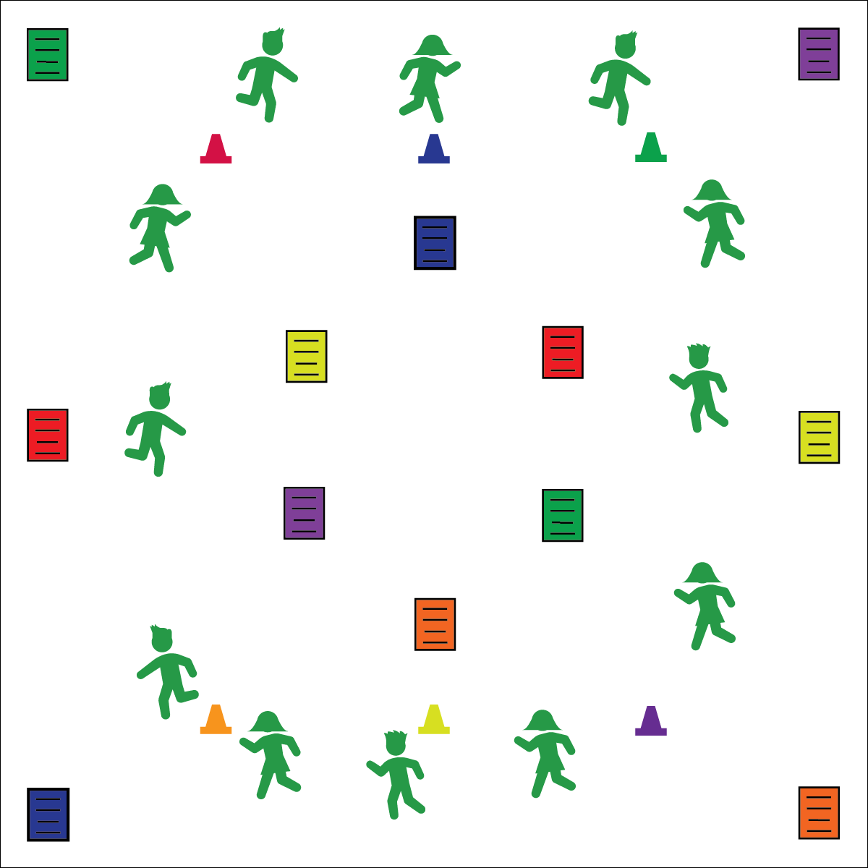

* Focus on Form
* Pace Your Jog
* Crush the Exercise

**COLOR CRUSHERS**

* **Skill:** I will demonstrate perfect exercise form.
* **Cognitive:** I will discuss the importance of perfect exercise form.
* **Fitness:** I will pace my activity so that I work within my target heart rate zone.
* **Personal & Social Responsibility:** I will work independently with a focus on improving my fitness.

**Equipment:**

* 1 set of 6-color cones
* 4 sets of Color Crusher exercise posters

**Set-Up:**

1. Create a large jogging loop using 6-color cones.
2. Post 6-color exercise posters in visible areas throughout the activity area and on the walls.
3. Students scattered around the jogging loop.

**Activity Procedures:**

1. Today’s Plug & Play Fitness activity is called Color Crushers.
2. The object of the activity is for you to crush (i.e., complete) the exercise listed on the exercise posters.
3. When the music starts, everyone will begin jogging around the loop.
4. When the music stops and you hear a color signal (e.g., “BLUE!”), move quickly to a poster and perform the exercise listed.
5. When the music restarts, begin jogging around the loop.

**Grade Level Progression:**

**3rd & 4th:** Play the activity as described above.

**5th:** Provide students with blank exercise posters. Prompt them to create new posters with a focus on all health-related components of fitness.

**COLOR CRUSHERS**



* Create custom exercise posters that meet the needs of all of your students.
* Provide a variety of demonstrations and cues to help students experience perfect exercise form.
* Allow students to move around the jogging loop using different locomotor activities, scooters, or wheelchairs.



Aerobic Capacity, Flexibility, Exercise Form, Dynamic Stretching, Muscular Fitness



* **Standard** **3 [E2.3-5]** Engages in the activities of physical education class without teacher prompting (3); Actively engages in the activities of physical education class, both teacher-directed and independent (4); Actively engages in all the activities of physical education (5).
* **Standard 3 [E5.3]** Demonstrates, with teacher direction, the health-related fitness components (3).



* **DOK 1:** What is exercise form?
* **DOK 1:** How can you recognize perfect exercise form?
* **DOK 2:** How does exercise form affect how you benefit from the exercises you perform?
* **DOK 3:** What might happen if a person performed an exercise with poor exercise form?
* **DOK 4:** What would we include on a practice plan designed to help us improve our exercise form?



**Identify critical content.** Exercise form is critical to both safety and effectiveness of all fitness exercises. This activity provides an important opportunity to identify and focus on exercise form. Describe, demonstrate, and discuss critical cues for each exercise performed, and then debrief based on student experience and understanding.

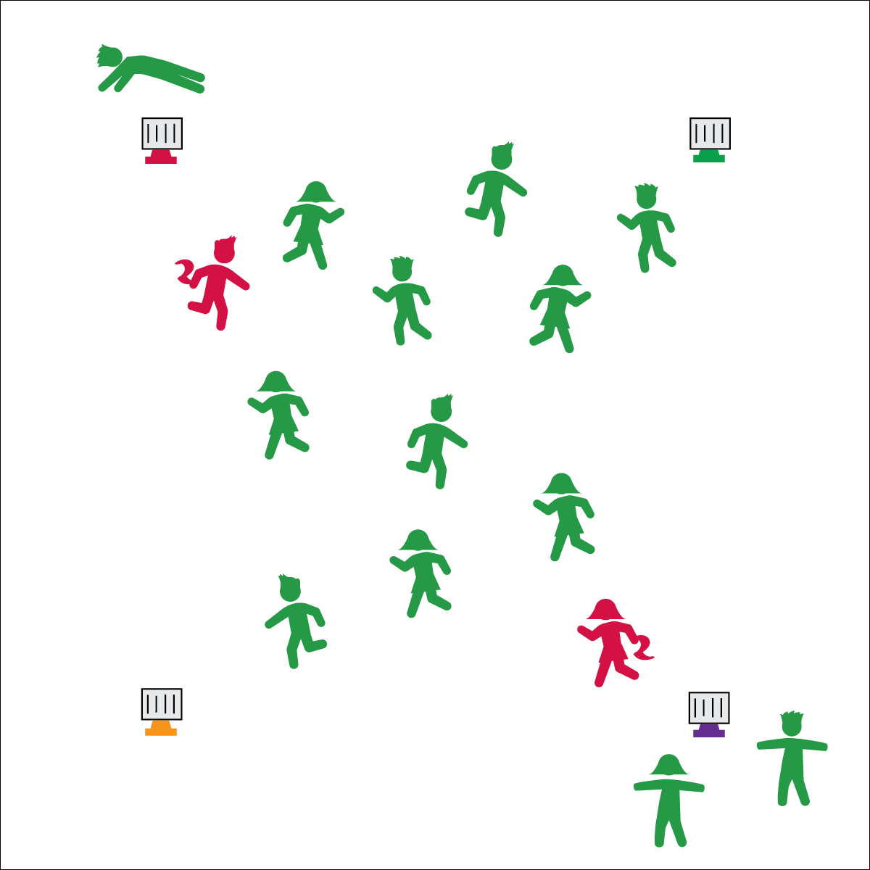

* **Skill:** I will demonstrate perfect form during each core balance stunt.
* **Cognitive:** I will discuss the importance of core strength.
* **Fitness:** I will pace my activity so that I work within my target heart rate zone.
* **Personal & Social Responsibility:** I will follow the rules for Core Balance Tag without the need for teacher reminders.

**CORE BALANCE TAG**

* Safe Tagging Form
* Controlled Balance for Safety

**Equipment:**

* 4 large cones
* 4 Task Tents
* 4 Core Balance Charts
* 2 scarves or pinnies

**Set-Up:**

1. Create a large activity area using 4 large cones.
2. Place charts and task tents on the cones to designate balance areas.
3. Scatter students throughout the activity area.
4. Give 2 students scarves or pinnies to identify them as taggers.

**Activity Procedures:**

1. Today’s fitness activity is called Core Balance Tag. It will help us work on aerobic capacity, flexibility, and core muscular endurance.
2. The object of the activity is to avoid being tagged by the taggers. If you are tagged, you will move to a balance area, perform a core balance stunt, and hold it until a classmate comes and mirrors your pose.
3. Once a classmate mirrors your pose, you may return to the game of tag.
4. Start at a skipping pace.

**Grade Level Progression:**

**3rd & 4th:** Play the activity as described above.

**5th:** Provide students with blank Core Balance Charts. Prompt them to create new charts with a focus on muscular fitness and flexibility.

**CORE BALANCE TAG**



* Create custom Core Balance Charts that meet the needs of all of your students.
* Provide a variety of demonstrations and cues to help students experience perfect exercise form.
* Provide “balance coaches” at each balance area to provide instruction and assistance to students who need it.



Balance, Base of Support, Control, Core, Muscular Endurance



* **Standard** **3 [E2.3-5]** Engages in the activities of physical education class without teacher prompting (3); Actively engages in the activities of physical education class, both teacher-directed and independent (4); Actively engages in all the activities of physical education (5).
* **Standard 3 [E5.3]** Demonstrates, with teacher direction, the health-related fitness components (3).



* **DOK 1:** What is core strength?
* **DOK 2:** How does core strength affect your ability to play and have fun with your friends? How does it affect your ability to help your family with chores at home?
* **DOK 3:** How is core strength related to good posture?
* **DOK 3:** Why is it important to have good posture? Can you support your answer with specific examples?



**Manage response rates with tiered questioning techniques.** All of the questions provided in the debrief sections of OPEN activity plans are designed with ascending cognitive complexity in order to help deepen students’ thinking about fitness concepts. Continue to advance through each Depth of Knowledge (DOK) level until students have difficulty with their responses. At that point, guide them through the discussion and make note of which level to aim for in the discussion section of future lessons.

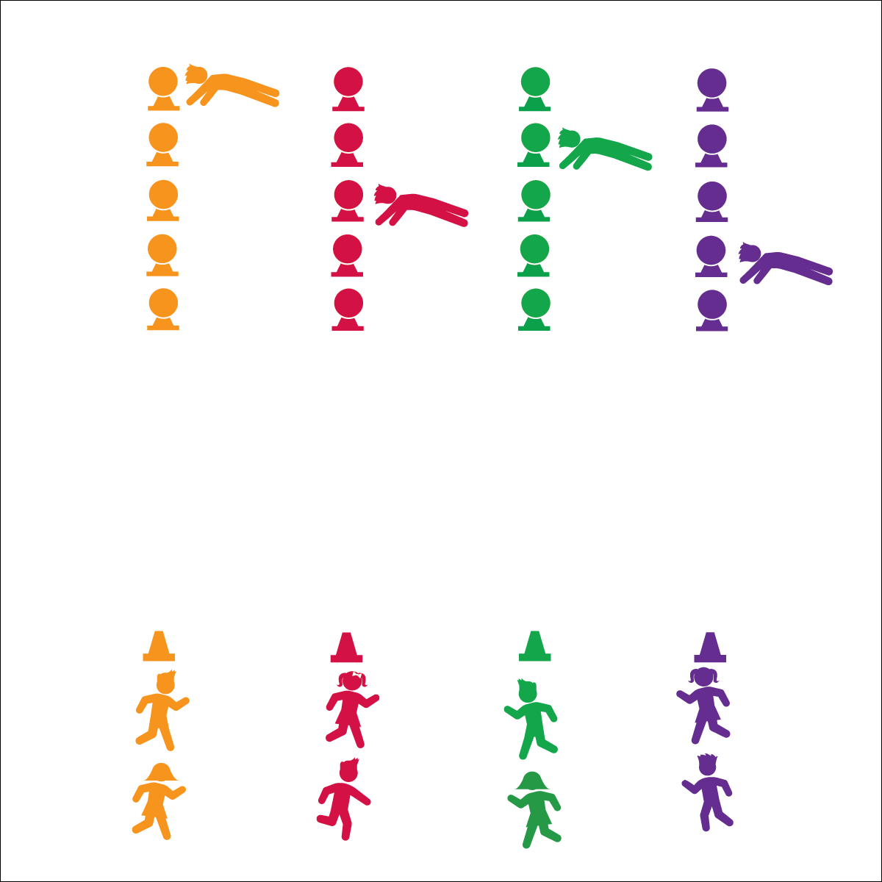

**PLANK-TAP RELAY**

* **Skill:** I will demonstrate perfect exercise form.
* **Cognitive:** I will discuss the benefits of planks.
* **Fitness:** I will pace my activity so that I work within my target heart rate zone.
* **Personal & Social Responsibility:** I will demonstrate teamwork by completing plank-taps quickly and with perfect form.
* Proper Planks
* Control Your Taps

**Equipment:**

* 1 large cone per group of 2–3 students
* 5 low-profile cones per group of 2–3 students
* 5 foam balls (or bean bags) per group of 2–3 students

**Set-Up:**

1. Create 1 relay race line per group using the large cone as the group’s home base.
2. 20 meters from home base, place 5 low-profile cones 1 meter apart with a foam ball balanced on top of each cone.
3. Create teams of no more than 3 students per relay line. Each team at a home base.

**Activity Procedures:**

1. Today’s activity is called Plank-Tap Relay. The object is for our class to collect as many plank-taps as we can. This activity is done in a relay-race format.
2. On the start signal, the first person in each line will run to the end of the row of foam balls, get into plank position, and tap the top of each foam ball with both hands (first left, then right). They will advance through all 5 foam balls before running back and giving a high-5 to the next person in line.
3. Begin on the start signal. Continue through your line until you hear the stop signal, repeating as many times as you can.

**Grade Level Progression:**

**3rd & 4th:** Introduce the activity such that students move to the foam balls, perform squats and tap each ball per squat, and then return to their line. When students have mastered this format, introduce plank-taps.

**5th:** Prompt students to create their own fitness relays.

**PLANK-TAP RELAY**



Core, Exercise Form, Muscular Fitness, Muscle Tone, Plank



* Substitute planks with exercises that meet the needs and abilities of your students.
* Change locomotor movements to meet the skills and abilities of your students.
* Substitute foam balls with larger or smaller objects.



* **Standard 3 [E2.3-5]** Engages in the activities of physical education class without teacher prompting (3); Actively engages in the activities of physical education class, both teacher-directed and independent (4); Actively engages in all the activities of physical education (5).
* **Standard 3 [E5.3]** Demonstrates, with teacher direction, the health-related fitness components (3).



* **DOK 1:** How can you recognize good plank position?
* **DOK 2:** What do you notice about your muscles when you hold plank position?
* **DOK 3:** Can you describe what happens to different muscles in your body when you hold plank position? Use specific examples. (E.g., What happens to your arms? Your core?)



**Organize students to interact with content.** Plug & Play Fitness activities are designed to be done on a regular basis throughout the school year. For example, you could begin one lesson per week with a Plug & Play activity. This ensures that fitness will remain a focus for both you and your students. Be creative and modify the activities to include elements of whatever unit or topic you’re currently teaching. For example, if you are in a floor hockey unit, students can stick-dribble a ball or puck down to the foam balls, perform plank taps, and then stick-dribble back to their teams. Be creative and have fun while you keep the focus on fitness concepts.