­­­

* Core
* Exercise Form
* Muscular Fitness
* Muscle Tone
* Plank

­

* **Skill:** I will demonstrate perfect exercise form.
* **Cognitive:** I will discuss the benefits of planks.
* **Fitness:** I will pace my activity so that I work within my target heart rate zone.
* **Personal & Social Responsibility:** I will demonstrate teamwork by completing plank-taps quickly and with perfect form.

*Replace the skill target above with the skill target from a skill-based activity plan…*

* **Standard** **3 [E2.3-5]** Engages in the activities of physical education class without teacher prompting (3); Actively engages in the activities of physical education class, both teacher-directed and independent (4); Actively engages in all the activities of physical education (5).
* **Standard 3 [E5.3]** Demonstrates, with teacher direction, the health-related fitness components (3).
* *List at least 1 standard from a skill-based activity plan…*
* Plug & Play Fitness DOK Exit Slips

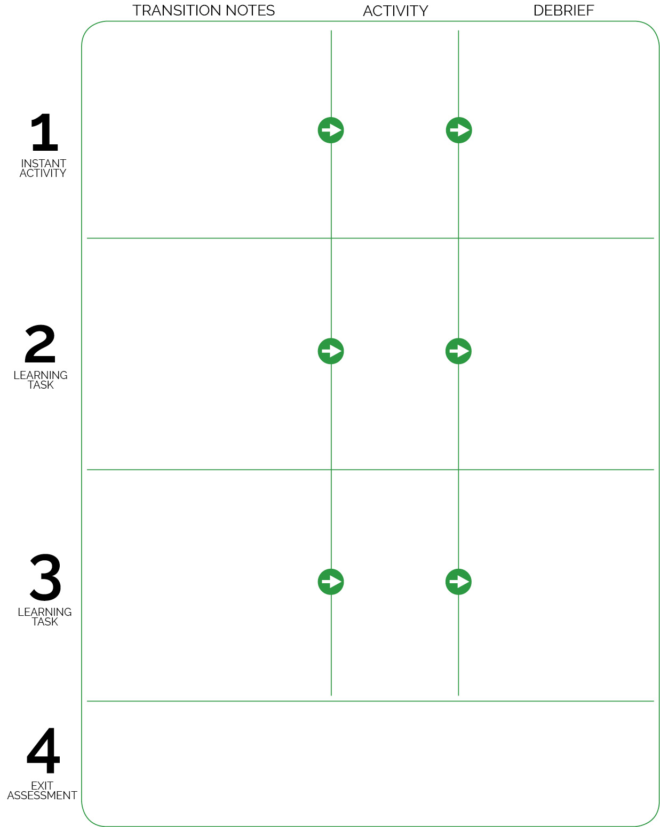

Students complete Plug & Play Fitness DOK Exit Slips.

Debrief is focused on skill-based concepts.

As students enter the activity area, they move to a relay line and begin to practice “perfect” plank form. Maximum of 3 students per relay line.

**DOK 1:** How can you recognize good plank position?

**DOK 2:** What do you notice about your muscles when you hold plank position?

Students transition to skill-based activities. This space is purposely left for you to complete in order to highlight the intended use of Plug & Play activities. This is not a module meant to be done together and in sequence; rather, each Plug & Play activity is meant to be embedded into your skill-based modules throughout the school year.

Transition notes for the next skill-based activity.

Debrief is focused on skill-based concepts.

Choose an activity from your current skill-based module.

Choose an activity from your current skill-based module.

Plank-Tap Relay