­­

**BUBBLE WINDOW**

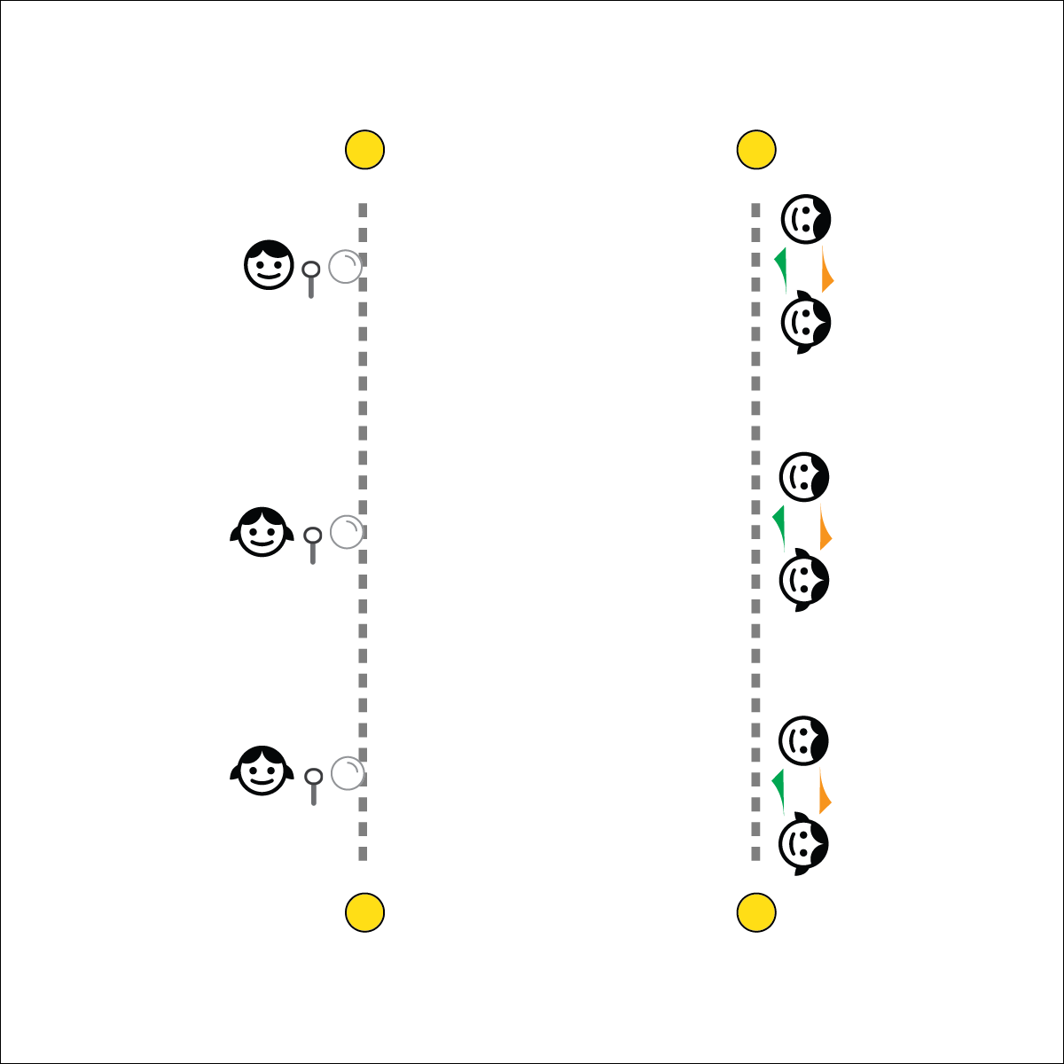

**Activity Procedures:**

1. It’s Active Classroom time! Today’s 1-Minute Challenge is called Bubble Window. One player in your group will start with the bubbles at one end of the area. The other 2 players will be at the other end of the area working together to hold the ends of the scarves to make a square window.
2. The object of the challenge is to blow a bubble at the starting line and then continue to blow on it so that it travels to the other end and through your team’s window. If the bubble pops, return to the starting line and try again. You have 1-minute to get a bubble through your window.
3. TEACHER NOTES:
   * This is a cooperative activity that takes patience and practice. Allow teams several minutes (and possibly a couple of days) to practice this task before starting the timed challenge. Emphasize communication and teamwork as fundamental relationship skills.

**Academic Language Focus:**

* **Teamwork** (noun) The combined action and effort of a group of people working toward a goal or purpose.
* Jess, Joey, and Ollie demonstrated great teamwork and completed the Bubble Window challenge.



**Communication (Relationship Skills)**

Timed challenges that require teamwork can often provide an environment for students to learn and practice positive communication skills. In these situations, it’s important for teachers to demonstrate patience and allow students to work through the process of trial and error as they strive toward cooperative success and improved communication.

**Teamwork (Relationship Skills)**

This challenge is a fun opportunity for students to experience the challenges and benefits of being a good teammate. Take the time to debrief, allowing students to express joys and frustrations as they process what it means to be a good teammate.

**Equipment:**

* 1-Minute Challenge music or stopwatch  
  ([iTunes](https://itunes.apple.com/us/album/1-minute-challenges/631219187), [Apple Music](https://itunes.apple.com/us/album/1-minute-challenges/631219187), [Spotify](https://open.spotify.com/album/1XZQC0B2bRVRp4MVNcDWRh))
* 2 scarves per team
* 1 bottle of bubbles per team
* Spot markers, cones or tape to mark floor lines

**Set-Up:**

1. Using floor markers, create lines approximately 15 feet apart (experiment with distance and time to complete the challenge).
2. Create teams of 3 students, each team with 2 scarves and a bottle of bubbles.



**Depth of Knowledge (DOK) Tiered Question Sets:**

* **DOK 1:** What would you include on a list about teamwork?
* **DOK 2:** How did you apply teamwork to the Bubble Window challenge?
* **DOK 3:** How is communication related to teamwork?
* **DOK 4:** It’s important to practice the skills we want to develop. Create a daily practice plan to help you improve your communication skills.