­­

**WADDLE RACE**

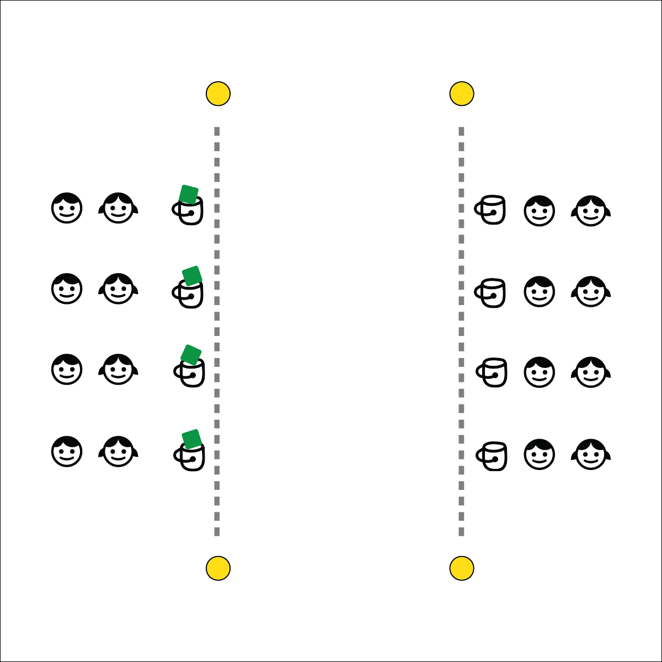



**Depth of Knowledge (DOK) Tiered Question Sets:**

* **DOK 1:** How would you describe Spirit of the Game?
* **DOK 2:** How can Spirit of the Game be applied to the Waddle Race?
* **DOK 3:** How is Spirit of the Game related to academic achievement?
* **DOK 4:** What information/examples can you gather to support your ideas about how Spirit of the Game relates to different areas of modern life? (Allow time for discussion.)

**Activity Procedures:**

1. It’s Active Classroom time! Today’s 1-Minute Challenge is called Waddle Race.
2. The object of the challenge is to score waddle laps by walking with your beanbag between your knees and dropping it into the bucket across from you without using your hands. The beanbag must land inside the bucket for a point to be scored.
3. As soon as the beanbag is dropped, the next player in line picks it up and places it between her/his knees and begins to waddle back to the opposite bucket. If a beanbag drops while waddling, pick it up, place it back between your knees and continue.
4. You have 1-minute to score as many waddle laps as you can.
5. TEACHER NOTES:
   * Students bring years of mixed experience with competition into the classroom. They’ve had good role models, and not-so-good role models. With focused guidance and instruction, they can learn to use competition as a way to promote self-improvement and team cohesiveness.

**Academic Language Focus:**

* **Spirit of the Game** (noun) An overarching concept that places the responsibility of fair play on each player. Respect, adherence to rules, and the joy of play are valued over competition.
* Kendra and Jacob really enjoy the waddle race and demonstrate the Spirit of the Game by playing fair, having fun, and respecting their classmates, even when they lose a race.

**Equipment:**

* 1-Minute Challenge music or stopwatch  
  ([iTunes](https://itunes.apple.com/us/album/1-minute-challenges/631219187), [Apple Music](https://itunes.apple.com/us/album/1-minute-challenges/631219187), [Spotify](https://open.spotify.com/album/1XZQC0B2bRVRp4MVNcDWRh))
* 1 beanbag per team
* 2 buckets per team
* Low profile cones or tape to mark floor lines

**Set-Up:**

1. Using cone, create lines approximately 15 feet apart (experiment with distance and time to complete the challenge).
2. Place 2 buckets across from one another on each line.
3. Place beanbags in the buckets on 1 side of the area.
4. Create teams of 4 with 2 students behind each bucket.



**Respect for Others (Social Awareness)**

Spirit of the Game is a concept borrowed from the early pioneers of Ultimate Frisbee. Because there weren’t any officials or referees the participants had to rely on fair play and respect to keep the games flowing smoothly. As educators, we can use this concept to help define how we want our students to perform in the competitive landscape of modern culture. We can’t remove competition from life, but we can prepare students to compete with integrity.