­­

**CARD COLLECTORS**

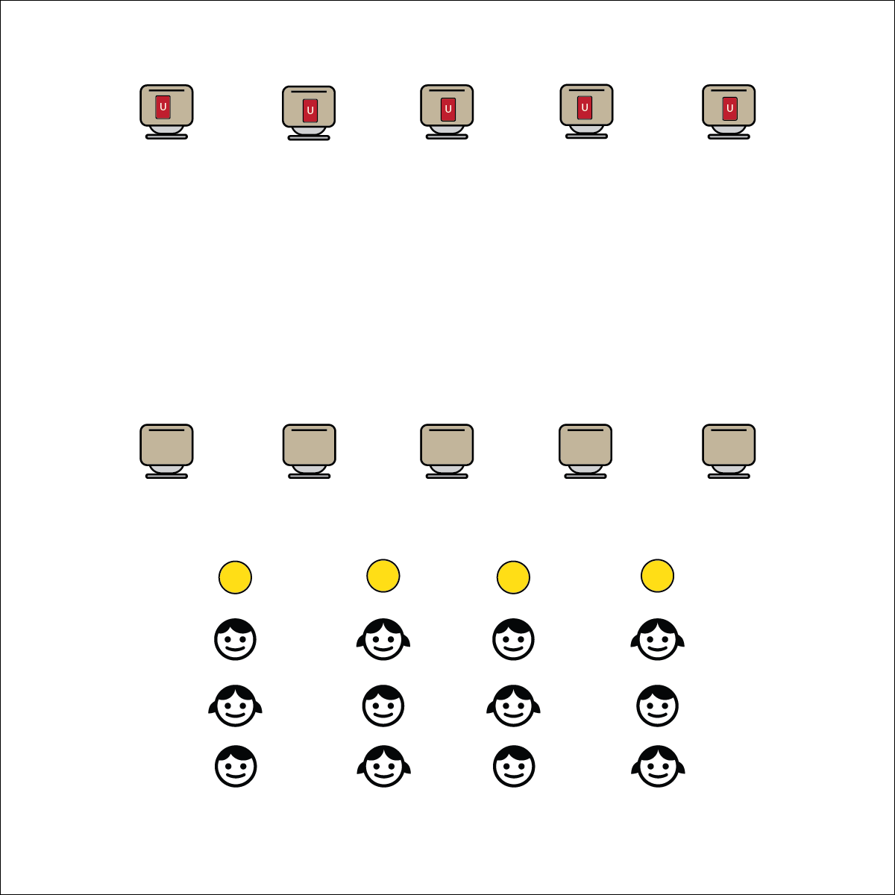

**Activity Procedures:**

1. It’s Active Classroom time! Today’s 1-Minute Challenge is called Card Collectors.
2. The object of the challenge is to work as a team to collect as many cards as you can in 1 minute. On the start signal, the first person in line will speed-walk to the card piles, take 1 card, and then return it her/his team placing the card face down on the spot marker.
3. As soon as the card is on the spot, the next person in line speed-walks to get another card. Continue in relay-race format until you hear the stop signal.
4. You have 1-minute to collect as many cards as you can.
5. TEACHER NOTES:
   * There are several management formats that work well for this activity depending on your classroom. Cards can be in the center of the room with spots laid out in a circle around the cards. Or, the cards can be placed as described above, at one end of the classroom with the students lined up at the other end. The most important aspect of this set-up is safety.

**Academic Language Focus:**

* **Impulse Control** (noun) The ability to overcome a sudden strong urge or unreflective desire in order to control personal actions.
* Kent demonstrated strong impulse control during card collector by walking instead of running to the cards.



**Impulse Control (Self-Management)**

As students try to speed-walk during this activity most of them will find it very difficult to control the impulse to run. (Try it with adults and you’ll find the same challenge.) This is the teachable moment that Card Collectors was designed for! Place the emphasis of your social and emotional instructional time on impulse control. Allow this simple and fun activity to help students develop one of the most important tools in their SEL toolbox.

**Equipment:**

* 1-Minute Challenge music or stopwatch  
  ([iTunes](https://itunes.apple.com/us/album/1-minute-challenges/631219187), [Apple Music](https://itunes.apple.com/us/album/1-minute-challenges/631219187), [Spotify](https://open.spotify.com/album/1XZQC0B2bRVRp4MVNcDWRh))
* 1 or 2 decks of UNO cards
* 1 spot marker per team

**Set-Up:**

1. Pace the UNO cards in 3 or 4 piles at the front of the classroom.
2. Place spot makers equal distance (15 to 20 feet) from the pile of cards.
3. Create teams of 2 to 4 students with students in file lines behind spot markers.



**Depth of Knowledge (DOK) Tiered Question Sets:**

* **DOK 1:** What is impulse control?
* **DOK 2:** How did you apply impulse control during Card Collectors?
* **DOK 3:** How is impulse control related to your academic performance?
* **DOK 4:** Let’s identify a situation in which you have difficulty with impulse control. What would you include on a plan to help you improve impulse control in that situation?