­­

**Warm or Cold**

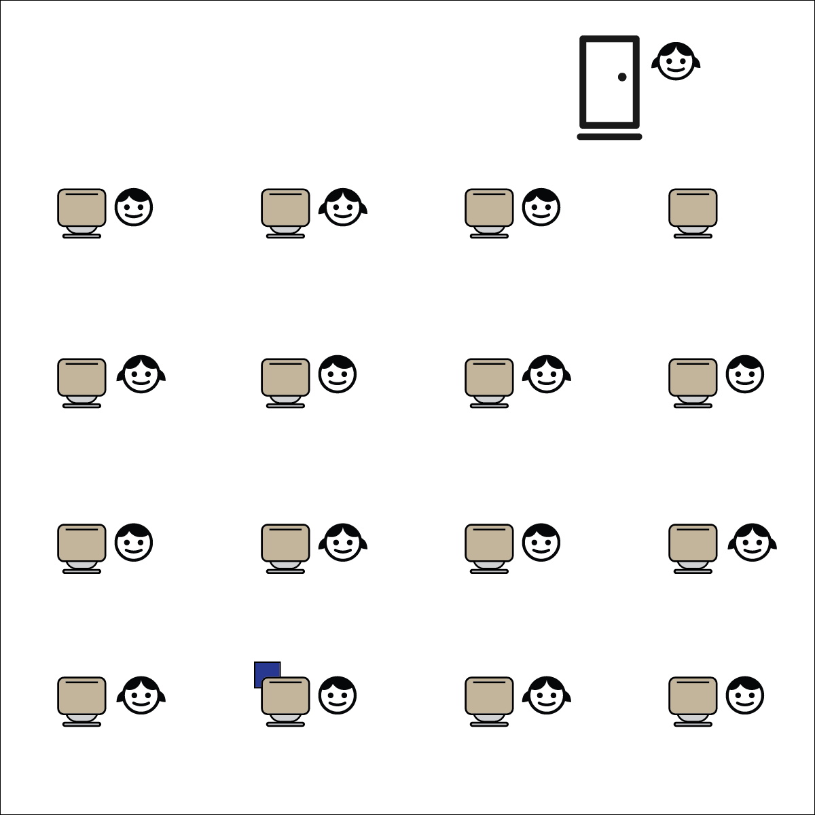[](https://champion.activeschoolsus.org/signup)



**Depth of Knowledge (DOK) Tiered Question Sets:**

* **DOK 1:** In your own words, what does control mean?
* **DOK 2:** What did you notice about the way students control their movements and behavior during Active Classroom time?
* **DOK 3:** How is self-control related to our ability to learn in our classroom?

**Activity Procedures:**

1. It’s Active Classroom Time! We’re going to play a game called Warm or Cold.
2. The object of the game is for the student “seeker” to find the bean bag hidden in the classroom.
3. One student will stand just outside the door while the teacher hides the bean bag. Once the bean bag is hidden, the teacher will call the student back into the room.
4. The students at their desks will indicate whether the “seeker” is warm or cold by either jogging slowly in place (cold), or running quickly in place (warm). The closer the “seeker” gets to the object, the faster the students will move.
5. When the student finds the bean bag, she/he will become the “hider,” and another student will become the “seeker.”
6. TEACHER NOTES:
   * The teacher can be the full-time “hider” if the students aren’t ready to play that role.
   * Any safe object can be hidden for the “seeker” to find.

**Academic Language Focus:**

* **Control** (verb) To manage or regulate the movement or actions of something.
* Prompt student to **control** the speed, balance, and silliness of their movements.



**College & Career Readiness (Speaking & Listening)**

Participate effectively in a range of conversations and collaborations with diverse partners, building on others’ ideas and expressing their own clearly and persuasively.

**College & Career Readiness (Language)**

Acquire and use accurately a range of general academic and domain-specific words and phrases sufficient for reading, writing, speaking, and listening at the college and career readiness level.

**Equipment:**

* 1 bean bag

**Set-Up:**

1. Students stand up next to their desks and push their chairs in.
2. One student will stand just outside the classroom door while the teacher hides the bean bag.