­­

**Fresh Fruit Frenzy**

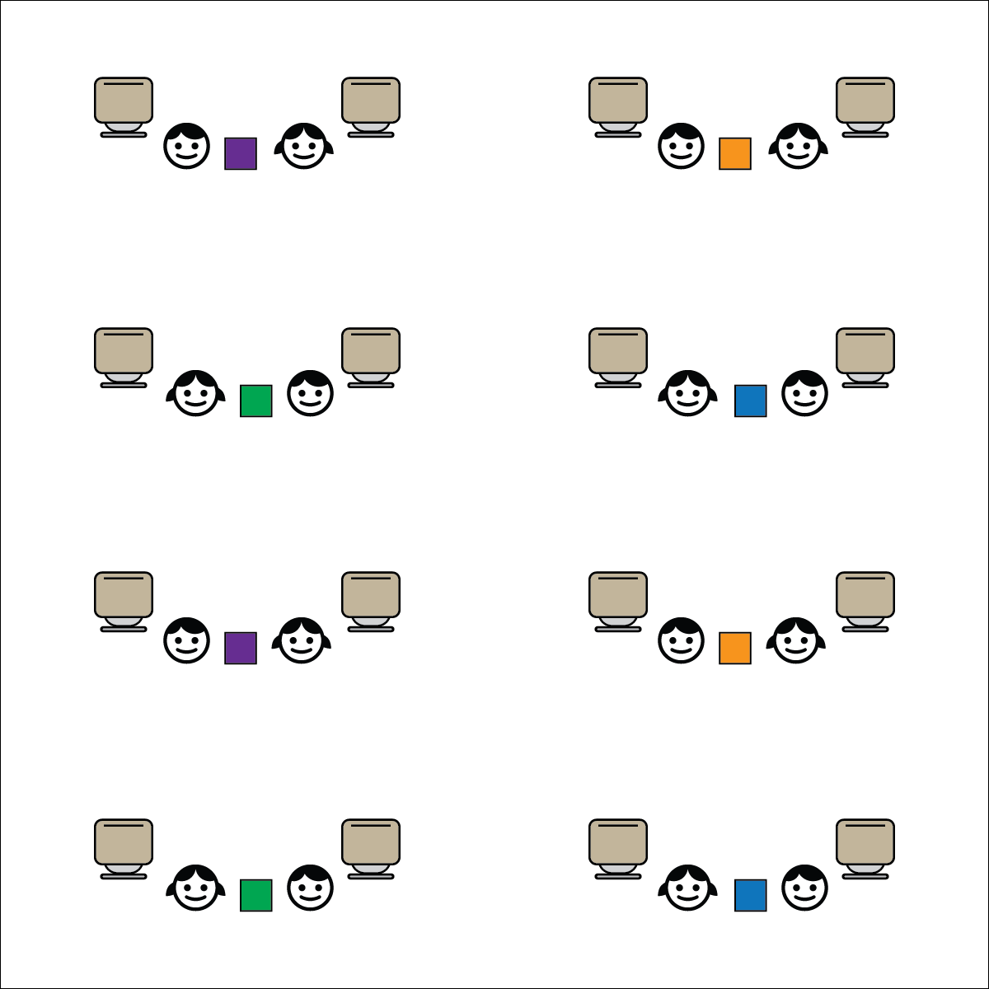[](https://champion.activeschoolsus.org/signup)



**Depth of Knowledge (DOK) Tiered Question Sets:**

* **DOK 1:** How can you recognize safe behavior?
* **DOK 2:** How does being safe affect how much fun we have during Active Classroom time?
* **DOK 3:** How is positive language related to social and emotional safety?
* **DOK 1:** What is an example of a fresh fruit?
* **DOK 2:** What do you know about why eating fruit is important?
* **DOK 3:** How is fresh fruit related to a balanced and complete meal?



**College & Career Readiness (Speaking & Listening)**

Participate effectively in a range of conversations and collaborations with diverse partners, building on others’ ideas and expressing their own clearly and persuasively.

**College & Career Readiness (Language)**

Acquire and use accurately a range of general academic and domain-specific words and phrases sufficient for reading, writing, speaking, and listening at the college and career readiness level.

**Activity Procedures:**

1. It’s Active Classroom Time! We’re going to play a game called Fresh Fruit Frenzy!
2. The object of the game is to grab the fresh fruit (bean bag or scarf) before your partner does.  
   You’ll do that by listening carefully to the music. When it stops, grab the fruit.
3. After each turn, replace the fresh fruit and listen for the music.
4. TEACHER NOTES:
   * Prompt students to move safely and with consideration for others. If a “tug-of-war” starts over the fresh fruit, take a few minutes to emphasize that Active Classroom activities are meant to be fun and active.

**Academic Language Focus:**

* **Safe** (adjective) Protected against physical, social, and emotional harm.
* Focus your feedback on safe participation and positive language.

**Equipment:**

* Music ([Everybody: Hip Hop Public Health](https://hhph.org/resources/everybody/))
* 1 bean bag or juggling scarf per pair

**Set-Up:**

1. Chairs are pushed under desks to provide room for students to sit in aisles or rows.
2. Students in pairs, sitting cross-legged facing each other.
3. Place the bean bag or scarf on the ground in between students.