­­

**MyPlate Dinner Dice**

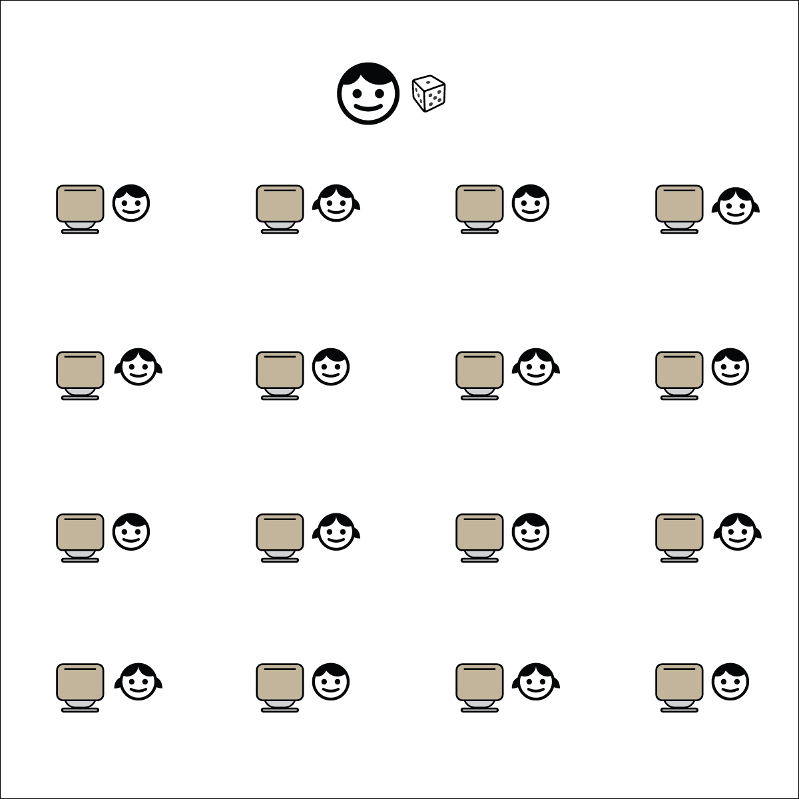[](https://champion.activeschoolsus.org/signup)

**Equipment:**

* Dice
* MyPlate Dinner Dice Chart

**Set-Up:**

1. Students stand up next to their desks and push their chairs in.
2. Teacher with dice (or a single die) at the front of the classroom.
3. Display Dinner Dice Chart on a screen for all to see.

**Activity Procedures:**

1. It’s Active Classroom Time! We’re going to play a game called MyPlate Dinner Dice!
2. I’m going to roll 1 die for each food group, starting with the protein group. Next, I’ll roll it for the grain group, and so on.
3. After each roll, we’ll name a food from that food group and then look at the chart and perform the exercise associated with the number for each specific food group.
4. After we roll 1 time for each food group, we’ll start again. Let’s see how many balanced meals we can build.
5. TEACHER NOTES:
   * Use the MS Word formatted MyPlate Dinner Dice Chart to create custom exercise charts.
   * If you have a 6-color set of dice, use the 5 colors that correspond to each MyPlate food group and roll them all at 1 time.

**Academic Language Focus:**

* **Energy Balance** (noun) The relation between intake of food and output of work that is positive when the body stores extra food as fats and negative when the body draws on stored fat to provide energy for work.



**Depth of Knowledge (DOK) Tiered Question Sets:**

* **DOK 1:** How would you describe energy balance?
* **DOK 2:** How does physical activity affect your energy balance? What about the foods that you choose to eat?
* **DOK 3:** How is energy balance related to good health?



**College & Career Readiness (Speaking & Listening)**

Participate effectively in a range of conversations and collaborations with diverse partners, building on others’ ideas and expressing their own clearly and persuasively.

**College & Career Readiness (Language)**

Acquire and use accurately a range of general academic and domain-specific words and phrases sufficient for reading, writing, speaking, and listening at the college and career readiness level.