­­

**Pass MyPlate**

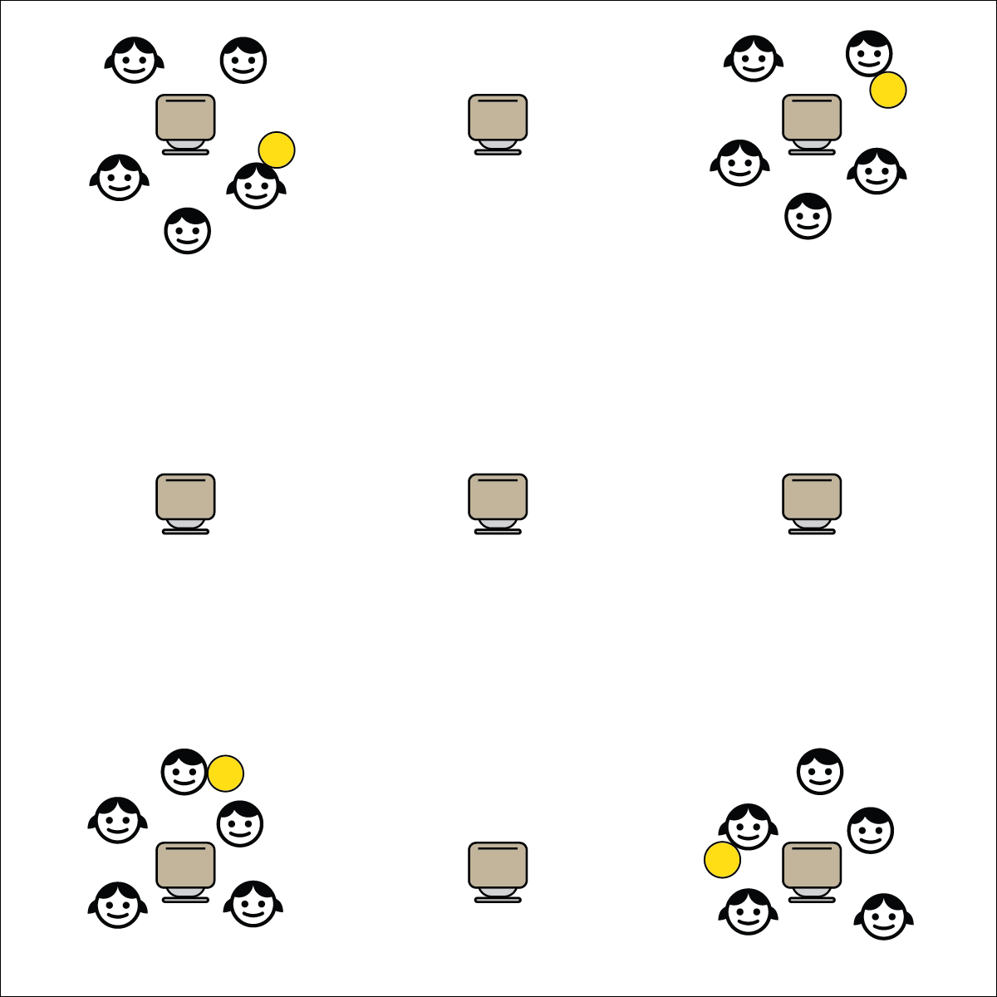[](https://champion.activeschoolsus.org/signup)

**Activity Procedures:**

1. It’s Active Classroom Time! We’re going to tossing a catching game called Pass MyPlate.
2. Each player on your team has been assigned a food group. The object of the game is to pass the ball around our group from player-to-player creating balanced meals with foods from each food group.
3. When you catch the ball, name a food from your food group. Next, pass the ball to a new player and listen for their food and food group.
4. How many balanced meals can you make in 60 seconds?
5. After 1-minute, assign new food groups to each player.
6. TEACHER NOTES:
   * This activity can be played with beanbags, scarves, or any other safe tossable item.

**Academic Language Focus:**

* **Food Group** (noun) A collection of foods that have similar nutritional values. There are 5 MyPlate food groups.
* Food groups are the building blocks of healthful eating. Help students remember and apply knowledge of the 5 food groups.



**Depth of Knowledge (DOK) Tiered Question Sets:**

* **DOK 1:** How can you recognize a balanced meal?
* **DOK 2:** How can you apply what you know about food groups when you’re choosing foods for a healthy meal?
* **DOK 3:** What facts would you select to support the importance of eating balanced meals? Can you elaborate on why you chose those facts?



**College & Career Readiness (Speaking & Listening)**

Participate effectively in a range of conversations and collaborations with diverse partners, building on others’ ideas and expressing their own clearly and persuasively.

**College & Career Readiness (Language)**

Acquire and use accurately a range of general academic and domain-specific words and phrases sufficient for reading, writing, speaking, and listening at the college and career readiness level.

**Equipment:**

* 1 ball per group of 5

**Set-Up:**

1. Students circled in groups of 5 with a clear desk in the center of the group.
2. Assign each student in the group with a food group (Fruits, Vegetables, Grains, Protein, Dairy).
3. Each group with 1 ball.