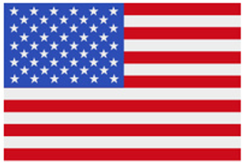
Basketball: Dribble Stoppers

It is time to visit the United States! Basketball is the only major sport that originated strictly in the United States. It was invented by James Naismith in 1891 at what is now known as Springfield College.
Activity Instructions:
- Today’s basketball activity is called Dribble Stoppers. The object of the activity is to dribble through open space while protecting your basketball from defenders.
- On the start signal, students will start dribbling across the activity area to the other side while avoiding the defenders. Defenders must maintain defensive ready position using side-slides and drop-steps to move throughout the activity area.
- If your ball is tagged by a defender (any touch on the ball) or it goes out of bounds, retrieve your ball, place it on the ball rack, and re-enter the game as a defender.
- When all untagged players are safe on the other side of the activity area, we’ll
repeat going in the opposite direction.
- The last remaining student with a ball is the winner!

