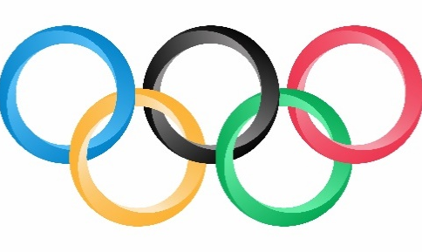
Olympic Rings Relay

The Olympic Rings represent the union of the 5 continents and the meeting of athletes from throughout the world at the Olympic Games. The 5 colors of the rings (blue, yellow, black, green, red) represent the colors of the flags from the original participating countries from the 5 continents.
Activity Instructions:
- This activity is called Olympic Rings Relay. The object is for your team to score points by throwing the disc through the Olympic Ring (hoop) and catch it before it hits the ground.
- All 3 players begin on the start line. Player 1 has the disc, player 2 has the ring, and player 3 is ready to catch the disc. On the start signal, player 2 will hold the ring up as a target.
- Player 1 will stay at the start line and attempt to throw the disc through the ring while player 3 tries to move and catch the disc before it hits the ground.
- Score 2 points if the disc goes through the ring and is caught by player 3.
Score 1 point if the disc does not go through the ring but is still caught by
player 3, or if the throw goes through the ring but is not caught.
- Rotate after each throw: Thrower to holder; holder to catcher; catcher runs
to the start line and becomes the thrower.

