­­

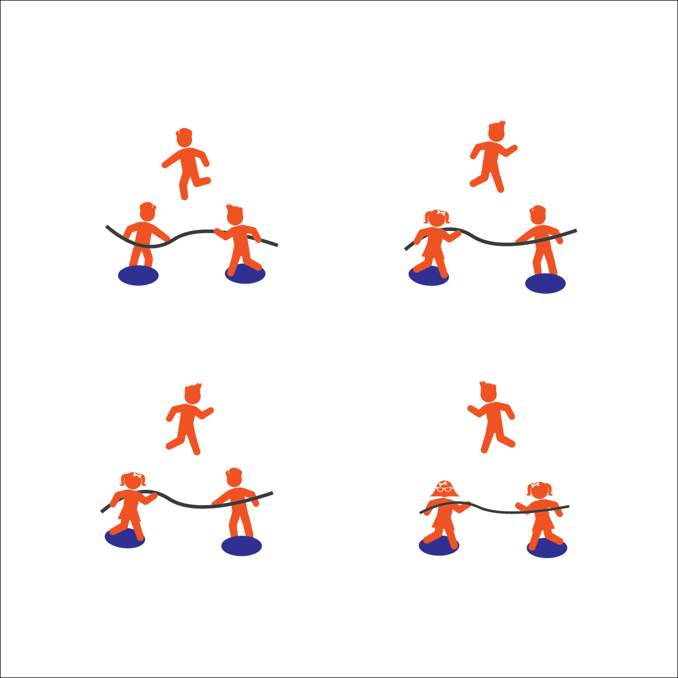



* **Etiquette**(K) Recognizes the established protocol for class activities. (1) Exhibits the established protocols for class activities without reminders. (2) Recognizes the role of rules and etiquette in teacher-designed physical activities. (3) Recognizes the role of rules and etiquette in physical activity with peers. (4) Exhibits etiquette and adherence to rules in a variety of physical activities. (5) Critiques the etiquette involved in rules of various game activities. (6) Identifies the rules and etiquette for physical activities/games and dance activities.

**Activity Procedures:**

1. Today’s activity is called 1 v 1 Tug to Victory. The object of the activity is for you to pull your opponent off of their base while saying on your base.
2. Start the activity with 2 players, each standing on a base and grabbing the rope. Students competing will count down together, "3, 2, 1, GO!" before pulling on the rope.
3. If either player's foot touches the ground off their base/platform, or a player lets go of the rope, the round is over. The 3rd person in the group then replaces the player who stepped off the spot.

**Modifications:**

* Tie a knot on each side of the rope to help students with grip.
* Students must keep 1 or both feet on the spot platform, based on students’ skill and fitness levels.

**Equipment:**

* 1 7–10' rope (or similar) per group of 3 students
* 2 standing bases per group of 3 students (e.g., large spot markers, 1' x 2' board)

**Set-Up:**

1. Create 1 activity station for every 3 students:
   1. 2 standing bases placed so that the distance between them is about 2’ shorter than the rope’s length.
   2. 1 rope extending between the bases.
2. Create groups of 3, each group at a station.

**1 V 1 TUG TO VICTORY**



* **Personal & Social Responsibility:** I will participate respectfully and demonstrate proper etiquette during a competitive activity.
* Bend Knees
* Hold Rope Tightly
* Low Center of Gravity