­­

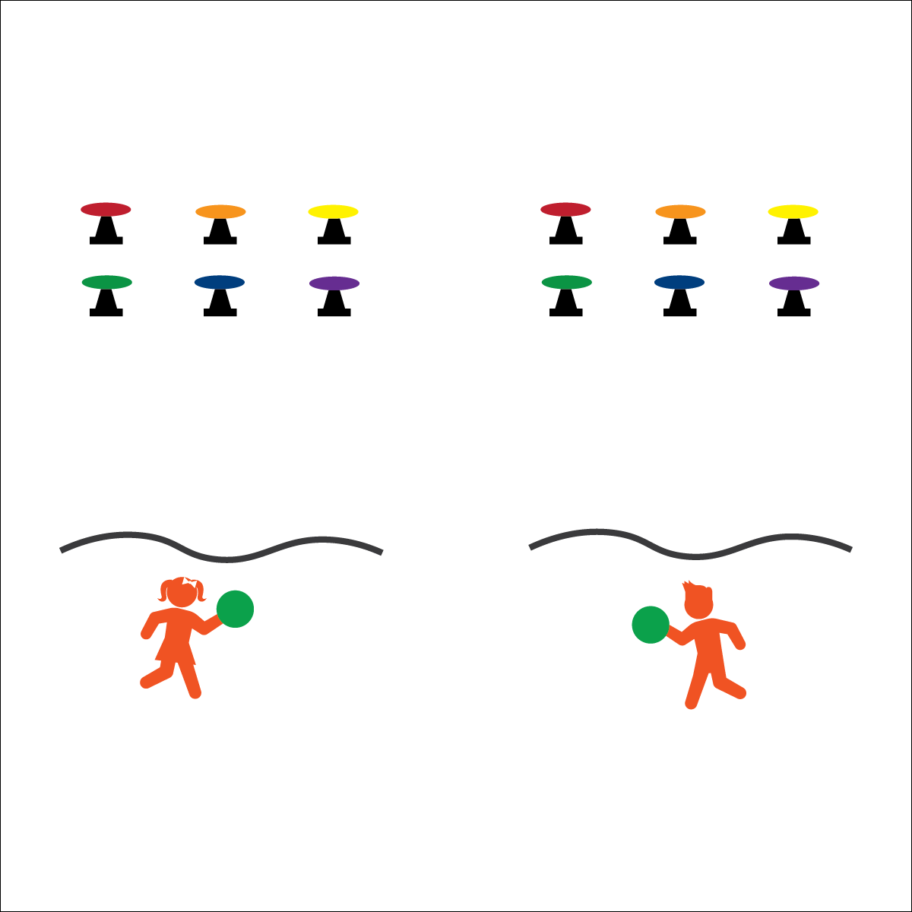



* **Etiquette**(K) Recognizes the established protocol for class activities. (1) Exhibits the established protocols for class activities without reminders. (2) Recognizes the role of rules and etiquette in teacher-designed physical activities. (3) Recognizes the role of rules and etiquette in physical activity with peers. (4) Exhibits etiquette and adherence to rules in a variety of physical activities. (5) Critiques the etiquette involved in rules of various game activities. (6) Identifies the rules and etiquette for physical activities/games and dance activities.

**Activity Procedures:**

1. This activity is an individual challenge called Space Invaders. The object is to knock apart as many “space invaders” as you can in 60 seconds by throwing the foam ball from behind the line and knocking the discs off the cones.
2. On the start signal, throw the foam ball at the cones and discs. After you throw the ball, run and get it, return to the throwing line, and then throw again. Continue for 1 full minute.
3. If you knock all 6 discs off of the cones, you can reset the discs and then move back to the line to attempt more throws. Don’t forget to count the number of “space invaders” you destroy!

**Modifications:**

* Use a variety of balls/tossable objects.
* Increase the number, size, and distance of targets.
* Play this game as a team relay challenge.

**Equipment:**

* 12 cones
* 12 flying discs
* 2 foam balls
* 2 jump ropes (or another line marker)

**Set-Up:**

1. Create 2 space invader game boards, side by side with one another. Each board should include 6 cones with 1 disc balanced on top of each, a jump rope to mark the throwing line, and 1 foam ball.
2. This is an individual challenge with 1 student per game board.

* **Personal & Social Responsibility:** I will recognize and adhere to the rules and etiquette of Space Invaders.

**SPACE INVADERS**

* Throw From Behind the Line
* Step with Opposite Foot
* Move Quickly