­­

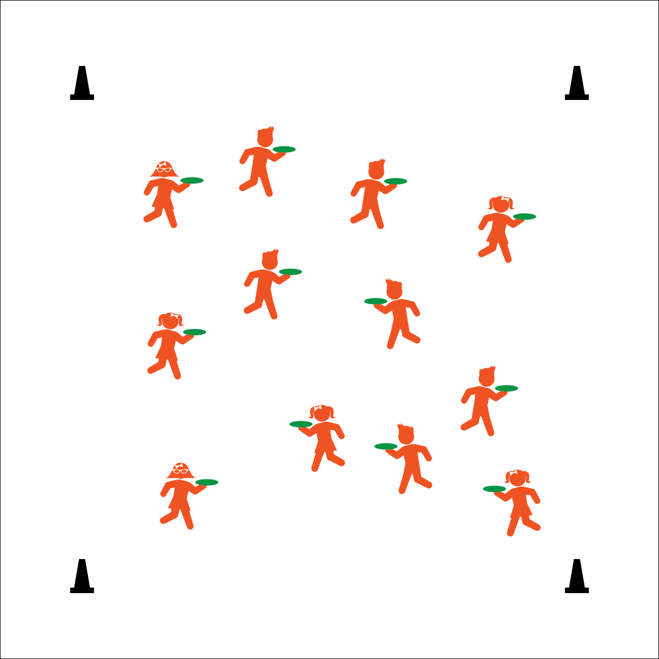

**Activity Procedures:**

1. This activity is an individual challenge called Pizza Delivery. The object of the game is to walk throughout the activity area while balancing your “pizza” on the palm of your hand without allowing it to be knocked to the floor by another player. At the same time, you’ll work to knock other players’ pizzas to the ground.
2. Begin by balancing your flying disc like a pizza platter. On the start signal, begin walking and continue to balance your disc. When the teacher yells, “TAG!” begin working to knock other pizzas to the floor.
3. If your disc falls to the floor, complete 10 jumping jacks, rebalance your disc, and continue playing.

**Modifications:**

* Assign 3–5 players as “taggers.” Only taggers are allowed to knock pizzas to the floor.
* When a pizza falls to the floor, students move to the perimeter and speed walk laps. The remaining players continue until there is only 1 pizza left.



* **Etiquette**(K) Recognizes the established protocol for class activities. (1) Exhibits the established protocols for class activities without reminders. (2) Recognizes the role of rules and etiquette in teacher-designed physical activities. (3) Recognizes the role of rules and etiquette in physical activity with peers. (4) Exhibits etiquette and adherence to rules in a variety of physical activities. (5) Critiques the etiquette involved in rules of various game activities. (6) Identifies the rules and etiquette for physical activities/games and dance activities.

**Equipment:**

* 1 flying disc per student (foam or plastic)
* 4 large cones

**Set-Up:**

1. Create a large activity area using 4 cones to mark boundaries.
2. Scatter students, each with a flying disc.

* **Personal & Social Responsibility:** I will recognize the rules and etiquette of this challenge in order to create a safe and positive activity environment.

**PIZZA DELIVERY**

* One Hand Under the Disc
* Head Up, Eyes Alert
* Control Tags for Safe Play