­­

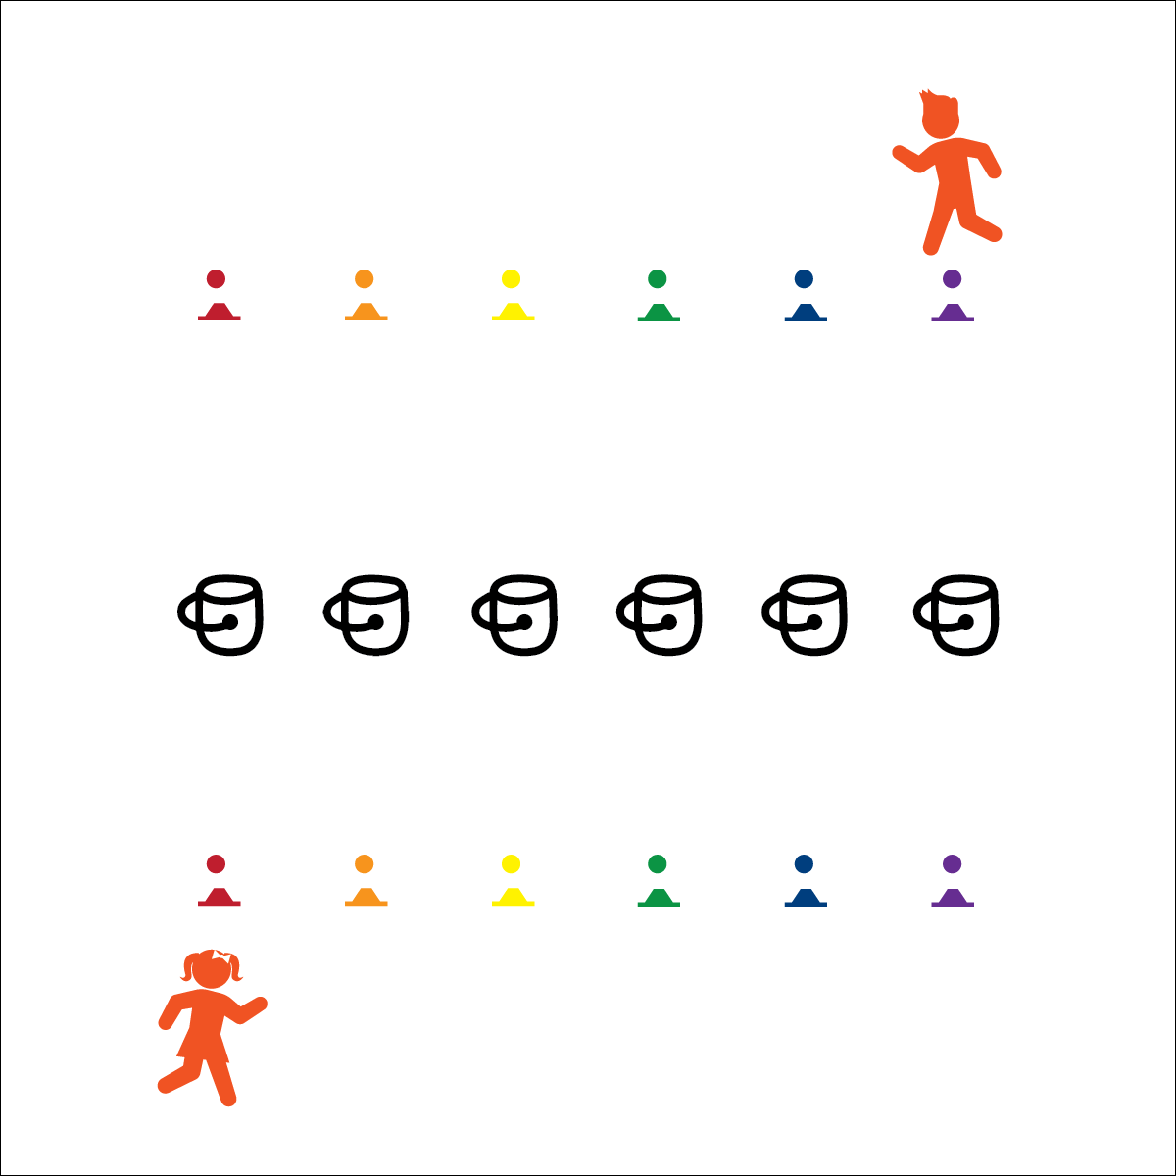

**Equipment:**

* 12 plastic buckets
* 12 golf-ball-sized whiffle balls
* 12 low-profile cones

**Set-Up:**

1. Create 2 parallel lines using the low-profile cones.
2. Place 1 ball at each cone.
3. Place 1 bucket approximately 3’ from each cone. They create a center line of buckets in the middle of the cones.
4. Divide students into 2 equal groups, groups lined up on each side.

* **Personal & Social Responsibility:** I will recognize and adhere to the rules and etiquette of the Grand Prize Game.

**Activity Procedures:**

1. This activity is the Grand Prize Game. The grand prize is the world’s largest imaginary stuffed animal!
2. The object of the game is to be the first player to toss each of the 6 balls on your side into each of the 6 buckets. You’ll compete head-to-head with the player on the opposite line.
3. On the start signal, begin by tossing 1 of the balls into 1 of the buckets. If you miss, retrieve the ball and try again. Do not interfere with your opponent’s toss. If you knock down your opponent’s toss, you’ll have to do 10 jumping jacks before tossing again. This will cost you valuable time.

**Modification:**

* Use ping pong balls. As an added challenge, the balls must bounce on the floor before landing in a bucket.



* **Standard 4 [E5.3-5]** Recognizes the role of rules and etiquette in physical activity with peers (3); Exhibits etiquette and adherence to rules in a variety of physical activities (4); Critiques the etiquette involved in rules of various game activities (5).

**GRAND PRIZE GAME**

* Step with Opposite Foot
* Eyes on Target
* 1 Ball per Bucket