­­

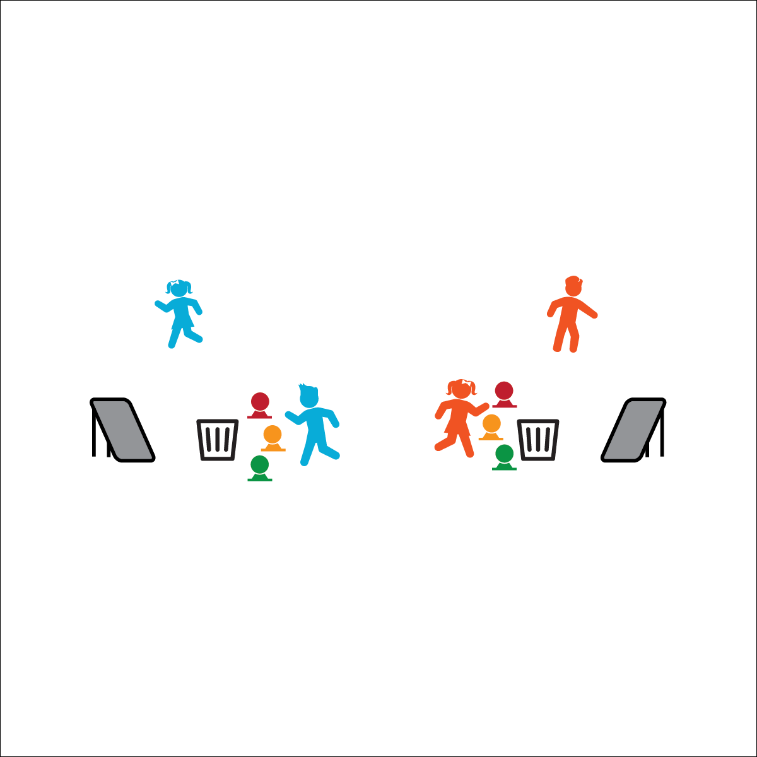

**Equipment:**

* 2 rebounders per pair of students
* 2 large buckets or trash cans per pair of students
* 2 low-profile cones per pair of students
* 6 Voit Bouncee Foam Balls

**Set-Up:**

1. Place rebounders 5–6’ from the large buckets/trash cans.
2. Place low-profile cones a safe throwing distance from the rebounders.
3. Pair students, or create 2 teams with 1 student from each team competing head-to-head.

* **Personal & Social Responsibility:** I will demonstrate the Spirit of the Game while competing in the game of Bounce Back.
* Throw with Control
* Using Throwing Cues
* Compete with the   
  Spirit of the Game

**Activity Procedures:**

1. This activity is called Bounce Back. The object of the game is to bounce all 3 of your foam balls into your bucket before your opponent bounces her/his into the opposite bucket.
2. You’ll do that by throwing your foam balls from behind the low-profile cone, off of the rebounder, and into the bucket. If you miss, quickly retrieve your ball and then try again from behind your cone.
3. When a player completes the challenge, the competition is over. Shake hands and allow the next player on your team to get ready for the next round.

**Modifications:**

* Adjust the distance between the rebounders, buckets, and cones.
* Use a solid wall rather than a rebounder. Demonstrate bounce strategies for successful throws.



* **Standard 4 [E1.3-5]:** Exhibits personal responsibility in teacher-directed activities (3); Exhibits responsible behavior in independent group situations (4); Engages in physical activity with responsible interpersonal behavior (e.g., peer to peer, student to teacher, student to referee) (5).

**BOUNCE BACK**