­­

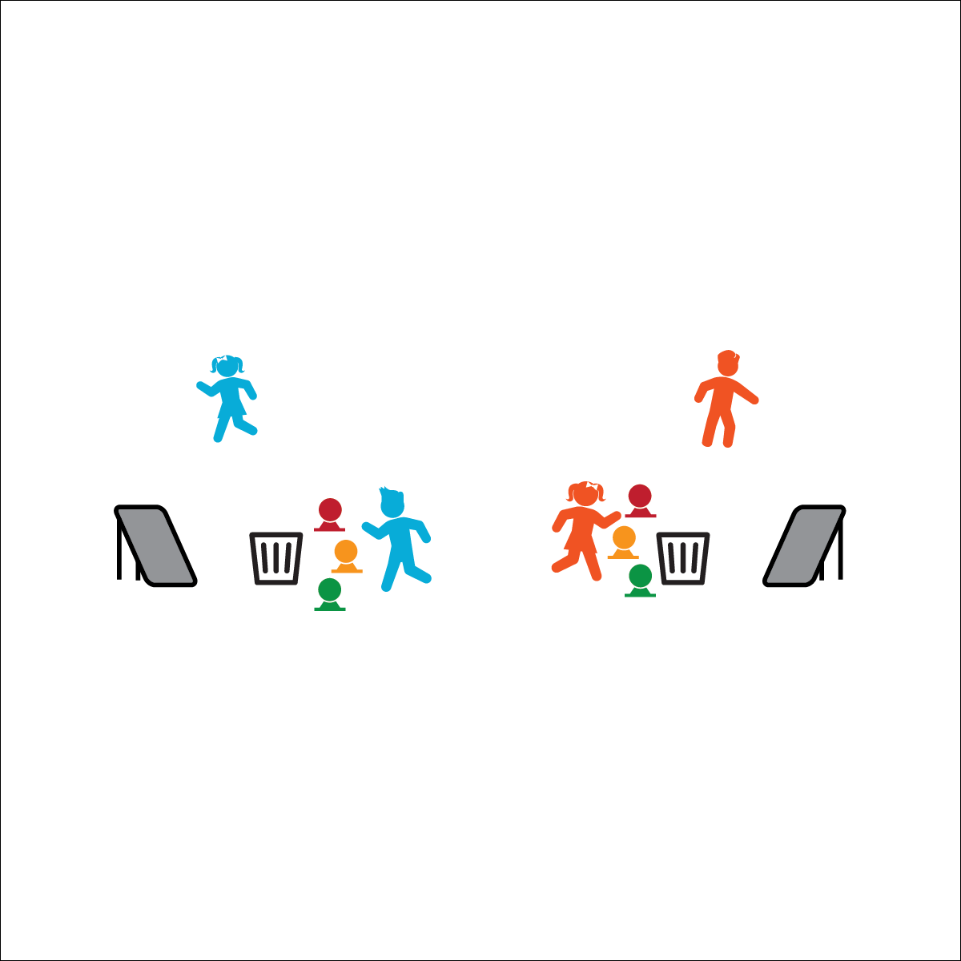



* **Social Interaction** (K) Discusses the enjoyment of playing with family and friends. (1) Discusses the reasons for participating in physical activity with friends. (2) Discusses ways to encourage others to be physically activity with friends. (3) Describes the positive social interactions that come when engaged with others in physical activity. (4) Describes and compares positive social interactions when engaged in partner, small-group, and large-group physical activities. (5) Describes the social benefits gained from participating in physical activity. (6) Demonstrates respect for self and others in activities and games by following the rules, encouraging others, and playing within the spirit of the game or activity.

**Activity Procedures:**

1. This activity is called Bounce Back. The object of the game is to bounce all 3 of your foam balls into your bucket before your opponent bounces her/his into the opposite bucket.
2. You’ll do that by throwing your foam balls from behind the low-profile cone, off of the rebounder, and into the bucket. If you miss, quickly retrieve your ball and then try again from behind your cone.
3. When a player completes the challenge, the competition is over. Shake hands and allow the next player on your team to get ready for the next round.

**Modifications:**

* Adjust the distance between the rebounders, buckets, and cones.
* Use a solid wall rather than a rebounder. Demonstrate bounce strategies for successful throws.

**Equipment:**

* 2 rebounders per pair of students
* 2 large buckets or trash cans per pair of students
* 2 low-profile cones per pair of students
* 6 Voit Bouncee Foam Balls

**Set-Up:**

1. Place rebounders 5–6’ from the large buckets/trash cans.
2. Place low-profile cones a safe throwing distance from the rebounders.
3. Pair students, or create 2 teams with 1 student from each team competing head-to-head.

* Throw with Control
* Using Throwing Cues
* Compete with the   
  Spirit of the Game
* **Personal & Social Responsibility:** I will demonstrate the Spirit of the Game while competing in the game of Bounce Back.

**BOUNCE BACK**