­­

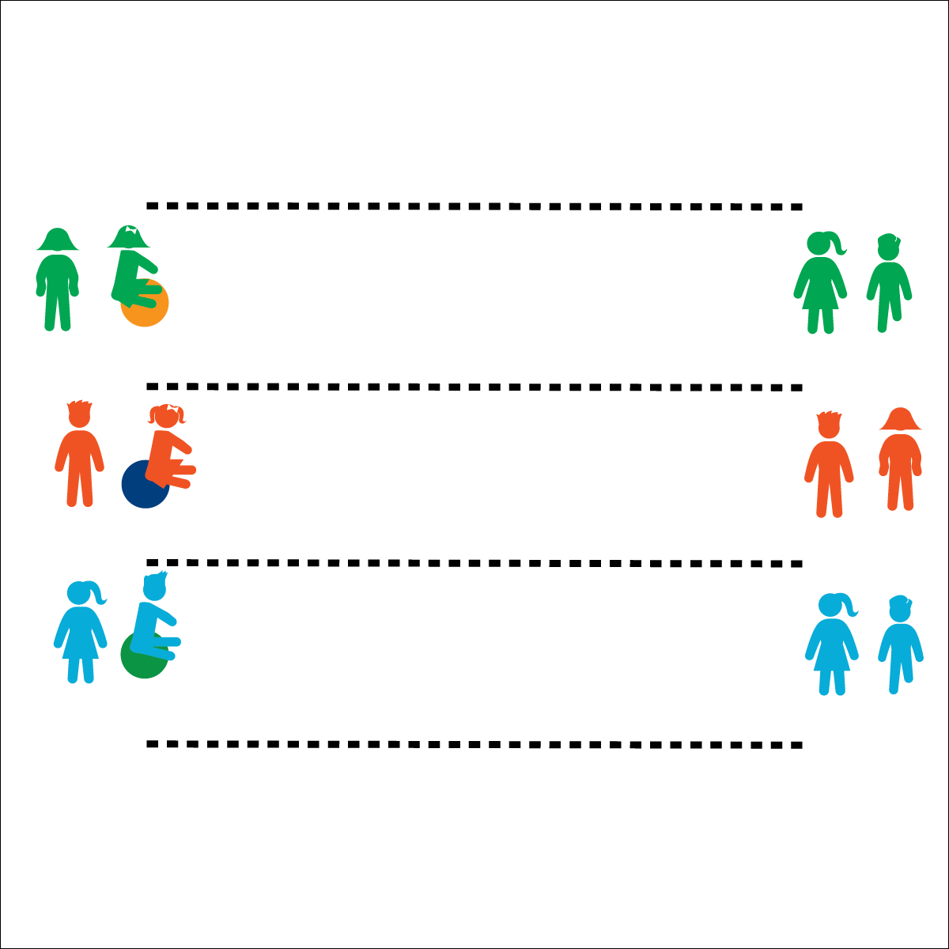



* **Social Interaction** (K) Discusses the enjoyment of playing with family and friends. (1) Discusses the reasons for participating in physical activity with friends. (2) Discusses ways to encourage others to be physically activity with friends. (3) Describes the positive social interactions that come when engaged with others in physical activity. (4) Describes and compares positive social interactions when engaged in partner, small-group, and large-group physical activities. (5) Describes the social benefits gained from participating in physical activity. (6) Demonstrates respect for self and others in activities and games by following the rules, encouraging others, and playing within the spirit of the game or activity.

**Activity Procedures:**

1. This activity is the Bounce Ball Team Relay. The object of the race is for each member of your team to bounce on the ball 1 full length of the race lane before all the members of the other teams finish.
2. On the start signal, the first bouncer on each team will begin bouncing down the race lane toward racer 2. At the end of the lane, racer 1 will get off of the bounce ball and give a fist bump to racer 2. Racer 2 will then race to racer 3, who will then race to racer 4.
3. When racer 4 crosses the finish line, all members of the team must sit quietly until all teams have finished.

**Modifications:**

* This race format can be used with a variety of locomotor movements, stilts, or scooters.

**Equipment:**

* 1 bouncy ball with handles per team
* Paint or low-profile cones to mark lanes (50–70’ in length)

**Set-Up:**

1. Mark race lanes with paint or cones.
2. Create teams of 4 students each.
3. Each team in a race lane with a bouncy ball at 1 end.
4. Racers 1 and 3 will line up behind the bouncy ball, racers 2 and 4 will line up at the opposite end of the lane.

* Work Safely
* Bounce with Purpose
* Listen for Teacher Cues
* Respect Equipment
* Cooperate with Friends
* **Personal & Social Responsibility:** I will demonstrate safe and cooperative play during each Bouncy Ball Team Relay.

**BOUNCE BALL TEAM RELAY**