­­

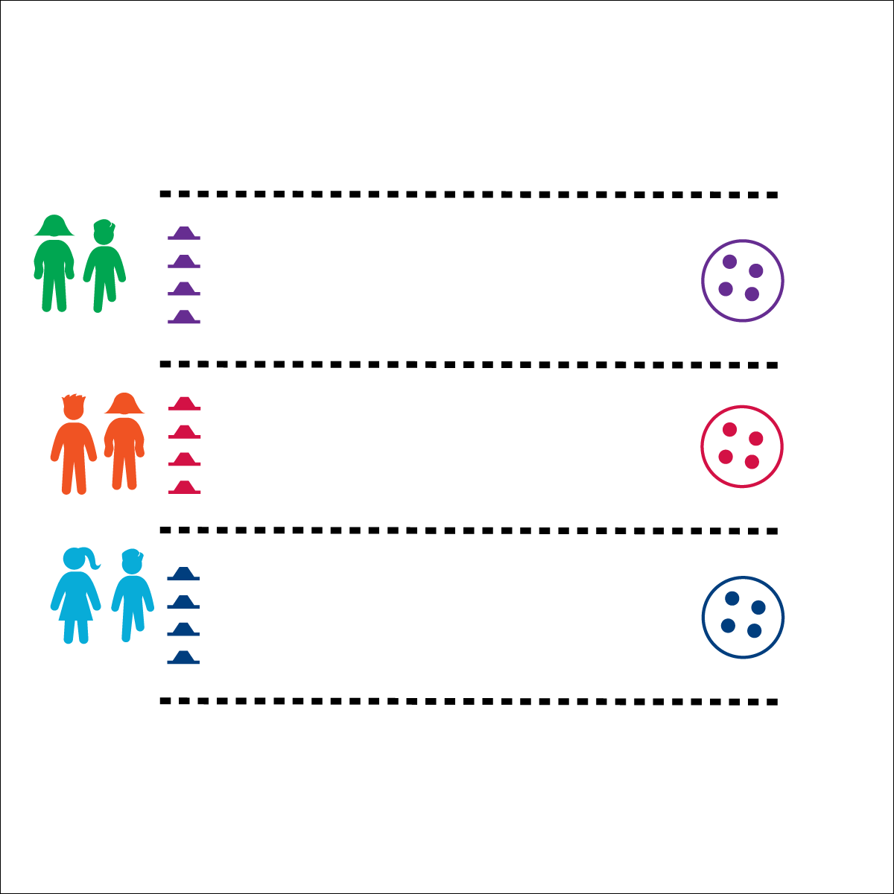

**Activity Procedures:**

1. This relay challenge is called Cherry On Top. The object of the activity is for you and your partner to take turns placing your colored balls (“cherries”) on top of your cones until all 4 “cherries” have been placed.
2. On the start signal, racer 1 will take 1 ball to a cone, place it on top, then return and fist-bump racer 2. Racer 2 will then take another ball to a cone. This repeats until all 4 balls are placed on the 4 cones. When your team is finished, sit quietly until all teams finish.
3. When the race is done, you’ll reset by getting your colored balls back in your hoop, ready for the next racers.

**Modifications:**

* This can be done with larger teams or as an individual challenge. Adjust the number of cones and colored balls accordingly.

**Equipment:**

* 4 cones of 1 color per team, each team with a different color
* 4 balls of 1 color per team, ball color matches team cone color
* 1 hoop per team, hoop color matches cone color

**Set-Up:**

1. Create racing lanes with 4 balls in a hoop at one end, and 4 cones at the other end (40’ to 50’ apart).
2. Pair students, each pair behind a hoop.



* **Standard 4 [E4.3-5]:** Works cooperatively with others (3a); Praises others for their success in movement performance (3b); Praises the movement performance of others both more and less-skilled (4a); Accepts “players” of all skill levels into the physical activity (4b); Accepts, recognizes, and actively involves others with both higher and lower skill abilities into physical activities and group projects (5).
* **Personal & Social Responsibility:** I will use positive and encouraging language with both my teammate and my opponent.
* 1 Ball at a Time
* Move Quickly
* Use Encouraging Language

**CHERRY ON TOP**