­­

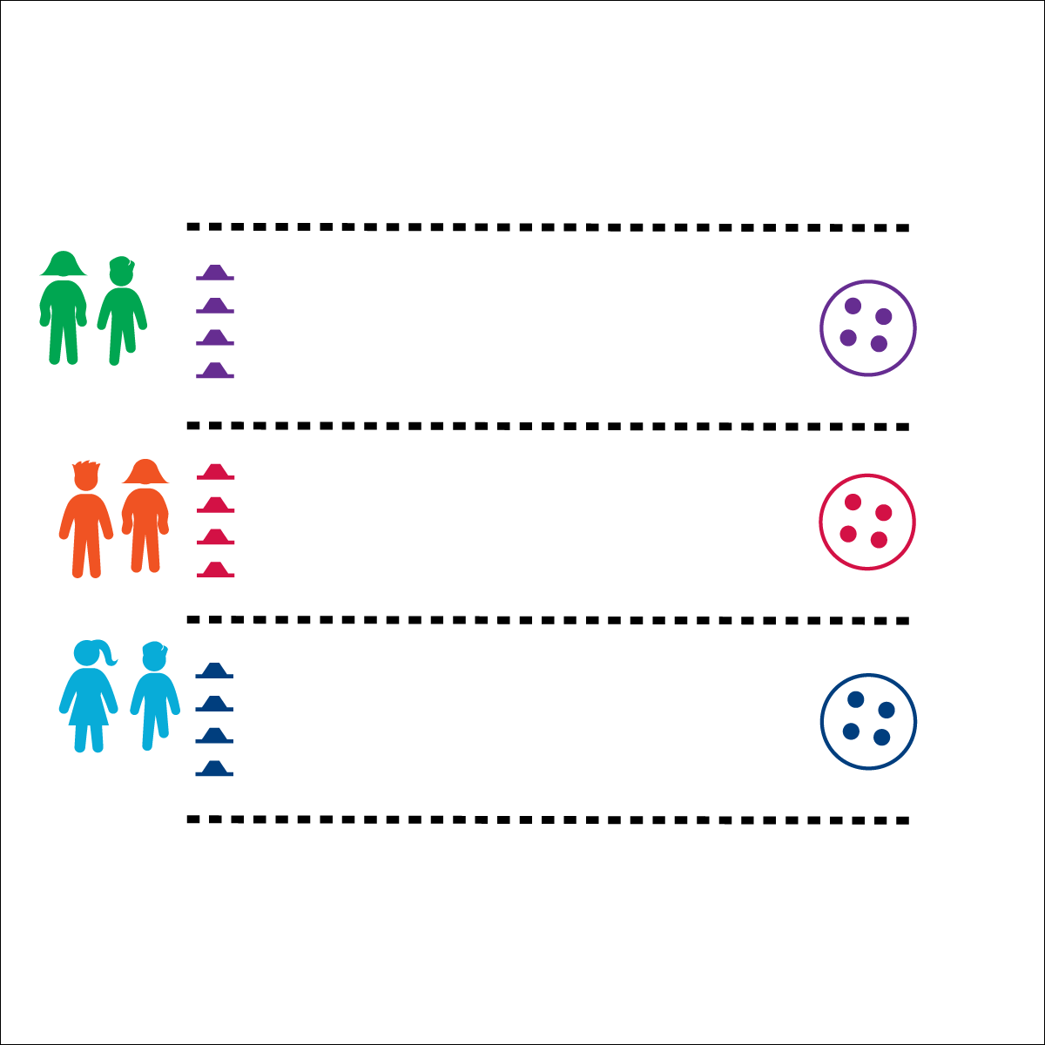



* **Social Interaction** (K) Discusses the enjoyment of playing with family and friends. (1) Discusses the reasons for participating in physical activity with friends. (2) Discusses ways to encourage others to be physically activity with friends. (3) Describes the positive social interactions that come when engaged with others in physical activity. (4) Describes and compares positive social interactions when engaged in partner, small-group, and large-group physical activities. (5) Describes the social benefits gained from participating in physical activity. (6) Demonstrates respect for self and others in activities and games by following the rules, encouraging others, and playing within the spirit of the game or activity.

**Activity Procedures:**

1. This relay challenge is called Cherry On Top. The object of the activity is for you and your partner to take turns placing your colored balls (“cherries”) on top of your cones until all 4 “cherries” have been placed.
2. On the start signal, racer 1 will take 1 ball to a cone, place it on top, then return and fist-bump racer 2. Racer 2 will then take another ball to a cone. This repeats until all 4 balls are placed on the 4 cones. When your team is finished, sit quietly until all teams finish.
3. When the race is done, you’ll reset by getting your colored balls back in your hoop, ready for the next racers.

**Modifications:**

* This can be done with larger teams or as an individual challenge. Adjust the number of cones and colored balls accordingly.

**Equipment:**

* 4 cones of 1 color per team, each team with a different color
* 4 balls of 1 color per team, ball color matches team cone color
* 1 hoop per team, hoop color matches cone color

**Set-Up:**

1. Create racing lanes with 4 balls in a hoop at one end, and 4 cones at the other end (40’ to 50’ apart).
2. Pair students, each pair behind a hoop.

* **Personal & Social Responsibility:** I will use positive and encouraging language with both my teammate and my opponent.
* 1 Ball at a Time
* Move Quickly
* Use Encouraging Language

**CHERRY ON TOP**