­­

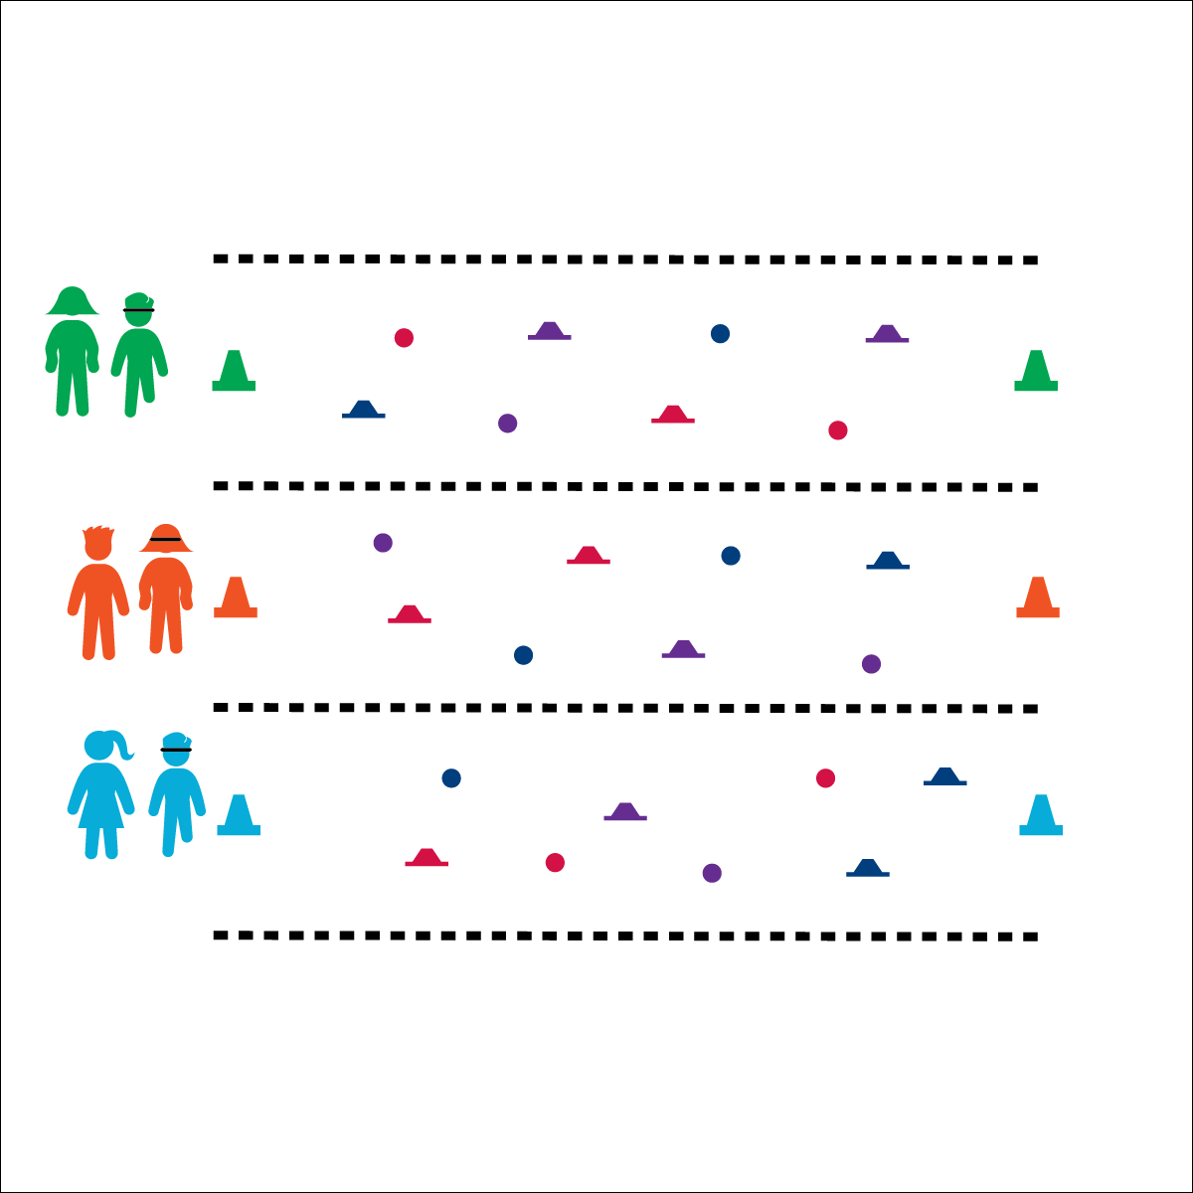

**Activity Procedures:**

1. This activity is the called Mission Impossible. You and your partner will work together to move across the minefield to the opposite cone and then back again without touching any mines.
2. The first player wearing the blindfold is the special agent, and the other player is the scout. The scout will use words to guide the special agent safely to the opposite cone, helping them avoid the mines. You may not touch or guide your partner with your hands.
3. Once you make it to the opposite cone, quickly switch roles and make your way back to the original cone.
4. If the special agent touches a mine, both players must return to the cone where they started, switch roles, and try again.

**Modification:**

* Use fewer “mines” to make the activity less challenging.
* Use nonverbal cues only (clap, stomp, whistle, etc.).



* **Standard 4 [E4.3-5]** Works cooperatively with others (3a); Praises others for their success in movement performance (3b); Praises the movement performance of others both more and less-skilled (4a); Accepts “players” of all skill levels into the physical activity (4b); Accepts, recognizes, and actively involves others with both higher and lower skill abilities into physical activities and group projects (5).

**Equipment:**

* 1 blindfold per pair of students
* 2 cones (of the same color) per pair of students
* 5–10 “mines” per pair of students (e.g., bean bags, cones, bowling pins, hula hoops, etc.)

**Set-Up:**

1. Use cones to create 1 relay line per pair with 40–50’ between cones.
2. Scatter “mines” all around the activity area, leaving enough space between mines for students to move safely.
3. Pair students, each pair at a starting cone with a blindfold.

* **Personal & Social Responsibility:** I will work safely and cooperatively with my partner using positive and encouraging language.

**MISSION IMPOSSIBLE**

* Blindfold Stays On
* Use Positive Language
* Communicate with Respect