­­

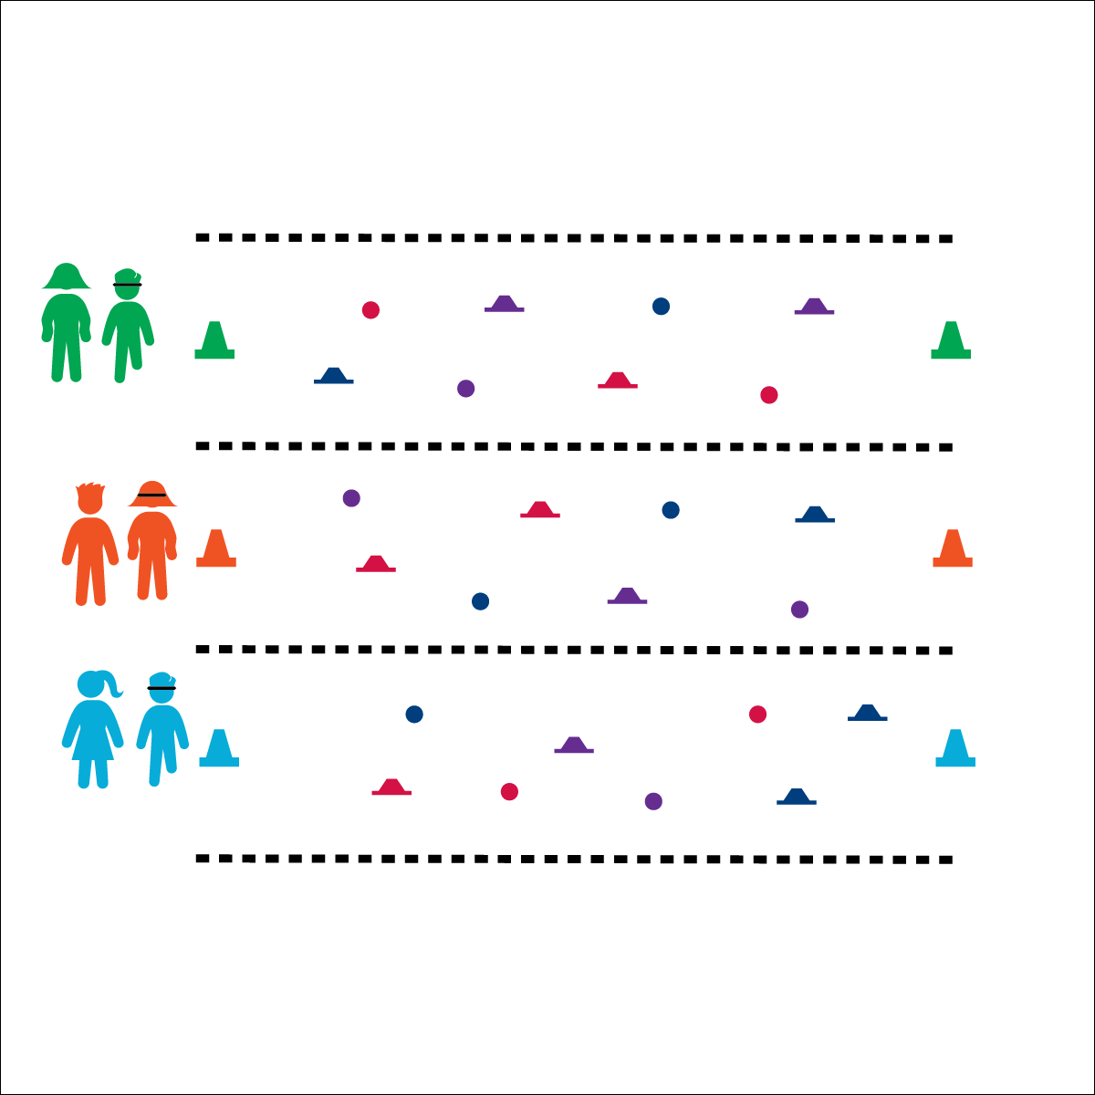



* **Social Interaction** (K) Discusses the enjoyment of playing with family and friends. (1) Discusses the reasons for participating in physical activity with friends. (2) Discusses ways to encourage others to be physically activity with friends. (3) Describes the positive social interactions that come when engaged with others in physical activity. (4) Describes and compares positive social interactions when engaged in partner, small-group, and large-group physical activities. (5) Describes the social benefits gained from participating in physical activity. (6) Demonstrates respect for self and others in activities and games by following the rules, encouraging others, and playing within the spirit of the game or activity.

**Activity Procedures:**

1. This activity is the called Mission Impossible. You and your partner will work together to move across the minefield to the opposite cone and then back again without touching any mines.
2. The first player wearing the blindfold is the special agent, and the other player is the scout. The scout will use words to guide the special agent safely to the opposite cone, helping them avoid the mines. You may not touch or guide your partner with your hands.
3. Once you make it to the opposite cone, quickly switch roles and come back to the original cone.
4. If the special agent touches a mine, both players must return to the cone where they started, switch roles, and try again.

**Modification:**

* Use fewer “mines” to make the activity less challenging.
* Use nonverbal cues only (clap, stomp, whistle, etc.).

**Equipment:**

* 1 blindfold per pair of students
* 2 cones (of the same color) per pair of students
* 5–10 “mines” per pair of students (e.g., bean bags, cones, bowling pins, hula hoops, etc.)

**Set-Up:**

1. Use cones to create 1 relay line per pair with 40–50’ between cones.
2. Scatter “mines” all around the activity area, leaving enough space between mines for students to move safely.
3. Pair students, each pair at a starting cone with a blindfold.

* **Personal & Social Responsibility:** I will work safely and cooperatively with my partner using positive and encouraging language.

**MISSION IMPOSSIBLE**

* Blindfold Stays On
* Use Positive Language
* Communicate with Respect