­­

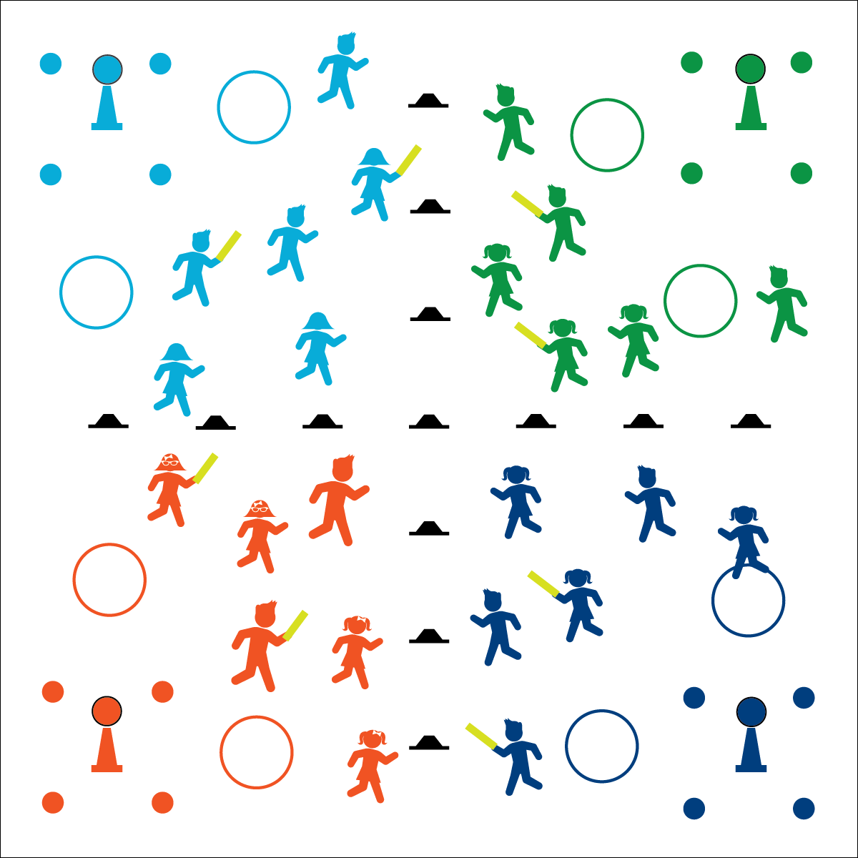



* **Social Interaction** (6) Demonstrates respect for self and others in activities and games by following the rules, encouraging others, and playing within the spirit of the game or activity. (7) Demonstrates the importance of social interaction by helping and encouraging others, avoiding trash talk, and providing support to classmates.

**Activity Procedures:**

1. Today’s activity is called 4 Way Capture the Flag. The object of the game is to capture the ball (“flag”) from 1 of the other teams. To capture the flag, you must run it back or make a completed pass. If the flag is passed, it must be caught before it touches the ground; otherwise, it must be returned to its cone.
2. Teams get a point (+1) for each time they return a flag to their own side. The team that had their flag captured loses a point (-1).
3. The taggers on each team try to protect their flag by tagging anyone who enters their quadrant. If tagged by noodle, players sit down in the spot they were tagged.
4. If you’re tagged, someone from your own team can free you by reaching you (before being tagged themselves). If you are freed, put a hand up signaling that you are taking your mandatory free walk back to own side. The player that set you free does NOT get a free walk.
5. Taggers are allowed to leave their side to free teammates or go for the flag.
6. If you step out of bounds, you’re “tagged.” Re-enter where you left the boundary and sit.
7. Hula hoops are safety zones, but only 1 person is allowed per hoop at a time.

**Modification:**

* Add more/fewer taggers to provide the appropriate challenge.

**Equipment:**

* 20–30 low-profile cones
* 16 poly spots
* 4 foam balls
* 4 12” cones
* 8 hula hoops
* 8 foam noodles

**Set-Up:**

1. Use low-profile cones to separate playing area into 4 equal quadrants (10–15 paces each).
2. Use poly spots to make a square (2 paces by 2 paces) as the “no-guarding zone” in each quadrant.
3. Place a 12” cone in the no-guarding zone and place a foam ball (flag) on each cone
4. Put 2 hoops in each quadrant.
5. Divide students into 4 equal teams. Select 2 members from each team as taggers, and give them noodles.

* **Personal & Social Responsibility:** I will accept the efforts and abilities of everyone on my team by using positive and encouraging language.
* Move Safely
* Work Together
* Apply a Strategy

**4-WAY CAPTURE THE FLAG**