­­

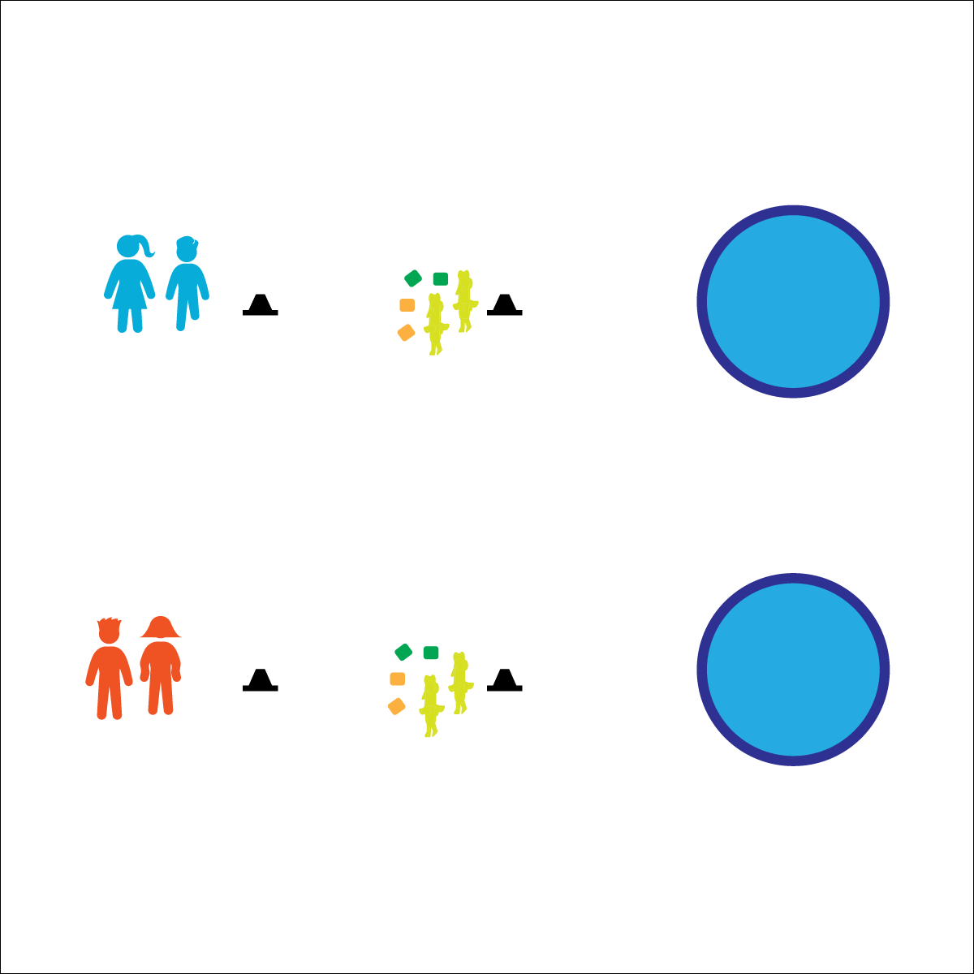

* **Personal & Social Responsibility:** I will compete fairly, following the rules and etiquette of field day activities.
* Move Quickly
* Throw with Control and Accuracy
* Throw from Behind the Cone

**Activity Procedures:**

1. This activity is called Chicken Pot Pie. The object is for you and your partner to throw all of your items (“veggies” and “chicken”) into the kiddie pool before the other team.
2. On the start signal, Partner 1 will run to the hoop, pick up an item, and toss it into the pool. If your throw is accurate and the object lands in the pool, turn and run back to Partner 2. Give her/him a high-5 and then she/he will move to toss the next object. Each player will throw 1 object at a time.
3. If you miss, quickly run to the object, pick it up, bring it back and place it in the hoop. Then move to high-5 your partner.
4. Continue until 1 team tosses all objects accurately into the pool.

**Modifications:**

* Adjust the throwing and/or running distances.
* Add more tossable objects.

**Equipment:**

* 1 Kiddie Pool (or large circular target)
* 2 rubber chickens per team
* 2 green bean bags per team
* 2 orange bean bags per team
* 2 low-profile cones per team

**Set-Up:**

1. Place low-profile cones 10–15’ from pool. Place rubber chickens and beanbags behind the cone closest to the pool.
2. Create teams of 2 students each; 2 teams will play at a time (head-to-head).
3. Teams stand behind low-profile cones facing the pool.



* **Standard 4 [E5.3-5]** Recognizes the role of rules and etiquette in physical activity with peers (3); Exhibits etiquette and adherence to rules in a variety of physical activities (4); Critiques the etiquette involved in rules of various game activities (5).

**CHICKEN POT PIE**