­­

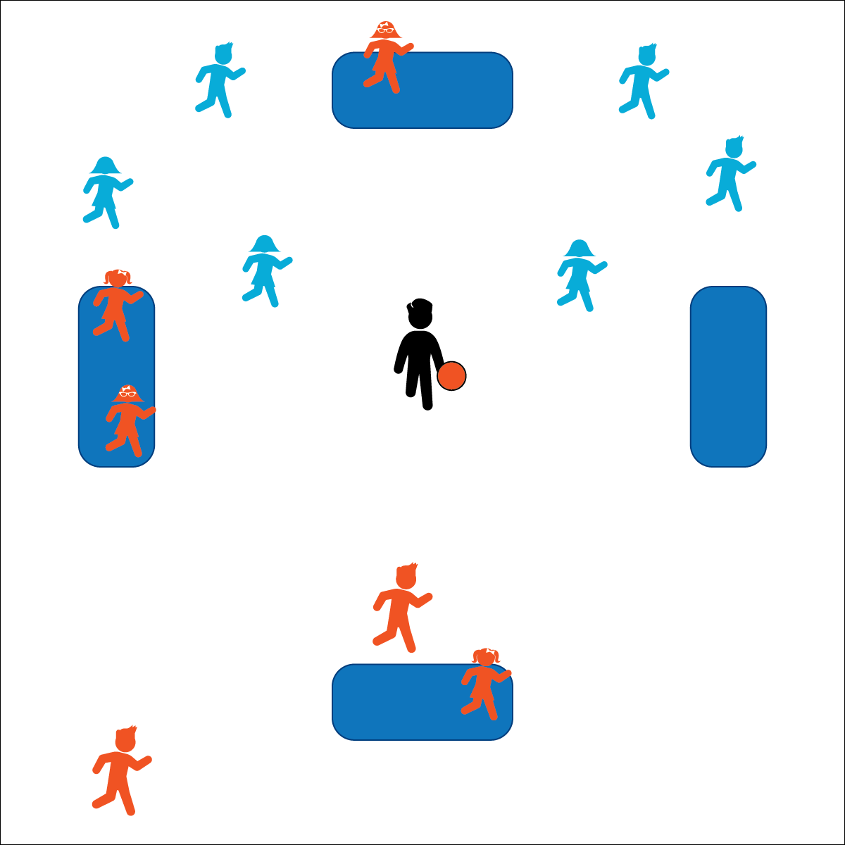

**Activity Procedures:**

1. This is Mega Mat Ball. The object of the game is to score points by running around the bases 2 full times without getting tagged. The game is similar to kickball. The pitcher on the fielding team rolls the ball to the 1st kicker, who kicks the ball and runs to 1st base.
2. To score, a player must successfully make it around the bases twice. The 2nd time they touch 4th base equals a run for their team (they rejoin the kicking line).
3. There are 2 ways to get out: 1) a pop fly caught before it bounces, or 2) being tagged by a ball when not on a base. There are no force outs.
4. You are never forced to run. There can be any number of players on a base, including 4th Base (usually home base). You can run at any time. However, once you leave a base, you MUST keep going forward to the next base.
5. The teacher (umpire) CAN call a foul ball on a kick if the ball goes backwards, gets stuck in an obstacle, or interferes in another game. Other than that, all kicks are fair. If a foul is called, this is the 1 and only time runners must go back to the base they were on before the foul was called.
6. After 3 outs, kickers and fielders switch (keep same/similar kicking order).

**Modifications:**

* Teachers pitch.
* Students only run once around the bases.

**Equipment:**

* 4 large bases (can mark base areas with field paint, cones, mats, etc.)
* 1 playground ball

**Set-Up:**

1. Create a large kickball-style playing filed with 4 bases.
2. Create 2 equal teams of 5–10 players each.
3. Provide multiple games for groups larger than 20.

**MEGA MAT BALL**

* Always Keep Your Eye on the Ball
* Cooperate and Communicate
* Maintain Control and Run Safely
* **Personal & Social Responsibility:** I will use positive language to help players of all skill levels feel accepted during the game of Mega Mat Ball.



* **Social Interaction** (6) Demonstrates respect for self and others in activities and games by following the rules, encouraging others, and playing within the spirit of the game or activity. (7) Demonstrates the importance of social interaction by helping and encouraging others, avoiding trash talk, and providing support to classmates.