­­

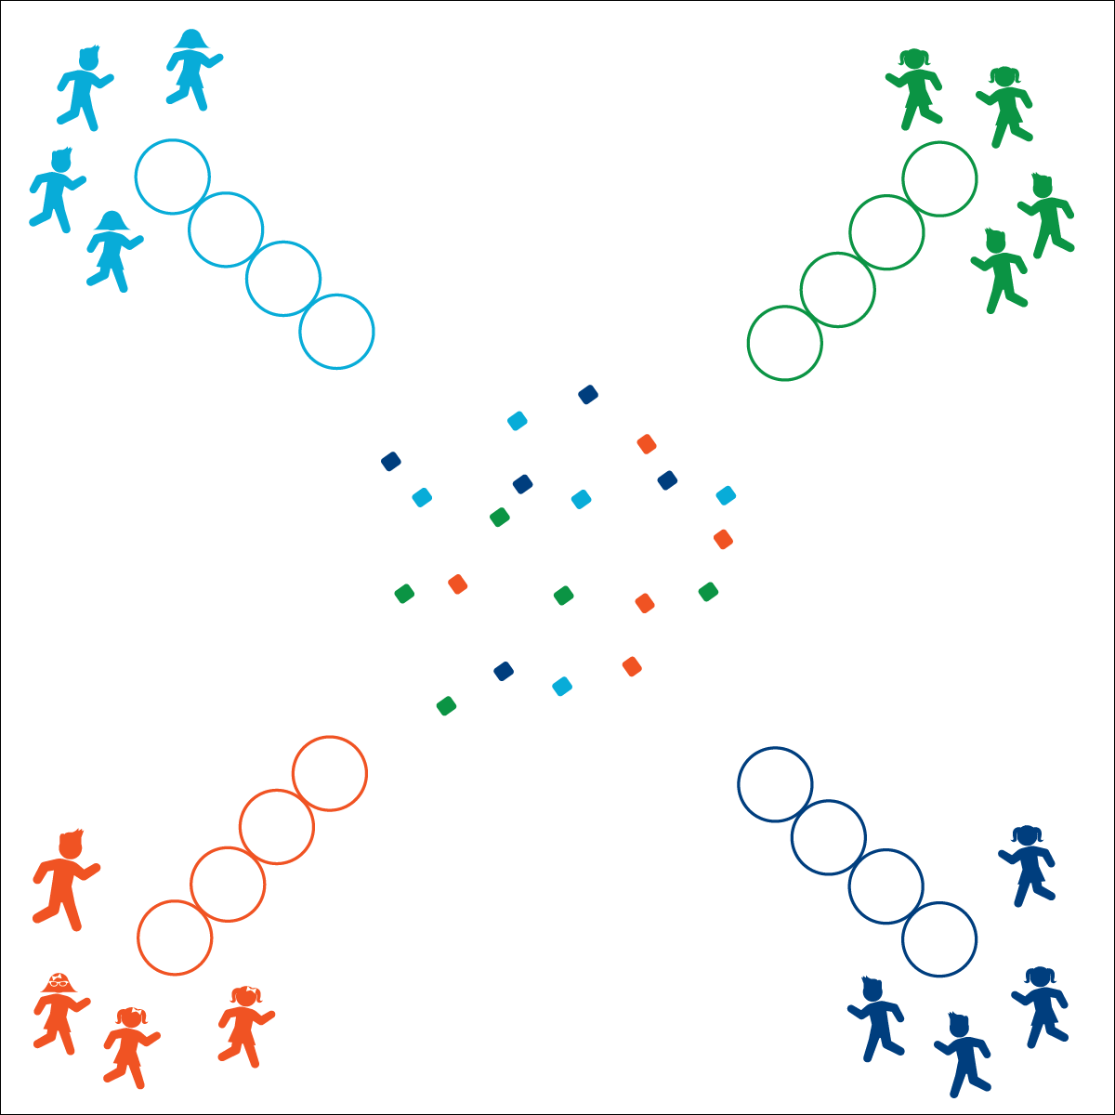

* Communicate
* Control Your Movements
* Cooperate

**RACE THROUGH THE GALAXY**

**Activity Procedures:**

1. This activity is called Race Through the Galaxy! The object of the activity is for you to fill your ship’s gas tank so you can take off and find a new planet to call home. You’ll do that by working together, moving in your “hover craft” (hoops) through the activity area, collecting “fuel” (items that match the color of your hoops), and then returning them to your home hoop.
2. On the start signal, each team will begin to travel by using 3 of your 4 hoops (the hoop in the corner is designated as the home hoop and does not move). You’ll collect 1 item that matches your team’s color and then return it to your home hoop. Continue in this way until all items are collected.
3. The play area is filled with poisonous swamp water, so all teams must travel inside of the hovercrafts (hoops). Hoops can’t be moved with players inside of them. You’ll need to squeeze your team into 2 of the 3 hoops, and then move the 3rd hoop in front of the team so you can continue moving in the direction you need to go.
4. If anyone touches the poisonous swamp water, the team has to drop any fuel items they’re holding, walk back to the home hoop, and continue from there.
5. Play continues until all teams complete their mission. Use the stopwatch to time the fastest group. Then play again, with all 4 teams trying to beat the previous record time.

**Modifications:**

* This can be done as a partner activity with 2 hoops as hover crafts.
* Allow students to pick up as many fuel items as possible.

**Equipment:**

* 4 hoops per team (1 color per team)
* 5 bean bags or foam balls per team (1 color per team)
* 1 stopwatch (optional)

**Set-Up:**

1. Create a large, square activity area with hoops arranged in a diagonal line from each corner, pointing into the center of the area.
2. Scatter each team’s colored bean bags and foam balls around the center of the activity area.
3. Create teams of 4–6 students, each team behind a line of hoops.

* **Personal & Social Responsibility:** I will work cooperatively with my teammates and use positive language to demonstrate acceptance for all of my teammates.



* **Social Interaction** (6) Demonstrates respect for self and others in activities and games by following the rules, encouraging others, and playing within the spirit of the game or activity. (7) Demonstrates the importance of social interaction by helping and encouraging others, avoiding trash talk, and providing support to classmates.